16305 WESTHEIMER PLAZA CENTER, HOUSTON, TX. 77082

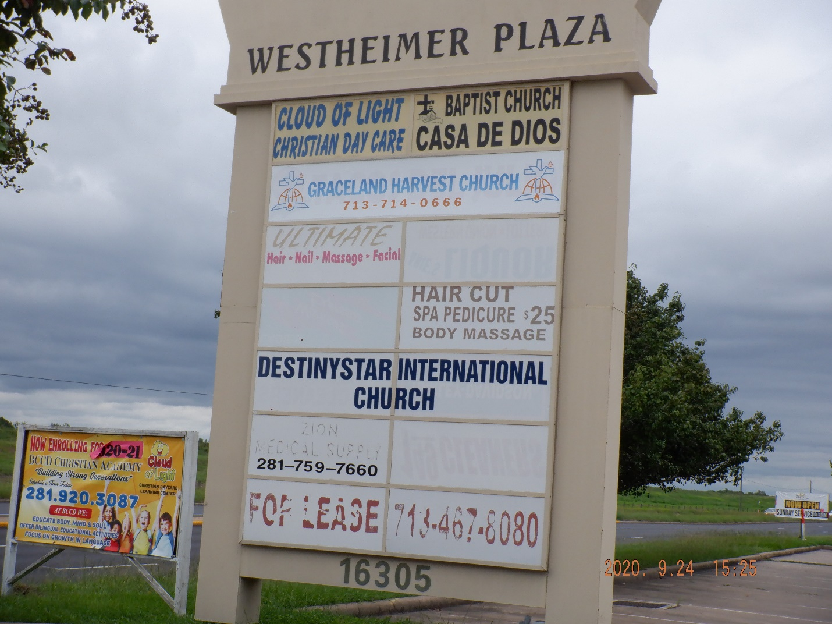
Base Rent: $15-18 psf/yr plus $4 psf/yr triple net estimate
Vincent R. Worley Vice President of Leasing- Broker
713 819 1365 cell Vincent.Worley@McCastleRealty.com Texas law requires all license holders to provide the
TREC LINK https://www.trec.texas.gov/forms/information-about-brokerage-services
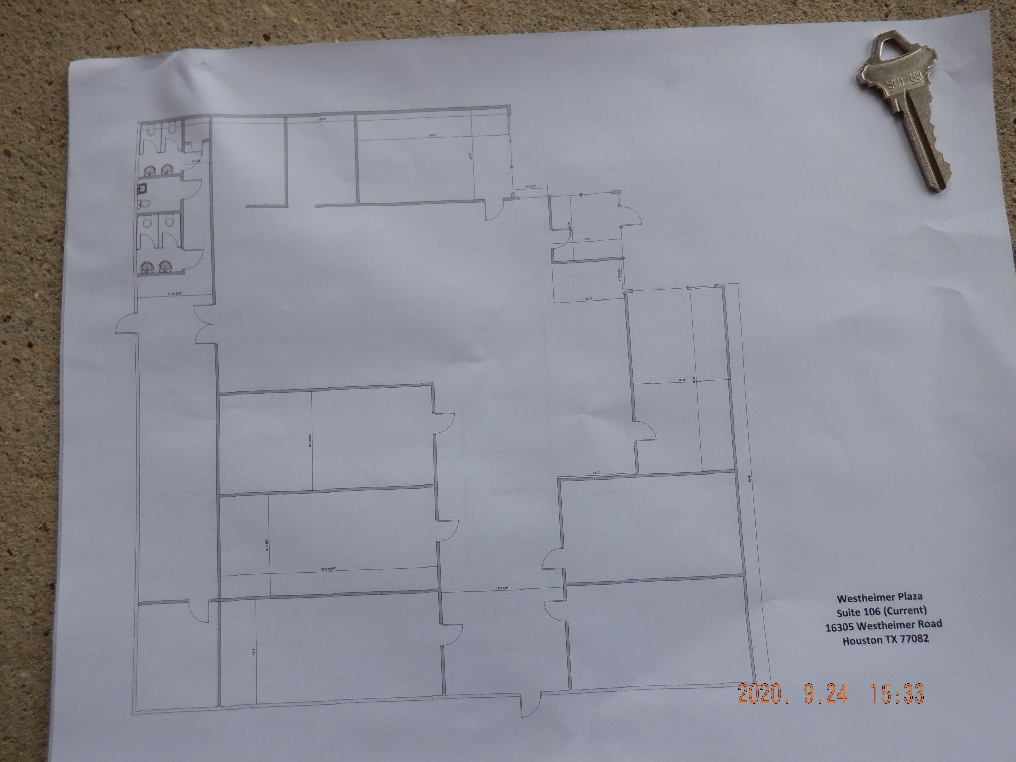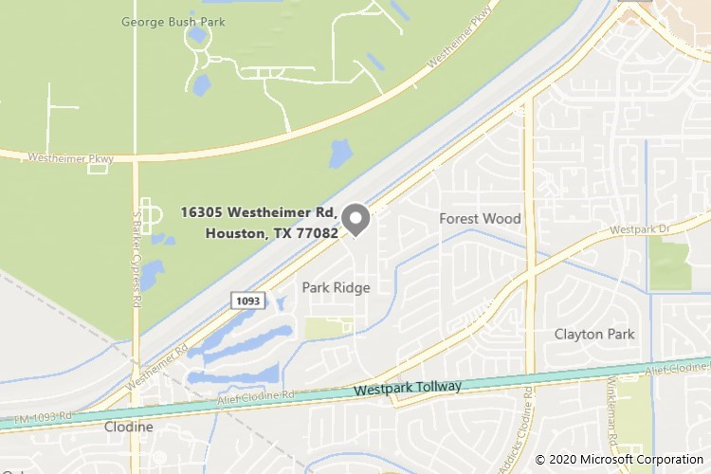
WEST OAKS CENTER AREA DEMOGRAPHICS
Population 1 mile 3 miles 5 miles
2019 Estimate 10,461 119,605 339,367
2024 Projection 10,823 123,339 356,319
2010 Census 8,451 103,470 302,731

Projected Annual Growth
2019-2024 0.7% 0.6% 1.0%
Estimated Household Income 1 mile 3 miles 5 miles
2019 Average HH Income $92,063 $92,093 $92,370
2019 Median HH Income $64,045 $65,990 $69,559

Household 1 mile 3 miles 5 miles
2019 Estimate 4,521 50,124 130,687
2024 Projection 4,832 53,441 141,036
2010 Census 3,502 41,417 111,593
Projected Annual Growth 2019-2024 1.4% 1.3% 1.6%

