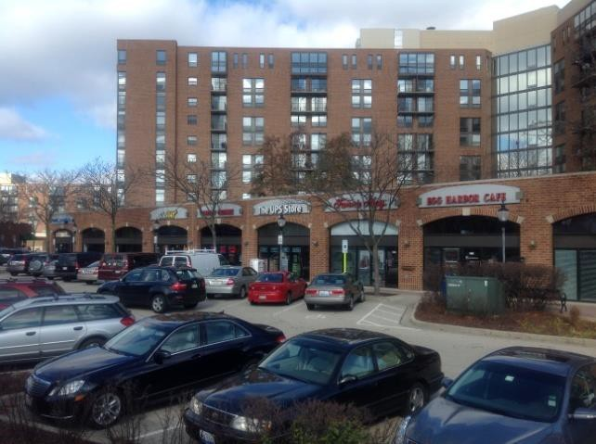
Office & Retail Space For Lease
Hancock Square at Arlington Station
Arlington Heights Road & Northwest Highway
Central Business District - Arlington Heights, IL

Specifications
- Retail & Office Space within Mixed Use Residential Community
- Two Building Upscale Apartment Complex with 409 units
  - Last Available Suite
- 1817 sq ft on Dunton
- Adjacent to Metra Train Station
Recruit and Retain Chicago Millennials
- Surface Lot and Parking Garage
- Over 120,000 Residents within 3 miles
- Average Household Income within 1 mile: $101,943

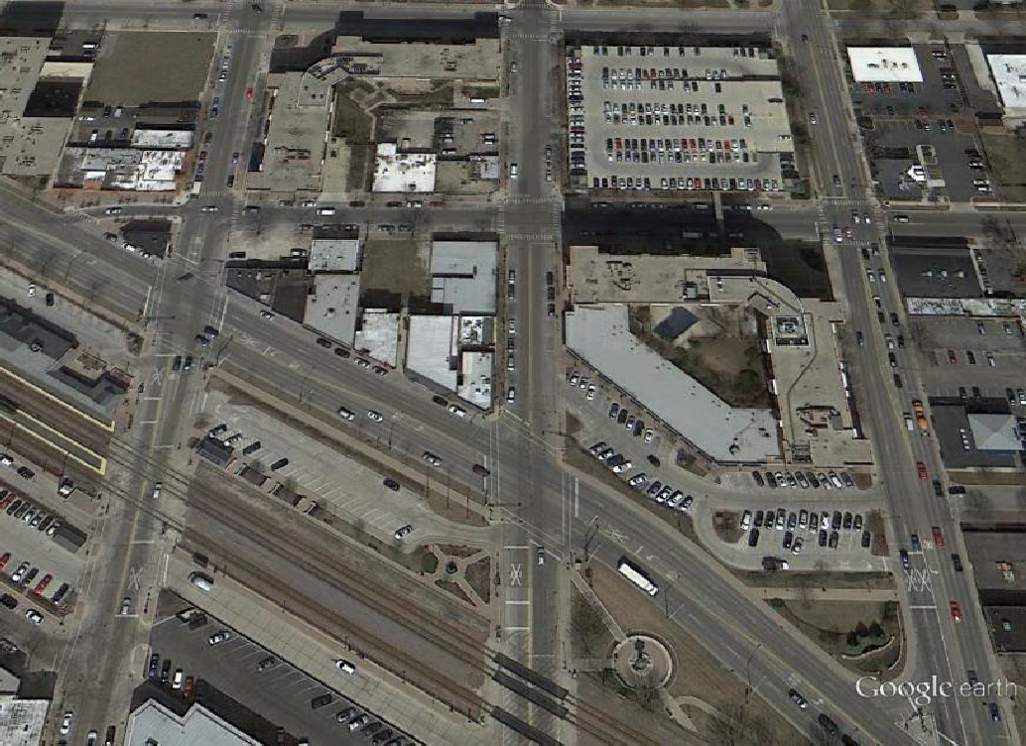



19
Building Two
Parking Garage
Miner St.
Building
One
Metra Station


For more information or to arrange a tour, contact:
Doug Gow (847) 772-3684
douglaslgow@gmail.com

Office & Retail Space For Lease
Downtown
Arlington Heights Tenants
Egg Harbor Café
UPS
Fannie May Jewel/Osco
Bath & Body Works Starbucks
Sport Clips
Peggy Kinane’s Courtland Grill Mago’s Wildfish
La Tasca
Salsa 17
Metropolis Performing
Arts
Center
Submitted subject to error, change in status
or withdrawal without notice
Hancock Square at Arlington Station
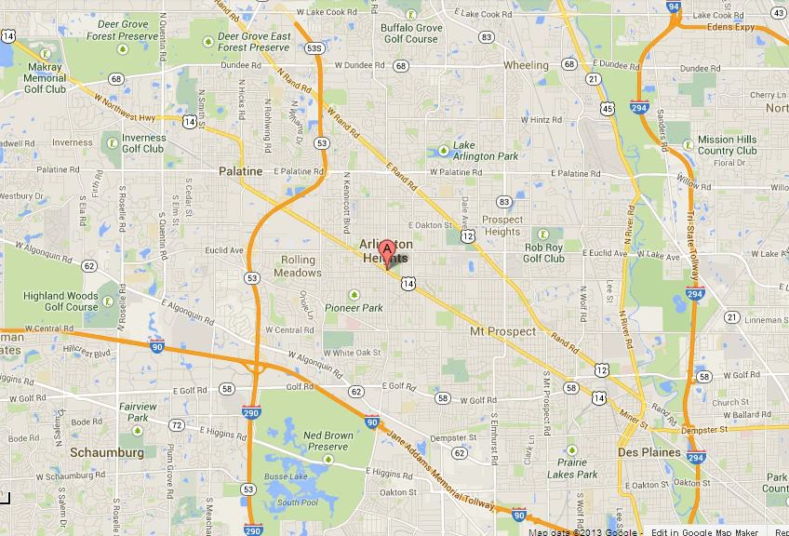
Central Business District - Arlington Heights, IL

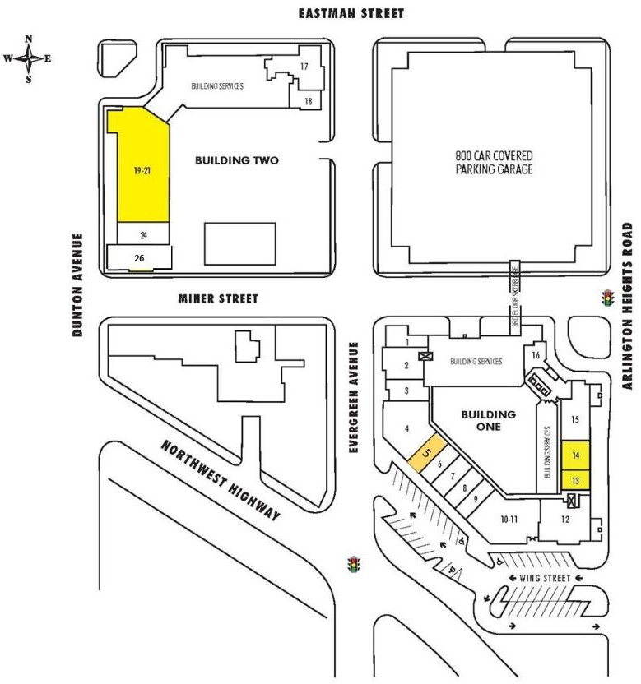
HANCOCK SQUARE - RETAIL & OFFICE
UNIT | TENANT | RSF | Address
1 | Aloha Poke |  | 163 N Evergreen
2 | Bitter and Sweet |  | 157 N Evergreen
3 | Nikki's Salon |  | 151 N Evergreen
4&5 | CB-NRT |  | 102 E Wing
6 | Fannie May |  | 114 E wing
7 | Arl Hts Currency Exchange |  | 118 E Wing
8 | UPS Store |  | 126 E Wing
9, 10 &11 | Egg Harbor Café |  | 140 E Wing
12 | Gumrai Thai |  | 170 N Arl Hts Rd
13 | Pure Health |  | 176 N Arl Hts Rd
17 | Thrown Elements Pottery |  | 260 N Evergreen
18 | Mindful Kitchen |  | 250 N Evergreen
19a | Enclave |  | 281 N Dunton
19b | 1817 sf available now |  | 281 N Dunton
20 | Exercise Coach |  | 281 N Dunton
24 | Dr. Relias, D.M.D. |  | 271 N Dunton
26 | Berkshire Hathaway |  | 6 E Miner

For more information or to arrange a tour, contact:
Doug Gow (847) 772-3684
douglaslgow@gmail.com

