Confidential Offering Memorandum

Milton, Ontario | Investment Opportunity
Milton Commercial
Investment Property
50 Steeles Avenue East, Milton, Ontario L9T 4X1

Asking Price  $999,999  Vendor asking price | Monthly Income  $3,800  In place, tenant occupied | Indicated Cap Rate  4.56%  On stated income

Stable long-term tenant • Below-market rent • Defined income-growth runway
Prepared for qualified investors and cooperating brokers
Presented by Evelyn Santizo
SoldBig Realty Inc., Brokerage
647-772-4009 | evelyn360@gmail.com

Executive Summary
A stabilised income-producing asset on Milton's Steeles Avenue East corridor, offered with an identified path to income growth.
This offering presents investors with the opportunity to acquire a commercial property at 50 Steeles Avenue East, Milton, producing approximately $3,800 per month in current income. At the asking price of $999,999, the stated income represents an estimated capitalisation rate of approximately 4.56%, assuming the $3,800 is net operating income before financing.
The property is occupied by a stable tenant with more than five years of operating history at the premises. The current rent is believed to be below prevailing market levels, creating the potential to improve income over time through negotiated rent growth, renewal, or future lease restructuring, subject to the existing lease and applicable law.

Core Investment Thesis
- Established tenancy. More than five years of continuous occupancy at the premises.
- Income from closing. An operating commercial tenancy produces cash flow from day one, subject to lease verification and adjustments.
- Below-market rental position. Current rent is believed to sit under market, offering a defined runway for NOI growth.
- Value creation through NOI. Every incremental dollar of sustainable NOI is capitalised into asset value at prevailing market cap rates.
- Milton growth corridor. Located within one of the GTA's fastest-expanding residential, employment and logistics markets.
- Flexible investor profile. Suits private investors, owner-investors planning future occupancy, and portfolio diversification mandates.

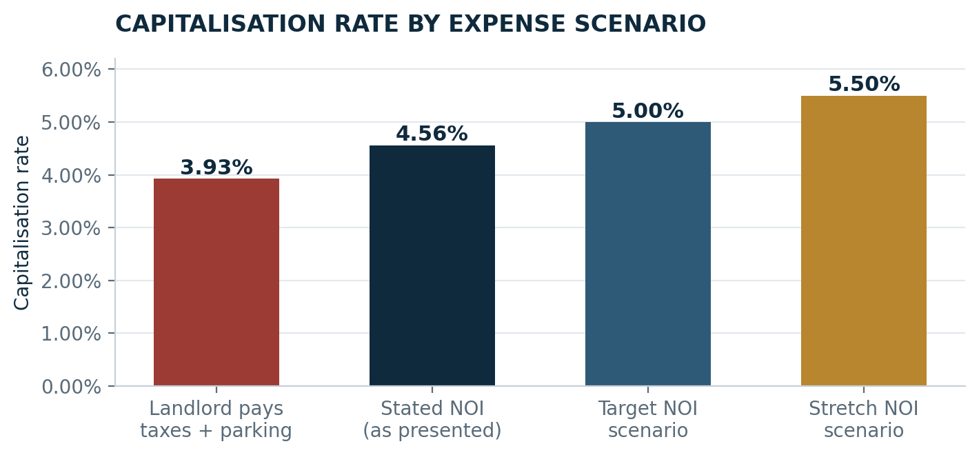
Figure 1 — Indicated capitalisation rate under four expense and income scenarios. All figures require verification through lease and expense review.
IMPORTANT ASSUMPTION
The 4.56% cap rate is accurate only if the stated $3,800 monthly amount is true net operating income. If the landlord pays property taxes, parking, insurance, condominium fees, maintenance or other operating expenses without reimbursement from the tenant, the effective cap rate will be lower. See the income bridge on the following page.

Financial Snapshot
Stated position, verified inputs and the items that must be confirmed before the return can be relied upon.
Metric | Current Information | Comment
Asking price | $999,999 | Vendor asking price
Monthly income | $3,800 | To be confirmed as gross rent or true NOI
Annualised income | $45,600 | $3,800 × 12 months
Indicated cap rate | 4.56% | $45,600 ÷ $999,999
Property taxes | $4,200.60 annually | Confirm whether paid or reimbursed by tenant
Parking | 2 spaces at $87.54 / month | Annual total $2,100.96 — confirm responsible party
Tenant history | More than 5 years | Stable occupancy record
Rental positioning | Believed below market | Basis for future income growth
All figures are preliminary and subject to verification through lease review, expense statements, tax bills, parking agreements and full due diligence.
Two variables drive the outcome of this acquisition. The first is whether the stated $3,800 per month is gross rent or true net operating income — the difference is worth more than sixty basis points of yield. The second is the gap between the in-place rent and market, which determines how much income can be recovered at renewal. Both are resolved by lease and expense review, and both are quantified on the following page.

Capitalisation Rate Scenarios
What the yield becomes under each expense and income assumption.
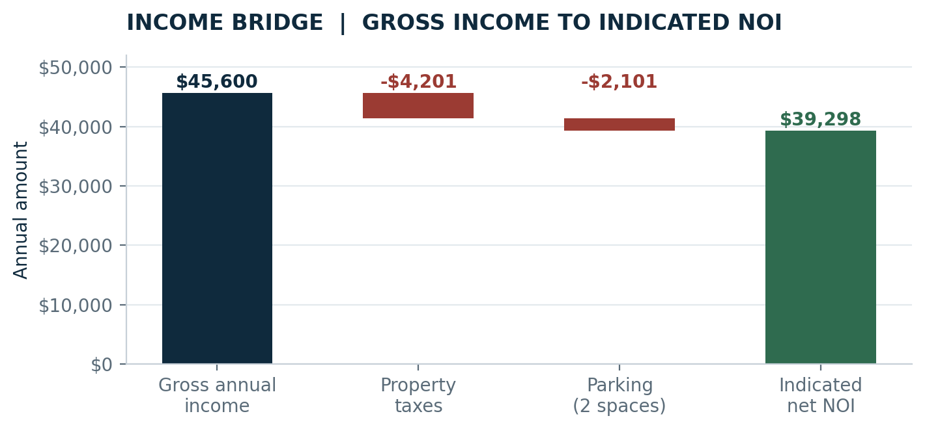
Figure 2 — Income bridge. If the landlord carries property taxes and parking without recovery, indicated NOI falls to $39,298 and the cap rate compresses to 3.93%.
Scenario | Annual NOI | Cap Rate | Interpretation
Stated NOI | $45,600 | 4.56% | Assumes $3,800 monthly is net to landlord
Landlord pays taxes + parking | $39,298.44 | 3.93% | Before insurance, maintenance, condo fees or vacancy
Illustrative NOI at 5.00% cap | $49,999.95 | 5.00% | Approximately $4,166.66 / month net
Illustrative NOI at 5.50% cap | $54,999.95 | 5.50% | Approximately $4,583.33 / month net
Scenario modelling only. Actual recoveries depend on the executed lease and any amendments.

Tenancy & Income-Growth Opportunity
The investment case rests on converting a below-market rent into sustainable net operating income.

Stable Occupancy
The existing tenant has occupied the property for more than five years. This established occupancy record may provide a purchaser with greater income visibility than a vacant or newly leased property, subject to confirmation of the tenant's covenant, payment history and remaining lease term.

Below-Market Rental Position
The current rental rate is believed to be below market. This creates a potential value-add strategy through future rent adjustments, renewal negotiations or lease restructuring. Any increase must comply with the existing lease, notice requirements, contractual renewal options and applicable law.

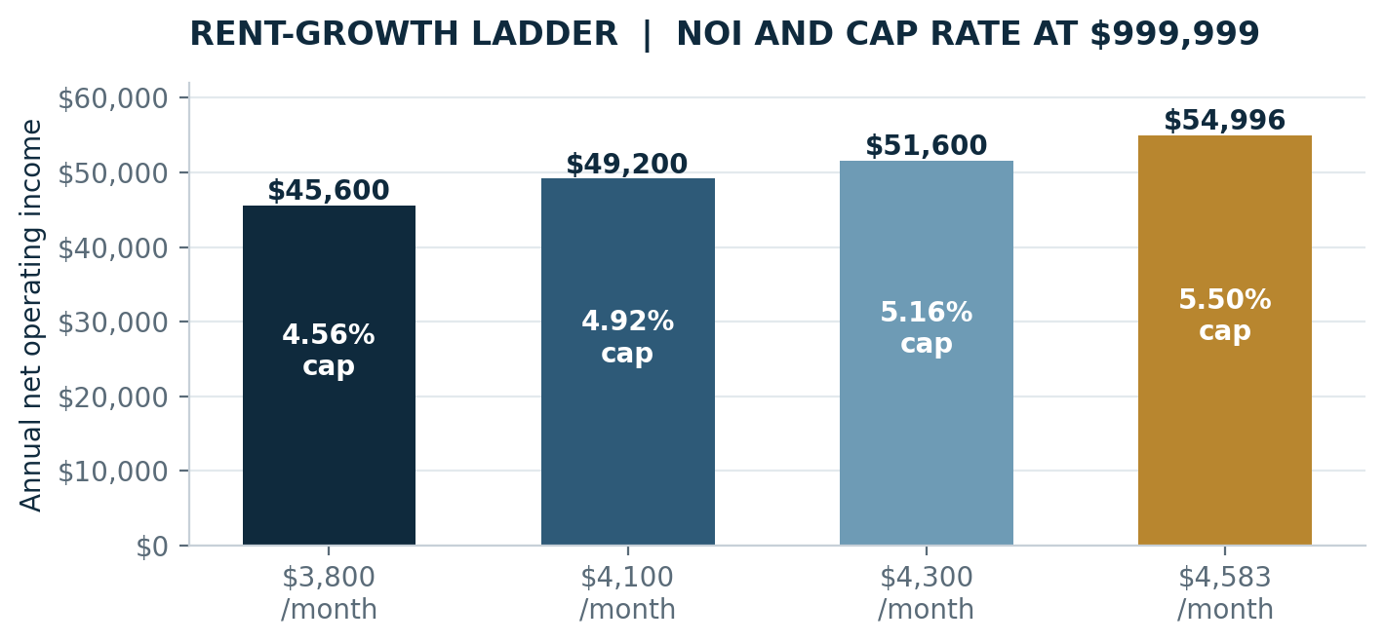
Figure 3 — Rent-growth ladder. Each step shows annual NOI and the resulting cap rate measured against the $999,999 asking price.
Monthly NOI | Annual NOI | Cap Rate at $999,999 | Increase vs. Current
$3,800 | $45,600 | 4.56% | Current stated income
$4,100 | $49,200 | 4.92% | +$3,600 / year
$4,300 | $51,600 | 5.16% | +$6,000 / year
$4,583 | $54,996 | 5.50% | +$9,396 / year
Illustration only. This is not a representation that any specific rent increase is available, permitted under the lease, or guaranteed.

Value Sensitivity & Exit Positioning
Commercial value is a function of sustainable NOI divided by the cap rate the market applies at the time of sale.
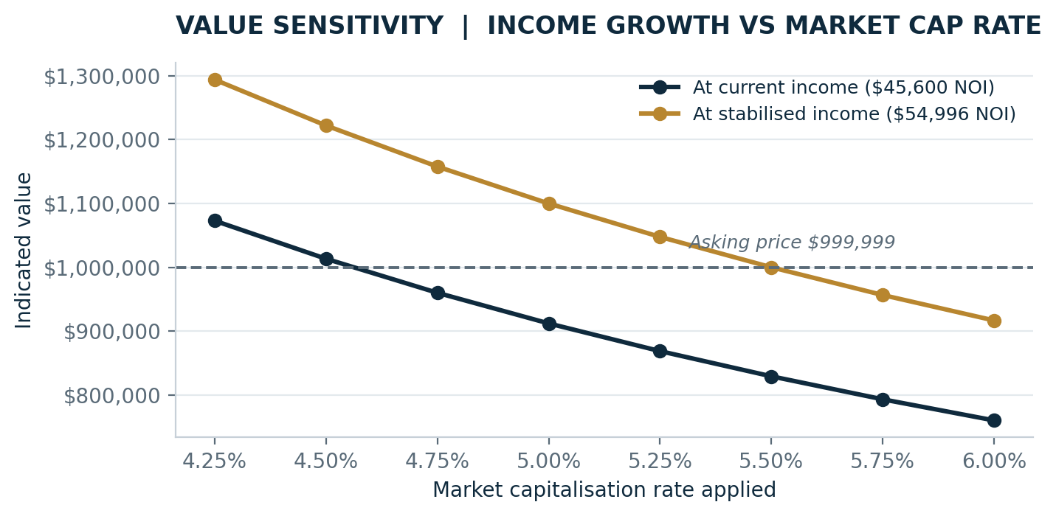
Figure 4 — Indicated value across a range of market capitalisation rates, shown at current income and at stabilised income of $54,996.
Read together, the two curves frame the core thesis: at current income the asset requires a cap rate below approximately 4.56% to support the asking price, whereas at stabilised income of $54,996 the same asking price is supported at a 5.50% cap rate. Income growth is therefore the principal defence against cap-rate expansion.

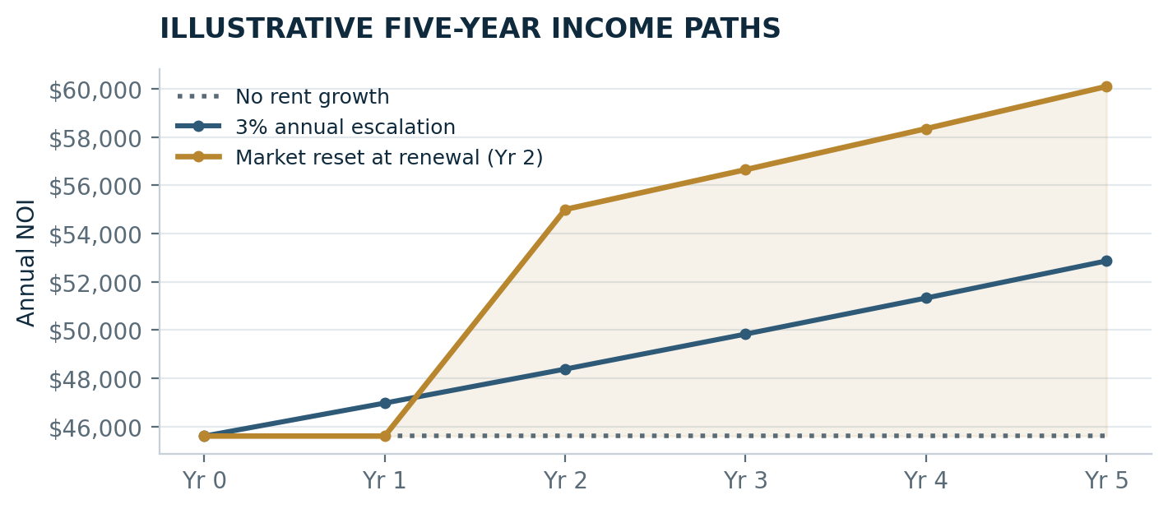
Figure 5 — Three illustrative income paths over a five-year hold. Shaded area represents the incremental income available if a market-level reset is achieved at renewal.

Illustrative Financing Analysis
How the return behaves under leverage, before and after a market rent reset.
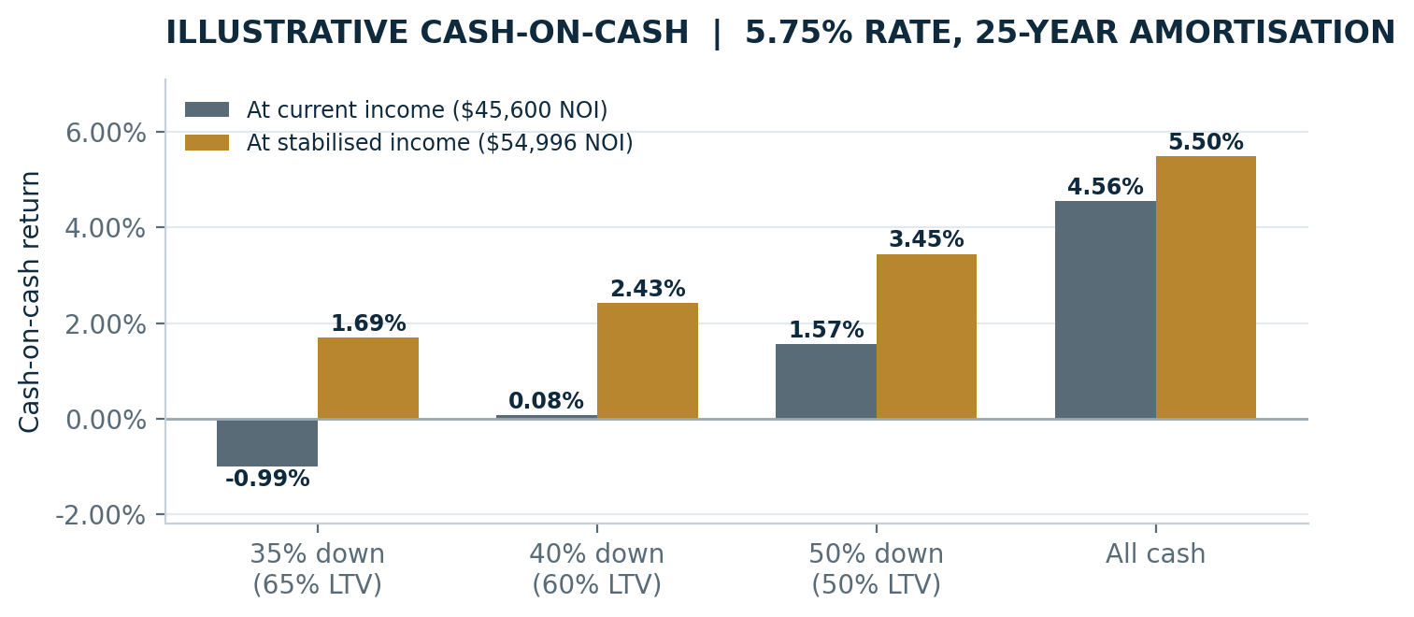
Figure 6 — Cash-on-cash return at an assumed 5.75% interest rate and 25-year amortisation. Illustrative only; actual terms depend on lender, covenant strength, lease term and borrower qualification.
At current income the spread between the going-in cap rate and prevailing commercial debt costs is narrow, which is characteristic of a value-add rather than a fully stabilised income asset. The analysis demonstrates why the rental repositioning is central to the return profile: as NOI moves toward market, cash-on-cash improves across every capital structure shown.
Investors should model their own assumptions for interest rate, amortisation, loan-to-value, vacancy allowance, capital reserve and closing costs. No representation is made that financing is available on these or any other terms.

Location & Market Context
50 Steeles Avenue East occupies the established Steeles Avenue / Ontario Street employment pocket, minutes from downtown Milton and the Highway 401 corridor.
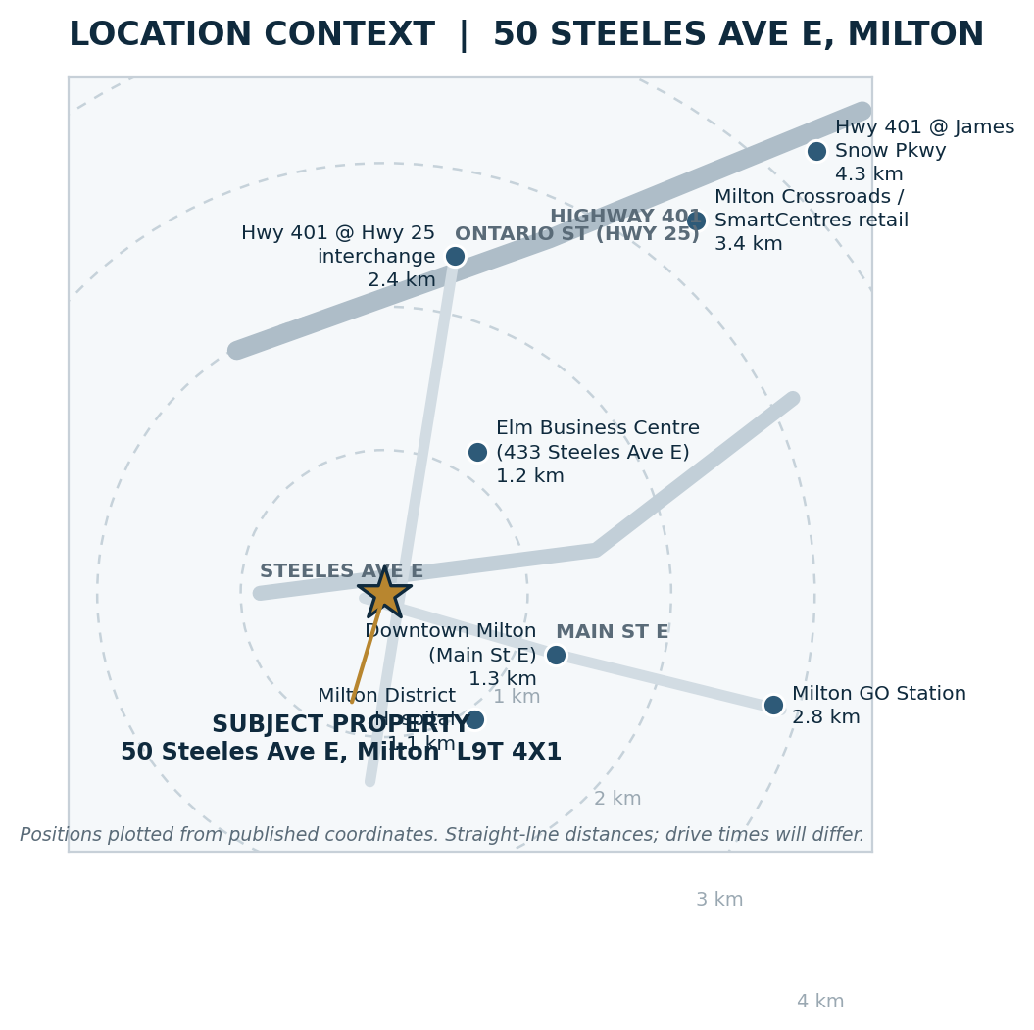
Figure 7 — Location context plotted from published coordinates. Straight-line distances shown; drive times will differ. Verify independently.
The property sits west of the Thompson Road big-box node and east of the Highway 25 corridor, in a block characterised by long-tenanted service-commercial and light-industrial occupiers — a functioning employment pocket with demonstrated occupier demand rather than a speculative growth area.

Corridor & Occupier Profile
Proximity, access and the character of surrounding occupiers.
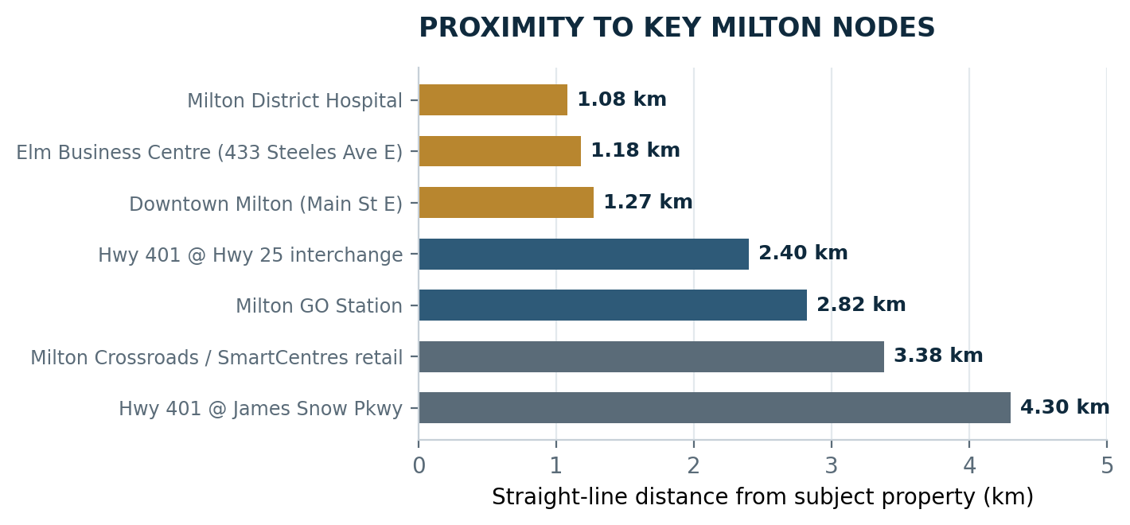
Figure 8 — Straight-line distance from the subject property to principal Milton destinations.

Positioning
- Arterial frontage. Steeles Avenue East is a primary east–west arterial running from the Ontario Street (Highway 25) corridor east toward Thompson Road and the James Snow Parkway employment lands.
- Highway 401 access. The Highway 25 interchange lies approximately 2.4 km north; James Snow Parkway approximately 4.3 km northeast — serving the wider GTA and the Highway 407 network.
- Downtown and commuter base. Downtown Milton is approximately 1.3 km away and Milton GO Station approximately 2.8 km, anchoring one of the region's largest commuter catchments.
- Growth trajectory. Milton has consistently ranked among the fastest-growing municipalities in Ontario, with continued residential, employment and infrastructure expansion planned across Halton Region.

Building Character
Publicly available listings indicate that 50 Steeles Avenue East is a multi-unit commercial address containing both ground-level units and second-floor suites, occupied by a mix of professional-service and service-commercial businesses. This multi-tenant configuration supports the divisibility and re-leasing flexibility that private investors typically seek at this price point.
Prospective purchasers should confirm the subject unit's designation, floor area, exclusive-use areas, common-element obligations and, where the property forms part of a commercial condominium, the declaration, budget and status certificate.
Occupier and corridor commentary is compiled from publicly available business listings and mapping data, is general in nature, and is provided for orientation only. Demographics, traffic counts, zoning and permitted uses must be independently verified.

Property Imagery
Photography to be inserted prior to circulation.


Placeholder frames. Replace with photography of the subject property, parking area, interior and street frontage before distribution.

Why Brokers Should Introduce This Opportunity
This property offers a compelling conversation for clients seeking a combination of existing income, established tenancy and future rental upside. Rather than relying solely on appreciation, investors may acquire an operating asset with a clear path to potential income improvement.
- Immediate income. An existing tenant provides income from closing, subject to lease verification and adjustments.
- Demonstrated tenant stability. More than five years of occupancy offers an established operating history.
- Income-growth potential. Below-market rent may provide an opportunity to increase NOI over time.
- Flexible investment profile. May appeal to private investors, owner-investors planning for future occupancy, or buyers seeking portfolio diversification.
- Milton growth story. The location may benefit from Milton's continued residential, employment and infrastructure expansion.

Broker Call to Action
Bring your qualified investor clients to review this stabilised Milton opportunity. The combination of current income, a long-term tenant and potential rent growth creates a strong basis for further due diligence and investment analysis.

Property & Due-Diligence Information
Property Detail | Information / Required Confirmation
Municipal address | 50 Steeles Avenue East, Milton, Ontario L9T 4X1 — confirm unit designation
Property type | [Industrial / retail / office / commercial condominium]
Unit size | [Insert square footage]
Legal description / PIN | [Insert]
Zoning | [Insert and verify permitted uses]
Current lease term | [Insert commencement and expiry dates]
Renewal options | [Insert]
Annual base rent | [Insert from lease]
Additional rent / recoveries | [Confirm taxes, parking, condo fees, insurance and maintenance]
Parking | Two spaces at $87.54 per month each
Property taxes | $4,200.60 annually
Condominium fees | [Insert, if applicable]
Utilities | [Confirm tenant or landlord responsibility]
Repairs and capital items | [Confirm roof, structure, HVAC and major replacement obligations]

Recommended Documents for Review
- Executed lease and all amendments
- Tenant payment ledger and arrears statement
- Current rent roll
- Property-tax bill
- Parking agreement and invoices
- Condominium declaration, budget and status certificate, if applicable
- Insurance information
- Utility and maintenance records
- Environmental and building-condition information
- Zoning confirmation and permitted-use review

Confidentiality & Disclaimer
This Offering Memorandum has been prepared solely for preliminary discussion with prospective purchasers and cooperating brokers. It is confidential and may not be reproduced or distributed without the seller's or listing brokerage's written authorisation.
The information contained herein has been obtained from sources believed to be reliable; however, no representation or warranty, expressed or implied, is made as to its accuracy or completeness. Financial information, measurements, expenses, income, lease terms, zoning, permitted uses and property condition must be independently verified by the purchaser and the purchaser's professional advisers.
All charts, graphs, projections and scenario analyses contained in this document are illustrative modelling based on the stated assumptions. They are not forecasts, appraisals or guarantees of investment performance, and they do not constitute financial, tax, legal or investment advice.
The estimated capitalisation rates are based on the stated assumptions and are not guarantees of investment performance. Financing costs, income taxes, acquisition costs, vacancy, capital expenditures and other ownership costs are not included unless expressly stated.
Location mapping is plotted from published coordinates and is provided for general orientation only; straight-line distances are not drive times. Photographic placeholders must be replaced with verified imagery of the subject property before distribution.
The seller reserves the right to modify the offering process, reject any or all offers, withdraw the property from the market, or negotiate with any party at any time without notice. The property is offered subject to prior sale and completion of definitive documentation.

Listing Representative | Evelyn Santizo
Brokerage | SoldBig Realty Inc., Brokerage
Telephone | 647-772-4009
Email | evelyn360@gmail.com
Property | 50 Steeles Avenue East, Milton, Ontario L9T 4X1

