OFFICE SPACE FOR SALE
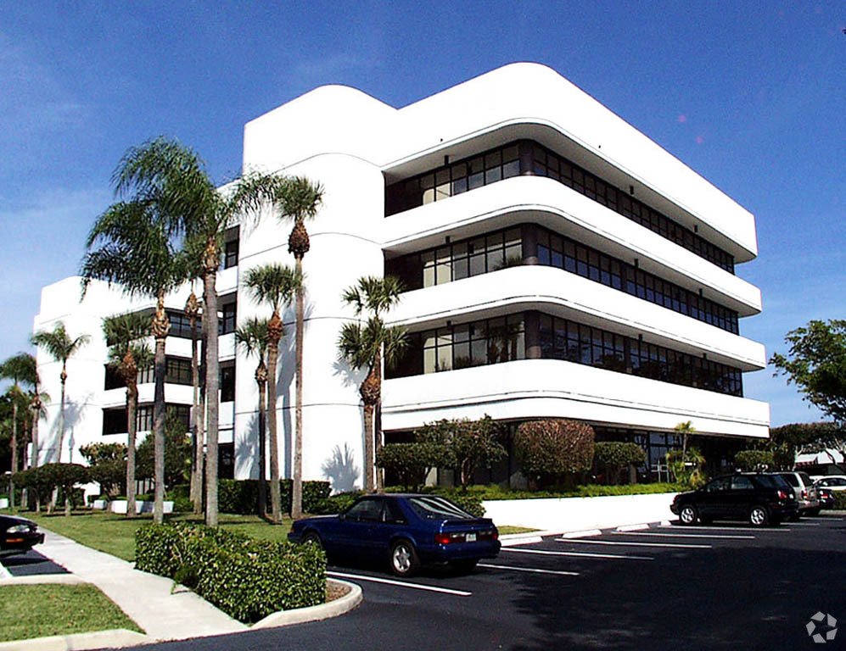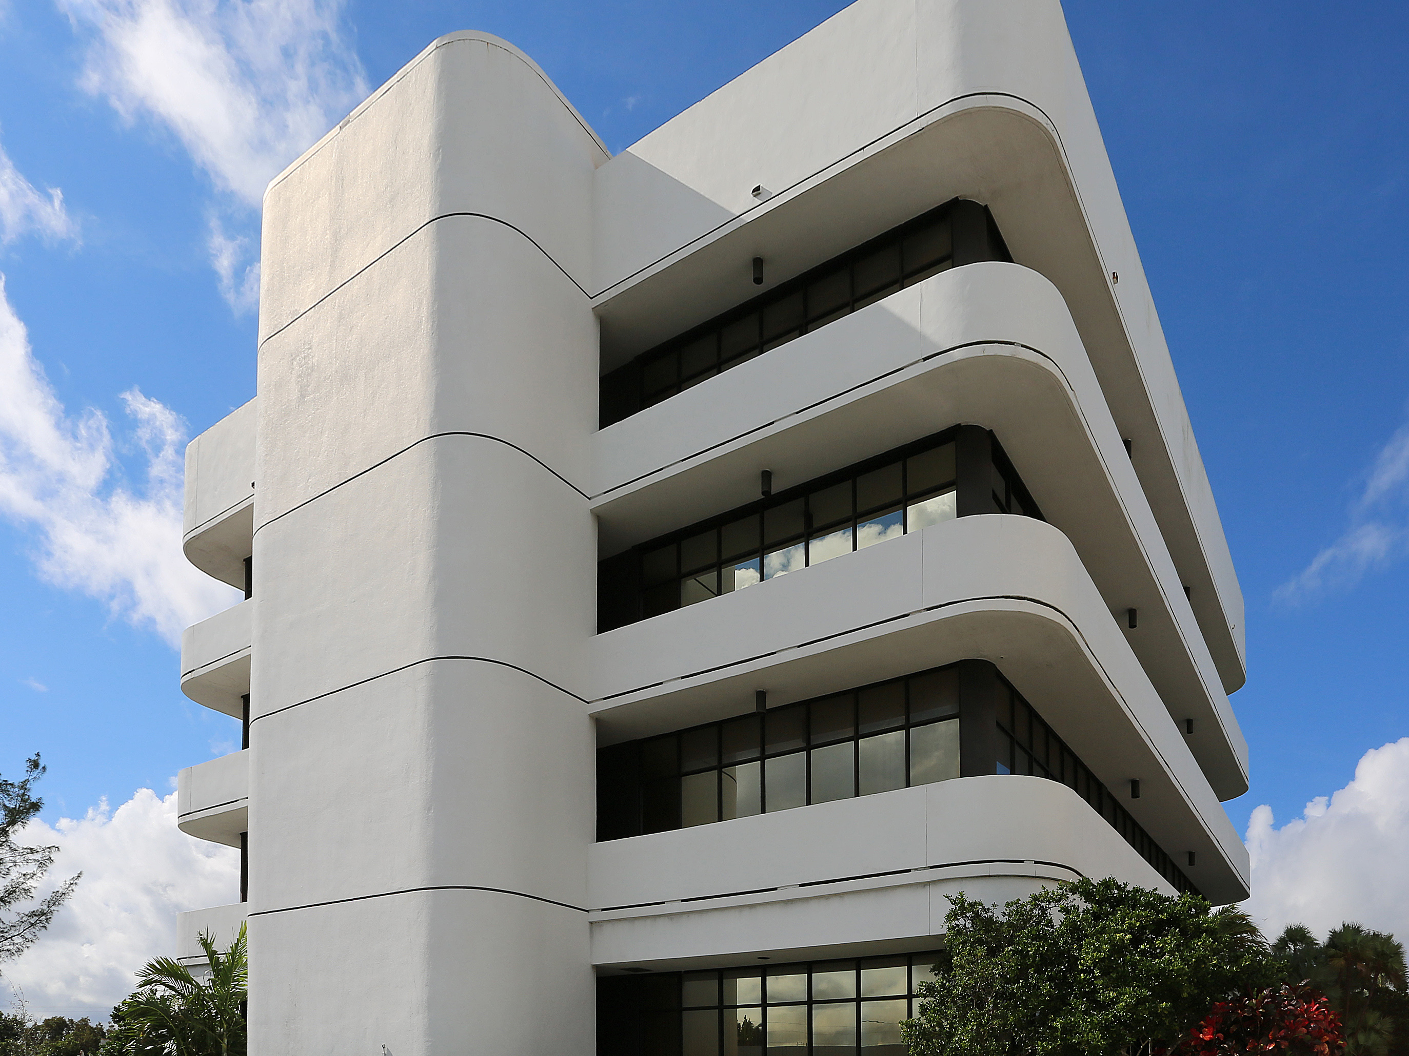
4700 NW Boca Raton Blvd.
Suite 301
Boca Raton, FL 33431
Suite : 301

Area: 957 square feet

Purchase Price: $329,900 ($344.72 per sq. ft.)

2024 Property Taxes: $4,156

2025 Association Fees: $3,594.26 per quarter/$1,198.09 per month

Condition of Premises: Reception area & 5 private offices

Parking: 5/1000 Overall parking ration - One (1) reserved space

Location: East Boca Raton immediately south of Yamato Road on Boca Raton Blvd. - quick access to I-95 and downtown Boca Raton.

For Information Contact:
Ingrid Fulmer 561- 479-5970
Coldwell Banker Commercial NRT


SUBJECT TO WITHDRAWAL, CHANGE OR PRIOR RENTAL

