

PRIME OFFICE SPACE
FOR LEASE

2178-2180 FOREST AVENUE
STATEN ISLAND, NY 10303

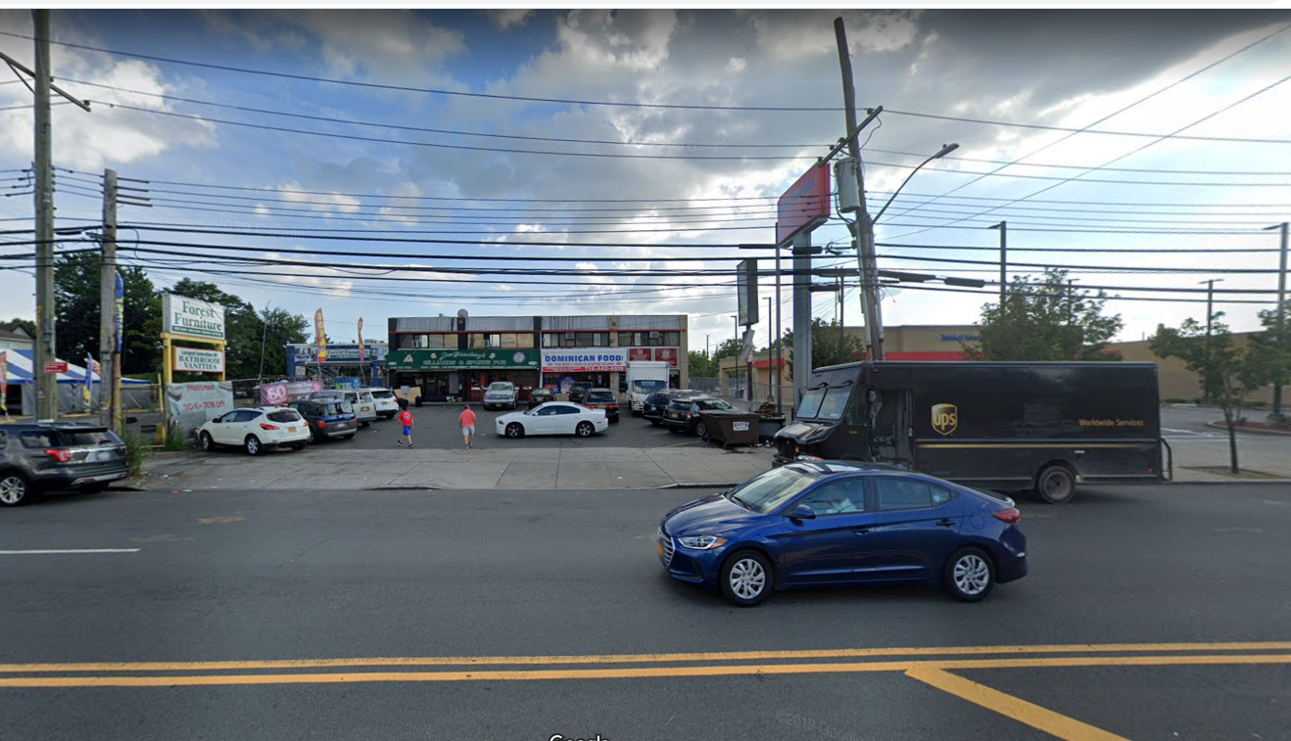

- MIXED USE COMMERCIAL BUILDING WITH GROUND FLOOR RETAIL AND SECOND FLOOR OFFICES.

- 3,000 SF SECOND FLOOR OFFICE AVAILABLE FOR LEASE AND SITUATED IN THE HEART OF THE COMMERCIAL & RETAIL CORRIDOR.

- EXCELLENT EXPOSURE & VISIBILITY ON FOREST AVE

- AREA RETAILERS INCLUDE: LOWES, DOLLAR TREE, HOME DEPOT, UNITED ARTISTS MOVIE THEATRE, VIP CAR WASH, METRO PCS, H&R BLOCK ,WESTERN BEEF SUPERMARKET, CVS, MAVIS DISCOUNT TIRE, BANK OF AMERICA, M&T BANK, LIBERTY TAX, DUNKIN DONUTS, BASKIN ROBINS, PLS CASH CHECKING, WHITE CASTLE. KOHLS,

- 40,000 + TRAFFIC COUNT IN FRONT OF SITE.

- DEMOGRAPHICS SHOW A POPULATION OF 100,000 PEOPLE WITHIN 3 MILES WITH AN AVERAGE HHI OF $78,000+

.

AERIAL PHOTOGRAPH OF SITE

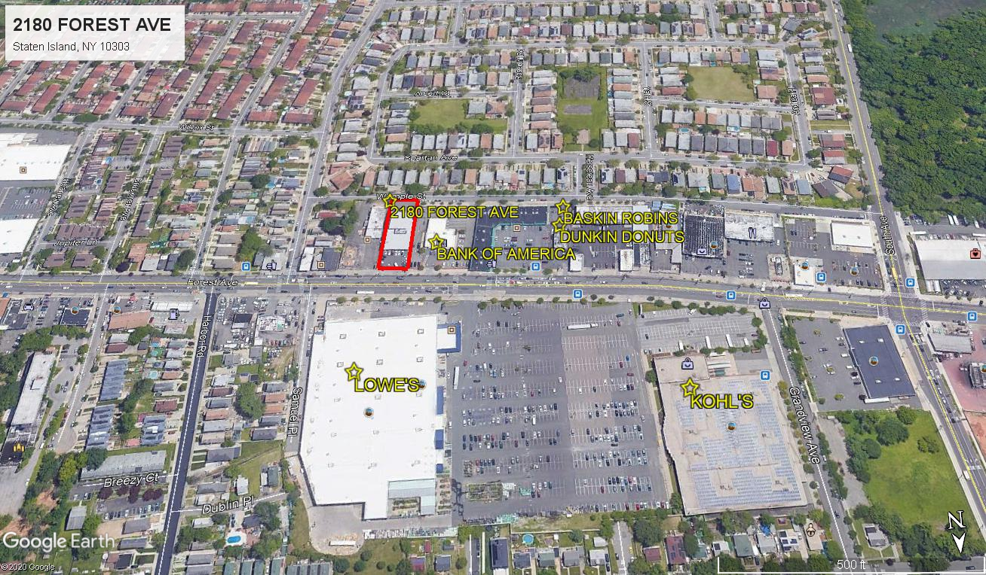

GREAT VISIBILITY ON THE COMMERCIAL & RETAIL CORRIDOR ALONG FOREST AVENUE

FOR FURTHER INFORMATION, CONTACT:

EXCLUSIVE BROKER
GLOBAL REALTY SERVICES, LLC.
2222 Richmond Avenue • Staten Island, NY 10314
T 718.273.1588 C 347.930.3021

EJ EHRLICH
(347) 930-3021 globalrealtyeje@gmail.com

Although all information is from sources deemed reliable, no representation is made as to the accuracy thereof; it is submitted subject to errors, omissions, changes of price, prior sale or lease, or withdrawal without notice.

