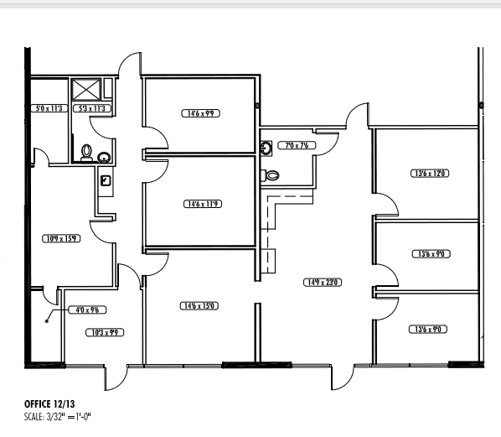
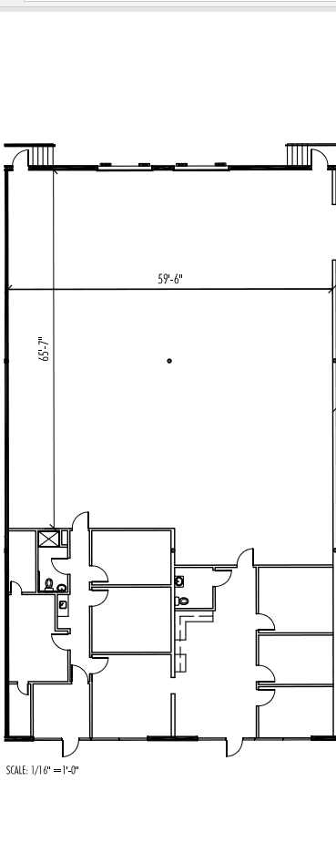

Center Point • Suite 12-13 • 5960 SF
Base Rent: $3705.13 ($7.46/ sf)
NNN: $1261.54 ($2.54/ sf)
Total $4966.67 ($10.00/ sf)
JB Dallas LLC • (214)854-0338
103’-8’

