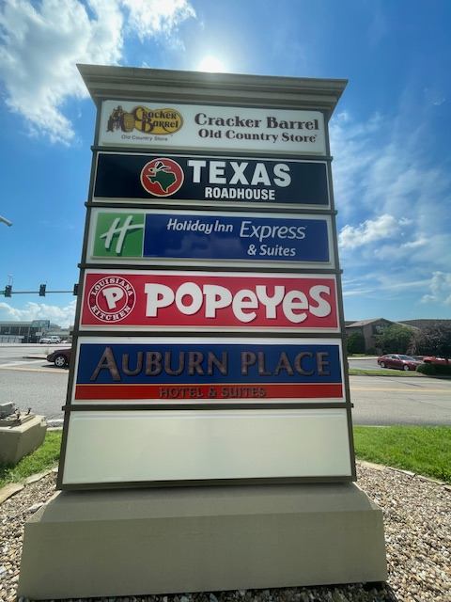



Route K. Multi-Tenant Sign

- Double sided sign

- Price per Month Includes Both Sides

- 10 Year Lease with Options to Renew

6/20/2024

