Jamie’s Outpost and
602 S. Clark Street $2,500,000

Utica, IL $156 / sq ft

Square footage 16,000 Listed 7/17/24
MLS # 12114021
Mix’s Trading Post
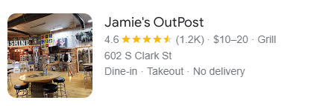
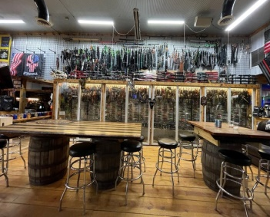
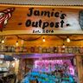

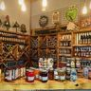

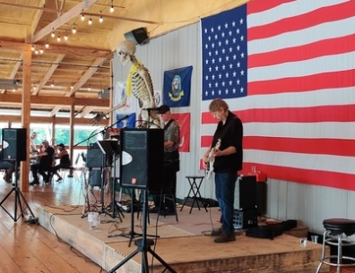
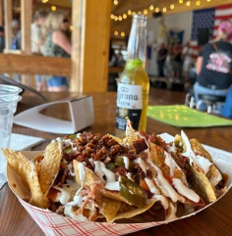
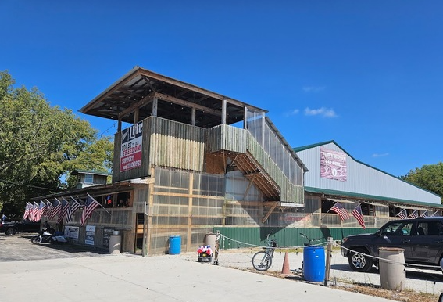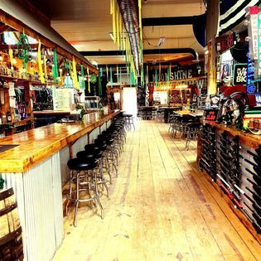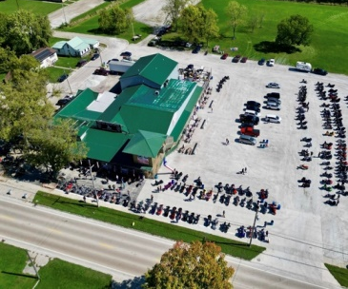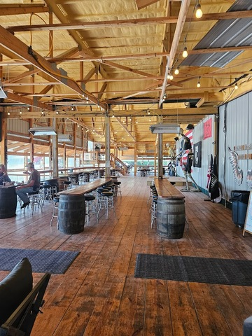

Jamie's Outpost and Mix’s Trading Post is a remarkable investment opportunity. This well-loved establishment, frequented by locals and visitors to the nearby Starved Rock State Park, combines a popular restaurant and bar with a unique shopping experience. Known for its live music, delicious food, and rare, interesting items in its attached store, Jamie's has carved out a distinct niche in Utica, Illinois. The current owners, ready for retirement, present a new buyer with a lucrative business characterized by excellent cash flow. The potential for profit is immense, whether you choose to maintain the current successful operation or reimagine the business and property to your liking. Spanning approximately 7 acres, the property features two full blocks of frontage on Utica's main street and is in close proximity to Starved Rock State Park. The expansive parking lot, capable of holding hundreds of cars, also serves as paid parking during the town's festivals, adding an additional revenue stream. Its prime location ensures heavy foot traffic and a steady influx of walk-in business, bolstered by the numerous festivals hosted in Utica throughout the year. Included in the sale is a beautiful private owner's residence within the main building, all meticulously maintained restaurant equipment (including cook tops, fryers, and coolers), two full bars, and extensive inventory in both the restaurant and store. This makes Jamie's Outpost and Mix Trading Post an exceptionally desirable acquisition for any investor looking to tap into a vibrant, profitable business. Please direct inquiries and financial questions to list agent, Lillian Baldwin.

Lillian Jo Baldwin
Keller Williams Preferred Realty
Call or email Lillian for more info:
708-889-9000
BaldwinPropertiesRE@gmail.com

