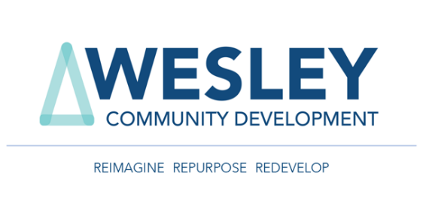

Cole Mill Road Church of Christ
REQUEST FOR PROPOSAL
FOR

1615 & 1617 Cole Mill Road
Durham, NC 27707

Property Highest and Best Offer or Use
Date: 5-7-2024

TO: ALL PROSPECTIVE BIDDERS

SUBJECT: REQUEST FOR PROPOSALS (RFP):
Cole Mill Road Church of Christ Project

You are receiving this Request for Proposal (RFP) because we believe you may have an interest in taking part in this process. Wesley Community Development Corporation (WCDC) is representing Cole Mill Road Church of Christ (CMRCC) in this exploration of property use. This RFP is a solicitation for proposals for the redevelopment or sale of the 1615 & 1617 Cole Mill Rd. Campus of CMRCC. The RFP process is being managed by Wesley Community Development Corporation (WCDC) and all communication will be directly with WCDC, no direct communication with CMRCC is permitted. The desired deliverables of this RFP are:
- Maximizing sales income, cash flow or a combination of the two through ground lease, joint venture or sale that will serve to support CMRCC’s position and growth as a long-term valuable member of the Durham community.
- Development of a project that complements and brings value to the community of Durham, including an element of service to help under-resourced members of our community.
- RFP goals:
  - Clear outline of objectives and proposed development
  - Should have a clear schedule with milestones.
  - Clear cash flow schedule
- While not mandatory, a proposal that incorporates a space for the church (to remain at this address) is a significant plus.

The bidder should show that the proposal is viable with current or proposed new zoning and planning categories. If rezoning is proposed that should be reflected in the project schedule.
The following pages will provide the timelines and the procedure for this process.
With Best Regards,

WESLEY COMMUNITY DEVELOPMENT CORPORATION

Mack King IV
Mack Ming IV
Senior Director of Real Estate Services

Table of Contents:

Part 1: Information and Instructions to Bidders

- General and Background Information
- Purpose for RFP
- Definitions
- RFP Timetable
- Proposal Submission Deadline
- Questions and Responses
- Proposed RFP Requirements
- RFP Proposal Evaluations & Criteria
- No Offer by WCDC / Owner; Firm Offer by Bidder
- Ownership of Proposals
- Rejection of Proposals; Cancellation of RFP; Waiver of Technicalities
- Representation
- Site Visit or Access
- Electronic Solicitation Documents
- Award of Contract; Execution

Part 2: Contents of Proposals and Submittals

- General Contents of Proposal
- Technical Proposal
  - Title Page
  - Table of Contents
  - Executive Summary
  - Organizational Structure and Key Personnel
  - Qualifications and Business References
  - Project Concept and Development Plan
  - Financial Proposal
  - Preferred Terms and Deal Structure
  - Financial Information (if Short Listed)
- Required Items if a Joint Venture or Partnership with Owner
  - Feasibility Analysis
  - Project Strategy, Overall Business Plan and Business Management Plan
  - Proposed Revenue Terms

Part 3: Submittal Forms

- Addenda Acknowledgement
- RFP Proposal Terms Breakdown
- RFI Form

Part 4: Attachments
- Attachment A: Location Map / Property Information

PART 1: INFORMATION AND INSTRUCTIONS TO PROPONENTS

- General and Background Information: The Wesley Community Development Corp (WCDC) is representing Cole Mill Road Church of Christ (CMRCC) in this RFP process.

WCDC is soliciting proposals on behalf of CMRCC church (Owner) from Bidders for a ground lease, joint venture development, or sale of (“CMRCC”) property at address 1615 & 1617 Cole Mill Rd., Durham, NC 27707 for Owner pursuant to the terms and conditions that will be contained in the contents of this RFP.

- Purpose for RFP: WCDC is seeking Proposals from qualified Bidder(s) that have the proven experience and capability to develop or purchase the property (hereinafter defined) at 1615 & 1617 Cole Mill Rd., Durham, NC 27707 address. Bidders may submit a Ground Lease, Joint Venture Development Proposal, or Purchase Offer for the redevelopment of the Property, as referenced in Attachment A.

- Definitions: The following terms shall have the following meanings when used throughout this Request for Proposals (“RFP"):

Bidder(s): Each Firm or aggregation of Firms (which may include a joint venture partnership, limited liability company or limited liability partnership) submitting a proposal in response to this RFP with the intent of partnerships, joint venture with Owner, or purchasing.

Firm(s): A company, entity, or development team capable of securing financing for the development of a project and or purchase in the City of Durham, Durham County, NC that has or will obtain, prior to the execution of any contract awarded hereunder, all necessary licenses required by the State of North Carolina to perform the Services and is authorized to do business in the State of North Carolina.

Development Proposal(s): A written response to this RFP prepared by a Bidder submitted to WCDC’s Office outlining the proposed type of development, land lease, or terms of purchase as described in this RFP.

Proposal Submission

The Bidder’s proposal should be submitted via email to mkingiv@wesleycdc.com. Please include the subject line "PROPOSAL Cole Mill Rd. Church of Christ - Durham."

It is the sole responsibility of the submitting Bidder to ensure that its proposal is received before the submission deadline. Submitting Bidders shall bear all risks associated with delays in delivery. Any proposals received after the scheduled closing date and time for receipt of proposals will not be accepted.

Questions and Responses

Prospective bidders may submit Request for Information (RFI) questions regarding this RFP by email to:
Mack King IV
Senior Director of Real Estate Services
mkingiv@wesleycdc.com
(O): 980-441-5123 ext. 5
(M): 704-500-4800

Wesley Community Development Corporation Headquarters:
13816 Professional Center Drive
Suite 200
Huntersville, NC 28078

When submitting RFI inquiries, please specify which section of the RFP you are referencing and quote the language that prompted the question. Under no circumstances shall there be communication or disruption of the Owner’s staff or church membership during this process.

WCDC will provide responses to RFI inquiries. WCDC reserves the right to group similar questions when providing answers.

Proposal Requirements

  - Proposals must be submitted according to the requirements of this RFP.

  - Proposals shall be signed, by hand, by a principal of the Bidder(s) with the authority to bind the Bidder(s) and enter into an agreement with Owner. Joint ventures or partnerships must designate one joint venture member/partner to represent the joint venture or partnership, respectively, with the authority to submit and execute a Proposal, bind the entity as well as enter an agreement with Owner. Each Bidder(s) is responsible for the preparation of its Proposal and for the costs associated therein.

  - Each Bidder(s) must submit a complete Proposal in accordance with the requirements of this RFP. The format for the submission of a Proposal mandated by this RFP is non-negotiable. The name and address of the property is: Cole Mill Road Church of Christ – 1615 & 1617 Cole Mill Rd., Durham, NC 27707. Proposals may be submitted digitally or in sealed envelope(s) or package(s). If by package the outside of the envelope(s) or package(s) must clearly identify the name of the Solicitation, Solicitation Address, Bidders’ Name, and address. All Proposals must be submitted to:

Wesley Community Development Corp
13816 Professional Center Drive, Suite 200
Huntersville, NC 28078

Electronic submissions can be accepted contingent upon the requirements listed in items a, b, d, e, and f. The subject line of the submission should identify the Project Name and Bidder.

  - If proposals are delivered in physical form, they must be submitted to the above address between the hours of 09:00AM and 3:00PM Eastern.

  - Each Bidder shall promptly notify WCDC in writing, prior to the Proposal Deadline, should the Bidder find discrepancies, errors, ambiguities, or omissions in any of Bidder’s Proposal documents or should the intent or meaning set forth in Bidder’s Proposal documents appear unclear or ambiguous.

  - Each Bidder shall promptly notify WCDC in writing should the Bidder find discrepancies, errors, ambiguities, or omissions in any of the RFP documents prior to the end of the question/comment period set forth herein. WCDC will reply to such notices, if necessary, by issuing an addendum to the RFP.

Proposal Evaluations & Criteria
Proposals will be evaluated in accordance with the following criteria.

Evaluation Criteria:
- Short- and Long-term financial benefit to CMRCC
- Benefit to CMRCC and its missional work to help the under-resourced in our community.
- Clear and unambiguous schedule for the project
- Bidders Qualifications and Experience
- Proof of financial strength of bidder
- Development of a project that complements and brings value to the community.
- The incorporation of certain existing church elements, such as stained glass, into the new project would be desirable.
- Inclusion MWBE contractors for the project.
- The preference of the church is to remain at 1615 or 1617 Cole Mill Rd., Durham, NC 27707 in some fashion. That can be shared space, dedicated or proposed space / area as the developer can accommodate. An outline of the desired space is attached to this RFP. (Attachment B: Owner’s Desired Presence in Redevelopment)

Following the initial evaluation, WCDC may select up to three Bidder(s) to enter into discussions (short list). Short List Bidders may be reasonably likely, in the opinion of WCDC, to be awarded the contract. If the Bidder is “short listed” WCDC reserves the right to request additional financial information to verify the financial stability of the Bidder.
The purpose of discussions with a Bidder on the “short list” will be to identify to that Bidder specific deficiencies and weaknesses in their proposal and to provide the Bidder with the opportunity to consider possible approaches to alleviate or eliminate the acknowledged insufficiencies or inadequacies. These deficiencies or weaknesses may include, but are not limited to, technical issues, development approach deficits, cost, or team composition. Discussions may take place through written correspondence and/or during face-to-face interviews.
WCDC reserves the right not to convene interviews or discussions, and to make an award based on initial proposals received. References may be contacted at any point in the evaluation process.
After a Bidder has been selected, WCDC and the prospective Bidder will negotiate a contract for execution by Owner. If a satisfactory contract cannot be negotiated, WCDC /Owner may, at their sole discretion, begin contract negotiations with the next qualified Bidder who submitted a proposal, as determined by WCDC/Owner. Bidders are further notified that WCDC/Owner may disqualify any Bidder with whom WCDC/ Owner cannot satisfactorily negotiate a contract.

- No Offer by WCDC/Owner; Firm Offer by Bidder: This RFP process does not constitute an offer by Owner to enter an agreement and cannot be accepted by any Bidder(s) to form an agreement. This RFP process is, and shall remain, strictly an invitation for offers from interested Bidder(s), and no offer or Proposal shall bind Owner. However, Bidder’s offer is a firm offer to Owner for a period of 120 calendar days from the Proposal Deadline and may not be withdrawn during such 120-calendar day period.

- Ownership of Proposals: Each Proposal submitted to WCDC/Owner will become the property of the Owner (Cole Mill Road Church of Christ), without compensation to a Bidder(s) for the WCDC’s/Owner’s use, and for the purpose of the purchase and/or development/redevelopment of the property at 1615 & 1617 Cole Mill Rd., Durham, NC 27707. The WCDC/Owner shall use reasonable discretion in the use of these documents.
- Rejection of Proposals; Cancellation of RFP; Waiver of Technicalities. WCDC/Owner reserves the right to reject any Proposal or all Proposals or to waive any technical defect in a Proposal before or after Proposal submission. WCDC/Owner also reserves the right to cancel this RFP at any time, for any reason, and reserves the right to reject and/or cancel the RFP without providing cause. Additionally, WCDC/Owner may, by addendum, modify any provision or part of this RFP at any time prior to the proposal deadline. The Bidder shall not rely on oral clarifications to the RFP unless they are confirmed, in writing, by WCDC in an issued addendum. WCDC/Owner also reserves the right to award based upon a Bidder’s original submission without discussion.
- Representation. By submitting a proposal in response to this RFP, the Bidder(s) acknowledges and represents that: (a) it has read all of the RFP documents (including, without limitation, the RFP Proposal Term Sheet) and acknowledges that, if successful, Bidder(s) shall be bound by the requirements stated therein; (b) the signatory to the Proposal is the Bidder(s) (or Bidder’s duly authorized agent or employee of the Bidder with the authority to bind Bidder(s) hereto); (c) any information or disclosure provided in response to this RFP are fully restated herein and remain truthful and accurate representations up to and including the date Bidder(s) submits its Proposal to WCDC/Owner; (d) WCDC/Owner will not agree to make any substantive revisions to the RFP Proposal Term Sheet; (e) it agrees that it will voluntarily notify WCDC/ Owner immediately if any information or disclosure provided to WCDC/ Owner during any part of this procurement process changes, is no longer accurate or would be misleading in any way.
- Site Visit or Access. The Church is still active on the CMRCC campus, so all access must be coordinated with WCDC. 24-hour notice is needed so all parties can be made aware of the activity. Access will be on a first come, first served basis. At no time will multiple bidders be granted access concurrently. Requests may only be made for a single, 24-hour period per request. Request must be submitted to Chad Brannan (contact information above).
- Electronic Solicitation Documents. This RFP is being made available to all Bidders by electronic means. By responding to this RFP, Bidder(s) acknowledges and accepts full responsibility to ensure that it is responding to the correct form of RFP, including any addenda issued by WCDC.
- Award of Contract; Initial Deposit & Execution: If Owner awards a Contract pursuant to this RFP Proposal, WCDC/Owner will prepare and forward to the successful Bidder a Contract for execution substantially in the form included in the solicitation document.
- Brokerage: All bidders are aware that WCDC is a licensed North Carolina Real Estate Company (NC License # C30680). WCDC is representing CMRCC as their agent throughout this process. Bidders using a licensed broker should identify as such.
PART 2: CONTENTS OF PROPOSALS AND SUBMITTALS

- General Contents of Proposal: A Bidder must submit a complete Proposal in response to this RFP in the format specified in this RFP. A Proposal consists of the information and submittals that are required by the RFP or being provided by Proponent as part of its proposals.

- Technical Proposal:

  - Title Page: The title page should show the title, the Bidder’s name, address and telephone and e-mail address of the contact person(s) for Bidder(s) and the date of Bidder’s proposal and identify which property the Bidder is proposing for.

  - Table of Contents: The table of contents should outline and index the contents of the Proposal and correspond to the requirements of this RFP.

  - Executive Summary: Each Bidder is required to provide an overview of the Bidder’s qualifications, contract terms and a high-level description of the proposed development. At a minimum, the Executive Summary must contain the following information:
    - Complete legal name of the Bidder and the name of the legal entities that comprise the Bidder.
    - The Bidder must provide the office address of each entity comprising it is organized, including entity name, brief history of the entity, contact name, address, phone number, and facsimile number.
    - The legal structure of the entity
    - Provide an overview of the Bidder’s qualifications and statement of why Bidder’s believes it is the best qualified entity to perform the Project.

  - Organizational Structure and Key Personnel: The Bidder should provide (a) an organizational chart of the Bidder's management structure and (b) corresponding resumes for each of the individuals listed on the organizational chart provided. The organizational structure and resumes should clearly identify the Bidder's management team.

    - Legal form of the Bidder and the state in which it is located/ incorporated. In the case where the Bidder is a partnership, joint venture, or affiliation of two or more firms, please provide information for all participants and the nature of the relationship. This should include organizational documents and a brief description of the rights and obligations of the parties.

    - Resumes must include at least the following information:
          - Name and Title
          - Tenure
          - Professional Background
          - Relevant Work Experience
          - Education
          - Current and Past Employment

    - The Bidder should also include a statement which clearly identifies the level of authority vested to each individual within the Bidder's management structure to make decisions on behalf of the Bidder.

    - The Bidder should include the name, address, and telephone number for the contact person authorized to communicate and negotiate on behalf of the Bidder.

- Describe any outstanding disputes involving the Bidder that may affect the Contract, which the Owner should be made aware of.

  - Qualifications and Business References: Bidder’s should provide:
    - At least three (3) written reference letters/statements from Bidder’s clients (including name of client, name of Project, and contact information) regarding completed development projects similar to the services being procured by this RFP.

    - A list of past and present clients Bidder(s) has worked for or with over the last five (5) years.

- NOTE: By submitting a response to this RFP, Bidder acknowledges and agrees that WCDC/Owner may directly contact any of Bidder’s references or clients provided.

  - Project Concept and Development Plan. The Development Plan must be included in the Proposal and contain the following at a minimum:

    - Overall Concept and Vision: Describe the development plan and state the vision of the proposed development, including key architectural and community goals. Provide a site plan for the proposed development at a scale of no greater than 1” =100’ and / or a schematic illustration showing massing, project scale and design character.

    - Development Program: Provide a tabular summary of the mix of uses within the proposed development including the amount and type of residential (including, without limitation, affordable housing units), retail, hotel, office, civic and church spaces. Summary should also include the estimated total square feet of land area, gross and net densities, Floor Area Ratio, public green space, number of parking spaces, and an estimated total cost of the development program once 100% build-out.

    - Compliance: Describe any Sustainable Building Practices; explain how the proposed project addresses pedestrian connectivity, common areas within the development, and other surrounding land uses; explain how the proposed project’s overall building and site design is compatible with design and site planning will blend with the surrounding area.

    - Community Engagement: Describe how Bidder would work with Owner and City of Durham residents, businesses, and property owners within the properties area.

  - Financial Proposal. The Financial Proposal must be included in the Proposal and contain the following at a minimum:

    - Sources and Uses of Funds: The Bidder(s) must include a proposed budget and capital stack showing proposed sources of funds including all debt, equity, public financing. If a Joint Venture or Partnership with Owner, list all fund uses including predevelopment, construction, financing, and operations.

  - Preferred Terms and Deal Structure: Owner’s preferred terms and general deal structure are set forth in the RFP Proposal Term Sheet attached as Part 3 of this RFP. The terms and conditions of the RFP Proposal Terms Sheet will be similar to those contained within the RFP Proposal Terms Sheet.

  - Financial Information (If Short Listed): Given the nature of this project, WCDC / Owner needs to understand the Bidder’s financial capability to undertake and successfully complete this project. Bidders must provide the following:

    - Audited financial statements or tax filings for the past three (3) years (i.e., 2023, 2022, and 2021). If Bidder’s current year’s audited financial statements are not yet complete, Bidder may provide either (a) audited financial statements or tax filings for 2022, 2021 and 2020 or (b) audited financial statements or tax filings for 2022 and 2021 as well as unaudited summary statements for the current year. The statements should include each of the following at a minimum:

- Balance sheet
- Income statement
- Statement of change in financial position, if any.

    - The names and phone numbers of references for the following:

- One letter of support from lender

    - Terms and conditions of any significant contingent liabilities, such as guaranteed loans or other obligations which could affect the ability of Proponent to obtain financing for this project.

    - ANY FINANCIAL STATEMENTS THAT BIDDER DEEMS TO BE CONFIDENTIAL SHOULD BE MARKED AS PROPRIETARY.

- NOTE: If the Bidder is a partnership, joint venture, or newly formed entity (e.g., limited liability company or corporation), the minimum requirements set forth throughout the RFP must be satisfied by the entity or individual(s) that own and control a majority equity interest (i.e., over 50%) of the partnership, joint venture, or newly formed entity.

- Required Items if a Joint Venture or Partnership with Owner: The Bidder’s response to all requirements includes, but is not limited to, the following information:

  - Feasibility Analysis (if Joint Venture or Partnership with Owner): The Bidder must provide a leveraged and unleveraged project specific financial pro forma analysis including all project development and construction costs and a ten (10) year operating cash flow with project returns in editable Excel format with all formulas and cell links intact.

      - Construction and absorption budget assumptions:
          - Land acquisition costs
          - Site preparation costs
          - Hard and soft construction and design costs
          - Lease-up costs, including working capital until building breaks even (i.e., capital necessary to operate a less-than-full building)

      - Stabilized annual operating budget assumptions (net cash flow of completed building at or near its expected long-term occupancy level):
          - Potential gross income
          - Vacancy allowance
          - Operating expenses
          - Net operating income

      - Fundamental return measures and valuation assumptions:
          - Internal rate of return
          - Net present value
          - Summary of the proposed financial returns to Owner

  - Project Strategy, Overall Business Plan and Business Management Plan. The Phasing Strategy and Business Management Plan must be included in the Proposal and contain the following at a minimum:

    - The Bidder(s) should describe their plan for executing the Project, highlighting the role played by member Bidder’s and key individuals of the Project Team. Address the following:
          - Predevelopment
          - Construction, shell completion
          - Long term phasing strategy and land use type
          - Continuing operations, property management and security plan, both during construction and post-construction.
  - Proposed Revenue Terms. The Price Proposal must include an outline of financing terms for the project including project lease revenue to Owner.

PART 3: SUBMITTAL FORMS

ADDENDA ACKNOWLEDGMENT

The bidder or proposer must complete and sign this form and submit it with each bid or proposal.

PROJECT NAME: ____________________________________________________________
Addendum Number (Can be listed on one line or separate lines):

The undersigned hereby acknowledges receipt of the addenda listed above and has taken the information contained therein into full consideration in the formulation of each bid or proposal. Failure to acknowledge receipt of each addendum may be cause for rejection of the Proposal.

Company Name: ________________________________________________________
Printed Name: ______________________________________________________
Title: ______________________________________________________
Signature: ____________ ____________Date: ____________________

RFP Proposal Terms:

Full Schedule:
Full calendar schedule from contract signing to financial closing. Every effort for accuracy should be made.

Joint Venture:
Define terms and conditions of Joint Venture.
The Church will not sign guarantees or put cash into partnership.

Ground Lease:
Terms of Lease
Number of Years
Lease Escalations

Purchase Price:
Earnest Money Deposit(s):
Deposit Amount:
Deposit Terms:
Inspection / Due Diligence Period:
Duration:
Planning and Permit Period:
Duration:
Closing:
Proposed Closing Date:

Project: Cole mill Road Church of Christ Date: ___________
Requestor: Phone No.: ____________
Architect Email:

REQUEST FOR INFORMATION NO.
FROM: (Name, Co.) | TO: (Name, Co.)
FROM REQUESTOR:
Subject:

Question:
Suggestion:
REPLY TO REQUESTOR | DATE ANSWERED:

PART 4: ATTACHMENTS

ATTACHMENT A: Location Map / Property Information
CMRCC consists of two parcels comprising one campus. The campus consists of a church / fellowship hall and parsonage for a total of 5.66 acres.
The property is located at the Northwest corner of the intersection of Berini Dr. and Cole Mill Rd.

- Property Address:
1615 & 1617 Cole Mill Rd.
Durham, NC 27707

- Property Current Zoning: RS-20







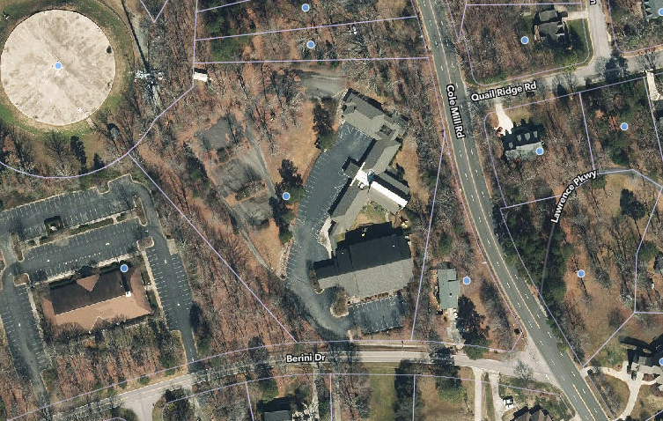

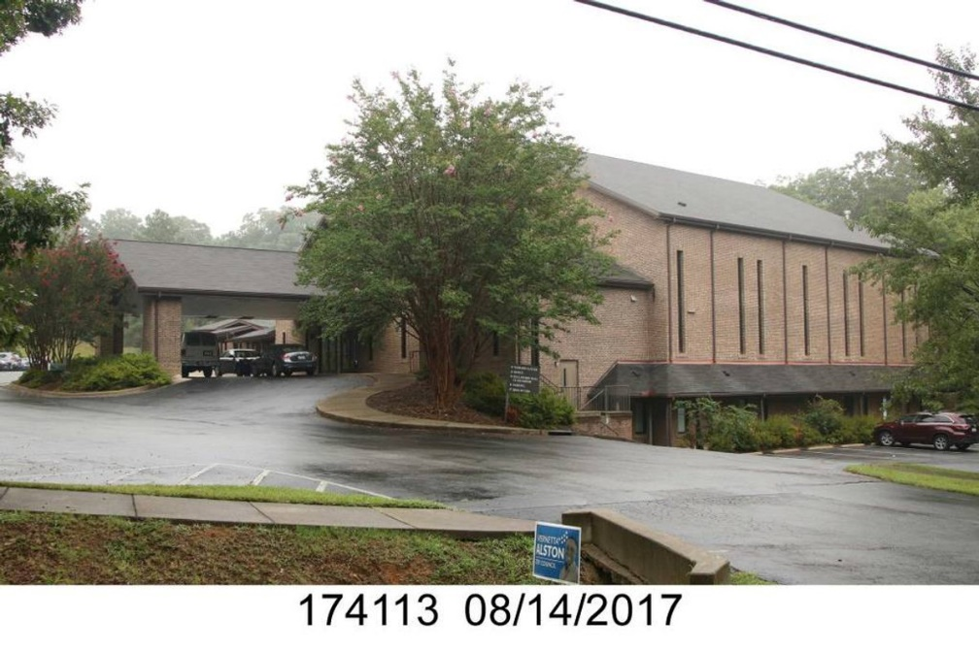

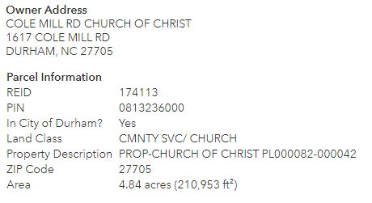

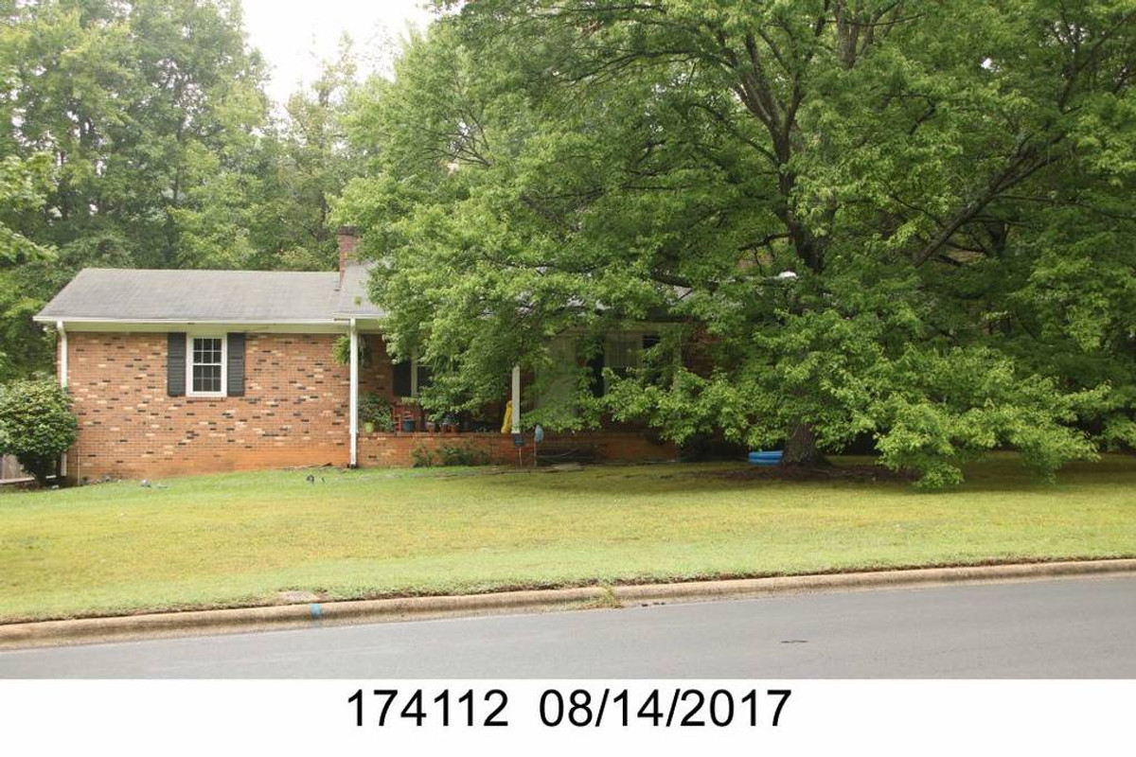

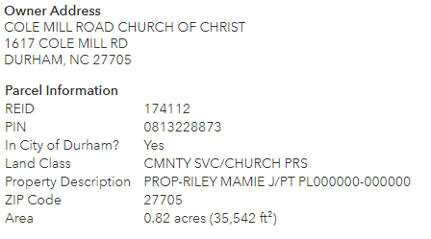

ATTACHMENT B: Owner’s Desired Presence in Redevelopment

Cole Mill Church of Christ would prefer to have a presence in the redeveloped property. That presence can be a dedicated space or building, a shared space, or a hybrid of both. This can be in the form of a subdivision or incorporation of uses in the proposed development. Details of the bidder’s response or proposal must be included in the bid. Desired presence would include:
- Multipurpose space flexible for worship, meals, and community events. This space should be able to accommodate 250 people and acoustics for acapella singing.
- Space should have a covered drive through portico for dropping off members and guests, and adequate parking spaces available for church usage.
- Space should have a highly visible location on Cole Mill Road.
- Conference room that can accommodate twenty people.
- Ample supply and storage areas.
- Office space.
- Classroom, nursery space, multi-use space. Minimum of twelve rooms.
- Commercial kitchen sized to serve the 250-person multipurpose room.
- Playground with picnic tables and shade.
- Multipurpose office and classroom spaces should be equipped with multi-media and communication technology capability.
- Space should be bright, energy efficient and inviting.

The Owner would be willing to consider preserving the current worship center building (the newest building dating from 2004) with significant renovation of the sanctuary/ nursery/ bathrooms area on the upper floor to allow multiuse activities [such as dining, sports play, etc.]. There would still be need for a new ancillary classroom building/ kitchen which would be connected to the worship center building.
The Owner is open to a creative conversation about this vision in concert with an energizing and well-planned overall development. These conversations can be initiated once the overall development has been presented.
It should be noted that there is an access easement granted to the house / lot at 1629 Cole Mill Road, adjacent to the church property.

