DIVISION I. OVERLAY DISTRICTS GENERALLY

Sec. 401. Establishment.
There is hereby established the following overlay districts in unincorporated Jackson County:
Jackson County Airport Overlay District
East Jackson Corridor Overlay District
West Jackson Corridor Overlay District
(Ord. No. 17-003 , § 1, 10-2-2017)

Sec. 402. Boundaries and interpretation.
(a) The boundaries of the overlay districts established in this article shall be shown on the official zoning map adopted per section 201 of this UDC, or via a separate map made a part of the official zoning map. Whether shown on the official zoning map or on a separate overlay district map or maps, overlay district boundaries are and shall be considered an integral part of the official zoning map.
(b) If an overlay district regulation specifically describes the boundaries of an overlay district, then the specific description regarding that overlay district shall apply.
(c) All applicable provisions regarding the official zoning map provided in article 2 of this UDC shall be considered applicable to overlay districts, including but not limited to, provisions regarding determination and interpretation of zoning district boundaries, as provided in section 204 and section 205 of this UDC respectively, which may be considered applicable by the public development director in the determination and interpretation of overlay district boundaries.
(Ord. No. 17-003 , § 1, 10-2-2017)

Sec. 403. Amendment of boundaries.
The boundaries of any overlay district may be amended from time to time, following the same requirements and procedures of this UDC for an amendment to the official zoning map to change an underlying zoning district.
(Ord. No. 17-003 , § 1, 10-2-2017)

Sec. 404. Relationship to underlying zoning district.
(a) The requirements of any overlay district established by this article or in article 5 of this UDC are in addition to the regulations established for the zoning districts in which a given property is located.
(b) In any case where the requirements of an overlay district conflict with requirements of an applicable zoning district or any other provision of this UDC, the requirements of the more restrictive section or provision shall apply.
(Ord. No. 17-003 , § 1, 10-2-2017)

Secs. 405—410. Reserved.

DIVISION III. EAST AND WEST JACKSON CORRIDOR OVERLAY DISTRICTS

Sec. 431. Applicability and exemption.
(a) This division applies to land in unincorporated Jackson County along State Route 15 Alt., U.S. Highway 441, State Route 98, State Route 334, State Route 326, and U.S. Highway 129 from the Clarke County line to the Arcade city limits, the boundaries of which are as depicted on the official zoning map or overlay district map as the East Jackson Corridor Overlay District. The overlay district boundary is drawn 500 feet from the centerline of the highway, or if a divided highway, from the centerline of the nearest direction of travel. The entire parcel of any parcel that is partially contained in the overlay district shall be subject to the requirements of the overlay district, even if subsequently subdivided.
(b) This division applies to land in unincorporated Jackson County along Lewis Braselton Boulevard, Davis Street, SR 124 and SR 53, the boundaries of which are as depicted on the official zoning map or overlay district map as the West Jackson Corridor Overlay District. The overlay district boundary is drawn 500 feet from the centerline of the highway, or if a divided highway, from the centerline of the nearest direction of travel. The entire parcel of any parcel that is partially contained in the overlay district shall be subject to the requirements of the overlay district, even if subsequently subdivided.
(c) This division shall not apply to any development, improvement, building or structure, or plans or permits therefor, which was approved prior to the effective date of adoption of the West Jackson Corridor Overlay District and the East Jackson Corridor Overlay District, as applicable.
(Ord. No. 17-003 , § 1, 10-2-2017)

Sec. 432. Uses requiring special use approval.
Notwithstanding the permitted use provisions for zoning districts established in article 2 of this UDC, the following uses if located within the East and West Jackson Corridor Overlay Districts in addition to abiding by the applicable underlying zoning district use requirements, shall require special use approval in accordance with the procedures of article 14 of this UDC for special uses:
(a) Adult entertainment establishment.
(b) Automobile or other vehicle repair or paint.
(c) Commercial recreational facility, outdoor.
(d) Group home, or rooming or boarding house.
(e) Pawn shop.
(f) Payday loan establishment.
(g) Salvage yard, junk yard, materials recovery processing.
(h) Tow service.
(i) Wrecked motor vehicle compound.
(j) Outside display and/or storage, in the HRC, LI, GI, and HI zoning districts.
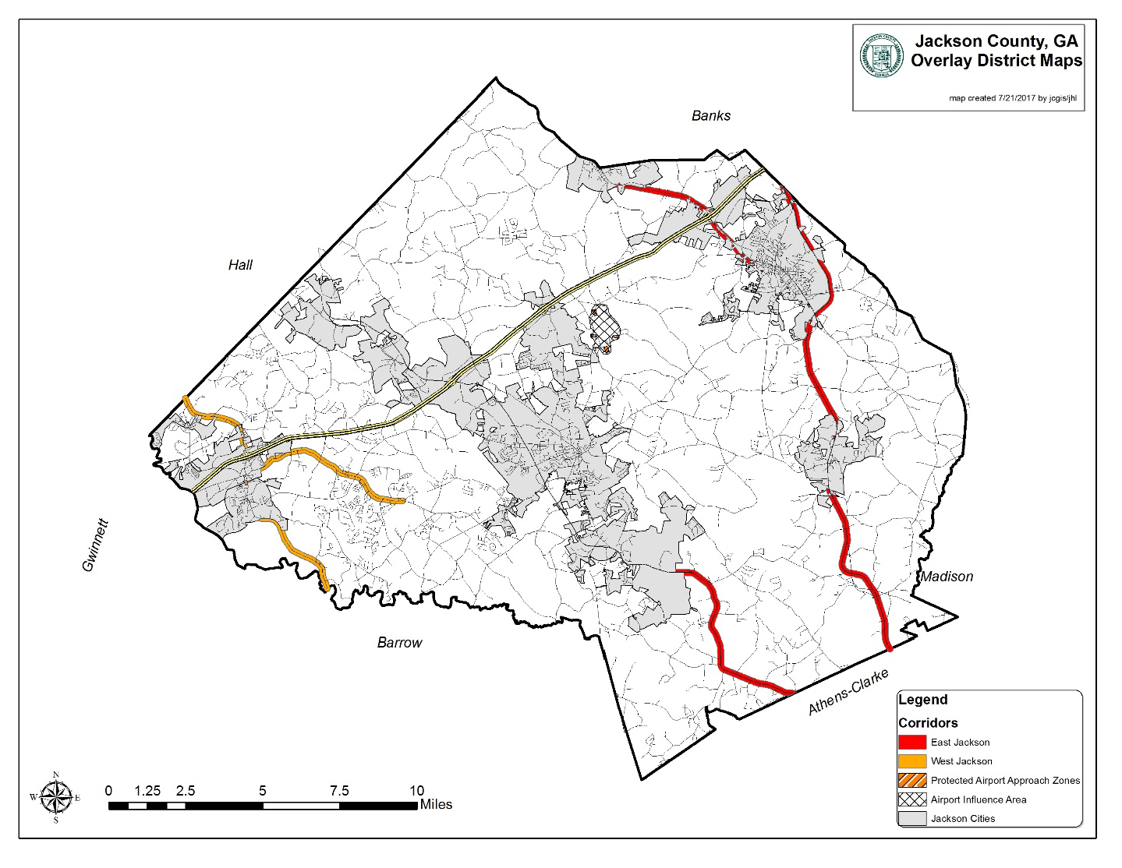
(Ord. No. 17-003 , § 1, 10-2-2017)

Sec. 433. Building height.
The height of any building to be placed in the East and West Jackson Corridor Overlay Districts shall be limited to three stories, unless a special use is granted by the Jackson County Board of Commissioners in accordance with article 14 of this UDC. In addition to special use criteria generally as provided in article 14 of this UDC, the board may consider any of the following factors in making a decision whether to grant special use approval to exceed the three-story maximum building height:
(a) Proximity and relationship of the proposed building to other buildings that are more than three stories or 35 feet in height.
(b) Impact of the proposed building on single-family residences on nearby tracts.
(c) Topography and vegetation that screen the view of the proposed building.
(d) On-site screening and/or landscaped buffers.
(e) Provision of public open space in exchange for increased building height.
(f) The effect of additional building height on traffic congestion.
(g) Accessibility of the site in relation to traffic patterns.
(h) Economic development opportunities for Jackson County.
(i) The necessity of greater building height to the function of the proposed use.
(j) The quality of the architectural design and its compatibility with its surroundings.
(k) The capability of the designated fire district to adequately handle a fire or other emergency situation for the proposed structure using existing equipment and personnel.
(Ord. No. 17-003 , § 1, 10-2-2017)

Sec. 434. Ground floor area limitation.
Any new institutional or commercial building within the East and West Jackson Corridor Overlay Districts shall not exceed 200,000 gross square feet in ground floor area, and any new industrial building within the East and West Jackson Corridor Overlay Districts shall not exceed 500,000 square feet in ground floor area, except by special use approval by the board of commissioners. In determining whether to grant such a special use, the Board of Commissioners shall consider the following factors, in addition to considering criteria applicable to special use applications generally as specified in article 14 of this UDC:
(a) Whether the building site will have safe, immediate access to a public maintained roadway with a functional classification of collector or higher as determined by the public development director;
(b) Whether the building site will provide convenient interconnections with adjacent uses and properties that serve both pedestrians and automobiles;
(c) Whether the proposed building floor area is the smallest feasible to serve the function of the proposed use;
(d) Whether the architectural design of the building reduces the perceived size of the building by appropriate articulations and variations in the massing, façade, roofline, materials, colors, and textures of the building exterior; and
(e) Whether the building and site meets or exceeds all other standards set forth in this overlay district and this UDC generally.
(Ord. No. 17-003 , § 1, 10-2-2017)

Sec. 435. Minimum nonresidential building floor area.
No nonresidential building shall have less than 2,000 square feet of heated floor space.
(Ord. No. 17-003 , § 1, 10-2-2017)

Sec. 436. Nonresidential lot standards.
No lot shall be divided for nonresidential use within the East and West Jackson Corridor Overlay Districts unless it conforms to the following requirements:
(a) Minimum lot size: One and one-half acre for outparcels or stand-alone commercial projects, and three acres for outparcels or stand-alone industrial projects.
(b) Minimum lot frontage for commercial or industrial lot: 175 feet.
(Ord. No. 17-003 , § 1, 10-2-2017)

Sec. 437. Residential lot standards abutting collector or arterial street.
When a residential use or residentially zoned lot abuts a street with a functional classification of collector or arterial as determined by the public development director, said lot shall have frontage on a local street and a minimum 20-foot wide no access easement shall be required along the entire frontage of the lot abutting a collector or arterial street. In addition, within the required 20-foot wide no access easement, one of the following requirements shall be met along the entire lot frontage (excluding any required sight visibility triangle):
(a) A continuous solid wall no less than four foot high, constructed entirely of brick or stone masonry shall be erected prior to a building permit being issued; or
(b) A fence no less than four-foot high constructed of iron pickets and intervening brick or stone masonry pillars, one for every 50 feet of fence; or
(c) A vegetated strip of canopy trees and shrubs, impenetrable by vehicles, approved by the public development department.
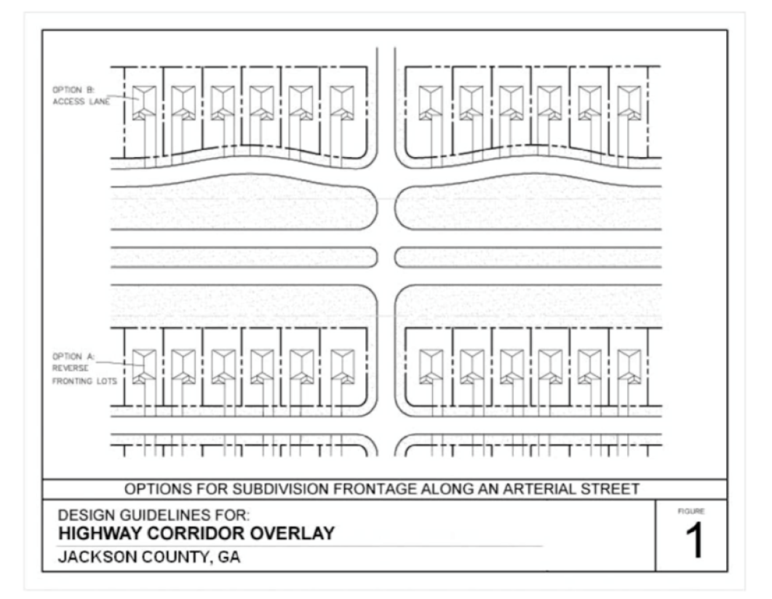
(Ord. No. 17-003 , § 1, 10-2-2017)

Sec. 438. Street and streetscape requirements.
Any proposed or future street must meet the requirements of this section. Rights-of-ways existing or proposed to be located within the East and West Jackson Corridor Overlay Districts shall be classified by type (i.e., arterial, collector, local, or access) as determined by the public development director. Existing and proposed streets shall be improved on both sides of the street in accordance with the following standards:
Street and Streetscape Requirements
East and West Jackson Corridor Overlay Districts
Requirement | Arterial Street | Collector Street | Local Street | Access Street (Private)
Design speed | 45 m.p.h. and over | 35 m.p.h. | 25 m.p.h. | 25 m.p.h.
Right-of-way (min.) | 150 feet | 64 feet | 50 feet | 50 feet
No. of travel lanes | Per GDOT | 3 | 2 | 2
Travel lane width (min.) | Per GDOT | 12 feet | 11 feet | 11 feet
Middle lane width* | Per GDOT | 14 feet | Not required | Not required
Curb and gutter | Per GDOT | Required 24-inch wide | Required 24-inch wide | Required 18-inch wide
Street lighting | Per GDOT | Required | Required | Optional
Pedestrian lighting | Required | Required | Required | Required
Sidewalk (width) | Required (6 feet) | Required (6 feet) | Required (6 feet) | Required (6 feet)
Crosswalks | Per GDOT | Required | Required | Required
Underground utilities | Required | Required | Required | Required

* An acceptable alternative for master planned developments is turn lanes at intersections and on-street parking between intersections.
(See also street cross-sections at the end of this division)
(Ord. No. 17-003 , § 1, 10-2-2017)

Sec. 439. Street and pedestrian network connectivity standards.
This section shall apply to all nonresidential or multi-family developments and any single-family residential development of five or more acres.
(a) Continuation of streets. All development plans shall incorporate and continue all collector, local, or access streets stubbed to the boundary of the development plan by previously approved development plans or existing development.
(b) Future street connections. All development plans shall provide for future public street connections (of a street type approved by the public development director) to adjacent developable parcels by providing a street connection spaced at intervals not to exceed 600 feet along each development plan boundary that abuts potentially developable or redevelopable land.
(c) Maximum local street length. No local street may be longer than 600 feet without an intersection with another local through street. Cul-de-sac streets shall not count as through streets.
(d) Maximum cul-de-sac street length. Dead-end streets, including cul-de-sac streets, shall not exceed 300 feet in length and shall not serve more than 30 dwelling units.
(e) Interparcel vehicular access. Developments abutting an arterial or collector street shall provide an access street to abutting commercial or multi-family residential development, whether existing or planned (i.e., according to either the zoning map and/or the future land use map, as determined by the public development director), so as to provide a vehicular connection among all adjacent parcels also abutting an arterial or collector street. This requirement may necessitate driveway aprons, stub-outs, or other design features to provide for cross-connection access to abutting properties as determined by the public development director.
(f) Interparcel pedestrian access. New commercial or multi-family residential development that abuts a planned, new or existing multi-family residential property or commercial property shall provide for a six-foot wide sidewalk connecting the two uses. This provision shall require such developments to construct the required sidewalk to the property line so that it may be continued by the adjacent development for future connectivity.
(g) Cul-de-sac pedestrian connection. A cul-de-sac street that ends within 200 feet of the right-of-way of an adjacent collector or arterial street shall provide a six-foot wide sidewalk within a minimum ten-foot wide easement connecting the sidewalk on the cul-de-sac to the sidewalk on the adjacent collector or arterial street.
(h) Internal pedestrian connections. Sidewalks shall be provided to connect building entrances to required sidewalks along street frontage.
(i) Recorded easement agreement required. Whenever easements are required to facilitate compliance of a development with the standards in this section, an easement agreement must be drafted by the developer and/or property owner and approved by the public development director prior to approval of development plans. Said agreement must allow vehicular and pedestrian access from neighboring developments as they currently exist or any future developments as provided in this section. Said agreement must also be noted on all development plans, and the easement agreement must be recorded in the records of the Jackson County Superior Court Clerk.
(Ord. No. 17-003 , § 1, 10-2-2017)

Sec. 440. Driveways.
Unless the driveway connects with a state route and is governed by more restrictive requirements of the Georgia Department of Transportation for driveways, all driveways shall conform to the following requirements.
(a) Location precluded. Driveways shall not be permitted within the controlled access zone of an intersection (see figure 2).
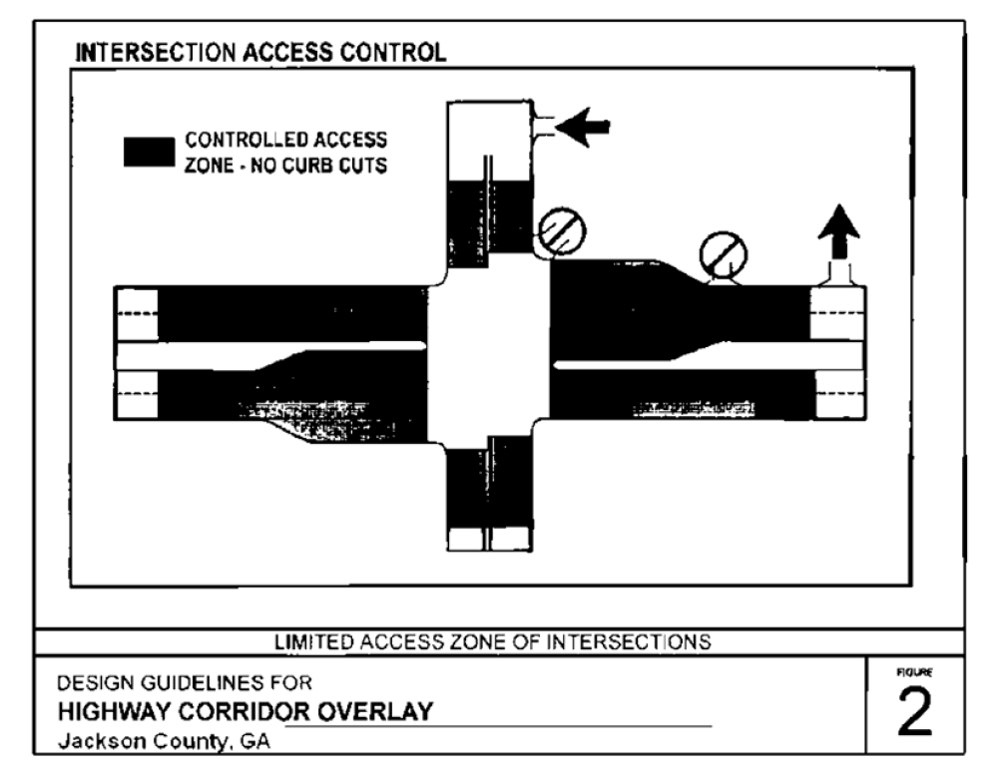
(b) Minimum number of vehicular access points. The minimum number of vehicular access points for nonresidential development shall be as follows:
Number of Required Parking Spaces Serving Nonresidential Development | Minimum Number of Vehicular Access Points to Public Streets
Less than 50 | 1
50 to 299 | 2
300 to 999 | 3
1,000 or more | 4

(c) Access for outparcels. Outparcels with less than 200 feet of road frontage are restricted to access from within the commercial or industrial development only.
(d) Driveways at signalized intersection. Driveways connecting with a collector or arterial road that are served with a traffic signal must have at least two outbound lanes and one inbound lane with a minimum width of 11 feet per lane.
(e) Driveway grades. Except for single-family and two-family residences, driveway grades shall conform to the requirements of the Georgia Department of Transportation Regulations for Driveway and Encroachment Control.
(f) Driveway alignment. Except where driveways are on opposite sides of a raised median, driveways on opposite sides of a street shall either directly align or have offsets of a minimum of 125 feet, as measured between the extended centerlines of such driveways. Whenever possible, driveways on undivided arterial, collector, or local streets should align with driveways (if any) on the opposite side of such street. On a divided arterial street that includes a median, driveways should align with median breaks whenever possible. Driveways not meeting this standard shall be limited to right turn in and right turn out only.
(g) Driveway throat length. The driveway "throat length" (i.e., distance between the driveway intersection and the first turning movement interior to the development) for a commercial or industrial development shall meet the following applicable minimum requirement: provided, however, that the director of public development shall be authorized to reduce the minimum required throat length for driveways with right turns only by one-third of the applicable requirement, for good cause shown (see figure 3).
Minimum Driveway Throat Length by Land Use
Land Use | Minimum Driveway  Throat Length (Feet)
Residential | 40
Institutional | 40
Commercial | 50
Industrial | 85

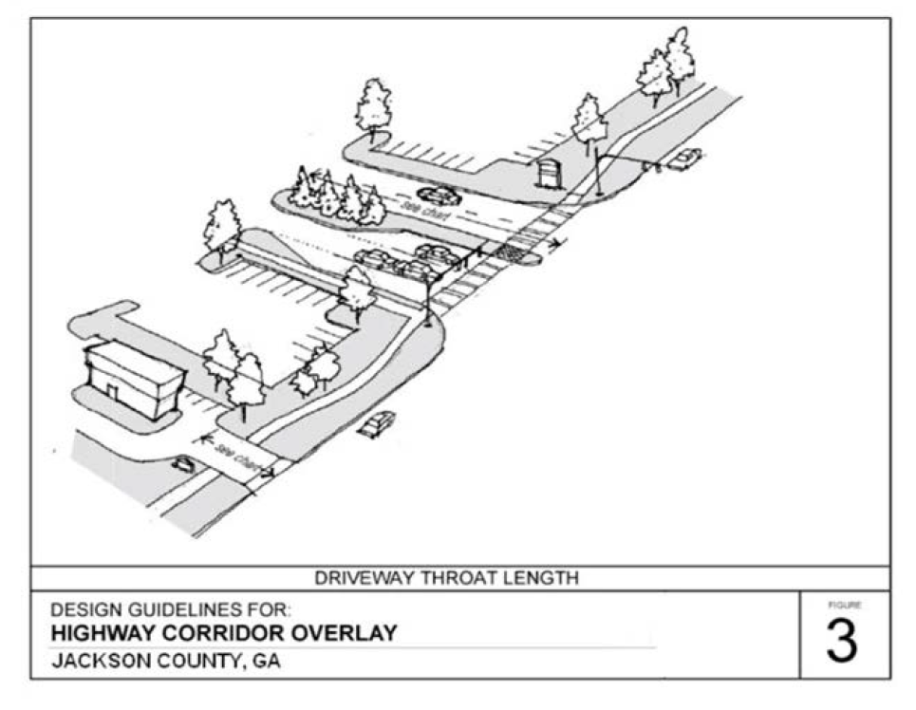
(Ord. No. 17-003 , § 1, 10-2-2017)

Sec. 441. Deceleration lanes.
(a) Driveways connecting to state routes may require a deceleration lane per standards of the Georgia Department of Transportation for driveways. Unless the driveway connects with a state route and is governed by more restrictive requirements of the Georgia Department of Transportation for driveways, all driveways entering an arterial street with a posted speed limit greater than 35 miles per hour shall provide a deceleration lane meeting specifications required by this UDC.
(b) Any deceleration lane that ends within 75 feet of another driveway or intersecting street shall be lengthened so that it connects with the adjacent street or driveway.
(Ord. No. 17-003 , § 1, 10-2-2017)

Sec. 442. Parking lots.
(a) Screening. Where a parking lot or loading area for a commercial, industrial, or institutional use abuts a public right-of-way, the required front landscape strip shall provide screening, as defined by this UDC, from the public right-of-way along the entire property line. The location of the required front landscape strip shall be setback from the future right-of-way for the road, not the existing right-of-way of the road, as determined by the public development director.
(b) Pedestrian circulation. Parking areas shall be designed to facilitate safe and convenient use by pedestrians. Institutional, commercial and multi-family developments shall provide designated pedestrian pathways or sidewalks connecting the front entrance of the principal building to the sidewalk along the abutting street, including marked crosswalks across interior driveways.
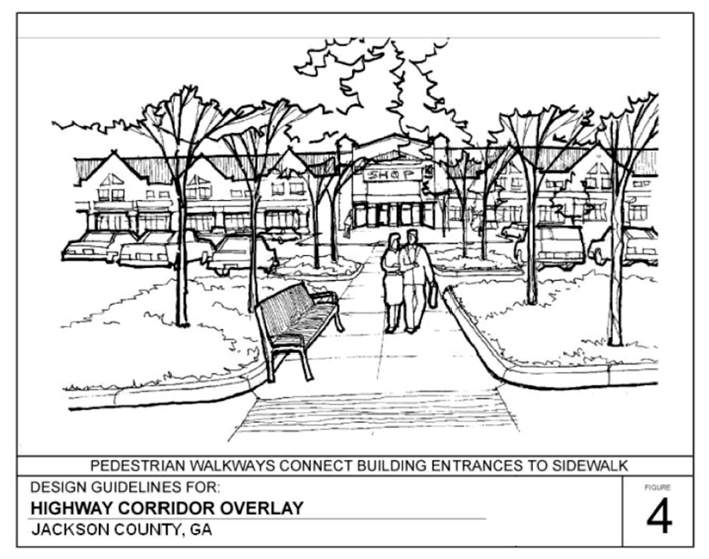
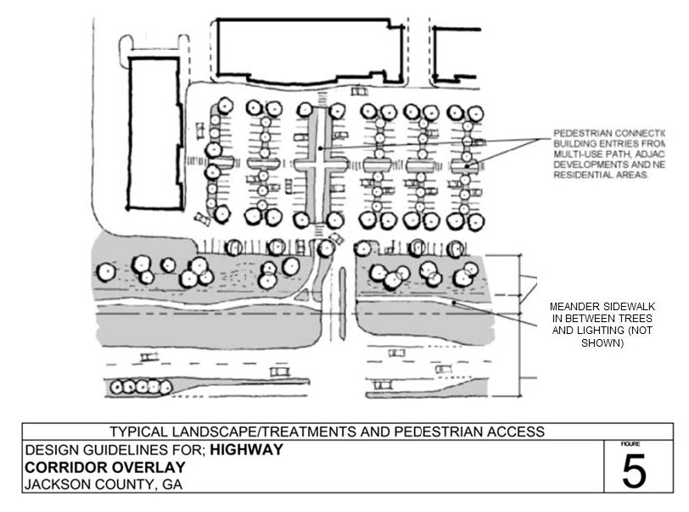
(c) Paving. All parking areas shall be paved with asphalt or concrete meeting specifications of this UDC, except that pervious materials may be substituted to meet stormwater management requirements, subject to the approval of the public development director.
(Ord. No. 17-003 , § 1, 10-2-2017)

Sec. 443. Dumpsters.
(a) Location. Dumpsters and trash receptacles shall be located to the rear of the principal building so that they are not visible from any public street or any adjacent residentially zoned and residentially used properties. Dumpsters shall be set back a minimum of five feet from all property lines. Dumpsters shall not be located within any required buffer or landscape strip.
(b) Screening. Dumpsters shall, regardless of location, be screened on three sides with a solid masonry wall to match the principal building, eight feet in height with an opaque gate on the accessible side.
(c) Pad. Dumpsters shall be placed on concrete pads of sufficient size and strength to support the weight of service vehicles. Restaurants and other food service establishments shall place dumpsters on concrete pads that are designed to slope into a drain that is equipped with a grease trap.
(Ord. No. 17-003 , § 1, 10-2-2017)

Sec. 444. HVAC and mechanical equipment.
(a) All ground mechanical, HVAC, and like systems shall be screened from public street view (within 300 feet) on all sides by an opaque masonry wall or landscaping.
(b) For all buildings, roof-mounted mechanical, HVAC, and like systems shall be screened from public street view (within 300 feet) on all sides by a raised parapet or pitched roof along the edge of the roofline.
(Ord. No. 17-003 , § 1, 10-2-2017)

Sec. 445. Building architecture, materials and colors.
(a) Applicability. The following design guidelines and standards apply to all newly constructed buildings used for multi-family residential, office, institutional, commercial, or industrial purposes to include all accessory structures. These standards do not apply to single-family residential or duplex uses.
(b) Architectural review. All design and construction for buildings subject to this section shall require architectural review by the public development department for consistency with the provision of this section. All building plans must be submitted with the development plan for review. All building plans shall clearly indicate all of the proposed building materials and colors for each façade sufficient to demonstrate compliance with this section. Approval of architecture must be granted by the public development department prior to issuance of a development permit.
(c) Consistent architectural identity. Buildings that are located within the same development shall be constructed of similar materials and colors to show continuity between all out parcels, accessory buildings, and principal building. The use of a common palette of building materials should be maintained for building façades to create a consistent and traditional architectural identity. Traditional architecture shall include, for example, the use of brick, pitched roofs, low-profile signage, and subdued colors.
(d) Building orientation. Principal building entrances shall be oriented to public streets.
(e) Modulation. For projects with more than one commercial/retail building and multi-family residential developments, variations in façade, roofline and depth should be provided to lend the appearance of multi-tenant occupancy. The massing of building façades longer than 150 feet that are approximately parallel to the right-of-way and oriented to a public street shall be modulated to increase visual interest, as follows:
1. Building façades that are less than 500 feet long shall be modulated at intervals no greater than 100 feet in length.
2. Building façades that are more than 500 feet long shall be modulated at intervals no greater than 20 percent of the length of the façade.
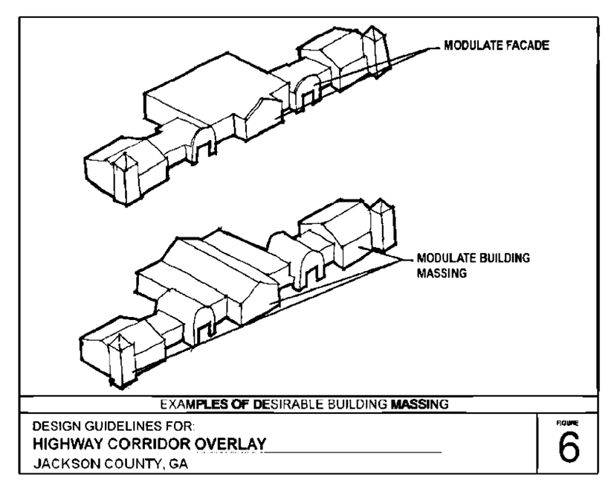
(f) Contrasting base. Building designs shall include a minimum two-foot high contrasting base, along the entire front façade of buildings and extending for a distance of at least ten feet along the sides of buildings.
(g) Primary building materials. This subsection specifies the primary building materials that may be used and combined to create a consistent, attractive, interesting and long-lasting building design. There shall be no more than two primary building materials used on a single building façade (excludes authorized use of secondary or accent materials). This subsection does not apply to doors:
1. Brick, except that brick veneers that are intended to simulate brick exteriors are not acceptable.
2. Stone. Natural stone such as, but not limited to, granite, limestone, and acid marble are allowed building materials. Terra cotta and/or cast stone, which simulate natural stone, are also acceptable. Painted stone is not allowed.
3. Split-face block/concrete masonry unit (CMU) is restricted to ten percent of the surface area of the façade on institutional and commercial buildings and 50 percent on industrial buildings.
4. Tilt/architectural pre-cast concrete is permitted by special use approval only and with a design plan consistent with the surrounding development and area
5. High grade stucco is restricted to 50 percent of the surface area of a façade (the amount of material shall be calculated using the gross square footage of wall area per façade).
6. Natural wood and/or cement-based artificial wood siding are allowed only for residential buildings.
7. Glass is restricted to 50 percent of the wall area per façade.
8. Metal is allowed up to 25 percent of the surface area of a façade for commercial and institutional buildings.
9. Exposed concrete block and tile are not allowed as building materials on a façade.
(h) Secondary (accent) materials. Other building materials not authorized as primary building materials in this section, such as but not limited to wood and tile, may be used as secondary or accent building materials to enhance the façade of the building or for decorative elements not exceed 15 percent of total wall area per façade for institutional and commercial buildings and 30 percent of total wall area per façade for industrial buildings.
(i) Accent colors. Contrasting accent colors on any single façade shall be limited to no more than ten percent of the total wall area for any single façade. If permitted, any exterior lighted bands shall be considered as part of the maximum ten percent of contrasting accent colors.
(j) Canopy support columns. The support columns for drive under canopies for gasoline pumps shall be made of the same material as the primary building on the property and shall match the trim and accent material. Trim or accent material may account for up to ten percent or 120 square feet, whichever is less, of any facade. Any signage on the canopy shall be counted towards the ten percent accent material maximum, in addition to having to meet signage requirements of this UDC.
(k) Arcade or structural canopy for retail use. For any multi-tenant commercial development, a covered arcade/structural canopy shall be provided along the front façade of the building. Arcades are covered walkways connected to the principal building. They should be a minimum of five feet in width and designed to provide covered areas for relief from the weather. Different arcade/structural canopy designs may be used for each individual tenant/business within a multi-tenant commercial development, provided that they blend aesthetically with the front façade of the building and are approved by the public development director.
(l) Roof requirements.
1. Pitched roofs. Pitched roofs of at least 3:12 are required for one-story buildings and may be required for taller buildings. A combination of flat roof and pitched roof may be acceptable for buildings of two or more stories if the pitched portion of the roof screens the view from the frontage of any flat roof. Arcades, porches, and other features must be designed with pitched roofs.
2. Mansard roofs. Mansard roofs shall have a maximum pitch of 12:12 with a minimum 12-foot vertical surface length.
3. Flat roofs. Building materials for flat roofs shall meet the state building code requirements for nonresidential buildings. Exposed metal flashing shall be copper or factory finished sheet metal. If factory finished metal flashing is used, such as standing seam, the color must be subdued to blend with other materials or of a color to simulate weathered copper or bronze. All buildings and structures with flat roofs should include parapet articulation on the front façade(s) of such building or structure. There shall be roof articulations/offsets at a minimum of one per each 125 linear feet of length by a change in the top line of the parapet. Additional articulation may occur at any lesser distance. If the front façade is less than 125 linear feet of length, then a minimum of one roof articulation must be provided.
4. Canopies. Drive under canopies for gasoline pumps may have flat roofs with vertical or factory formed facing of finished sheet metal.
(Ord. No. 17-003 , § 1, 10-2-2017)

Sec. 446. Outdoor and street lighting.
(a) Along the entire property frontage of any new development fronting on and accessing a county road (excludes state routes) in the West Jackson Corridor Overlay District, streetlights shall be required to be installed by the developer at no installation cost to the county consistent with the specifications of this section.
(b) All parking lot lighting and pedestrian lighting shall meet the specifications of this section.
Lighting Specifications
East and West Jackson Corridor Overlay Districts
Requirement | Streetlights | Pedestrian lights | Parking lot lights
Maximum height (feet) | 40 | 16 | 35
Minimum height (feet) | 35 | 8 | 20
Color | Black | Black | Black
Pole type | Not specified | Fluted | Fluted
Fixture type | Cobra head | See guidelines | Box head
Shielding | Full cutoff | Semi-cutoff, cutoff, or full cutoff | Full cutoff
Spacing (feet on center) | 150 | 50 | Not specified

(c) Security lighting shall be semi-cutoff luminaires. The public development director may limit the number of luminaires remaining activated for security lighting to one-fourth of the total number of each type of luminaire used.
(d) Permanent mounted exposed exterior neon lights shall not be allowed.
(e) Roof-mounted lights are not permitted.
(f) Light fixtures for drive-under canopies shall be recessed into the canopy ceiling so that the bottom of the luminaire does not extend below the ceiling of the canopy.
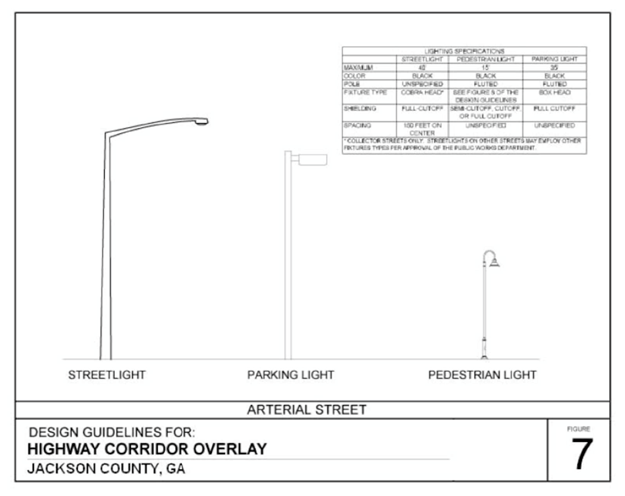
(Ord. No. 17-003 , § 1, 10-2-2017)

Sec. 447. Signage.
Except as provided in this section, signage shall comply with the regulations in article 7 of this UDC.
(a) Prohibitions. Electronic changeable copy signs, neon signs, internally illuminated signs, and the outlining of windows or doors with any lights are prohibited. Externally illuminated signs are allowed, but only with full cut-off luminaires that are directed downward and away from streets and adjacent properties.
(b) Monument ground signs. Freestanding and project entrance signs shall be limited to ground monument signs. The base and sign structure shall be constructed of materials such as brick, or stone, consistent with the architecture and primary building materials for the building or buildings served.
(c) Ground sign maximum height. Ground signs for lots zoned commercial or industrial shall be limited to a height of no greater than 15 feet, including the base and sign structure.
(d) Maximum ground sign area. Ground signs shall not exceed the following maximum areas:
1. Ground signs on lots zoned commercial or industrial with one tenant: 50 square feet.
2. Ground signs on lots zoned commercial or industrial, including shared signs, on lots with more than one tenant: 100 square feet.
3. All other ground signs: 32 square feet.
(Ord. No. 17-003 , § 1, 10-2-2017)

Sec. 448. Landscaping.
(a) Development within the East and West Jackson Corridor Overlay Districts shall comply with the following landscaping requirements in addition to those landscaping requirements generally applicable to the development as provided in article 12 of this UDC.
(b) The minimum width of landscape strips abutting a public or private access street shall be 15 feet. The landscape strip shall be planted with one shrub for each five feet of landscape strip frontage and street trees which shall be spaced at approved intervals depending on the type and size of tree planted, as provided in the list of approved tree species provided below.
(c) The public development department may, upon application, approve different species than those listed in this section, provided that the applicant for modification of approved tree species submits a proposed plan showing desired placement, prepared and stamped by a registered landscape architect, and which includes a planting list with common names, minimum size, and required spacing.
(d) No more than 25 percent of the trees installed in a development may be of any one genus. No more than 50 percent of the street trees used in a single development shall be of the small tree species.
Approved Species with Required Spacing and Permitted Placement East and West Jackson Corridor Overlay Districts
Scientific Name | Common Name | Required Spacing on Center | Permitted Placement
Acer palmatum | Japanese Red Maple | 20 Feet | Landscape strip, parking and under power lines
Acer rubrum | Red Maple | 40 Feet | Buffer, landscape strip, and parking
Acer saccharum | Sugar Maple | 40 Feet | Buffer, landscape strip, and parking
Amelanchier abroea | Serviceberry | 20 Feet | Landscape strip, parking and under power lines
Betula nigra | River Birch | 50 Feet | Buffer
Carya illinoensis | Pecan | 50 Feet | Buffer
Carya laciniosa | Shellbark Hickory | 40 Feet | Buffer, landscape strip, and parking
Castanea mollissima | Chinese Chestnut | 50 Feet | Buffer
Cercis canadensis | Eastern Redbud | 30 Feet | Landscape strip, parking and under power lines
Cotinus coggygria | Smoketree | 10 Feet | Landscape strip, parking and under power lines
Crataegus phaenopyrum | Washington Hawthorn | 20 Feet | Landscape strip and parking
Cupressocyparis leylandii | Leyland Cypress | 20 Feet | Buffer
Faqus grandifoila | American Beech | 40 Feet | Buffer, landscape strip, and parking
Fraxinas Pennsylvania | Green Ash | 20 Feet | Buffer, landscape strip, and parking
Fraxinus americana | White Ash | 50 Feet | Buffer
Halesia tetraptera | Carolina Silverbell | 20 Feet | Buffer, landscape strip, and parking
Juniperus virginiana | Eastern Red Cedar | 20 Feet | Buffer
Koelreuteria paniculata | Goldenraintree | 30 Feet | Buffer, landscape strip, and parking
Lagerstroemia indica | Crape Myrtle | 10 Feet | Landscape strip, parking and under power lines
Liquidambar styraciflua | American Sweetgum | 40 Feet | Buffer, landscape strip, and parking
Liriodenendron tulipifera | Yellow Poplar | 40 Feet | Buffer, landscape strip, and parking
Magnolia grandiflora | Southern Magnolia | 40 Feet | Buffer, landscape strip, and parking
Magnolia stellata | Centennial Star Magnolia | 10 Feet | Landscape strip, parking and under power lines
Magnolia virginiana | Sweetbay Magnolia | 10 Feet | Landscape strip, parking and under power lines
Magnolia x soulangeana | Saucer Magnolia | 20 Feet | Landscape strip, parking and under power lines
Malus sargentii | Sargent Crabapple | 10 Feet | Landscape strip, parking and under power lines
Malus snowdrift | Snowdrift Crabapple | 20 Feet | Landscape strip, parking and under power lines
Metasequoia glyptostroboides | Dawn Redwood | 20 Feet | Buffer
Nyssa sylvatica | Black Gum | 20 Feet | Buffer, landscape strip, and parking
Oxydendrum | Sourwood | 20 Feet | Buffer, landscape strip, and parking
Pinus strobes | White Pine | 30 Feet | Buffer
Plantanus racemosa | California Sycamore | 50 Feet | Buffer
Quercus accutissima | Sawtooth Oak | 50 Feet | Buffer
Quercus alba | White Oak | 60 Feet | Buffer
Quercus falcata | Southern Red Oak | 40 Feet | Buffer, landscape strip, and parking
Quercus palustris | Pin Oak | 30 Feet | Buffer, landscape strip, and parking
Quercus phellos | Willow Oak | 30 Feet | Buffer, landscape strip, and parking
Quercus prinus | Chestnut Oak | 60 Feet | Buffer
Querous shumardi | Shumard Oak | 50 Feet | Buffer
Querus coccinea | Scarlet Oak | 40 Feet | Buffer, landscape strip, and parking
Sequoia sempervirens | Coast Redwood | 50 Feet | Buffer
Taxodium disticum | Baldcypress | 20 Feet | Buffer
Tsufa candensis | Canadian Hemlock | 30 Feet | Buffer
Ulmus parvifolia | Lacebark Elm | 40 Feet | Buffer, landscape strip, and parking
Xelkova serrara | Japanese Zelkova | 50 Feet | Buffer

(Ord. No. 17-003 , § 1, 10-2-2017)

Sec. 449. Street cross-sections.
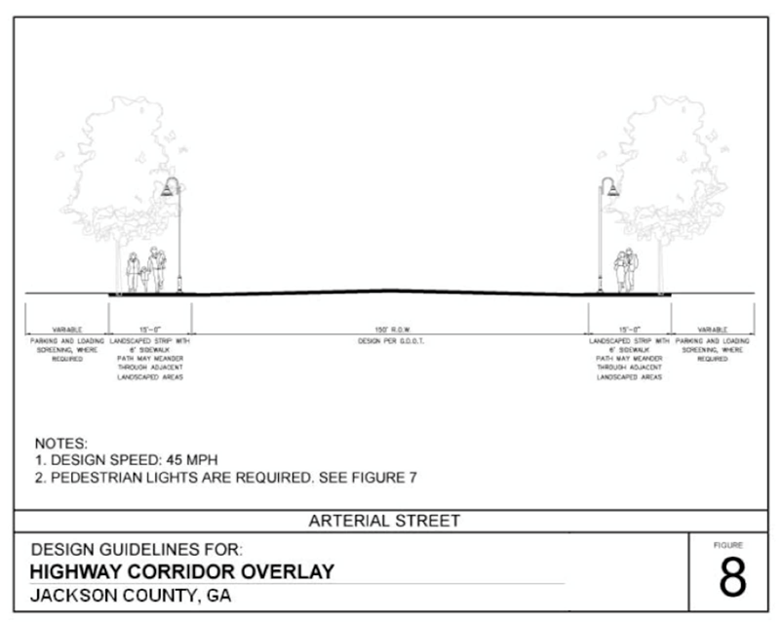
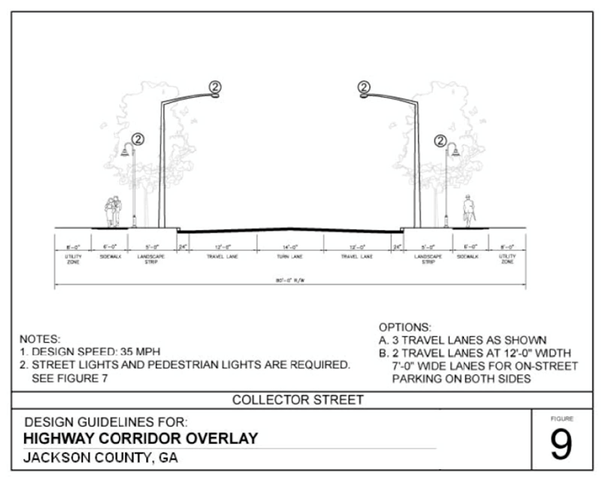
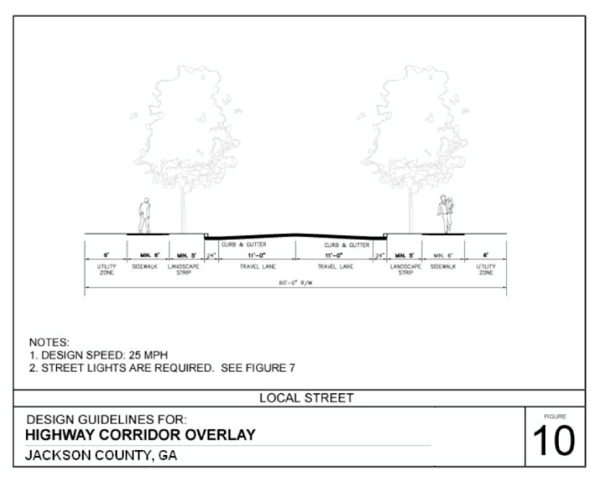
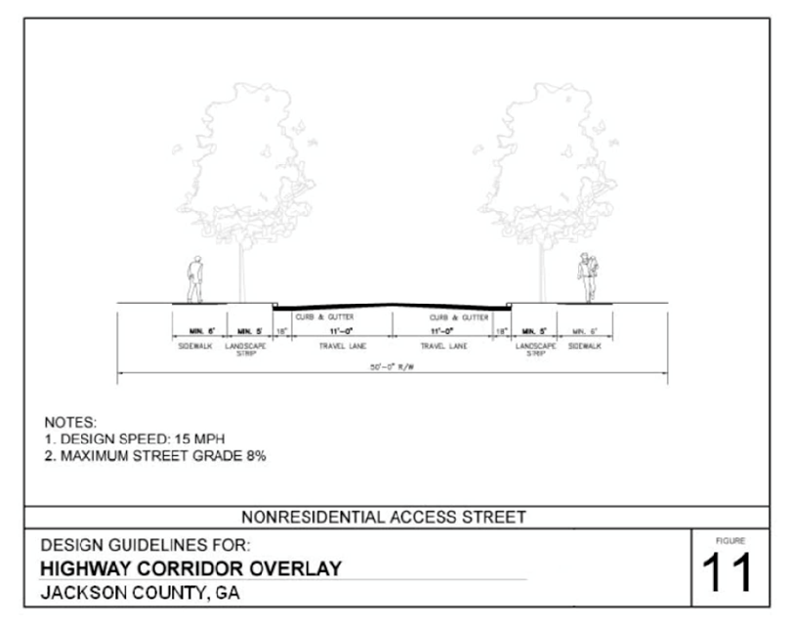
(Ord. No. 17-003 , § 1, 10-2-2017)

Sec. 450. Reserved.

