
MEDICAL/PROFESSIONAL OFFICE FOR RENT
Little Silver Commons
180 White Road, Suite 104 · Little Silver, NJ 07739 · Contact: Lisa (201) 563-1665
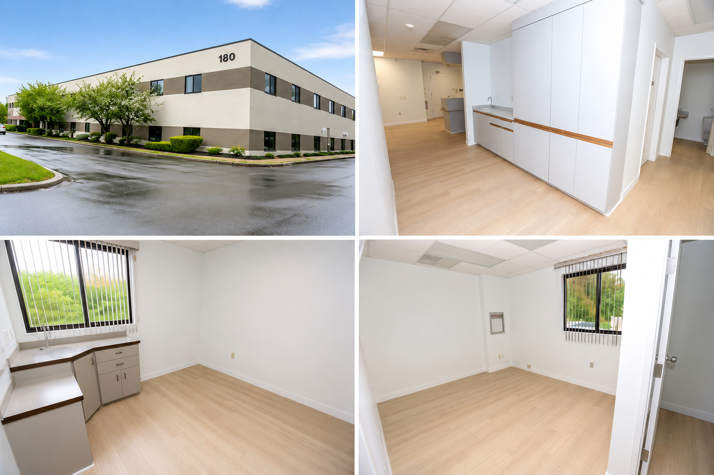

● Building: Office (Class B) ● Suite Size: 1,802 square feet ● Building Vacancy: Remaining offices fully occupied
● Parking: 400 Surface Parking Spaces ● Floor: 1st ● Rent: Base Rent $28/ square foot
Summary: 1,802 SQ FT modern, newly renovated medical office located in prestigious Little Silver Commons. The suite is in outstanding condition and has a spacious patient waiting room and reception area, 2 private restrooms, four (4) exam rooms, a large private office, generous administrative space, an ample storage area that may be used as additional office space; a hallway sanitizing station equipped with a sink and cabinetry, and an ancillary room with generous cabinetry and sink.
Notable Little Silver Commons Tenants
180 White Road: Regional Cancer Care Associates; Kai Sports Medicine; Shore Pulmonary, P.A.; Mitchell T. Zimell DPM; Riverview Women's Health; Odell Family Medicine; Marc. J. DeVito, M.D.; Atlantic Eye
200 White Road: Red Bank Radiologists; Little Silver Mammography & HerSpace; HerSpace MedSpa; Dr. Elizabeth Edelstein; Dr. John Connors; Dr. Peter Hetzler; Little Silver Pediatrics and Family Medicine; Coastal Pediatric Orthopedics; Dr. David Lopez; Atlantic Pediatric Dentistry; Dr. Maryann Yehl.

