
7686 W. 88th Ave * Arvada, CO 80005
✉ sambrown@brown-associates.com
📞303-938-9946
LAKEWOOD CROSSING PAD SITE
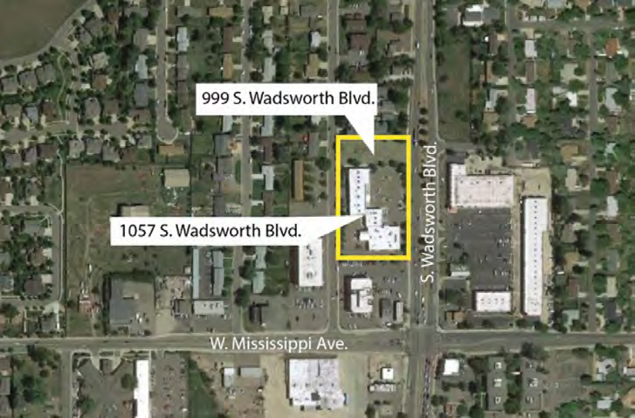
Located at 999 South Wadsworth, Lakewood, Colorado 80027. 26,271 Square feet pad site
Part of Lakewood Crossing which currently has approval for a 2,850 square foot building with a drive through. The approved Site Plan may be changed. Approximately 59,000 vehicles per day pass the property.
Owner will ground lease, may build to suit for qualified tenant or sell.
Sam Brown
Brown & Associates
✉ sambrown@brown-associates.com
📞: 303-938-9946

