1445 S. M-30 Gladwin MI. 48624, Asking: $179,000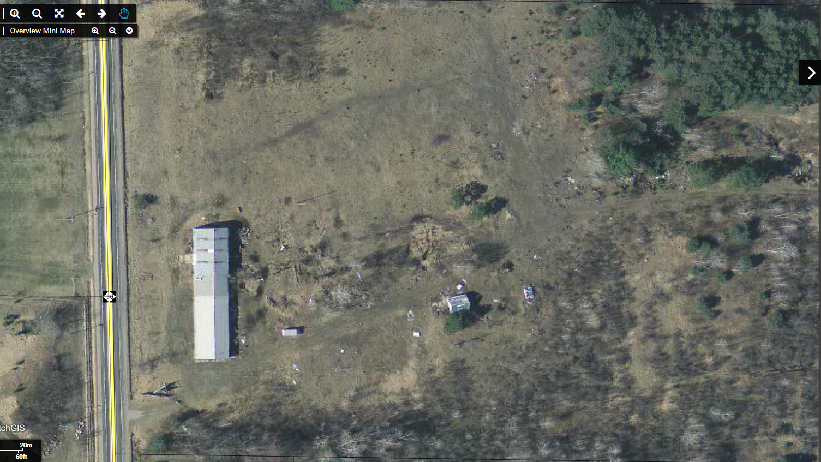
7 Acres With a 6,500 sf Grow facility, Warehouse, Industrial site. Great Homestead, Hunting Property!
Check Listings @ https://henryjohnsonrealestate.com/
