1908 East 177th Street, Bronx NY 10472 – FOR SALE BY OWNER
Asking Price: $2,250,000
Block & Lot: 03794-0120
Zoning: R6 / C1-2
Lot Dimensions: 50 x 149.54 (Irregular)
Lot Size: 6,750 Sq. Ft.
FAR: 3.9
Buildable: 26,325 Sq. Ft.
Existing Footage: 3,250
Air Rights: 23,075
Building Dimensions: 50 x 120 Ft.
Building Size: 3,250 Sq. Ft.
Stories: 1
Units: 3
Taxes (23/24): $32,053
For more information please call owner at:
212-682-2048
Next to Hugh J. Grant Circle, shopping and transit hub
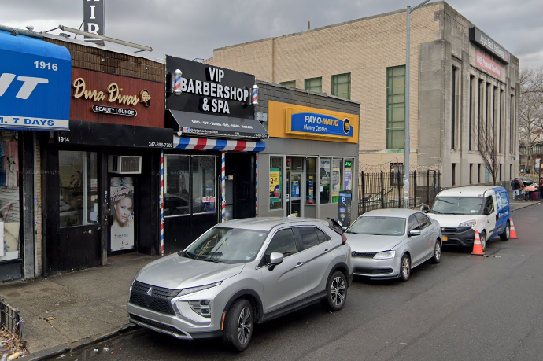
Located on the south side of East 177th Street between Newbold Avenue and Hugh J. Grant Circle. Access to the 6 line Subway. Built in 1925, one story retail building with 3 tenants:
Pay-O-Matic: Monthly rent $6,377.88 / Annual Rent $76,534.56 – Leases expiration 11/13/2027 with a 5 year renewal option
VIP Barber Shop & Spa LLC: Monthly rent $2,654 / Annual Rent $31,848 – Lease expires 06/30/2030
Manny’s Unisex: Monthly rent $3,130.04 / Annual rent $37,560.48 – Lease expires 12/13/2029
Gross Annual Income: $147,342
NOI: $105,327 Annually

