FOR LEASE
13719 I-10 East Fwy - Houston, Tx 77015
RENOVATIONS UNDER WAY !!

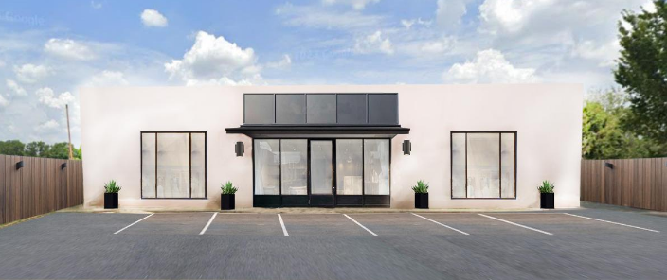

*High Profile Fwy Site * Strong Retail Location * Major Retailers Near
* Large Pylon Signage * Heavy Traffic Site * Bldg Color to Suit
Call for Pricing and Terms
713-683-0404

For Information - Mike Zatopek
I - 10 East @ Uvalde St.
Email: resource@sbcglobal.net

The information contained herein has been obtained from sources deemed to be reliable; however, Resource nor its agents make any guarantee or warranty as to its accuracy or validity or current status. All persons or companies must reach their own conclusions about this property and its suitability for their use and purposes by lease or purchase.
Michael Zatopek 0341258 resource@sbcglobal.net (713) 683-0404
Name License No. Email Address Phone Number

_________________________________________ _____________________ __________________
Name of Buyer/Tenant Initials Date

Regulated by the Texas Real Estate Commission Information available at www.trec.texas.gov

