9 Property Portfolio:
979-314 Limited Partnership
61-215 Limited Partnership
253-124 Limited Partnership
Paul Tucker, et.al.

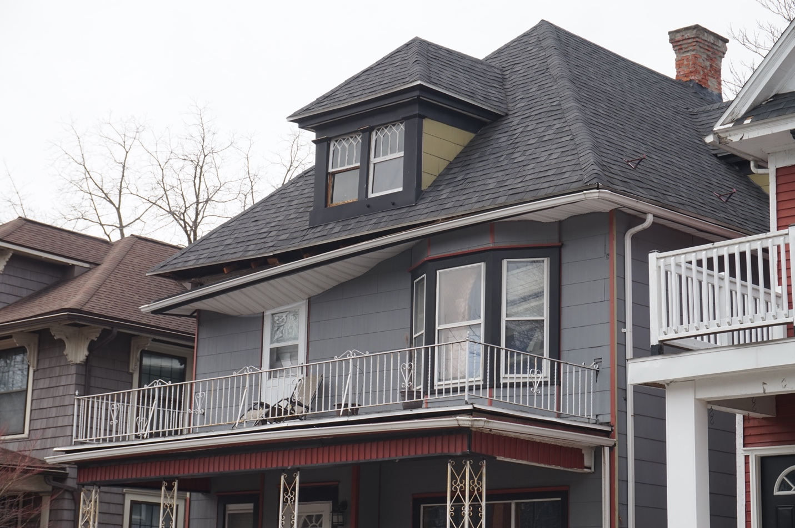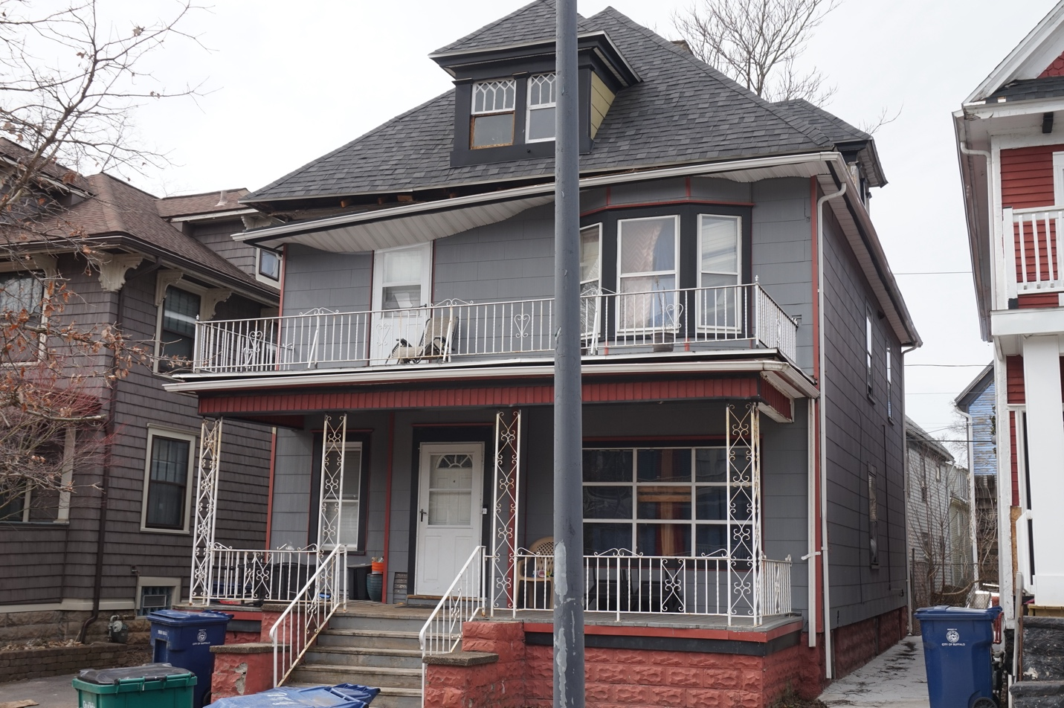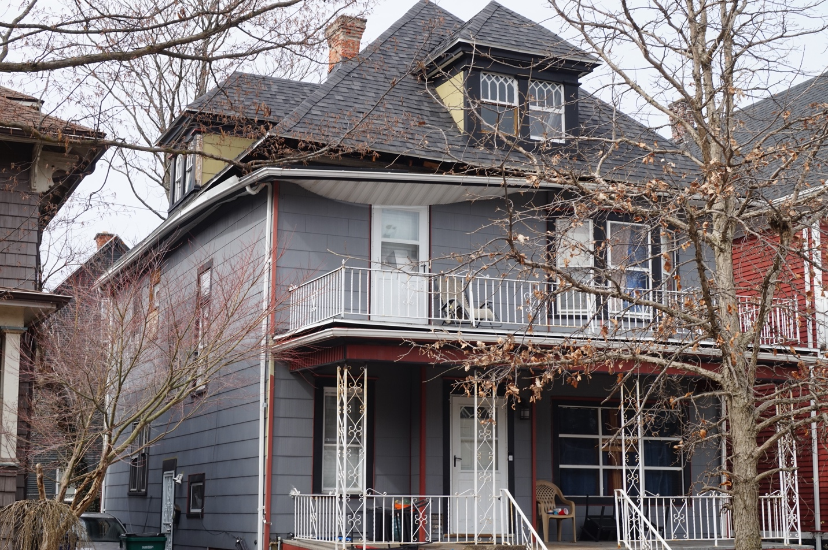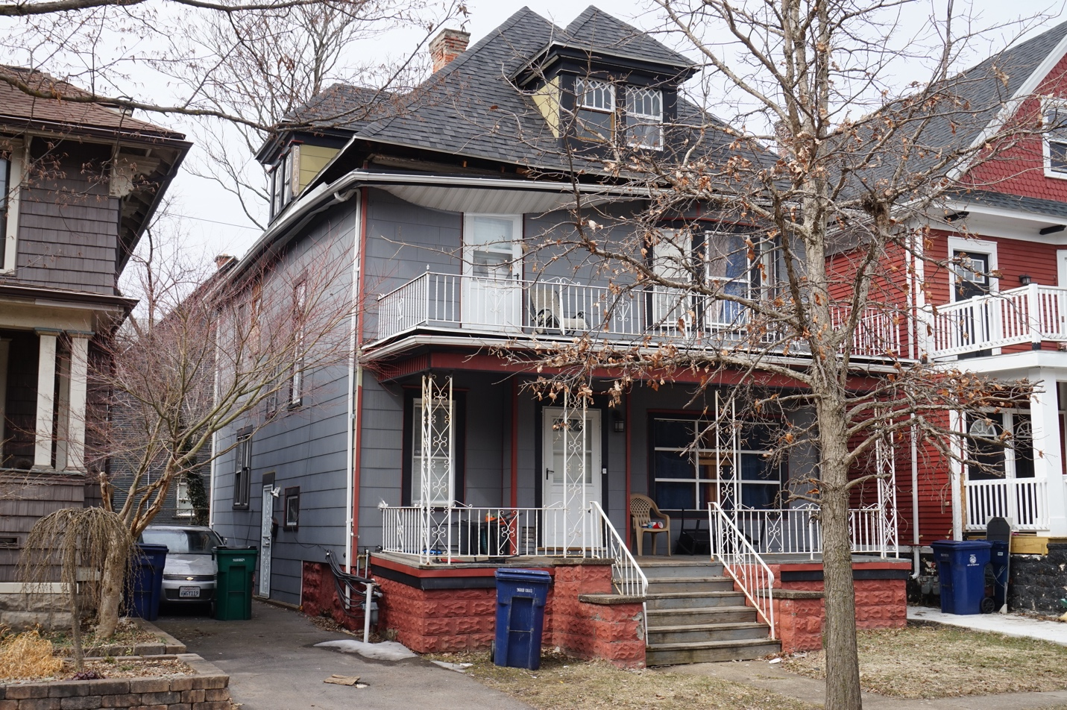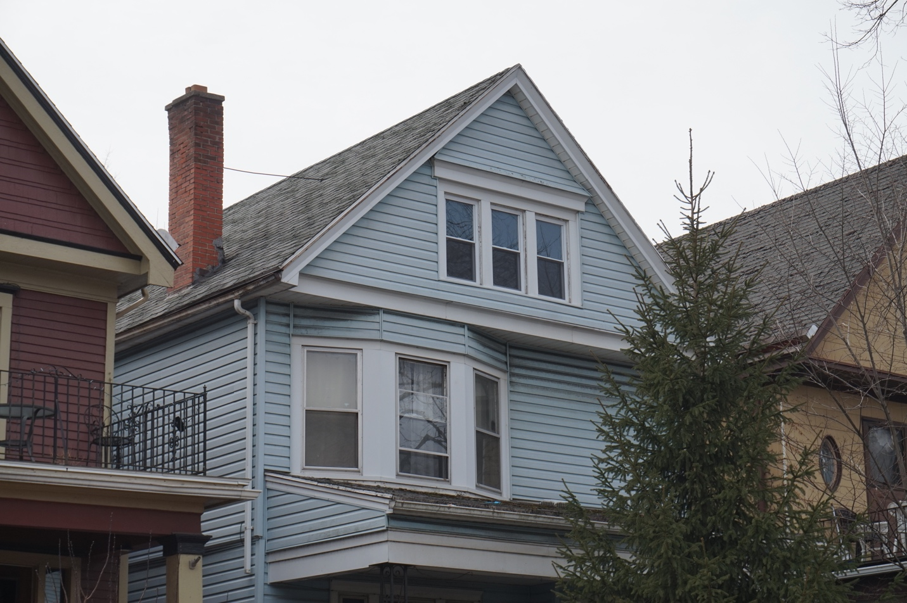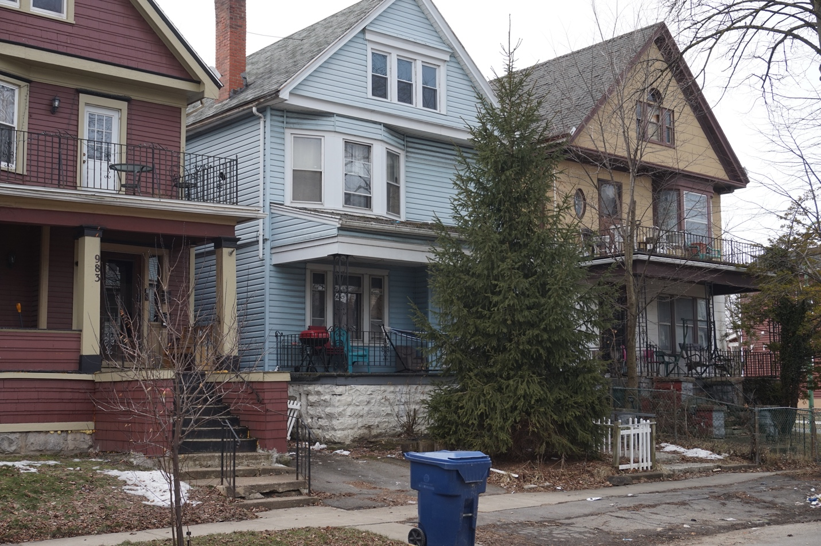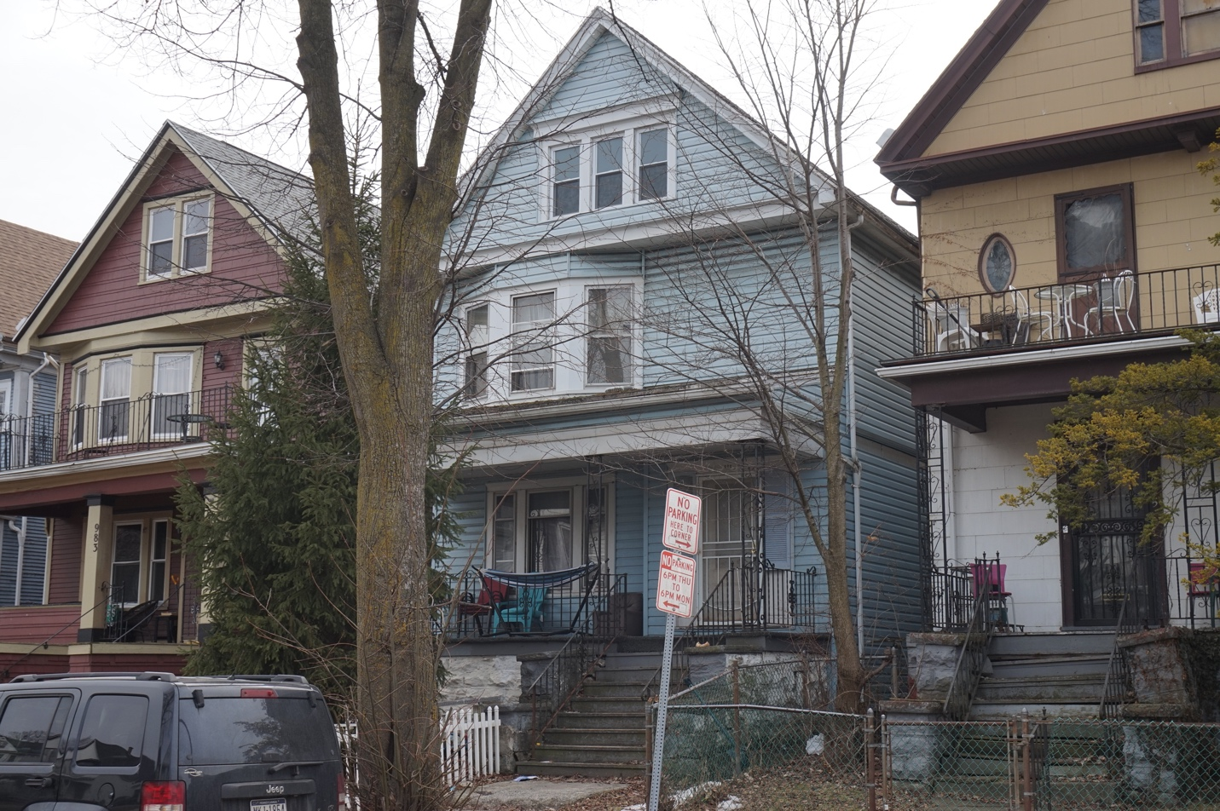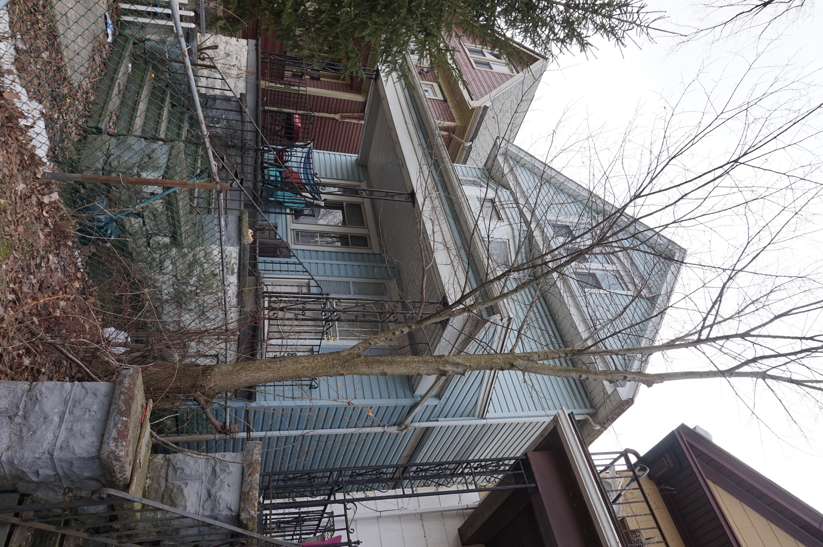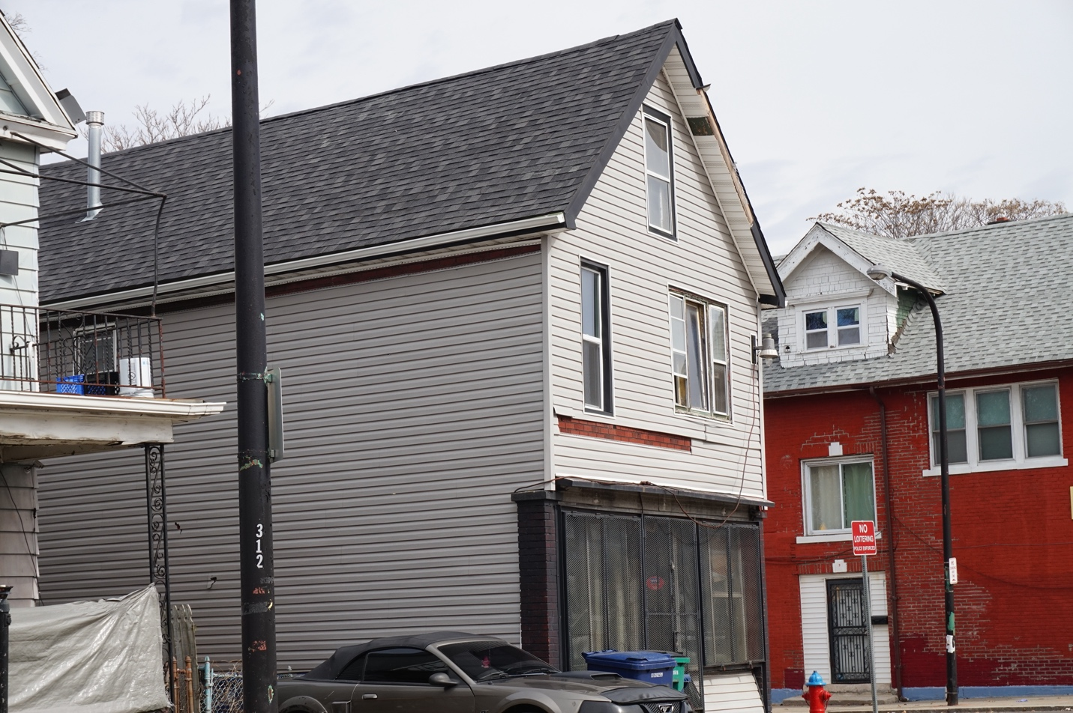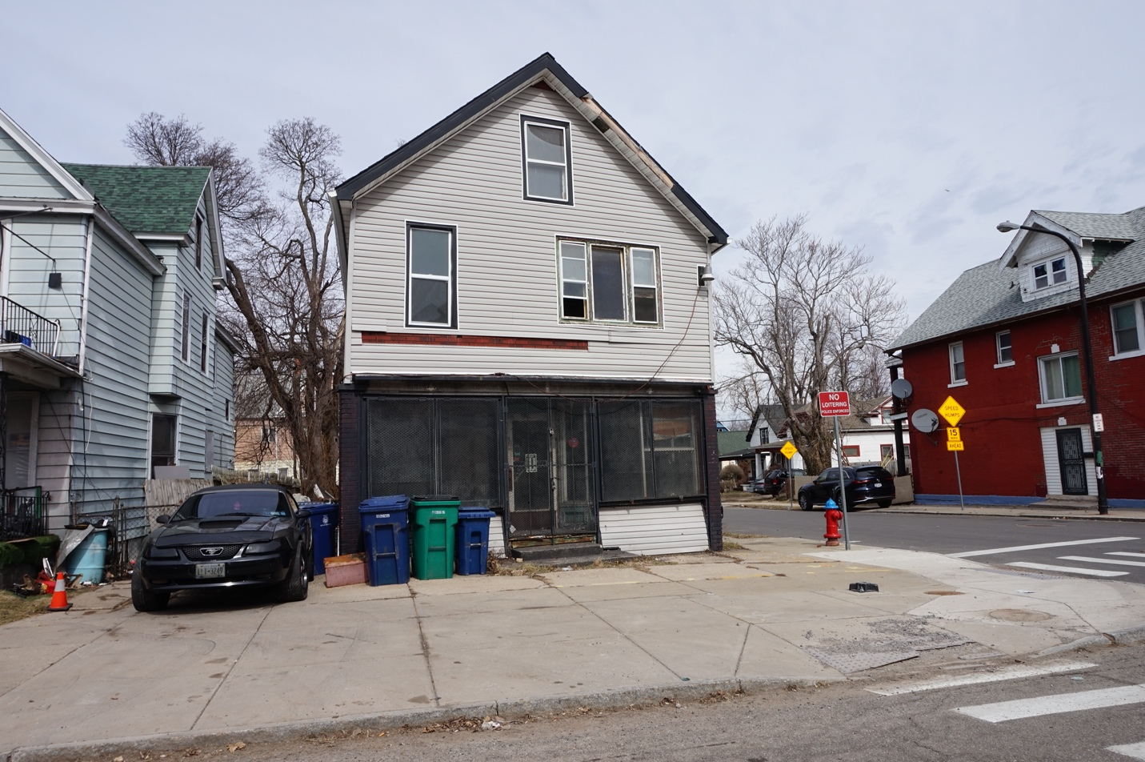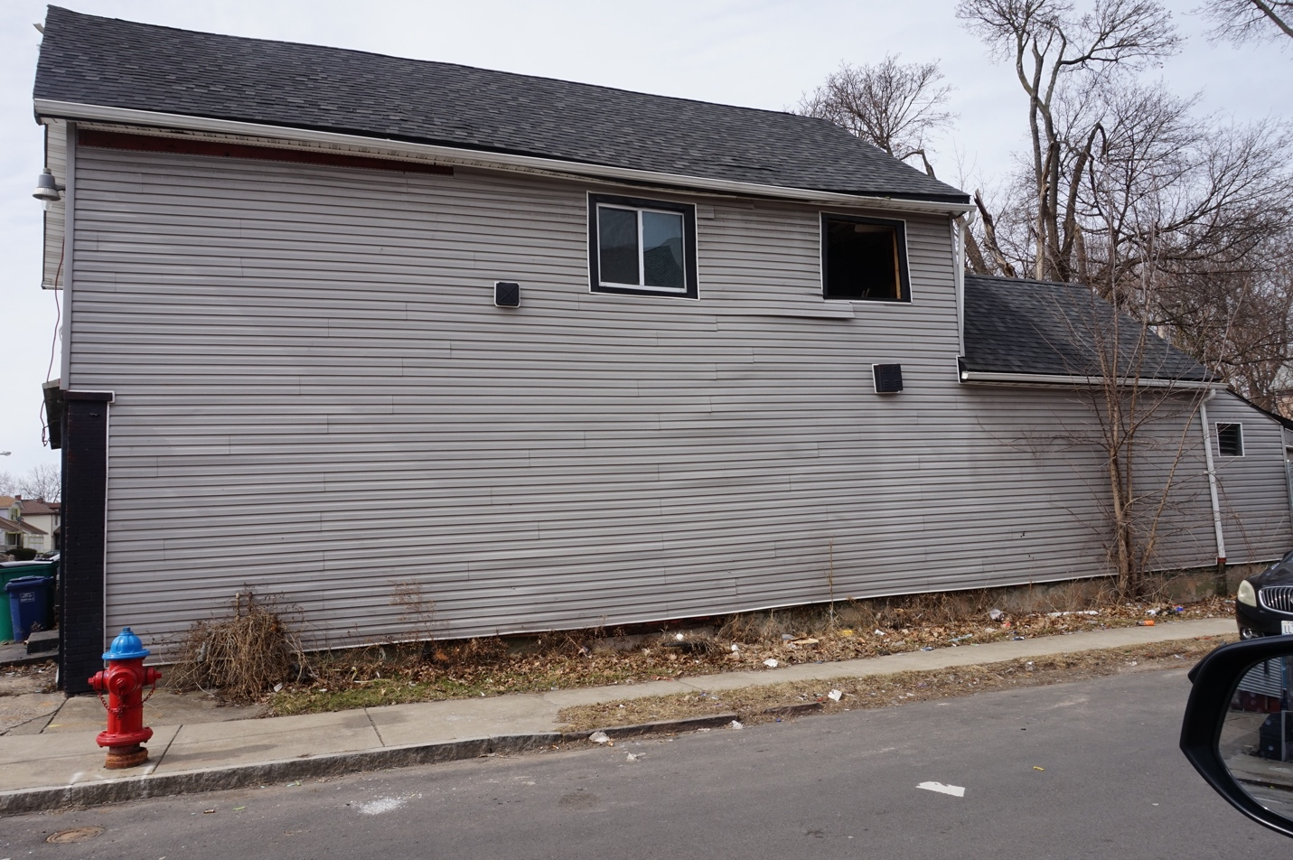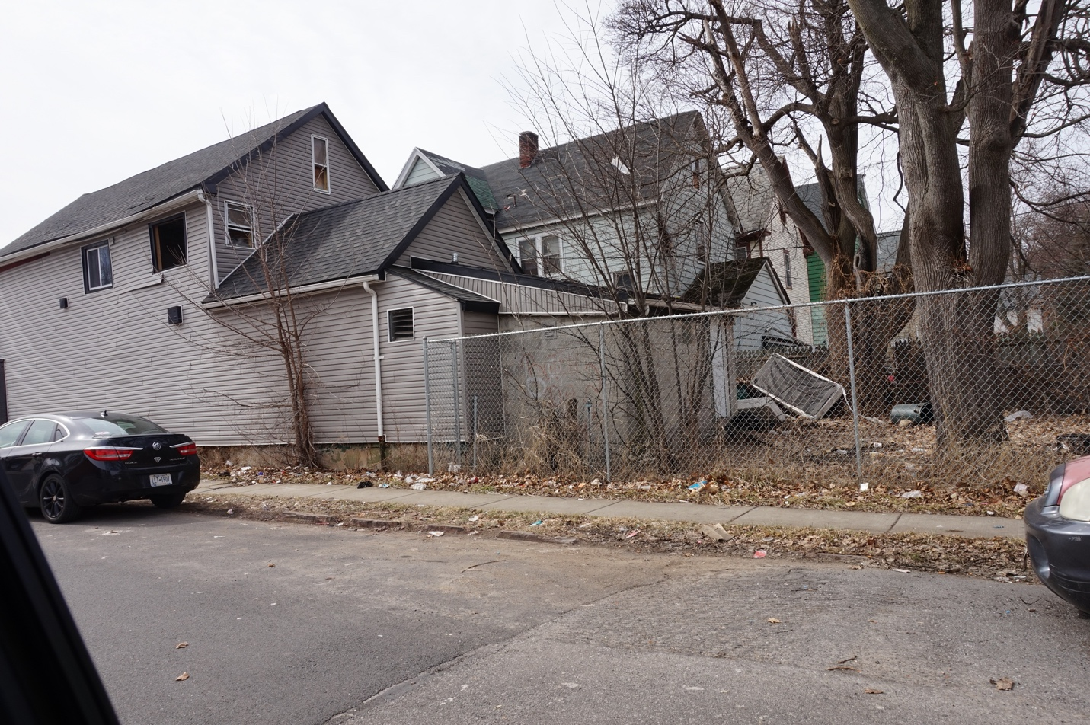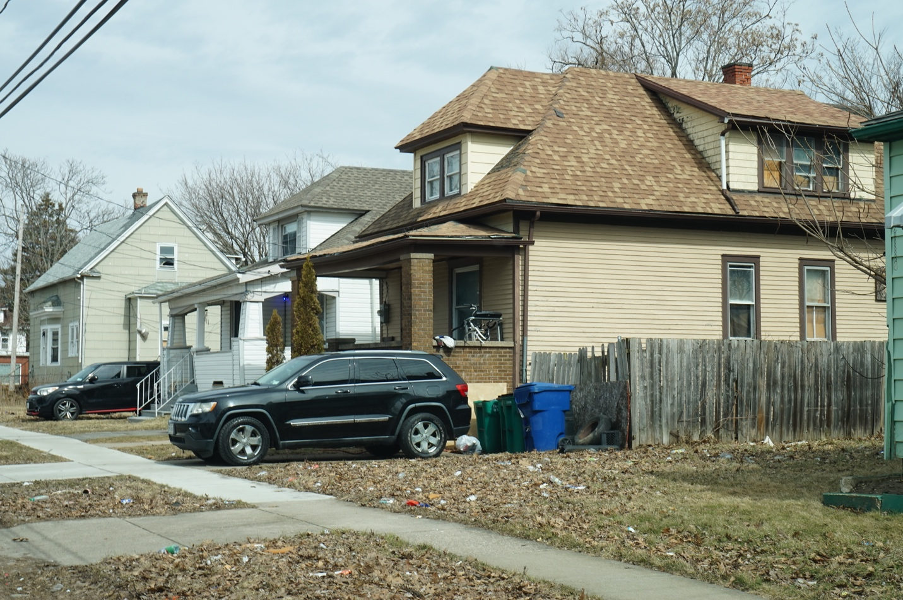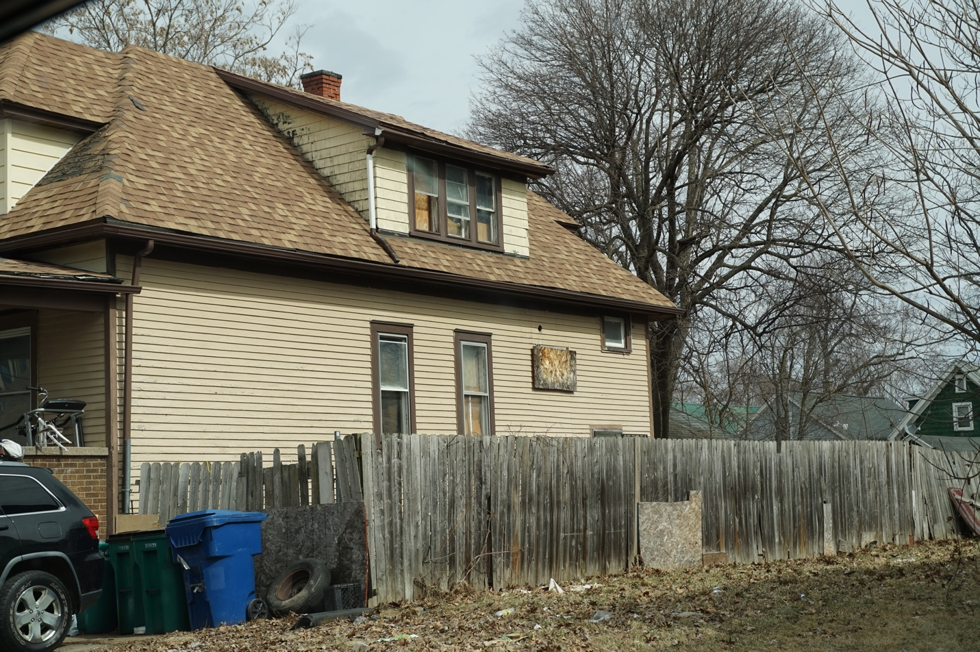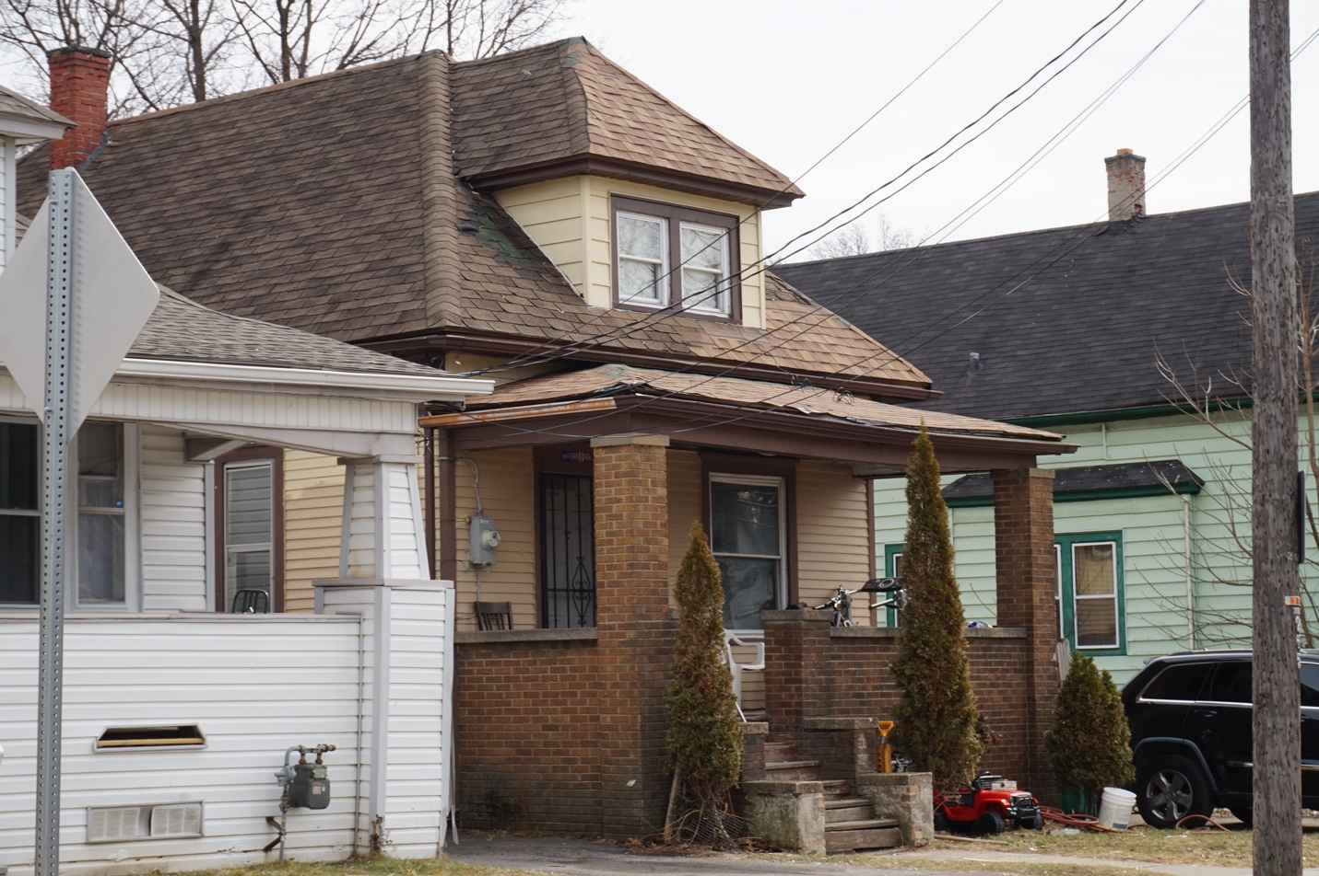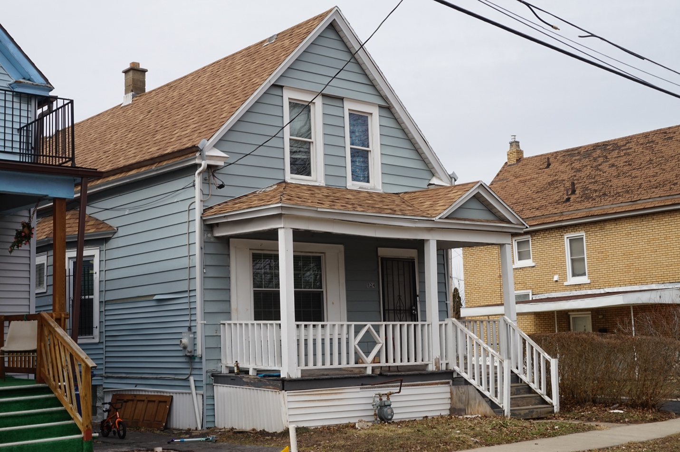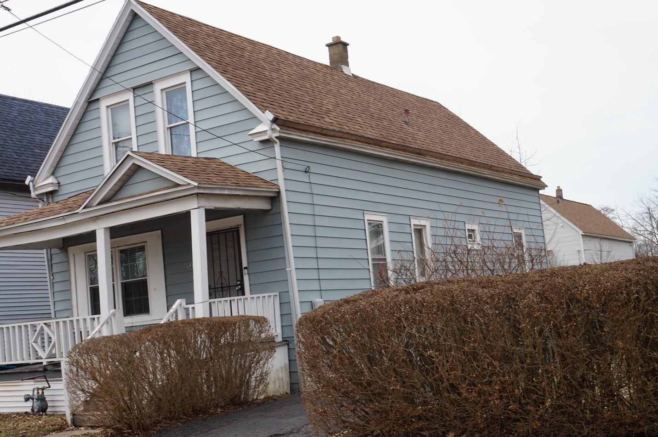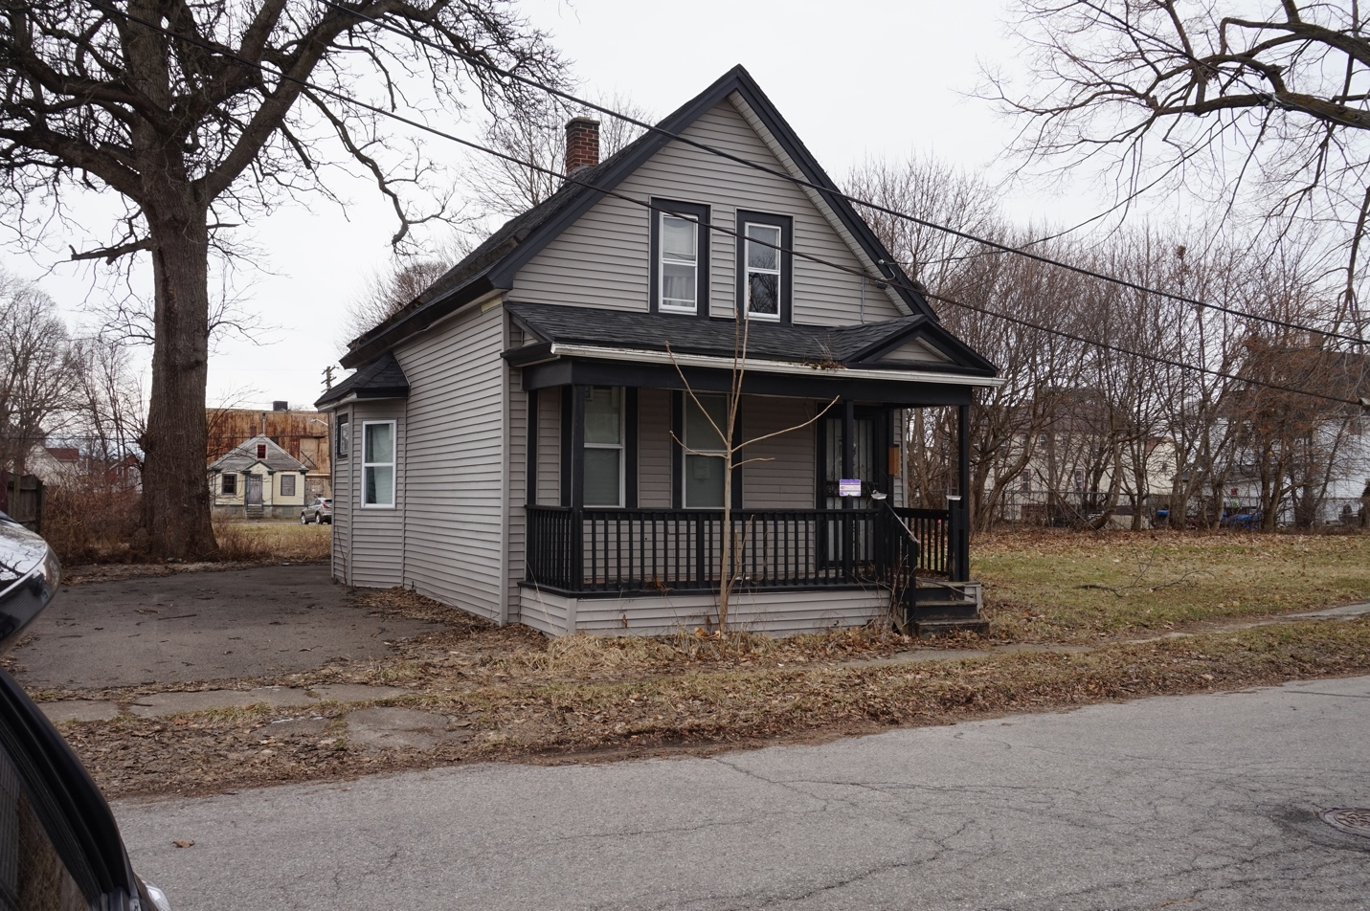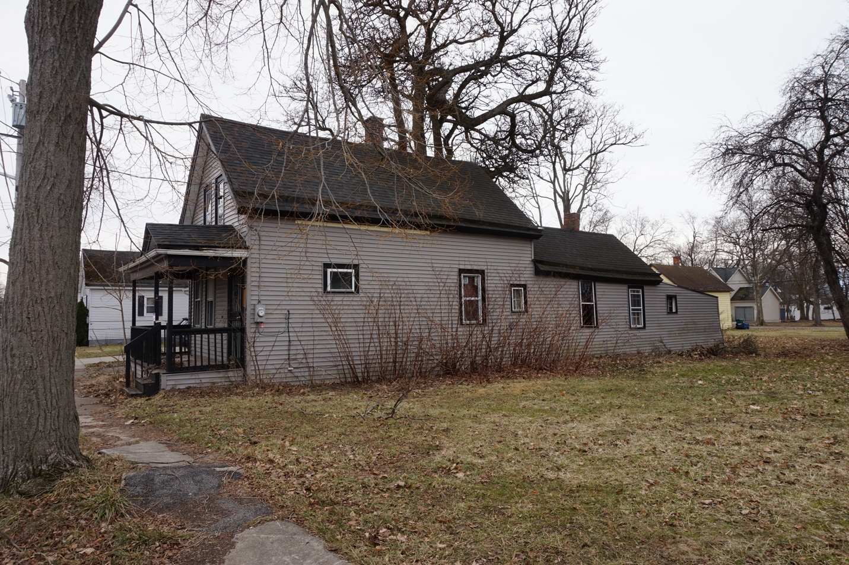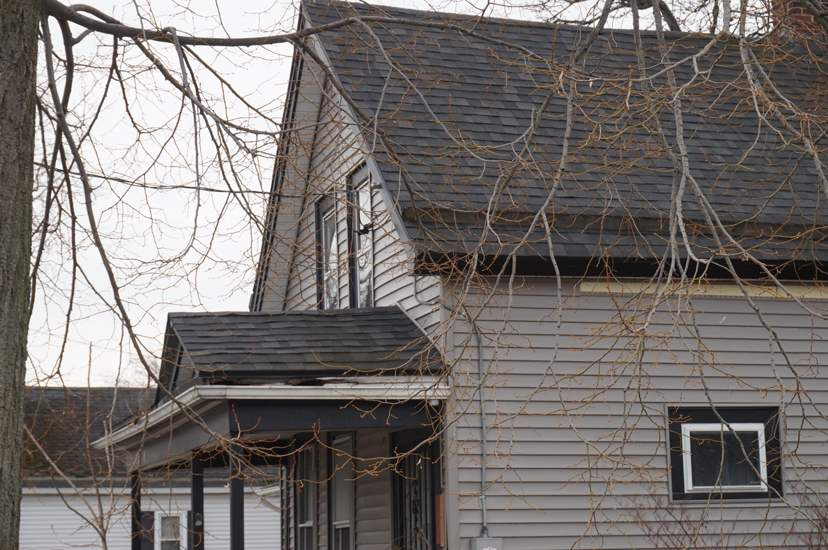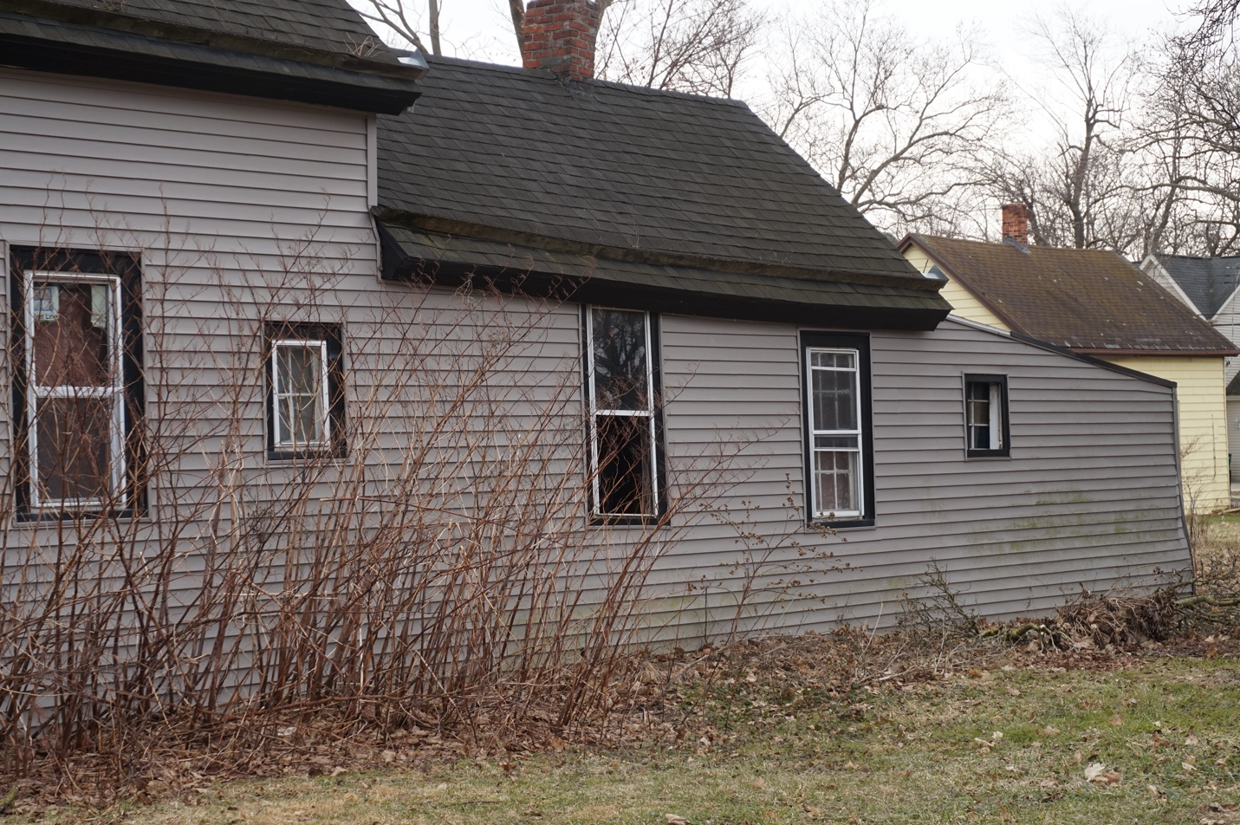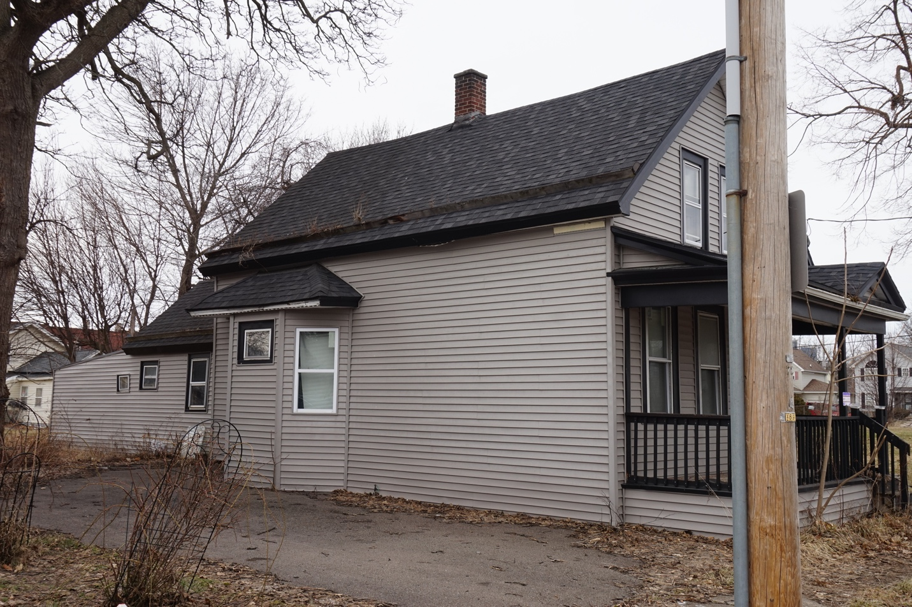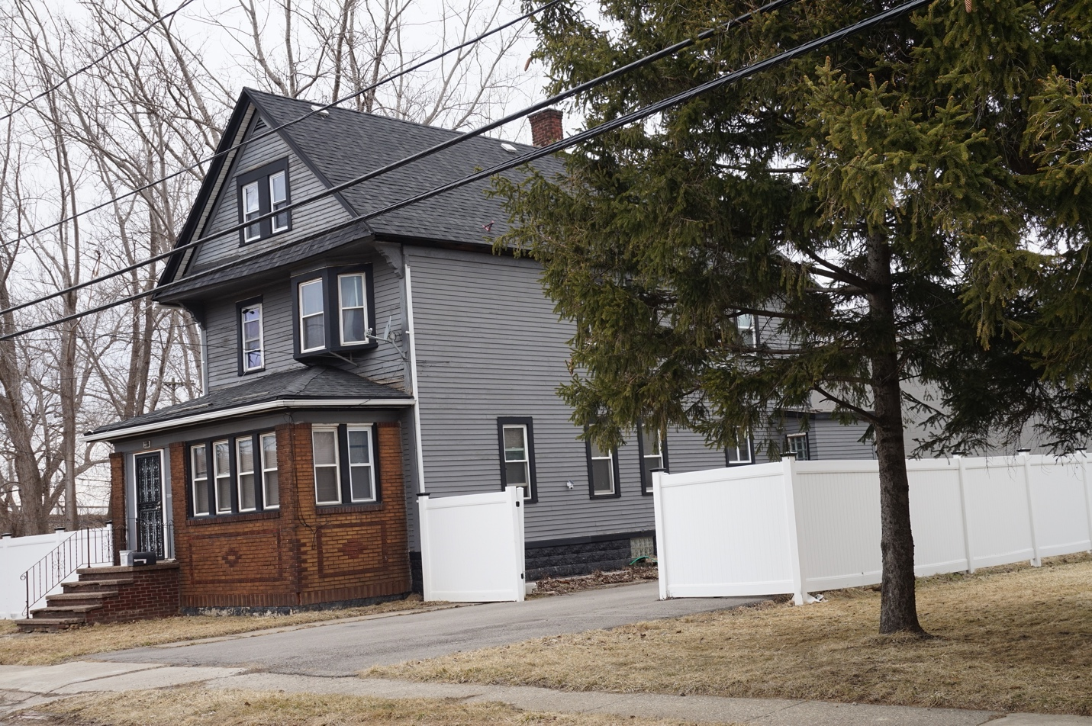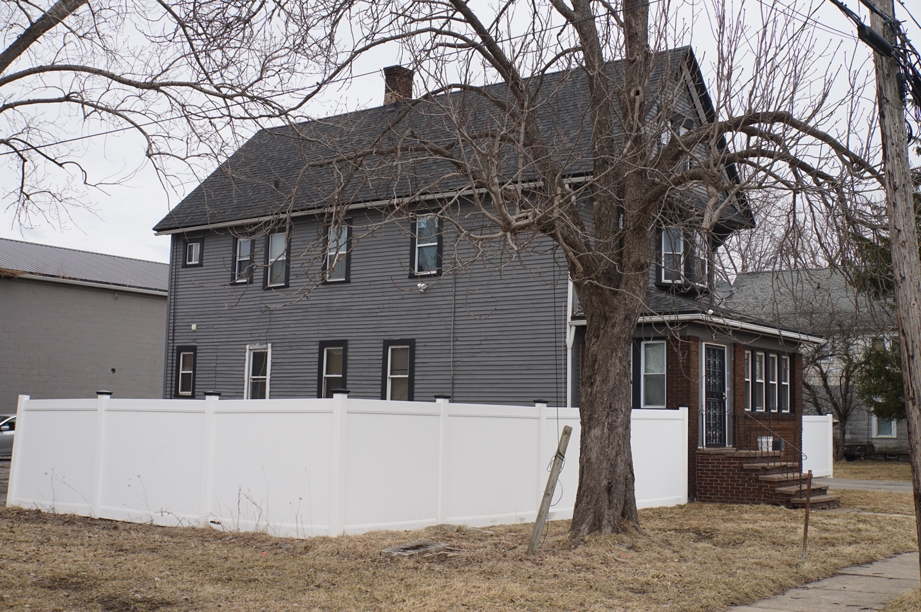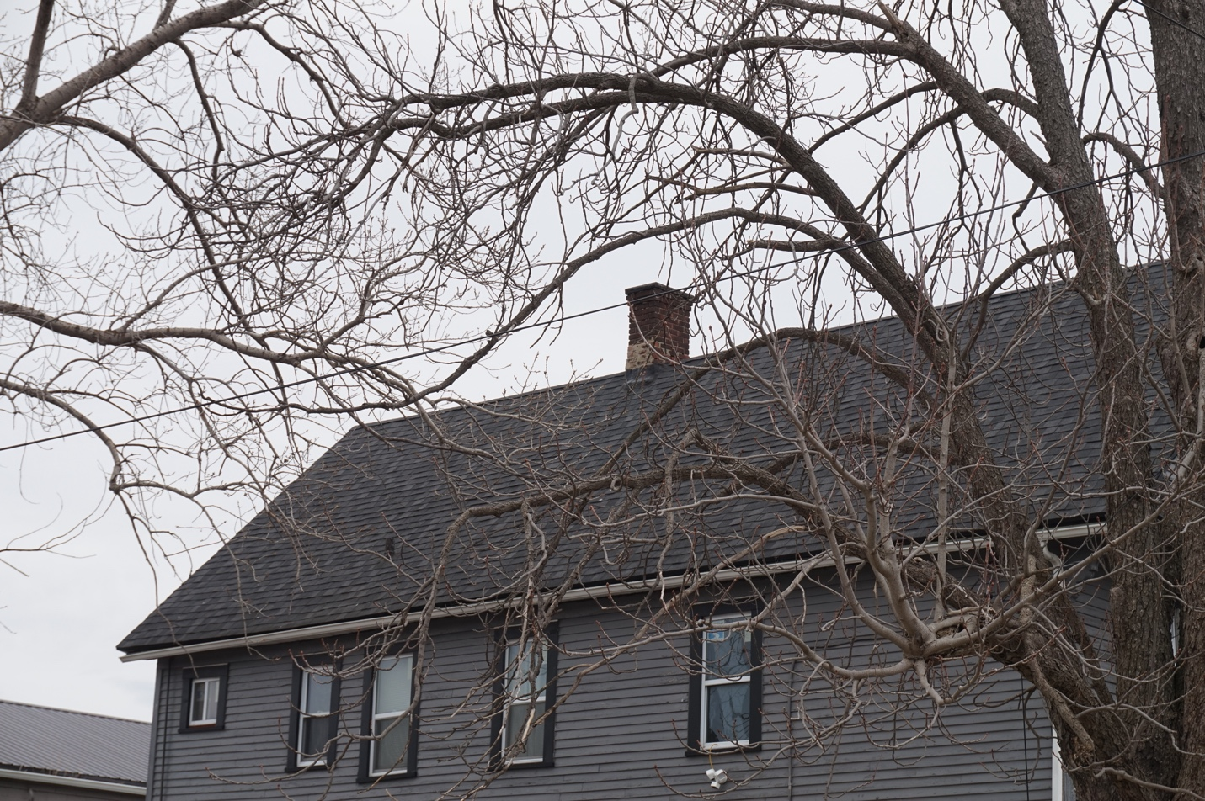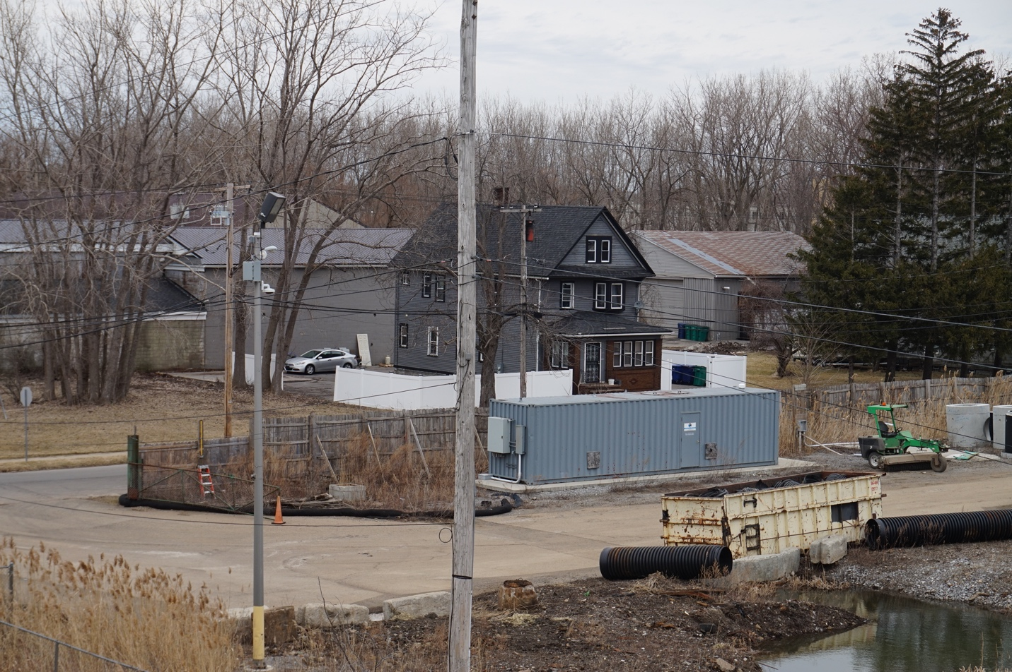

Property Valuation Report

Summary
This report provides an assessment of the value of nine properties, including several that are classified as distressed. Each property's condition, estimated market value, and potential investment opportunities are outlined below. The final values

Property Valuations

Property 1
- Address: 24 Horton Buffalo, NY 14209
- Condition: Good
- Key Factors: The house is listed as a 3 bed, 2 bath 2,334 s/f multi-family (upper/lower duplex) home on the tax records. It has a driveway for off street parking, a standard yard and is located in an emerging neighborhood, with a mix of renovated properties, stagnant properties and new construction. The property currently has utility service for the 2nd floor unit only with the gas and electric meters being removed from the 1st floor. There is visible evidence of tenants living in the property and utilities have confirmed that electric and gas are on for the upper. Inspection from the road shows the roof and siding, doors and windows seem to be in good condition; The foundation and porches seem stable and maintained

Property 2
- Address: 979 Lafayette Buffalo, NY 14213
- Condition: Fair
- Key Factors: The house is listed as a 6 bed, 2 bath 2,668 s/f multi-family (upper/lower duplex) home on the tax records. It has no driveway for off street parking, a standard yard and is located in an emerging neighborhood, with a mix of renovated properties, stagnant properties and new construction properties. The property has connected gas and electric service and meters for both the upper and lower units. There is visible evidence of tenants living in the property and utilities have confirmed that electric and gas are on in each unit. Inspection from the road shows a need for maintenance.

Property 3
- Address: 76 Camp Buffalo, NY 14204
- Condition: Fair
- Key Factors: The house is listed as a 3 bedroom, 1 bath 1109 s/f single family home on the tax records. The house is surrounded by newer infill homes built in the late 1990's & early 2000's. This home seems to have had some exterior renovation - roof, siding, windows and porch in the past 5 years which adds some value, however the inside is exposed and down to the studs. It has missing windows, and the interior may have weather damage as a result. The house is vacant, and no utilities have been in service in some time..

Property 4
- Address: 215 Scoville
- Condition: Vacant Land
- Key Factors: This is a vacant parcel at the end of a street.

Property 5
- Address: 61 Imson
- Condition: Vacant Land
- Key Factors: This vacant lot is off Seneca Street near the 190 and Food Terminal

Property 6
- Address: 314 Northland
- Condition: Distressed
- Key Factors: This mixed use corner property is in need of repair to secure it from the elements, missing windows and while the roof appears to be solid, it may have been recently repaired and the old roof must have leaked bad as the 2nd floor ceiling is visibly collapsed. The utilities are off and have been for some time as all meters have been removed. The yard is fenced, but full of debris and the 1st floor is commercial storefront.

Property 7
- Address: 124 Colorado
- Condition: Good
- Key Factors: This single family 3 bed, 2-1/2 bath home is 1201 s/f and seems to have been updated in the past 8-10 years. The roof is architectural shingle that is clean, goods color and looks to be in good shape, maybe 3-5 years old. There seems to be good drainage with proper gutters and down spouts. The siding, though a couple of different types is of consistent color and seems to have full coverage. The windows seem to be vinyl replacements, some done recently, as Google earth shows old windows, and these are nicely trimmed on the front and sides. The front door is newer, insulated with protective storm. The structure seems straight and solid and the front porch in good condition.

Property 8
- Address: 253 Carl
- Condition: Fair
- Key Factors: This single family 3 bed, 1 bath bungalow style home is listed at 1092 s/f and seems to have some work started. The roof is architectural shingle that is clean at the peak, however some shingles are missing and there is severe discoloration at the front dormer and the porch roof. There are a mix of sidings which from the front and sides do not appear to be in bad condition. There are some vinyl replacement windows, but also a couple of boarded over windows. The yard is good size, but there is considerable debris and the fence is falling in areas. The front door is newer, insulated with protective storm. The structure seems straight and the brick at the front porch seems in good condition.

Property 9
- Address: 238 Marilla
- Condition: Good
- Estimated Market Value: $200000-235000
- Key Factors: The house is listed as a 4 bed, 2 bath 2,384 s/f multi-family (upper/lower duplex) home on the tax records. It has a large driveway with rear parking in the fully fenced yard. Located in South Buffalo the house seems to be maintained reasonably well. The property is surrounded by vacant lots, a light industrial property behind and 2 Auto wrecking yards across the street. There is visible evidence of tenants living in the property and utilities have confirmed that electric and gas are on in each unit. Inspection from the road shows the house has been updated and maintained with a newer roof, nice, painted siding and replacement windows all around with proper exterior trim. The front porch with brick seems straight and in nice shape and there are no visible signs of foundation. Maintenance concerns are minor and include the chimney is not capped and the new vinyl fencing is not completed around the entire yard.

