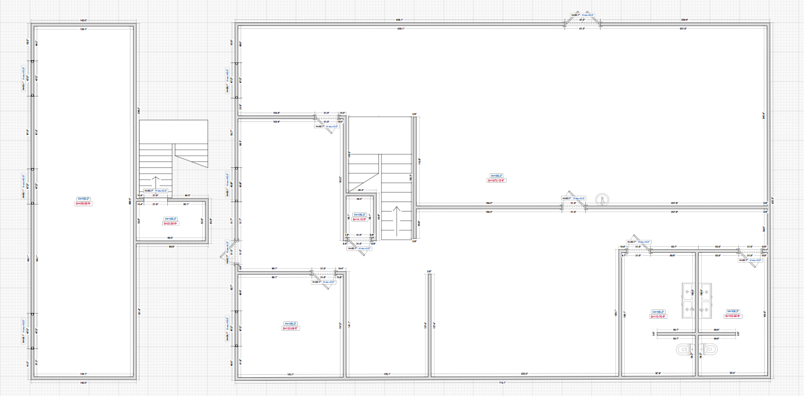
5x3ft
20x38ft
(includes bathrooms)
20x48ft
9x17ft
2nd floor
12x40ft
5x9ft
12x10ft
12x17ft
8 x14ft
8 x14ft
12 x12ft
Front 40ft
SIDE 60 ft

