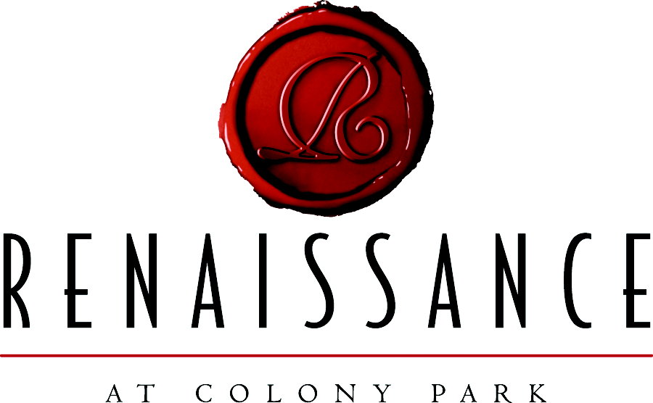

Updated August 26, 2008

Mississippi’s First Lifestyle Center

The finest in fashion and retail shops and restaurants are now open on the Highland Colony Parkway at the northwest corner of I-55 and Old Agency Road in Ridgeland, Mississippi.

P.F. Chang’s China Bistro and Biaggi’s Ristorante Italiano opened in the Fall of 2007 and were joined in March 2008 by Fresh Market Gourmet Grocery, Barnes & Noble Booksellers, Talbots, Ann Taylor, Ann Taylor Loft, J.Jill, Williams-Sonoma, Cellularsouth.com, Learning Express Toys, Sweet Peppers Deli, Solstice, Merle Norman, Hallmark, Portrait Innovations, Ridgeland Visitors Center, Southern Breeze Art Gallery and Material Girls. Also recently welcomed by their co-tenants were Chico’s, White House/Black Market, Cache’, Harold’s, Ethan Allen, Migi’s, Francesca’s Collection, Pink Bombshell, Smoothie King, Banana Republic, Justice for Girls, J. Crew, I.O. Metro Furniture, and Ruth’s Chris Steakhouse.

Other tenants opening soon include: Apple, Anthropologie, Mint Restaurant, Maggie Moo’s, Fuze Sushi Bar, Lucky Brand Jeans, Sleepstore by Miskelly, Bath Junkie, Red Square Clothing, Wine Bistro, Wine Market, a salon and day spa, and a new Hyatt Place Hotel.

The development, with its distinctive Lifestyle Main Street concept, provides spacious common areas for strolling and relaxing, beautiful water features throughout, sidewalk cafes and a town center square hosting an on-going array of special events and music.

The open-air lifestyle center concept goes beyond shopping, dining and entertainment, relying heavily on the architecture and amenities to create a new experience for the consumer. The architectural style for Renaissance at Colony Park has been derived from European and Mediterranean influences, utilizing a mix of classical features, such as arched openings, clay tile roofs, and stone and stucco facades. There is a variety of forms, shapes and color with a strong emphasis on pedestrian scale elements such as landscaping, varied paving patterns, benches, wrought iron railings and trellises, fountains, and decorative lighting.

A European fountain will soon be the focal point of the “front door,” and additional features will include a central square with a clock tower and a community green space that allows for afternoon and evening entertainment and activity. The design theme places a high value on architectural beauty with water features that blend landscape architecture with a user-friendly retail environment. All of these elements come together to create a vibrant destination offering the visitor a unique environment second to none in this region in terms of an exciting shopping, dining and entertainment experience.

The center is highly visible from Interstate 55, the Natchez Trace, Old Agency Road and the Highland Colony Parkway. The Natchez Trace and I-55 are essential to the location of the Renaissance. This site is the hub where all major thoroughfares empty. Access to I-220 is less than one mile from the site.

The project which employed approximately 500 construction employees will consist of approximately 500,000 square feet of building space on 57 acres. With more than sixty retail stores, projected retail sales will be approximately $162,000,000 annually. In addition to the retail stores, the development will feature at least five full service restaurants, five specialty food stores and 50,000 square feet of office space above the retail shops.

The center will employ approximately 600 full time retail employees. Upon completion, this exceptional development will attract shoppers from at least a one-hundred mile radius and will be a destination unto itself.

For more information, contact The Mattiace Company, 601.352.1818
www.mattiace.com
www.renaissanceatcolonypark.com

