

214 Ellis St - 216 Ellis St
MULTI-FAMILY INVESTMENT OPPORTUNITY
Augusta, GA 30901

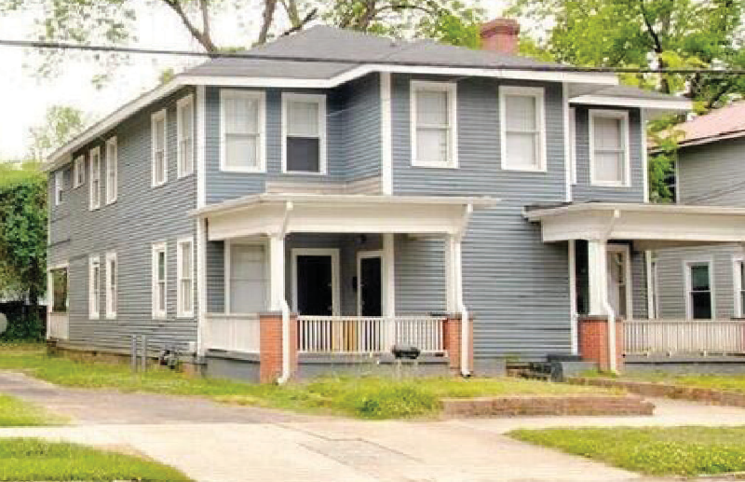
$499,000 | MLS # 534750

214A: Rent: $850; BR: 1 BA: 1 SqFt: 680
EXCELLENT RENTAL INCOME POTENTIAL
214B: Rent: $855; BR: 1 BA: 1 SqFt: 680
216A: Rent: $1,100; BR: 2; BA: 1 SqFt: 1,260

216B: Rent: $1,050; BR: 2; BA: 1 SqFt: 1,295
OFFICE: 706-863-8218 · GoGregOldham.com
706.877.4000
GREG OLDHAM
REALTOR®, Vice President

212 Ellis St
Augusta, GA 30901

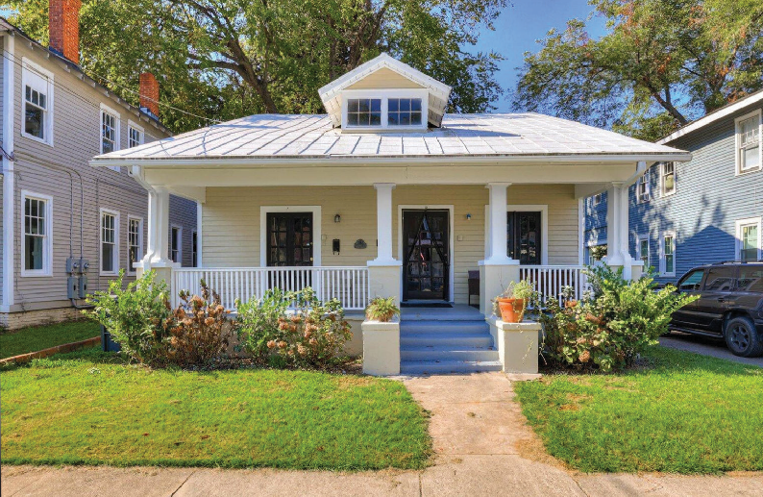
$230,000 | MLS # 534749

212A: Rent: $945; BR: 1 BA: 1 SqFt: 1,014
212B: Rent: $1,025; BR: 1 BA: 1 SqFt: 1,460



