16-20 Convent Avenue, New York NY 10027
DEVELOPMENT SITE FOR SALE BY OWNER – Manhattanville near Columbia University
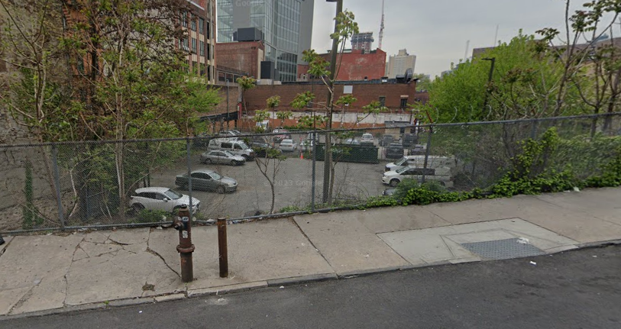
Asking Price: $10,000,000
Block & Lot: 1967-0078
Zoning: R7A
Lot Dimensions: 84.33 x 90.5 ft. (Irregular)
Lot Size: Approx. 9,303 Sq. Ft.
FAR: 5.01
46,608 Buildable Sq Ft.
For more information please call owner at:
212-682-2048
Located on the corner of Convent Avenue and West 128th Street in Harlem. Property was formerly used as a parking lot. The property will be sold vacant.
Asking $10,000,000

