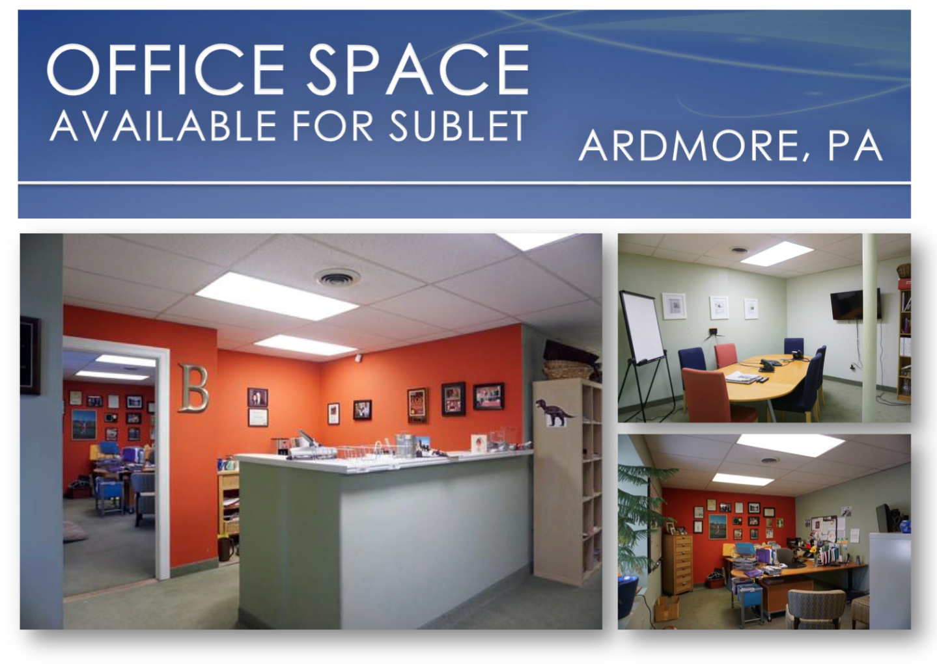
1800 Square Foot Space -Existing 5 Offices Can be built out to multiple offices or open floor plan

3500 Square Foot Space - Existing 5 Offices Can be built out to multiple offices or open floor plan

Plenty of Free Parking

Close to Public Transportation

Conference Room & Reception Area

Shared Kitchen & Restrooms

Ground Floor Office with Street Visibility

Easily Reconfigured: Retail, Medical, Yoga Studio, Physical Therapy etc
Call (610) 322-2083 or
email teammskri@gmail.com
