FOR LEASE
2294 Scranton road
cleveland, ohio 44113
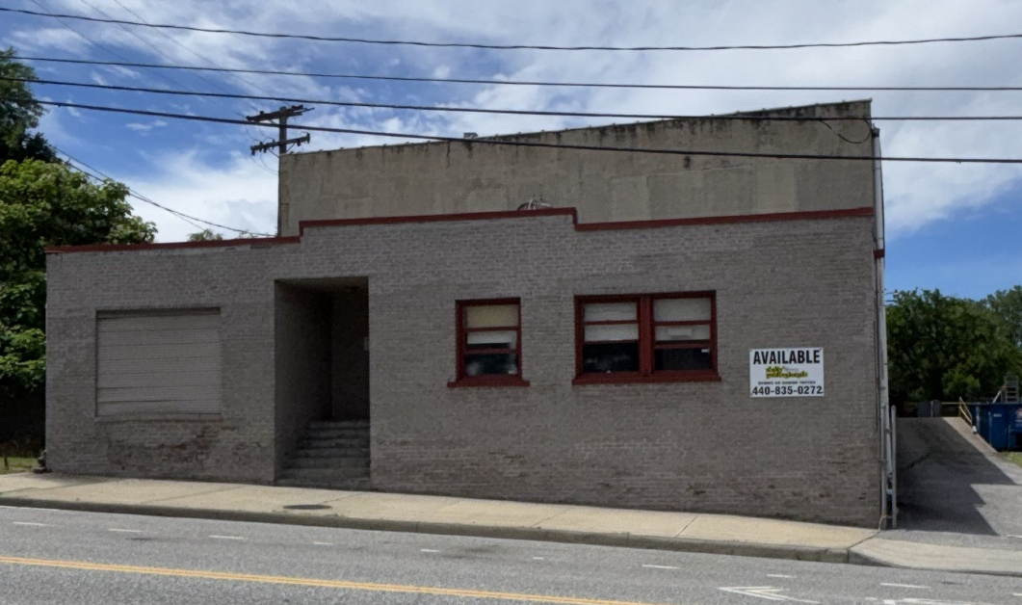

Total S/F: 15,620 Sq. Ft. AVAILABLE: 2,500 Sq. Ft.
Zoning: Heavy Industrial WAREHOUSE/MANUFACTURING AREA:
Land Area: 1.71 Acres Loading Facilities: 1 overhead door (10’x10’)
Base Rent: $3.00 Sq. Ft., and 1 Dock
Additional Rent: $1.33 Sq. Ft. Heating: Gas Unit Heaters (Tax, Insurance, Storm Water) Lavatory: 1 (no shower)
Spaces: 1 – 2294 Scranton, 5,000 Sq. Ft. on the first floor, Electric Power: 200 amps 120/208
extra 2,500 Sq. Ft. second floor walk up, drive in ramp Ceiling Clearance: 11’ first floor, 12’ second floor and outside dock to common area. Term: 3/5 years, plus options

Provided is Deemed Reliable But Not Guaranteed.
For more information contact:
DENNIS TROYAN DAMON TROYAN
Broker 216-870-1900 Mobile
onetroyan@aol.com damon@drtroyan.com
216-409-1902 Mobile
www.Realtyproscle.com 440-835-0272 Office


Property Information:
LEASE RATE: $1,804.17 PER MONTH

FOR LEASE
2294 Scranton road
cleveland, ohio 44113

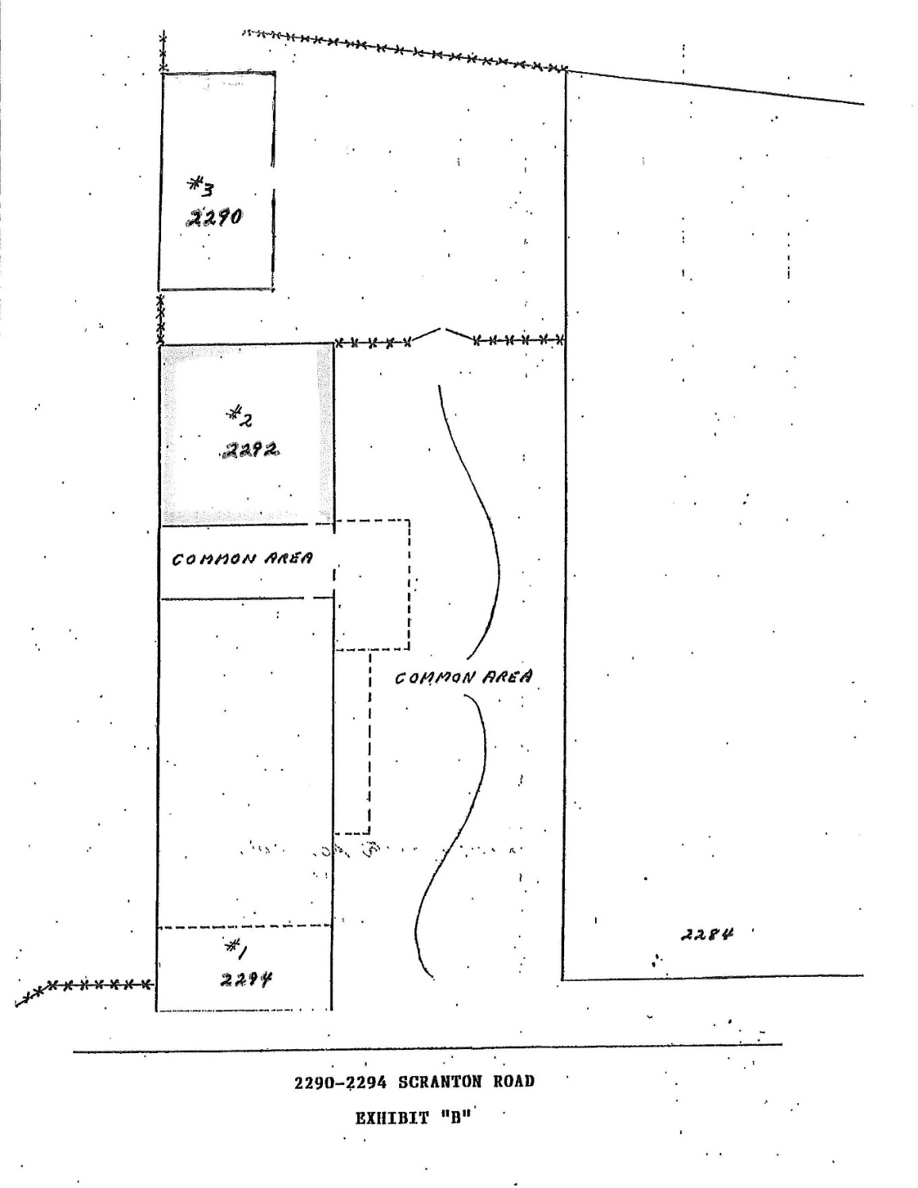

Information Provided is Deemed Reliable But Not Guaranteed.

For more information contact:
DENNIS TROYAN DAMON TROYAN
Broker 216-870-1900 Mobile
onetroyan@aol.com damon@drtroyan.com
216-409-1902 Mobile
www.Realtyproscle.com 440-835-0272 Office

FOR LEASE
2294 Scranton road
cleveland, ohio 44113
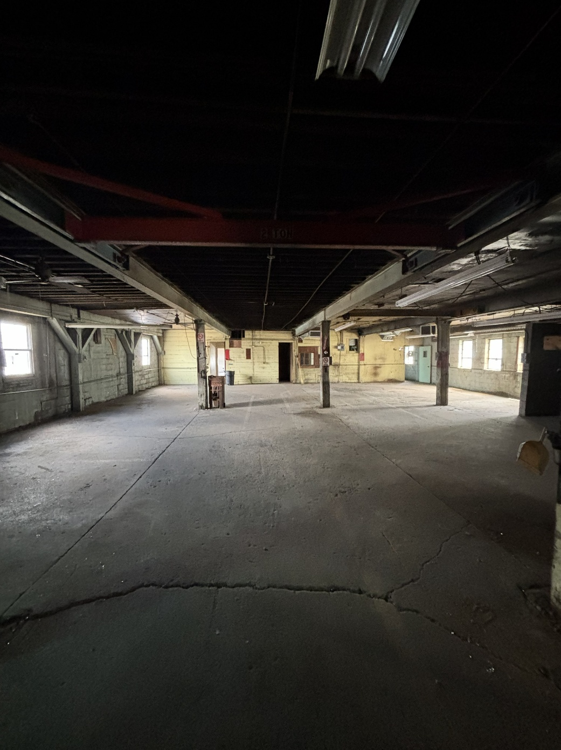
For more information contact:
DENNIS TROYAN DAMON TROYAN
Broker 216-870-1900 Mobile
onetroyan@aol.com damon@drtroyan.com
216-409-1902 Mobile
www.Realtyproscle.com 440-835-0272 Office

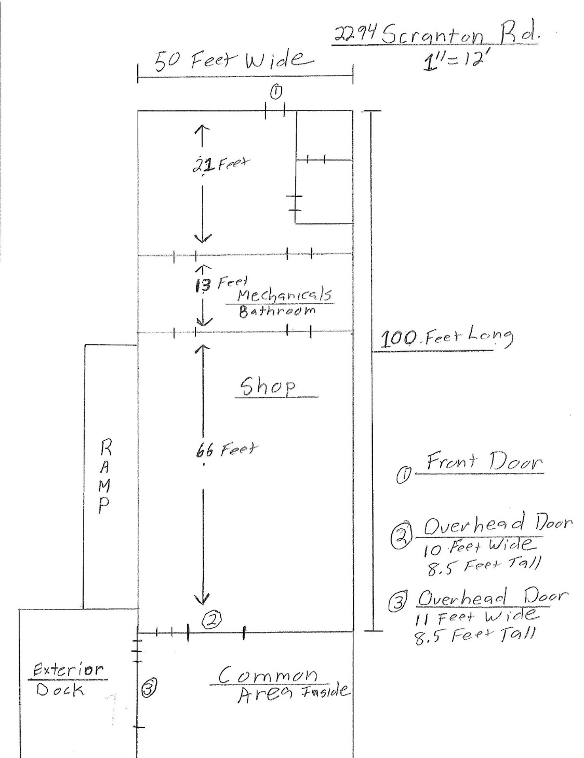

FOR LEASE
2294 Scranton road
cleveland, ohio 44113
For more information contact:
DENNIS TROYAN DAMON TROYAN
Broker 216-870-1900 Mobile
onetroyan@aol.com damon@drtroyan.com
216-409-1902 Mobile
www.Realtyproscle.com 440-835-0272 Office

