OFFERING MEMORANDUM
Confidential Investment Summary

GREASE MONKEY
White Bear Lake, Minnesota
4561 Lake Avenue | White Bear Lake, MN 55110

$1,200,000  ASKING PRICE | $85,800  ANNUAL NOI  Post-2026 Rent Bump | 7.15%  CAP RATE  Post-2026 Rent Bump

4,736 SF  NET RENTABLE AREA  Single-Tenant Automotive | NNN  LEASE STRUCTURE  Zero Landlord Responsibilities

2026  10% RENT BUMP  Then 2%/yr Through All Option Periods | ~1,000  NATIONAL LOCATIONS  Full Speed Automotive / Grease Monkey

★ POTENTIAL BONUS DEPRECIATION OPPORTUNITY ★
This property may qualify for significant bonus depreciation — a powerful tax benefit that can substantially enhance after-tax returns for eligible investors. Consult your tax advisor.

CONFIDENTIAL — FOR QUALIFIED INVESTORS ONLY

Presented by
ENTHEOS COMMERCIAL REAL ESTATE
Curtis Romano, Investment Sales | 952-270-8363 | curtis@entheoscommercial.com
Broker is also the Owner — see Disclosure section

Executive Summary

Entheos Commercial Real Estate presents an exceptional single-tenant, triple-net (NNN) investment opportunity: the Grease Monkey automotive service facility at 4561 Lake Avenue, White Bear Lake, Minnesota 55110. This offering delivers the rare combination of a nationally recognized, credit-backed tenant, absolute NNN lease structure, and a compelling near-term rent escalation — positioned in one of the Twin Cities' most established suburban communities.
The property is 100% occupied by Grease Monkey, a leading national automotive quick-lube and multi-service franchise operating under the Full Speed Automotive platform — one of the largest automotive service networks in the United States with nearly 1,000 locations nationwide. Investors will benefit from zero landlord responsibilities, a scheduled 10% rent increase in 2026, and 2% annual increases thereafter through all option periods — providing built-in NOI growth throughout the hold period.
Disclosure: The listing broker, Curtis Romano of Entheos Commercial Real Estate, is also the owner of the property. This relationship is disclosed in accordance with applicable real estate licensing requirements. Prospective buyers are encouraged to conduct independent due diligence.
Investment Highlights
Lease & Income Security
- Asking price: $1,200,000 — Annual NOI: $85,800 — 7.15% cap rate (all on post-2026 bump basis)
- Absolute NNN lease — tenant responsible for property taxes, insurance, and all maintenance
- Corporate guarantee from Grease Monkey / Full Speed Automotive national entity
- 10% rent bump in 2026 with 2% annual increases through all option periods
- Minimal landlord management burden — ideal for 1031 exchange or passive income investors
- Property may qualify for significant bonus depreciation — consult your tax advisor for eligibility and potential impact on after-tax returns
Tenant Strength
- Full Speed Automotive / Grease Monkey operates nearly 1,000 locations across the United States
- One of the largest quick-lube and multi-service automotive platforms in the country
- Recession-resilient business: automotive maintenance is a non-discretionary consumer expense
- High repeat-visit, drive-through service model generates consistent customer volume and durable unit economics
- Established operating history at this location
Location & Market
- Located on Lake Avenue, a primary commercial corridor in White Bear Lake — near major roadways and established retail density
- White Bear Lake is a premier Twin Cities suburb with strong household incomes and high vehicle ownership
- High-traffic location with strong consumer visibility
- Within the Minneapolis-St. Paul MSA, one of the Midwest's largest and most economically resilient metros
Property Summary

Property Address | 4561 Lake Avenue, White Bear Lake, MN 55110
Property Type | Single-Tenant Net Lease | Automotive Service
Gross Building Area | 4,736 Square Feet
Lease Structure | Triple Net (NNN)
Tenant | Grease Monkey / Full Speed Automotive
Tenant Scale | Nearly 1,000 locations nationwide
Guarantee Type | Corporate Guarantee
Landlord Responsibilities | None — Absolute NNN
Use | Quick-Lube & Multi-Point Automotive Service
Market | White Bear Lake, MN (Minneapolis-St. Paul MSA)
County | Ramsey County, Minnesota
Lease Summary

Tenant | Grease Monkey / Full Speed Automotive
Lease Type | Triple Net (NNN)
Guarantee | Corporate Guarantee
Landlord Responsibilities | None — Tenant covers taxes, insurance, and maintenance
Rent Escalation — 2026 | 10% scheduled rent increase
Rent Escalation — Ongoing | 2% per year through all option periods
Lease Details | Provided upon execution of signed LOI
Full DD Package | Provided upon execution of Asset Purchase Agreement (APA)
Asking Price | $1,200,000
Annual NOI | $85,800 (post-2026 10% rent bump)
Cap Rate | 7.15% (on post-bump NOI)
Price Per SF | $253.38 / SF
Note: Complete lease abstract, rent schedule, and remaining term will be furnished to qualified buyers upon execution of a signed Letter of Intent. The full due diligence package is released following execution of the Asset Purchase Agreement.
Pricing & Financial Summary

$1,200,000  ASKING PRICE | $85,800  ANNUAL NOI  Post-2026 Rent Bump | 7.15%  CAP RATE  Post-2026 Rent Bump

Asking Price | $1,200,000
Annual NOI (Post-2026 Bump) | $85,800
Capitalization Rate | 7.15%
Price Per Square Foot | $253.38 / SF
Building Size | 4,736 SF
Lease Type | Triple Net (NNN) — Zero Landlord Responsibilities
Rent Escalations | 10% in 2026; 2% per year thereafter through all option periods

Note: NOI and cap rate are presented on a post-2026 rent bump basis. The 10% scheduled rent increase takes effect in 2026, producing the $85,800 NOI reflected above. Buyers acquiring at asking price will step into the increased rent, making the 7.15% cap rate the effective going-in yield. Pre-bump NOI and current rent details will be provided upon LOI execution.
Investment Thesis
Why NNN Automotive Service?
Quick-lube and light automotive service is among the most durable tenant categories in the net lease investment market. Unlike discretionary retail, vehicle maintenance is demand-inelastic — consumers continue oil changes, fluid services, and safety checks regardless of economic cycles. This behavioral stickiness produces consistent foot traffic, predictable unit economics, and low franchisee turnover for established brands like Grease Monkey.
Scale of the Full Speed Automotive Platform
Grease Monkey operates under the Full Speed Automotive umbrella, one of the largest automotive service platforms in the United States with nearly 1,000 locations. This institutional scale supports brand recognition, supply chain efficiency, and franchisee stability — all of which reduce tenant credit risk and support long-term lease performance. Investors are acquiring exposure to a tenant with the operational depth of a national platform, not a local operator.
Rent Growth Built In
The 10% rent escalation in 2026 followed by 2% annual bumps through all option periods is materially above-average for the single-tenant NNN sector, where flat rents or periodic bumps every 5 years are the norm. Investors acquire both current-income security and structured NOI growth that compounds through the hold period — a meaningful advantage relative to flat-rent NNN alternatives at comparable pricing.
Potential Bonus Depreciation Opportunity
Important Tax Advantage — Consult Your Accounting Professional
This property may qualify for bonus depreciation under current federal tax law — one of the most powerful after-tax return enhancers available to commercial real estate investors. Under bonus depreciation rules, investors may be able to immediately expense a substantial portion of certain property components (equipment, land improvements, personal property) in the year of acquisition rather than depreciating them over 27.5 or 39 years. For the right buyer, this can generate significant first-year tax losses that offset ordinary income, dramatically improving the effective after-tax yield on the investment.
Automotive service facilities like this Grease Monkey location are particularly well-suited for cost segregation analysis — the process by which a qualified engineer and tax professional identify building components that qualify for accelerated depreciation or bonus treatment. Equipment (lifts, compressors, diagnostic systems), site improvements, and specialty systems often reclassify into 5-, 7-, or 15-year property categories, all of which may qualify for bonus depreciation treatment depending on the applicable tax year and legislative status.
Why This Matters: A buyer acquiring this property at $1,200,000 who qualifies for and successfully applies bonus depreciation could generate a substantial first-year paper loss — potentially sheltering significant other income. This can meaningfully reduce the effective net cost of the investment and improve the real after-tax return well above the stated 7.15% cap rate. The actual benefit depends on cost segregation results, the investor's tax situation, the applicable bonus depreciation percentage in the year of acquisition, and current legislation.
Disclaimer: The foregoing is general informational discussion only and does not constitute tax advice. Bonus depreciation rules, applicable percentages, phase-out schedules, and eligibility requirements are subject to change under federal legislation. Prospective buyers must consult with a qualified CPA, tax attorney, or other licensed accounting professional to determine whether bonus depreciation is available to them and what the impact would be on their specific tax situation. Entheos Commercial Real Estate makes no representation regarding tax outcomes.
MSA Quality & Submarket Stability
White Bear Lake sits within the Minneapolis-St. Paul MSA, one of the top-15 largest metro areas in the United States with a diversified economy anchored by Fortune 500 employers, healthcare, and financial services. White Bear Lake is a mature, high-income suburban community with low vacancy, stable retail corridors, and high household vehicle ownership — structural supports for durable quick-lube demand.
Market Overview — White Bear Lake, MN
Minneapolis-St. Paul Metropolitan Area
The Minneapolis-St. Paul MSA is home to approximately 3.7 million residents and ranks among the strongest Midwest economies, with over 20 Fortune 500 company headquarters including Target, UnitedHealth Group, Best Buy, and 3M. The metro's diversified employment base — healthcare, financial services, technology, manufacturing, and retail — provides recession resilience and consistent population stability.
White Bear Lake Submarket
White Bear Lake is a well-established suburb located approximately 12 miles northeast of downtown St. Paul in Ramsey County. The community is characterized by:
- Strong owner-occupied housing stock with above-average household incomes
- Mature commercial corridors along major arterials including Lake Avenue
- High vehicle ownership rates consistent with suburban Minnesota demographics
- Stable, low-vacancy retail environment with limited speculative new supply
Automotive Service Demand Drivers
Ramsey County and the northeastern Twin Cities suburbs support above-average vehicle counts per household, driven by limited transit alternatives in suburban geography. The average vehicle age in the U.S. continues to rise — now over 12 years — directly increasing maintenance frequency and per-visit revenue for quick-lube operators. Grease Monkey's multi-service model positions the White Bear Lake location to capture a growing share of aging-fleet maintenance spending.
Property Photos
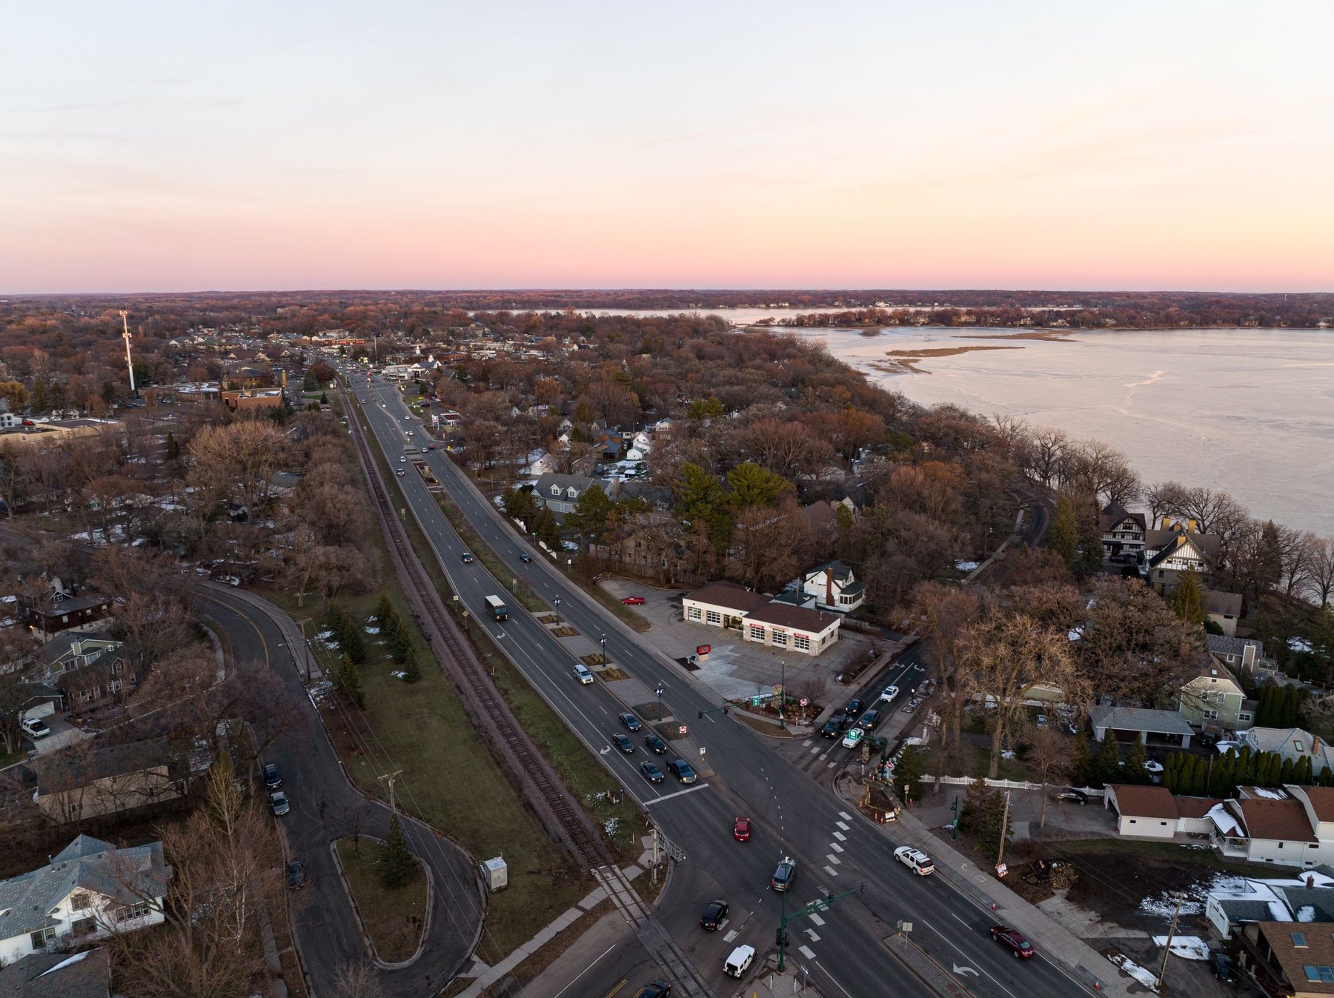
4561 Lake Avenue — Aerial view of building, drive lanes, and monument sign
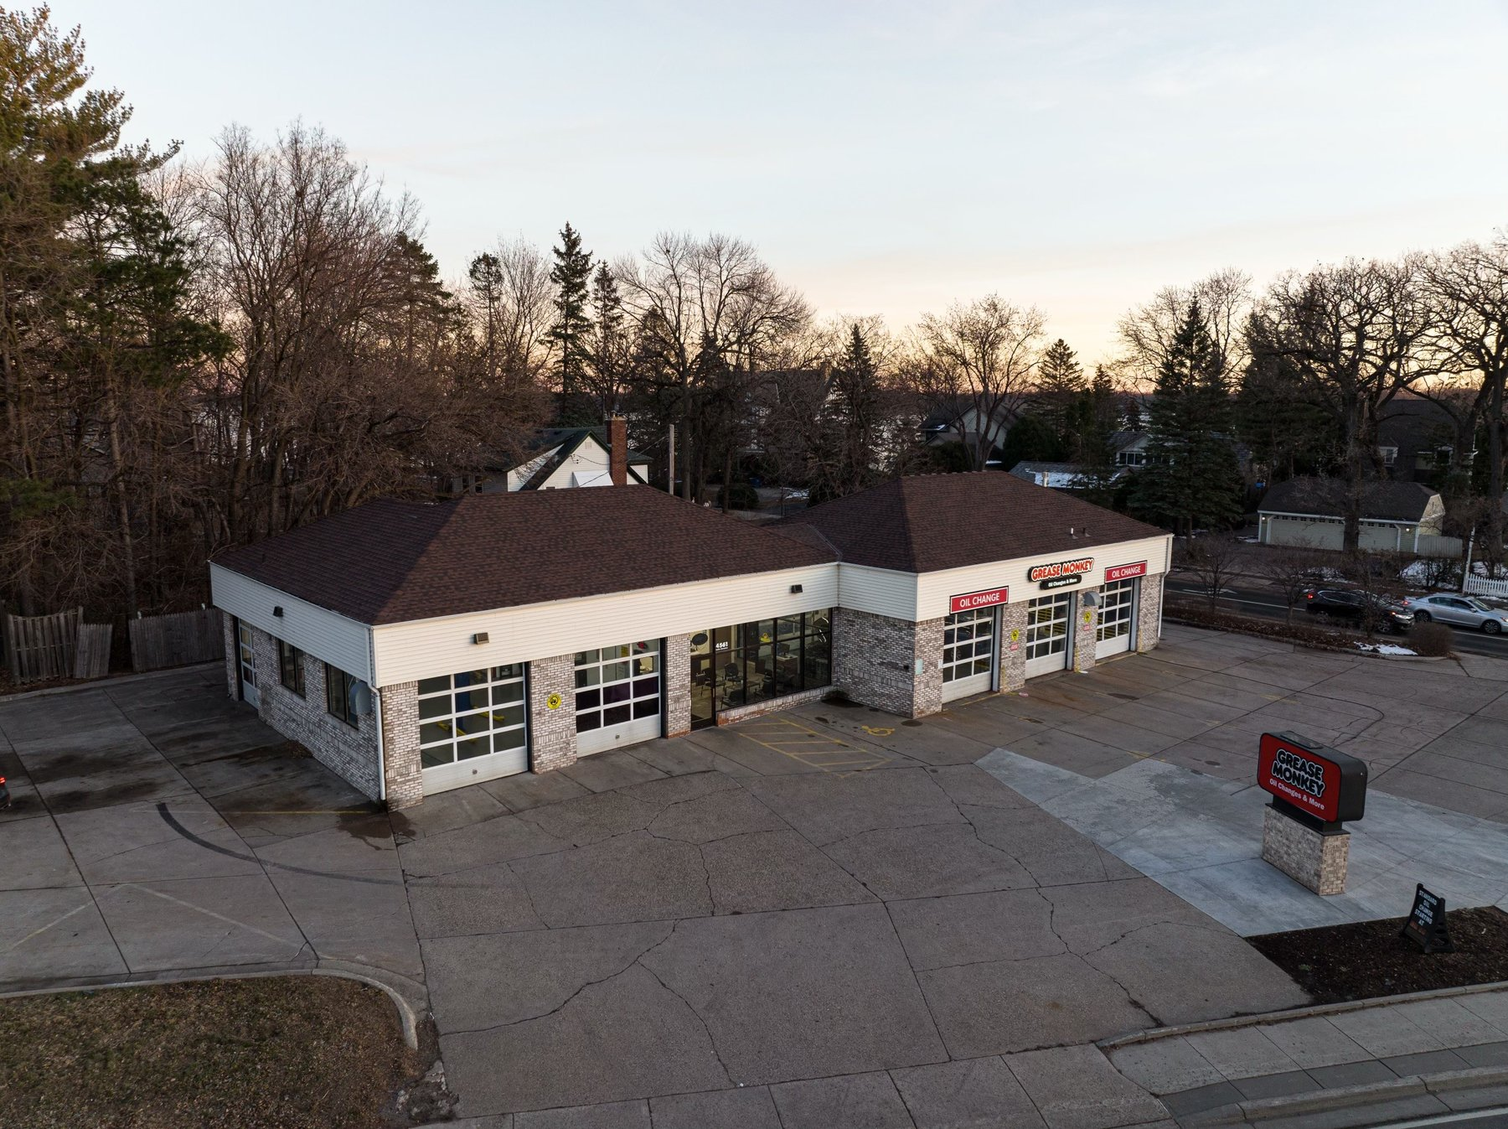
Lake Avenue frontage and drive access — White Bear Lake visible in background
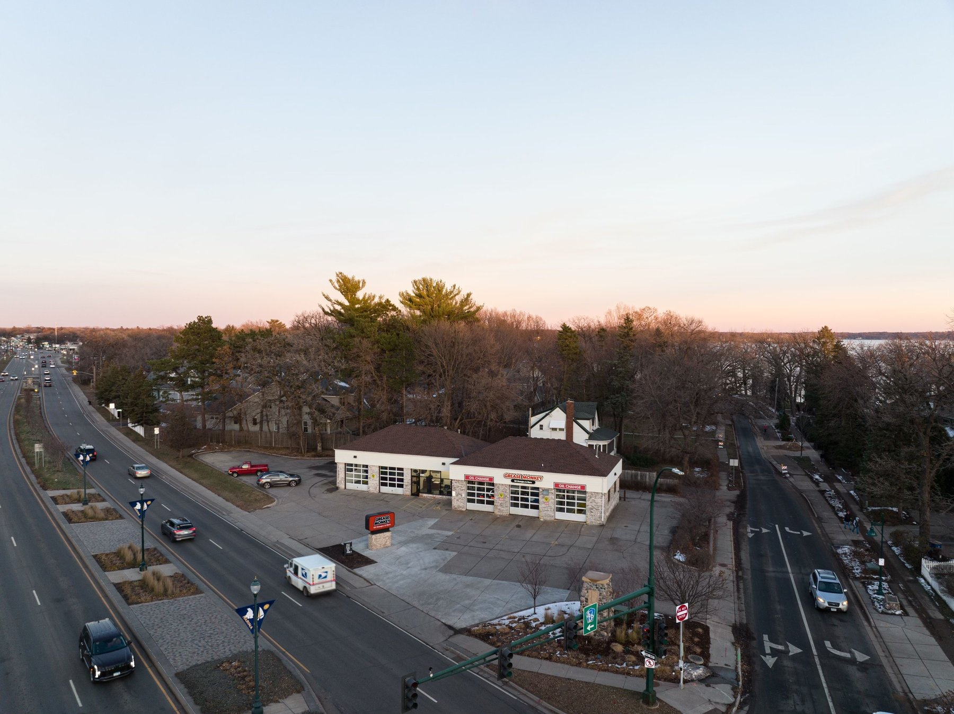
Submarket aerial — property at center, White Bear Lake in background

White Bear Lake — Community Profile
White Bear Lake is one of the Twin Cities’ most desirable suburban communities, offering a rare combination of lakefront character, strong household incomes, and established commercial demand. The following demographic profile reflects the resilience and purchasing power of the consumer base that drives foot traffic to this location.
Population & Households
White Bear Lake (city) has a population of approximately 24,000 residents within an established, fully built-out suburban footprint. The broader trade area within a 5-mile radius encompasses over 120,000 residents, providing a deep and consistent consumer base. Household formation in the area remains stable, supported by the community’s reputation as one of Ramsey County’s premier residential destinations.
Household Income & Consumer Spending
The median household income in White Bear Lake exceeds $72,000, meaningfully above national averages and consistent with the northeastern Twin Cities’ suburban income profile. Average household incomes in the 3-mile trade area approach $90,000 — a demographic that actively maintains multiple vehicles and represents the core customer for quick-lube and preventive maintenance services. Higher-income households own newer and more vehicles on average, sustaining per-ticket revenue and service frequency.
Vehicle Ownership & Traffic
Suburban Minnesota households average well above 2 vehicles per household, driven by limited public transit alternatives and the region’s commuter geography. Lake Avenue is a primary arterial serving White Bear Lake’s commercial core, with traffic counts exceeding 18,000 vehicles per day — providing the Grease Monkey location with high daily visibility and drive-by capture from the surrounding residential base. The site’s corner positioning at a signalized intersection maximizes both inbound traffic flow and accessibility.
Community Character & Market Stability
White Bear Lake is named for one of Minnesota’s most recognized lakes, and the community’s lakefront identity drives a distinctive residential quality and civic pride that anchors long-term stability. The area features high homeownership rates, a strong independent business community along its downtown corridor, and a well-regarded public school system — all factors that support low residential turnover and a stable, entrenched consumer base. The commercial environment along Lake Avenue benefits from this community permanence: residents return to trusted local service providers year after year, making quick-lube a particularly durable use in this context. White Bear Lake consistently ranks among the Twin Cities’ most livable suburban communities — a designation that supports property values, retail demand, and long-term submarket health.
Offering Process
How to Proceed
Entheos Commercial Real Estate has structured a streamlined acquisition process designed to minimize friction for qualified buyers:
- Step 1: Contact Curtis Romano to express interest and receive the property overview – 952-270-8363
- Step 2: Submit a Letter of Intent (LOI) with proposed price and terms — lease abstract and rent schedule provided upon LOI execution
- Step 3: Negotiate and execute the Asset Purchase Agreement (APA)
- Step 4: Full due diligence package released upon APA execution
- Step 5: Complete buyer's independent due diligence during the inspection period
- Step 6: Close
There is no NDA requirement to receive initial property information or to submit an LOI. Qualified buyers may engage directly with the listing broker to advance the process.

Broker / Owner Disclosure
In accordance with applicable Minnesota real estate licensing laws and professional standards, the following disclosure is provided:
Curtis Romano, Investment Sales at Entheos Commercial Real Estate, is both the listing broker and the owner of the property being offered for sale. This dual role creates an inherent conflict of interest that all prospective buyers should consider. Curtis Romano is acting in his capacity as seller and is represented by Entheos Commercial Real Estate in this transaction. Buyers are encouraged to retain independent legal and real estate counsel to represent their interests in connection with any purchase of this property.
All information contained in this Offering Memorandum is provided in good faith and is deemed reliable, but is not guaranteed. Buyer to verify all information independently.
Confidentiality & Disclaimer

This Offering Memorandum has been prepared by Entheos Commercial Real Estate for informational purposes only and is intended solely for the use of prospective qualified investors. The information herein has been obtained from sources deemed reliable; however, no representation, warranty, or guarantee — express or implied — is made as to its accuracy or completeness.
All financial projections and pro forma figures are illustrative and based on assumptions that may not materialize. The property is offered subject to prior sale or withdrawal from the market without notice. All buyers are encouraged to conduct their own independent due diligence including legal, financial, and physical inspections. This document contains confidential information and is not to be reproduced or distributed to any third party without the prior written consent of Entheos Commercial Real Estate.

CONTACT
ENTHEOS COMMERCIAL REAL ESTATE
Investment Sales | Minneapolis-St. Paul Metro
Curtis Romano
952-270-8363
curtis@entheoscommercial.com
www.entheoscommercial.com

All information deemed reliable but not guaranteed. Buyer to verify. Subject to prior sale or withdrawal without notice.

