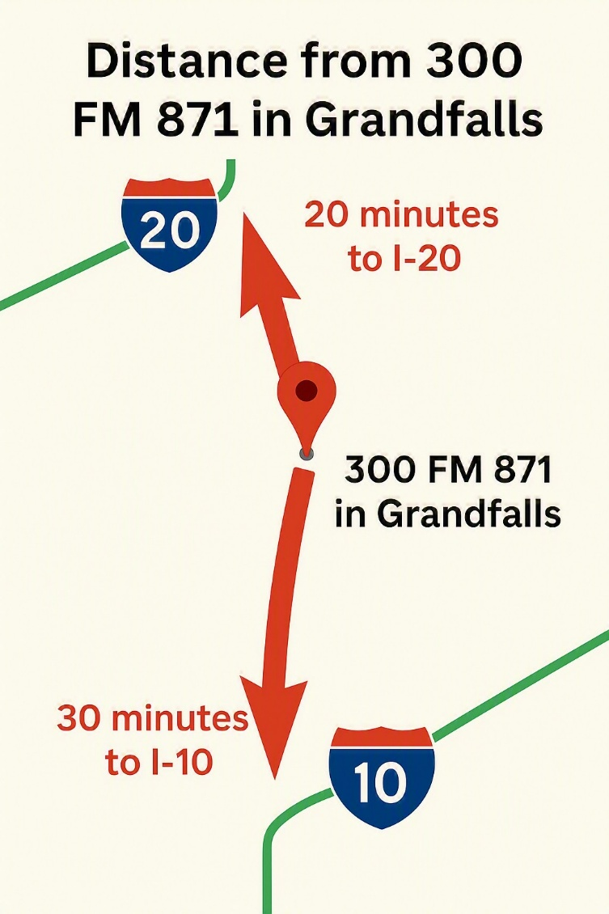
Congue nihil imperdiet doming id quod mazim placerat facer minim veni am ut wisi enim ad minimeniam, quis erat nostr uexe
rci tation ullamcorper nostru exerci tation ullam corper et iusto odio dig nissim qui blandit praesent lupta. Tummer delenit
augue duis dolore te feugait nulla facilisi. Con erattis sectetuer adip iscing elit, sed erat diam nonummy nibh magna erat.
Your Neighborhood Specialist
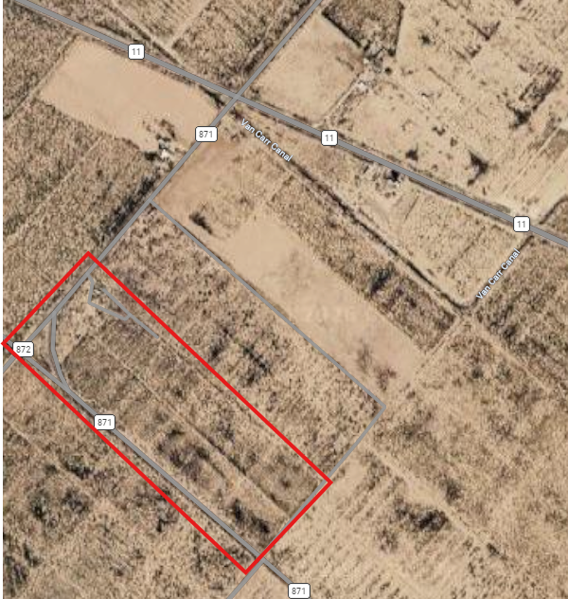
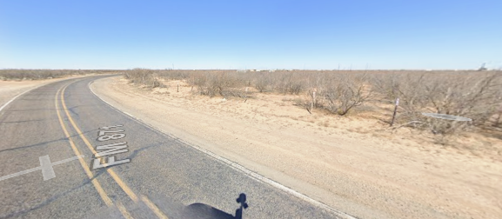
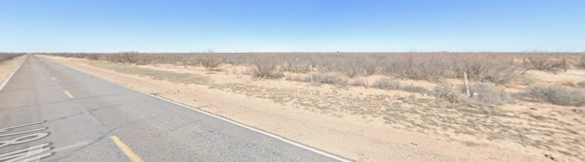

Low operational costs with access to critical transportation
Contact
Jimmy Williams
Phone: 806-239-9527
Email: jwilliams7869@yahoo.com
Asking Price:
$595,000
- Paved Access and Available Utilities

- Located between major corridors (I-10 and I-20)

- Ready for immediate use / development

- Fully usable, flat land

- Flexible use, outside of city limits

- State-maintained paved FM frontage road on two sides of the property, maximizing pavement access

Positioned in the core of the Permian basin, this 50-acre tract delivers direct access to the two major interstate corridors, making it highly attractive for industrial users, logistics operators, and energy service companies. The property combines paved access, available utilities, and development-ready terrain – creatin immediate usability and long-term upside.
Acceptional Access & Development Potential
Premium Permian Basin Opportunity
- 50 Acres

