Total Space Available:
805 SF
Rental Rate:
$20/SF/Year
Property Type:
Medical/Office
Building Size:
24,600 SF
Building Class:
A
Lot Size:
2.52 AC

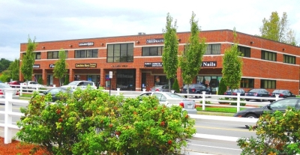

Professional Office/ Medical space in well maintained building. Partially built out as medical space. 4 Offices, Kitchenette and waiting room.

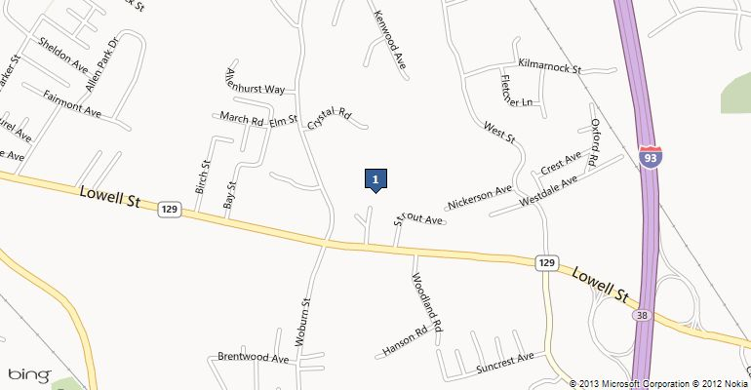

230 Lowell St, Wilmington, MA 01887

Centrally located less than 1 mile
from Rt 93,
3 miles to the intersection of
Rt 93/128 (95), and
9 miles to the intersection of
Rt 93/495.

For Lease:
Office/Medical
Space

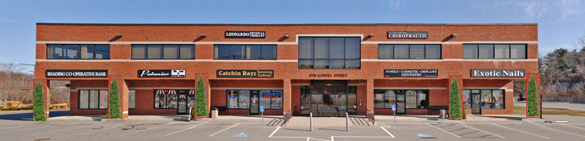

230 Lowell St, Wilmington, MA 01887

Carol King and John Lucci
Lucci Realty Trust
Wilmington, MA 01887
john@luccismarket.com
(978) 658-8086

L U C C I R E A L T Y T R U S T

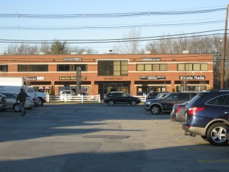

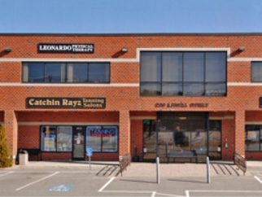

SPACE 1:
1st Floor / Unit
Space Available: 805 SF
Rental Rate: $20/SF/Year
Space/Lot Type: Medical/Office
Date Available: 2023
Lease term: 3-5 Years

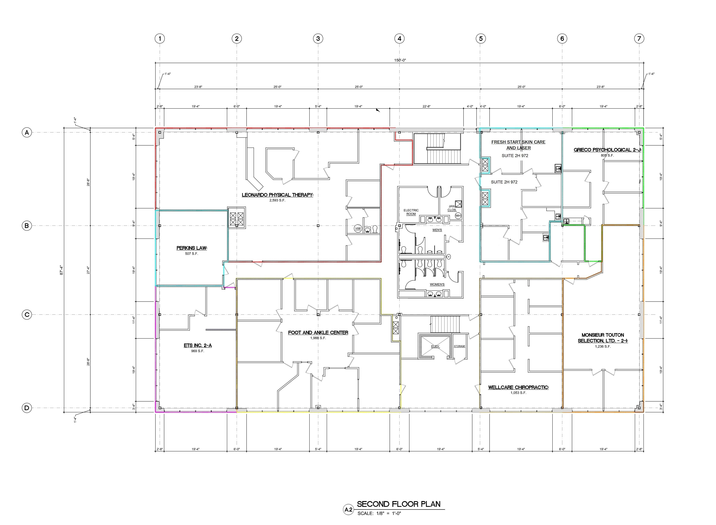

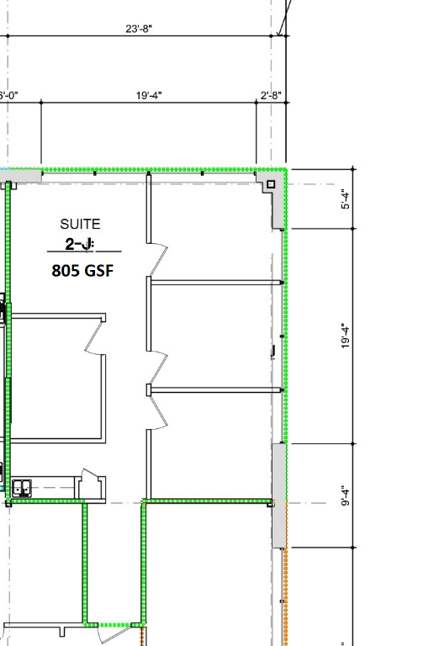

Utilities Included
CAM included
RE Taxes Included
Expense 100% of your lease.
Free parking.

