Building For Sale
211 Roanoke Ave, Riverhead

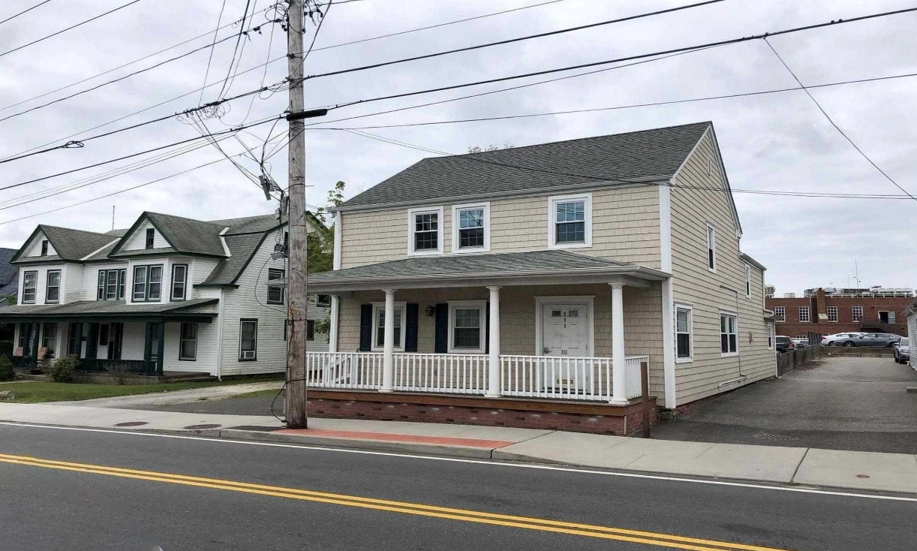

Price $ 650,000
- 2 Story Office Building
- 0.14 Acres
- Building Size: 2,437 SF
- Zoning: Downtown Center 3 (DC-3), many uses allowed
- Taxes: $14,702
- 8 Private Parking Spaces, On Street & Municipal parking across the street
- Public Sewer & Water, Natural Gas, 2 Electric Meters
- Close Proximity to Main Street in Downtown Riverhead

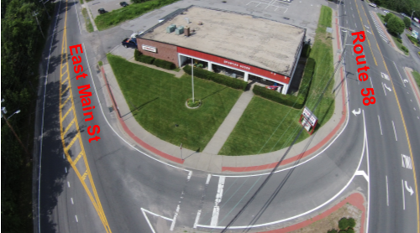
Exclusive Broker
Richmond Realty Corp
889 Harrison Ave, 2nd FL Office: 631-727-5500
Riverhead, NY 11901 Fax: 631-727-5545
www.RichmondRealtyCorp.com
Richmond Realty Corp www.richmondrealtycorp.com 631-727-5500
Located on Roanoke Ave
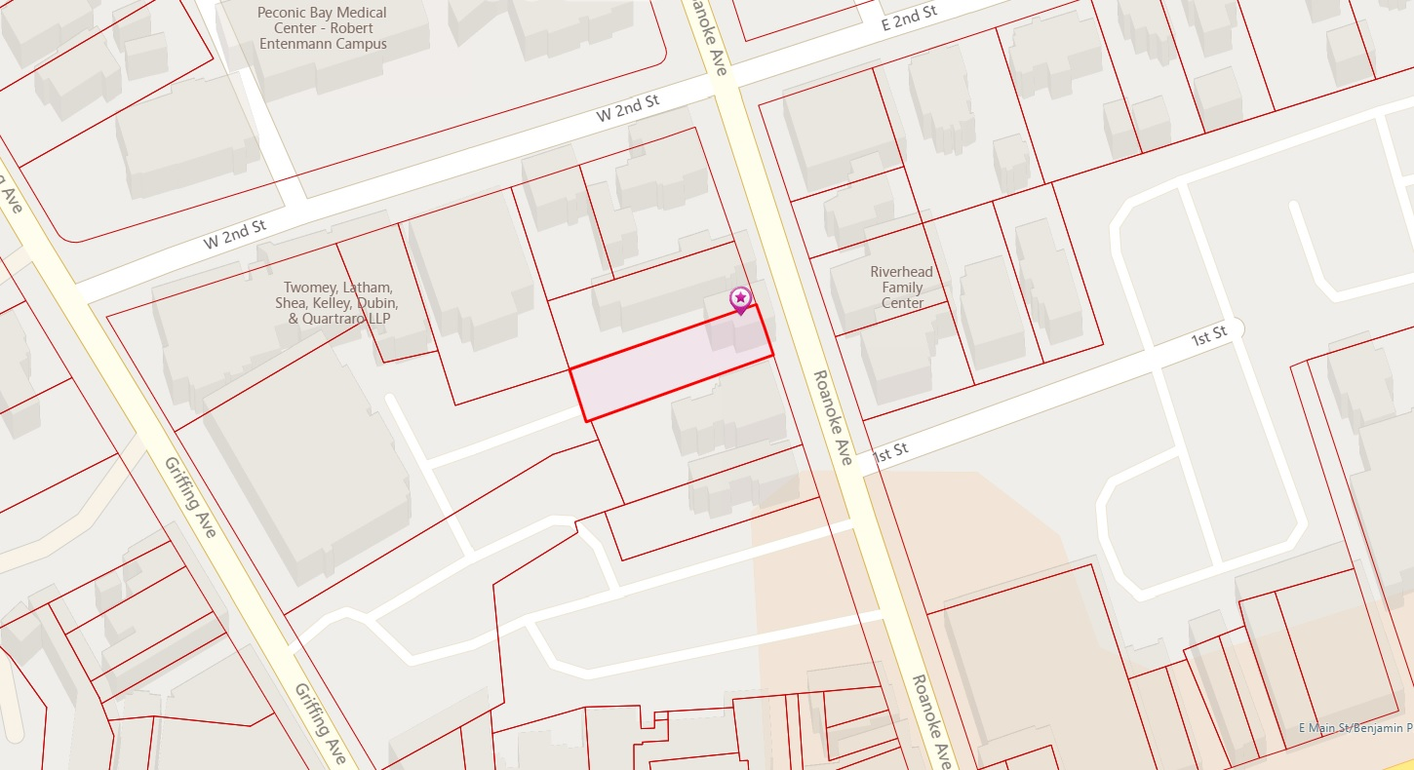
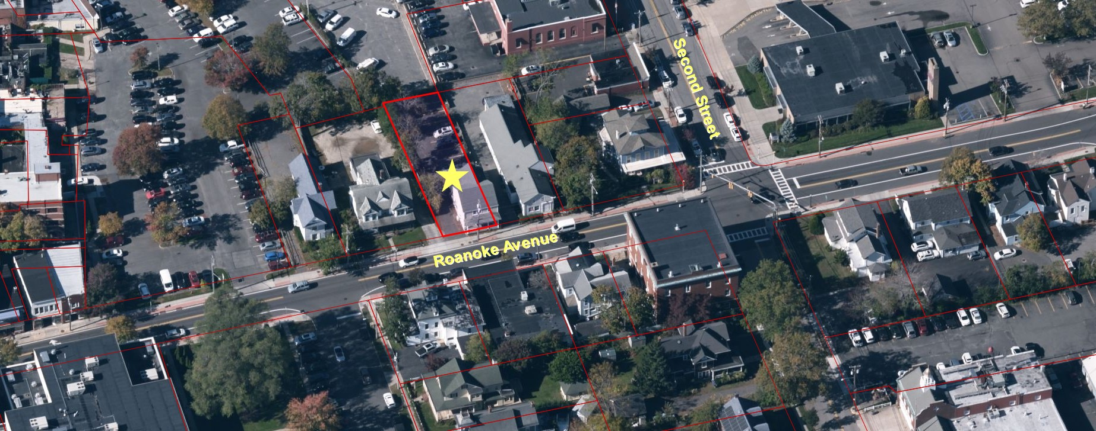
2
Richmond Realty Corp www.RichmondRealtyCorp.com 631-727-5500
211 Roanoke Ave Survey
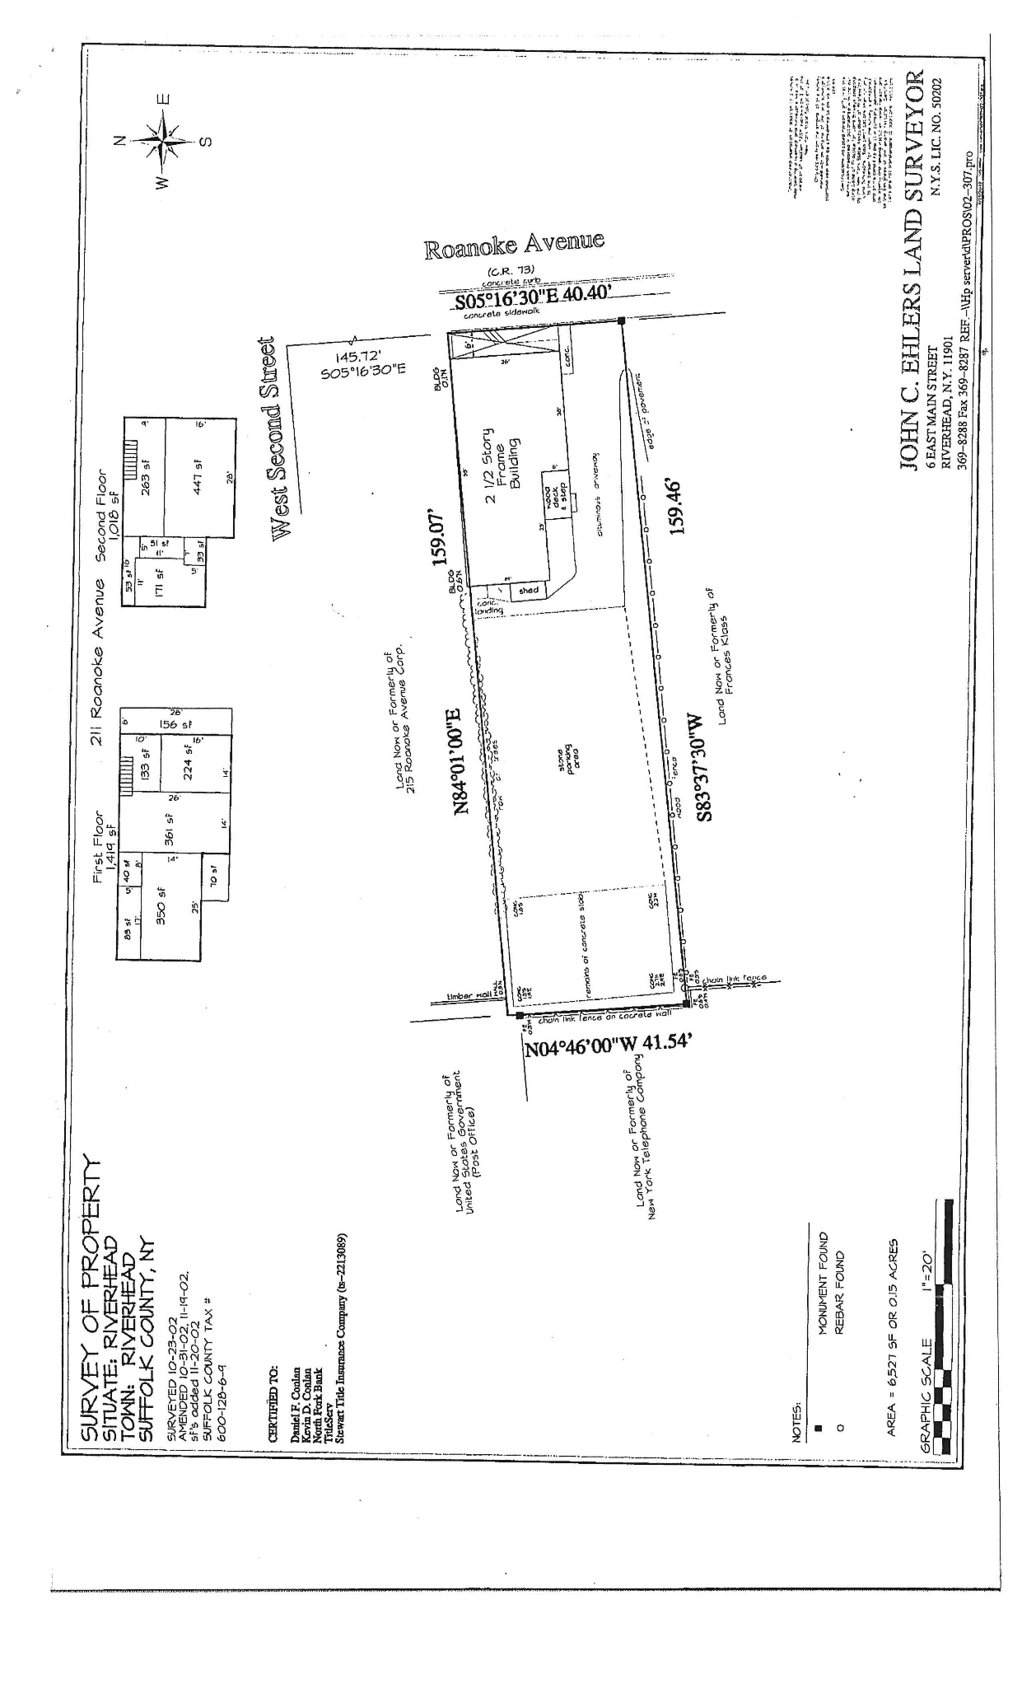
3
Richmond Realty Corp www.RichmondRealtyCorp.com 631-727-5500

211 Roanoke Ave Floor Plans
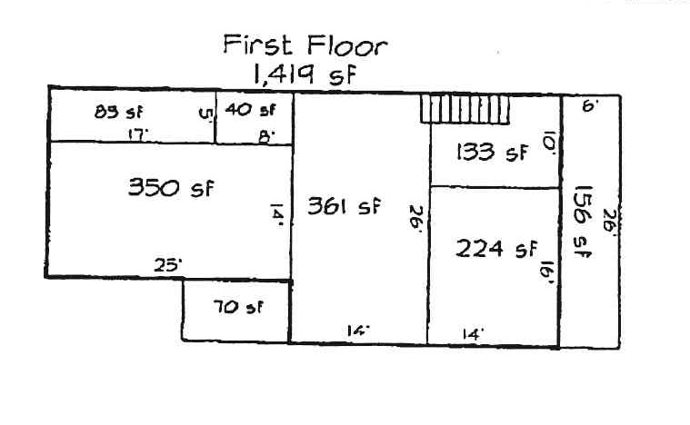
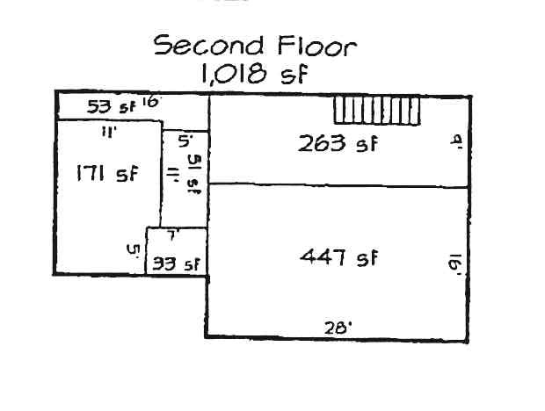
4
Richmond Realty Corp www.RichmondRealtyCorp.com 631-727-5500

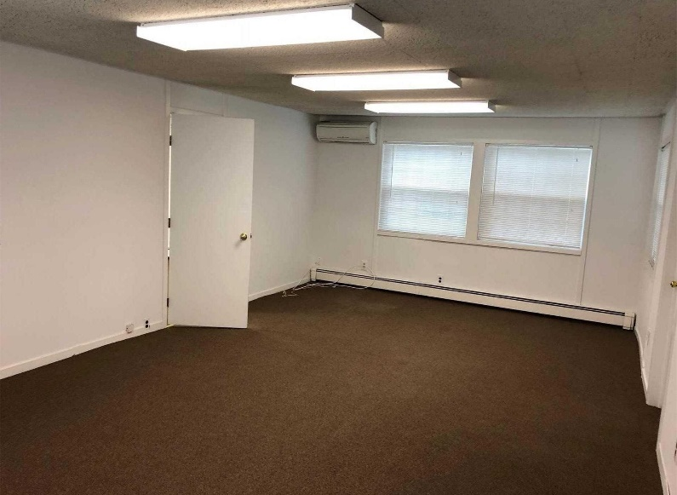
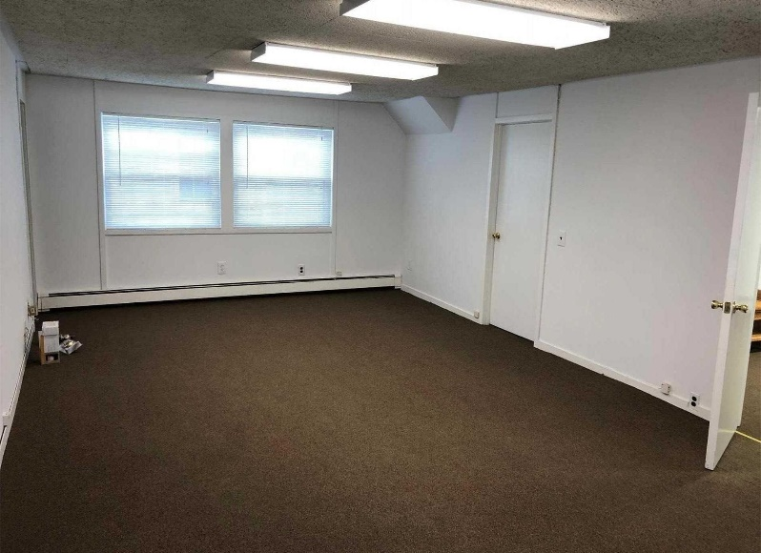
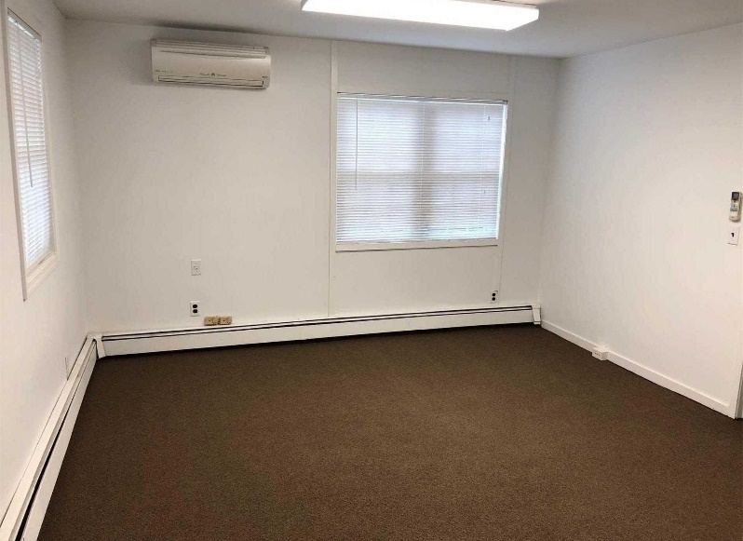
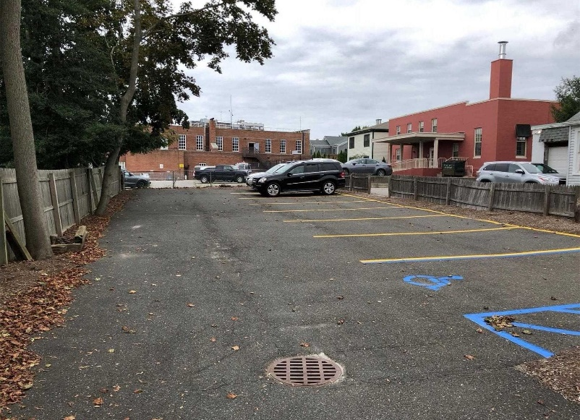
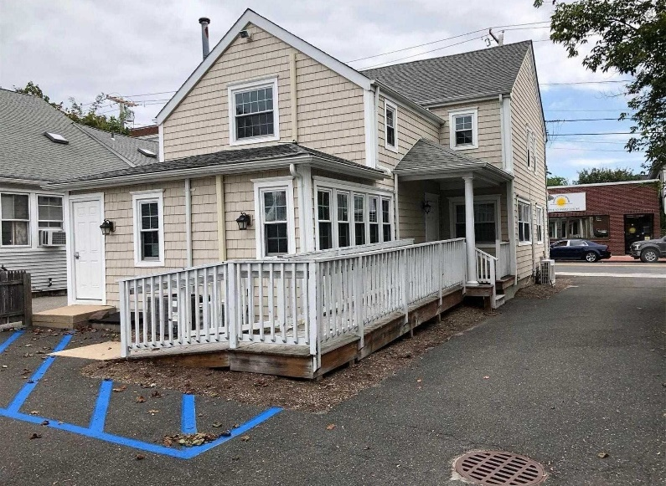
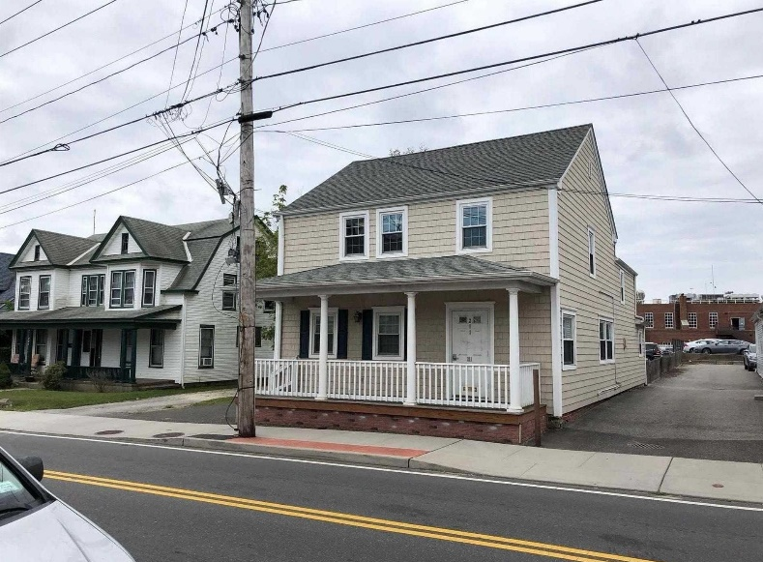
211 Roanoke Ave Pictures
5
Richmond Realty Corp www.RichmondRealtyCorp.com 631-727-5500

Zoning- Downtown Center 3 (DC-3)
6
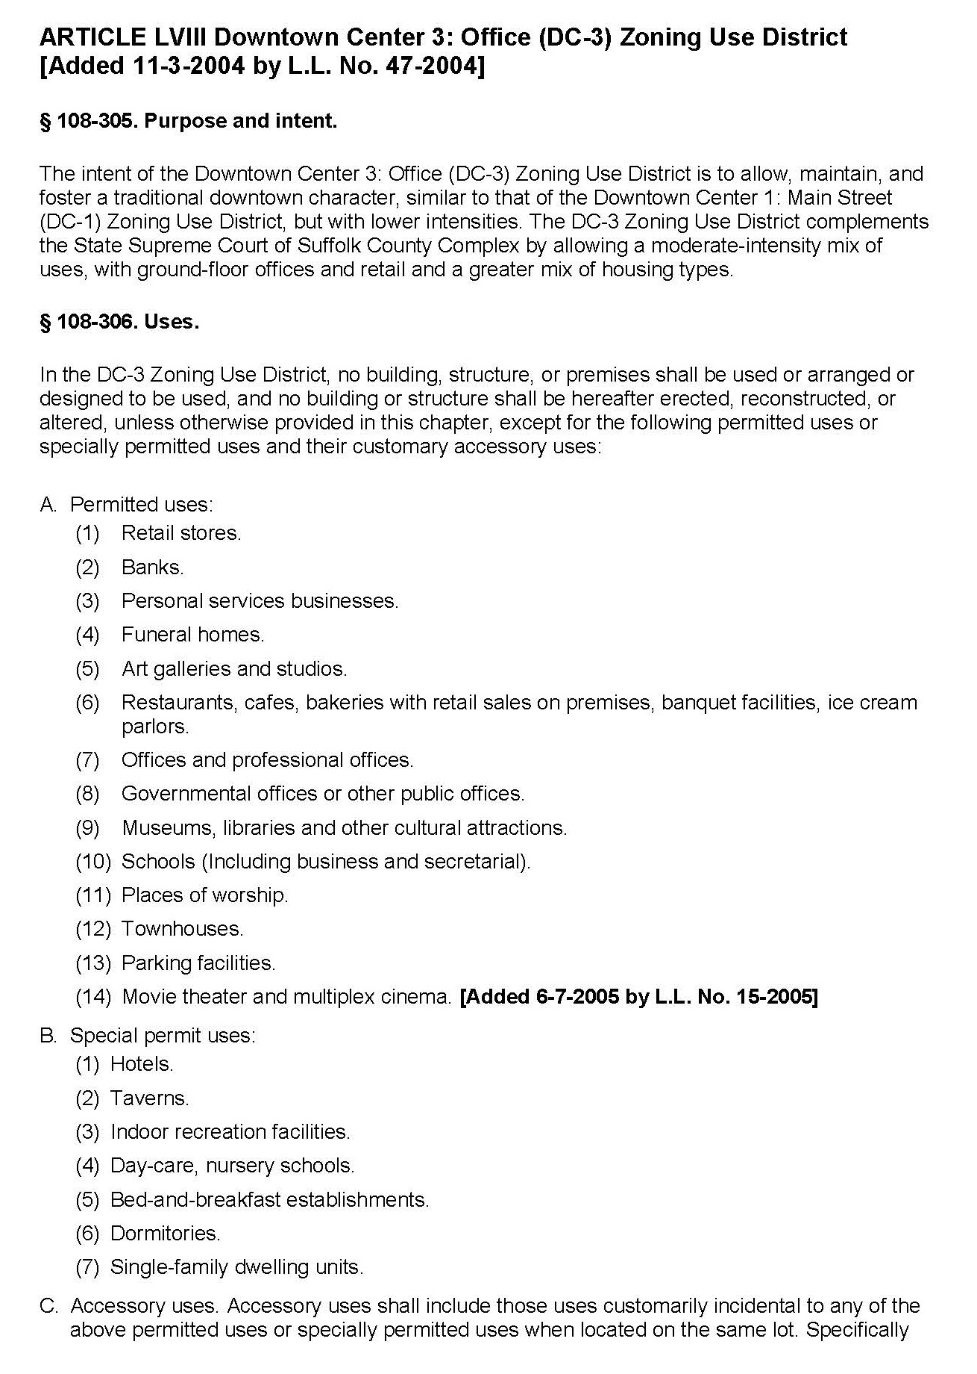
Richmond Realty Corp www.RichmondRealtyCorp.com 631-727-5500

7
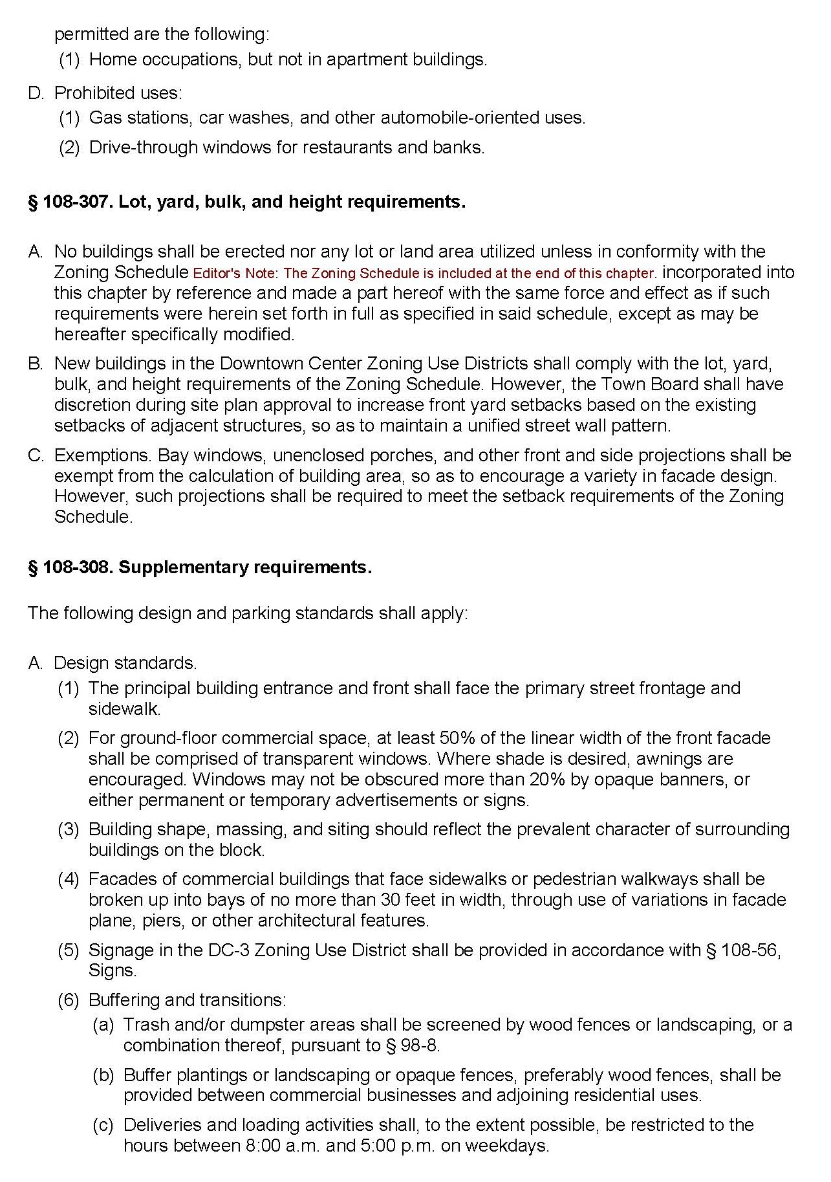

Richmond Realty Corp www.RichmondRealtyCorp.com 631-727-5500

7
6
Richmond Realty Corp www.RichmondRealtyCorp.com 631-727-5500

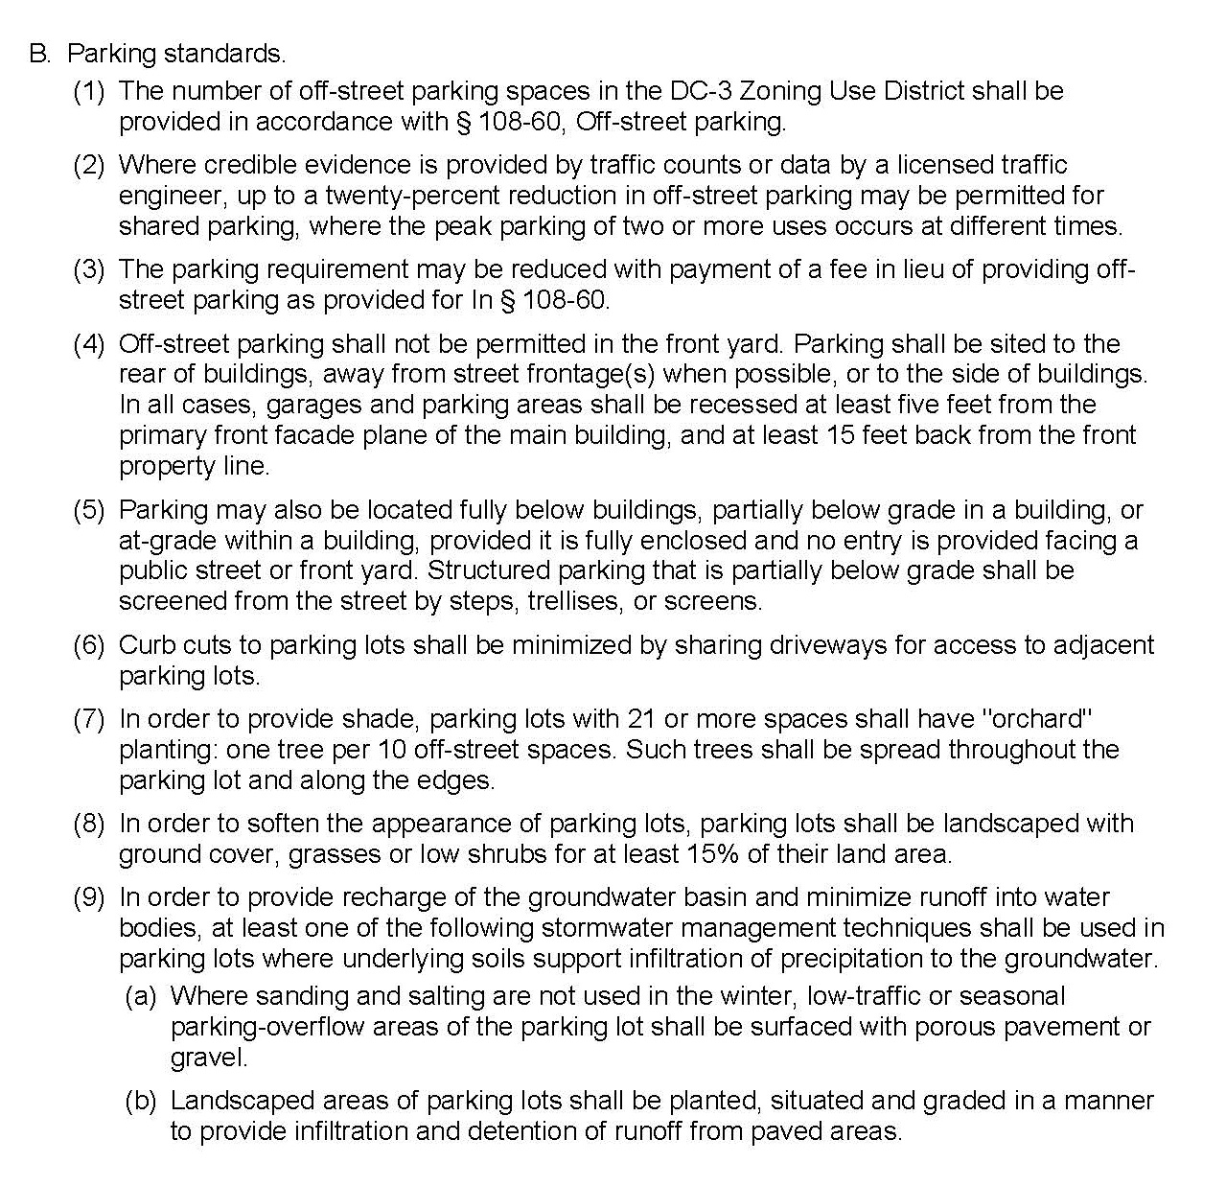
8
Richmond Realty Corp www.RichmondRealtyCorp.com 631-727-5500

211 Roanoke Avenue, Riverhead

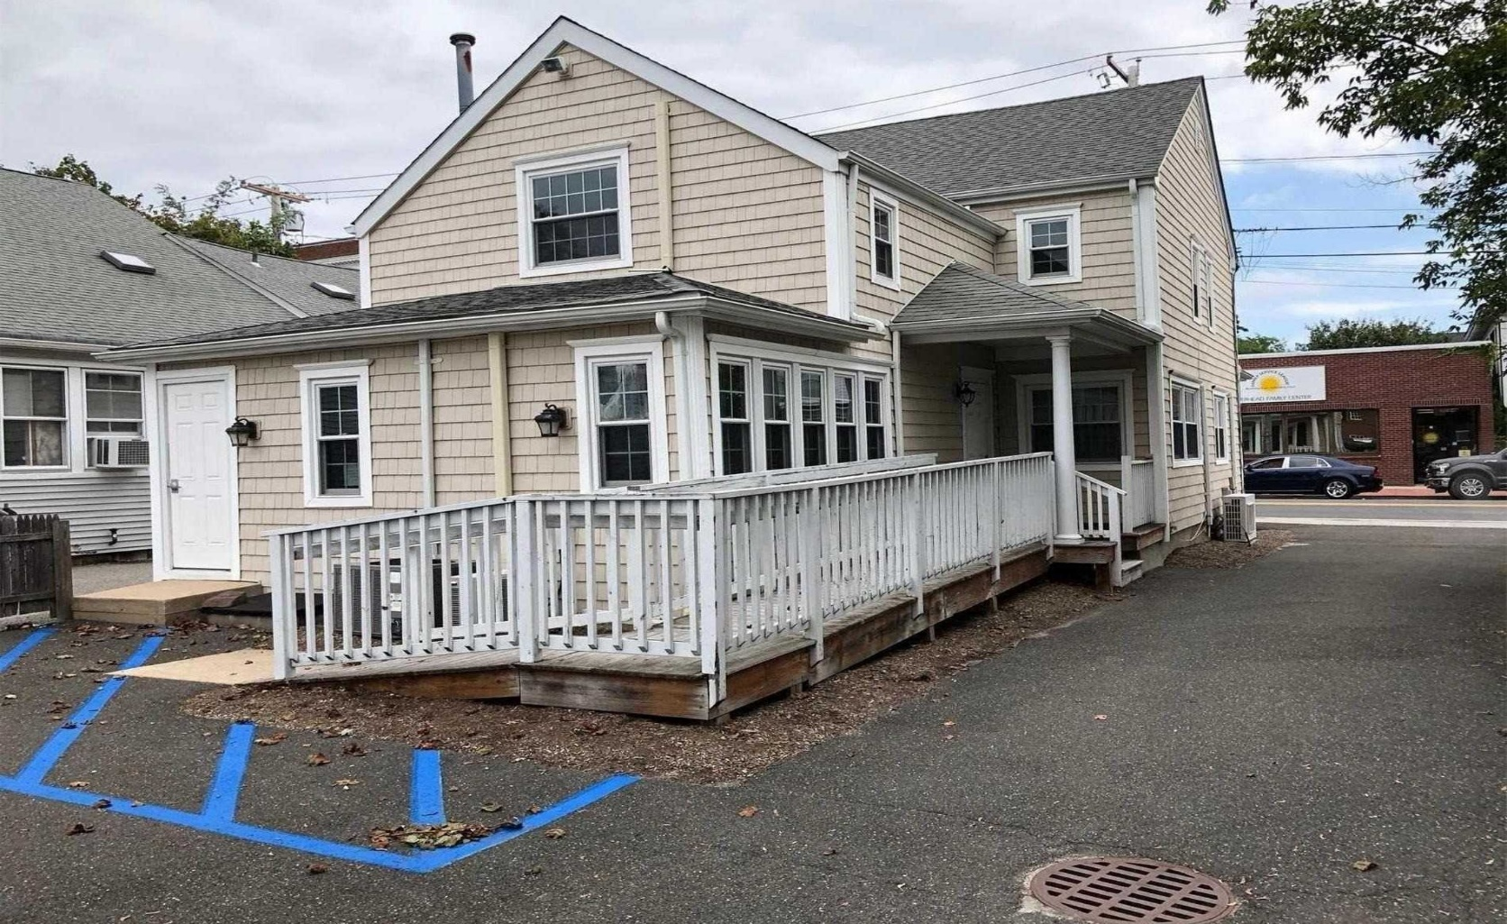


9
Richmond Realty Corp
Isaac Israel, Listing Agent Cell: 631-902-5202
889 Harrison Ave, 2nd FL Office: 631-727-5500
Riverhead, NY 11901 Fax: 631-727-5545
Ike@RichmondRealtyCorp.com

www.RichmondRealtyCorp.com
The information contained herein was obtained from sources deemed reliable and is believed to be true, it has not been verified as such cannot be warranted nor form any part of any future contact.

