

PRIME MIAMI COMMERCIAL REDEVELOPMENT OPPORTUNITY
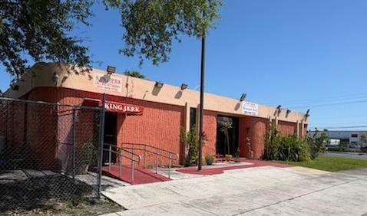
For Sale $4,000,000
161 NE 183rd St
Miami, Fl 33179

TWO PARCEL CORNER LOCATION ENDLESS POSSIBILTIES

Unlock the potential of one of North Miami's most strategic commercial redevelopment opportunities.
Positioned on a highly visible corner with approximately 153 feet of frontage along NE 183rd Street, this rare two-parcel assemblage offers investors, developers, and owner-users the flexibility to capitalize on one of Miami-Dade's busiest commercial corridors. The offering includes an existing 4,905-square-foot commercial building plus an adjacent parcel that significantly enhances parking, expansion, or future redevelopment potential.
- Rare two-parcel assemblage
- Major corner location with exceptional visibility
- Minutes from I-95, Florida's Turnpike, SR-826, and the Golden Glades Interchange
- Existing income-producing commercial structure
- Additional parcel provides valuable parking or redevelopment flexibility
- BU-1A zoning supports a broad range of commercial uses
- Potential mixed-use redevelopment opportunity utilizing Florida's Live Local Act incentives (subject to approvals)
- Located within a densely populated trade area serving nearly 200,000 residents within three miles.
- One Property. Two Parcels. Unlimited Potential
- Corner Commercial Assemblage with Exceptional Redevelopment Upside
- Prime Miami Development Opportunity in a High-Traffic Corridor
- Location. Visibility. Flexibility. Opportunity
Endless Possibilities
- Medical Office Campus
- Urgent Care or Specialty Medical Facility
- Retail Plaza
- Professional Office Complex
- Church or Religious Facility
- Childcare / Educational Center
- Fitness Studio
- Banquet & Event Venue
- Mixed-Use Residential / Commercial Development
- Investment Hold with Future Redevelopment Potential

Location Matters
This property sits in the heart of the Golden Glades/North Dade market with immediate access to South Florida's major transportation network, placing millions of consumers within easy reach.
Whether you're an investor seeking value-add potential, a developer pursuing your next mixed-use project, or a business looking for a flagship location, this unique assemblage offers the location, flexibility, and upside rarely available in today's South Florida market.

Parcel 1
The subject property is a freestanding commercial building primarily used for entertainment and social gatherings.
- Address: 161 NE 183rd Street, Miami, FL 33179
- Property Type: Commercial (Nightclub / Lounge / Banquet Hall)
- Building Size: ± 4,905 SF
- Lot Size: ± 16,956 SF (0.39 Acres)
- Year Built: 1972
- Parcel ID (APN): 30-2101-022-0100
- Subdivision: Abbott Acres
- Zoning: BU -1A (Limited Business)

- 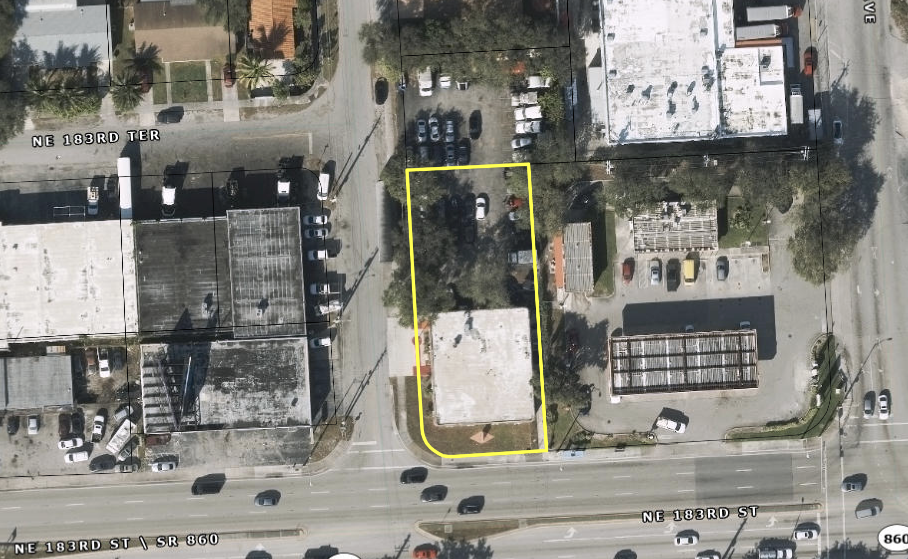

Parcel 2
- Property Type: Vacant lot
- Lot Size: ± 8767 SF (0.20 Acres)
- Parcel ID (APN): 30-2101-022-0200
- Subdivision: Abbott Acres
- Zoning: RU 2 (Two Family Residential/ Parking)
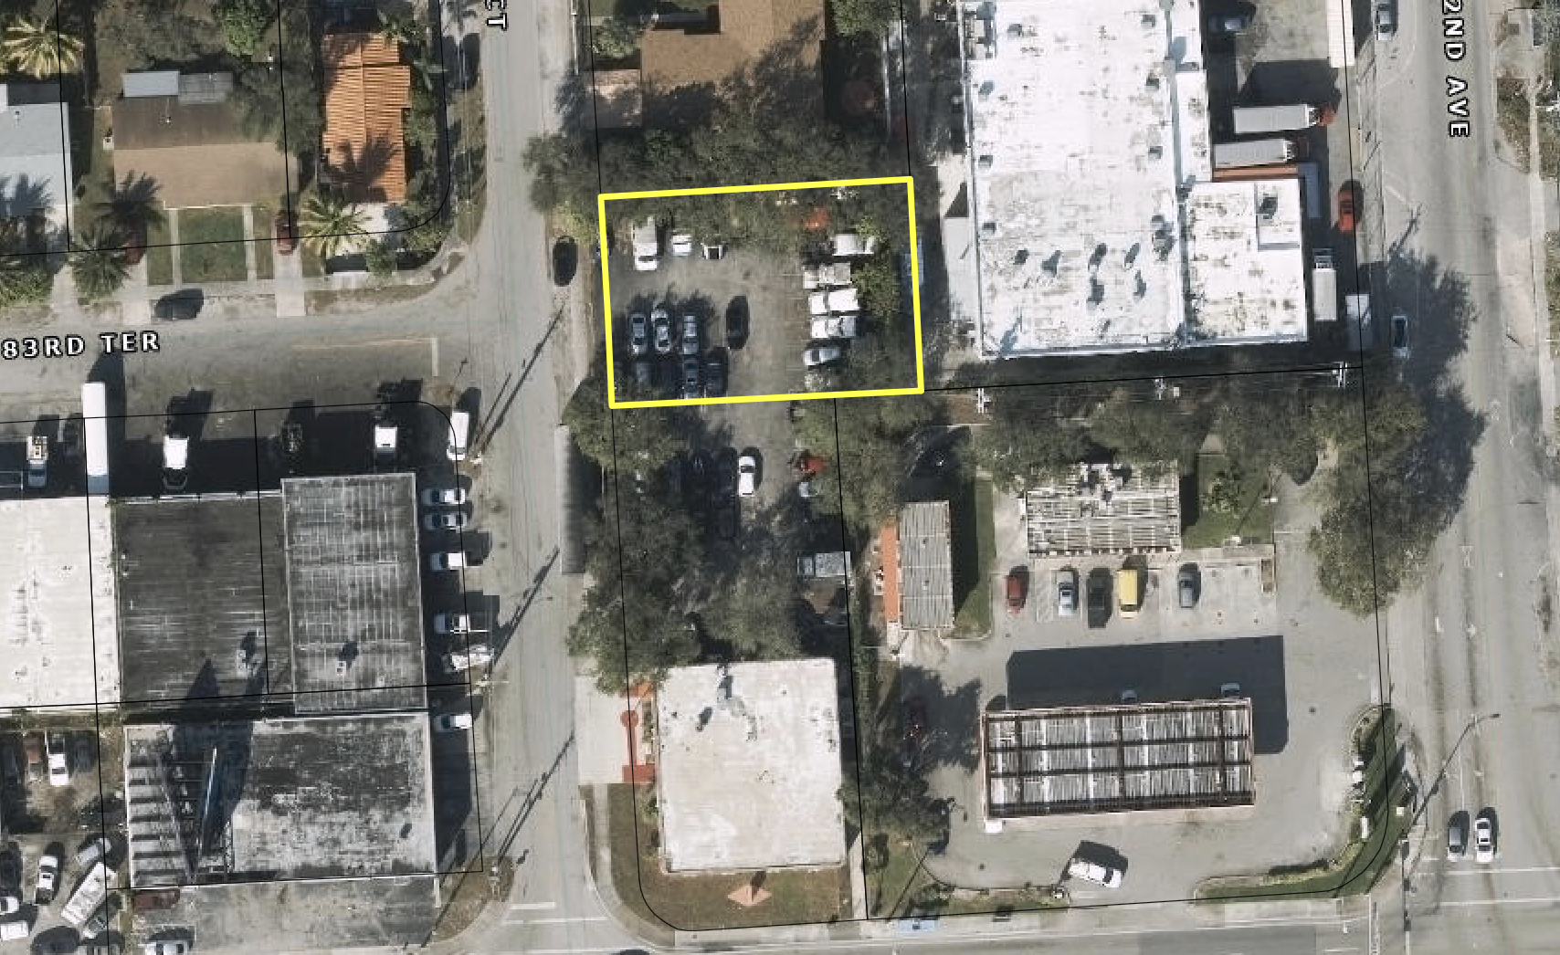
The property is situated in the Golden Glades / North Dade area, a high-traffic corridor with excellent access to major South Florida arteries.
- Transit Access: Immediate proximity to the Golden Glades Interchange, connecting I-95, Florida's Turnpike, and SR-826 (Palmetto Expressway).
- Walkability: Walk Score of 66/100 (Somewhat Walkable).
- Neighborhood: The surrounding area features a mix of residential communities (Cloverleaf Estates, Pickwick) and commercial retail along 183rd Street (Miami Gardens Drive).

Zoning Implications (BU-1A)
The BU-1A Limited Business District is designed to satisfy the essential needs of adjacent residential neighborhoods.
- Retail & Service: All uses permitted in BU-1 (Neighborhood Business), plus more specialized facilities.
- Hospitality/Entertainment: Restaurants, cocktail lounges, and banquet halls are permitted (subject to specific distance and beverage regulations).
- Enclosed Requirement: All permitted uses must be conducted within completely enclosed buildings. Storage of materials must also be within an enclosed area.

Zoning Implications (RU-2)
The RU-2 (Two-Family Residential District) zoning for Parcel 2 introduces specific constraints and opportunities for the total assembly:
- Permitted Uses: Primarily allows for single-family homes or duplexes.
- Commercial Interaction: Since this parcel is adjacent to a BU-1A (Commercial) zone, it acts as a buffer.
- Parking Restrictions: Under standard Miami-Dade code, using RU-2 land for commercial parking for the banquet hall usually requires a non-use variance or a "Special Exception" through a public hearing.
- Setback Requirements: Because Parcel 1 (Commercial) abuts Parcel 2 (Residential), Parcel 1 must adhere to stricter "residential adjacency" setbacks, including a 5-foot masonry wall along the property line.
SEE APPENDIX FOR MUNICODE

Market Demographics (3-Mile Radius)
- Population: 194,000
- Median Household Income: $51,542
- Owner-Occupied Housing: 56.6%
- Average Household Size: 2.9 persons

For further information Contact

Judith Marra Doug Shavel
201 396 7296 786 763 3050
Jmarra Doug
@signaturecommercialre.com @signaturecommercialre.com

DISCLAIMER
This information contained in the following Marketing Brochure is proprietary and strictly confidential. It is intended to be reviewed only by the party receiving it from Signature Commercial Real Estate, LLC and should not be made available to any other person or entity without the express written consent of Signature Commercial Real Estate, LLC.
The Marketing Brochure has been prepared to provide summary, unverified information to prospective purchasers, and to establish only a preliminary level of interest in the subject property. The information contained herein is not a substitute for a thorough due diligence investigation.
Signature Commercial Real Estate, LLC has not made any investigation, and makes no warranty or representation, with respect to the income or expenses for the property, the future projected financial performance of the property, the size and square footage of the property and improvements, the presence or absence of contaminating substances, PCB’s or asbestos, the compliance with State and Federal regulations, the physical condition of the improvements thereon, or the financial conditions of any tenant, or any tenant’s plans or intentions to continue its occupancy of the subject property.
The information contained in this Marketing Brochure has been obtained from sources we believe to be reliable; however, Signature Commercial Real Estate, LLC has not verified, and will not verify, any of the information contained herein, nor has Signature Commercial Real Estate, LLC conducted any investigation regarding these matters and makes no warranty or representation whatsoever regarding the accuracy or completeness of the information provide.
All potential buyers must take appropriate measures to verify all of the information set forth herein.

Appendix Zoning Information
BU- 1A ( Miami Dade Code of Ordinance)
Sec. 33-247. - Uses permitted.
No land, body of water and/or structure shall be used or permitted to be used, and no structure shall be hereafter erected, constructed, reconstructed, moved, maintained or occupied for any purpose in any BU-1A District, except for one or more of the following uses:
(1) All uses permitted in the BU-1 District, except that residential uses that are not part of a mixed-use development are subject to approval at a public hearing.
(1.1) Amusement center as defined in Section 33-1(5.1).
(2) Auditoriums.
(3) Automobile new parts and equipment, sales only. Notwithstanding the provisions of Section 33-251.2 to the contrary, as an ancillary service, a facility selling new automobile parts and equipment may perform minimal automobile maintenance repairs in that facility's on-site designated parking area, provided that all of the following conditions are satisfied:
(a) Such repairs are performed at no charge, solely as a courtesy for which no payment is charged or received;
(b) The sum of the repairs performed on an individual vehicle shall take no more than a total of twenty (20) minutes to perform;
(c) Such repairs shall not include oil changes, oil filter changes, transmission fluid changes, transmission fluid filter changes, engine coolant or engine anti-freeze changes, brake fluid changes, power steering fluid changes, tire repair, tire installation, tire rotation, or any other repair that falls within the scope of the repair certification categories set forth in Section 8A-161.25(2)(a)—(e) and (g) of this Code:
(d) The price(s) charged by the facility for automobile parts or equipment is not increased because of the performance of such repairs;
(e) The repairs are performed by an employee of the facility; and
(f) All residual, discarded, or waste products, parts, equipment, packaging, fluids, and other materials left over from such repairs are stored or disposed of by the facility immediately after the completion of the repairs, in compliance with all applicable laws, ordinances, and regulations governing the storage, handling, and disposal of such items.
(4) Automobile and light truck, new sales agency or rental shall be permitted only upon approval after public hearing and subject to the following conditions:
(a) That a continuous, densely planted greenbelt of not less than fifteen (15) feet in width, penetrated only at points approved by the Director and the Director of the Public Works Department for ingress or egress to the property, shall be provided along all property lines abutting public rights-of-way or properties zoned residential. Said greenbelt shall have shade trees planted at a maximum spacing of thirty (30) feet on center. The shade trees shall have a minimum caliper of two and one-half (2½) inches at time of planting.
(b) That a decorative masonry wall at least five (5) feet in height shall enclose the vehicle storage area and repair area approved through public hearing. The placement of said wall and openings through same shall comply with the requirements contained elsewhere in this article.
(c) That all outdoor paging or speaker systems are expressly prohibited.
(d) That no repair work of any type is permitted on premises unless approved after public hearing.
(e) That accessory used vehicle sales shall be permitted providing said vehicles are late model and in operable condition.
(f) That the applicant obtain a certificate of use and occupancy which shall be automatically renewable yearly upon compliance with all terms and conditions applicable.
(5) Automobile gas stations/mini marts (which may include facilities available for sale of other retail products and services related to the servicing of automobiles) including rental of single axle hauling trailers. Plans for paved areas, driveways or curb cuts of gas stations shall be submitted to and approved by the Department of Public Works and Waste Management and, where required, the Florida State Department of Transportation before a permit can be issued. Gas stations providing self-service dispensing of fuel with attendant control of pumps shall ensure that the attendant-control area has clear visibility to all pumps. The use of signs on windows of the attendant-control area that would obstruct the clear visibility to all pumps are prohibited. As an accessory use, the gas stations may perform minor automobile repairs as herein listed:
(a) Sale and servicing of spark plugs and batteries.
(b) Tire repair and servicing, but no recapping.
(c) Replacement of mufflers and tailpipes, water hose, fan belts, brake fluids, light bulbs, floor mats, seat covers, wiper blades, arms for windshields and replacement of grease retainers and wheel bearings.
(d) Radiator cleaning and flushing.
(e) Washing and polishing.
(f) Greasing and lubrication.
(g) Exchanging fuel pumps and installing fuel lines.
(h) Minor servicing or replacement of carburetors.
(i) Emergency wiring repairs.
(j) Adjusting brakes and installing or exchanging brake shoes.
(k) Tuning engines, with the exception of grinding valves, cleaning carbon or removing the head of engines and/or crankcases.
(l) Wheel balancing and aligning.
(m) Shock absorbers.
(6) Reserved.
(7) Automobile storage within a building.
(8) Automobile tires, batteries and accessories (new) retail only installation permitted.
(9) Automobile washing.
(10) Bait and tackle shops.
(11) Banks, including drive-in teller service.
(12) Billiard rooms and pool rooms.
(13) Boats carrying passengers on excursion, sightseeing, pleasure or fishing trips.
(14) Bowling alleys, provided that such establishments are not located closer than five hundred (500) feet to an RU, or EU District, unless such building is so constructed as to prevent the emission of sound and vibration.
(14.1) Brew Pubs (Restaurant, Pub, or Bar with a Brewery, Distillery, or Winery as Accessory Use), subject to the following conditions:
(a) Off-street parking for restaurant and other allowable uses shall be provided as otherwise required in this Code.
(b) The use complies with Article X (Alcoholic Beverages) of this chapter.
(c) In addition to a brewery, distillery, or winery as accessory use, a restaurant may also have an accessory cocktail lounge-bar use subject to the requirements of Article X of this chapter.
(15) Convention halls.
(16) Dancing halls or dancing academies in air conditioned buildings providing no intoxicating beverages of any kind are served, providing that such establishments are not located closer than five hundred (500) feet to an RU, or EU District, unless such building is so constructed as to prevent the emission of sound and vibration.
(17) Dog and pet hospitals in air-conditioned buildings.
(17.1) Donated goods centers, including drive-through drop-off facilities, for the acceptance and sale of new or used merchandise, excluding furniture and major appliances, upon compliance with the following conditions:
(a) The donated goods center must be operated by an organization which has been incorporated as a not-for-profit organization under the laws of Florida for a charitable purpose and which has been declared exempt from the payment of federal income taxes by the United States Internal Revenue Service;
(b) The donated goods must be accepted by personnel directly employed by or volunteers for the not-for-profit organization;
(c) The monetary proceeds resulting from the sale of said merchandise must be used in accordance with the organization's charitable purpose to benefit persons within the boundaries of Miami-Dade County or outside of Miami-Dade County to provide emergency relief for victims of natural, man-made or economic disasters;
(d) The operation of the donated goods center, the collection and use of donations and proceeds thereof must be conducted by said not-for-profit organization and not by a licensee, subtenant, subcontractor or agent of the not-for-profit organization;
(e) The merchandise sold in the donated goods center must be neatly sorted and displayed.
(18) Dry cleaning establishments, using noninflammable solvents in self-contained dry cleaning units of the Prosperity type or Dedrick type or an equal approved by the Director, provided such establishments contain not more than four thousand (4,000) square feet of floor area.
(19) Electrical appliance and fixtures stores including related repair shops.
(20) Employment agencies.
(21) Furniture stores, retail of new merchandise only.
(22) Grocery stores.
(22.1) Group residential facility, in accordance with the group residential facility requirements of Section 33-208.
(23) Handcrafted-products shop.
(24) Health and exercise clubs, including bath and massage parlors.
(24.1) Home improvement centers, subject to the conditions enumerated below. As used herein, a home improvement center is a facility engaged in the retail sale of a variety of home improvement products, including hardware, appliances, cleaning supplies, construction supplies, electrical and plumbing fixtures and supplies, paint and wall coverings, lumber, pool supplies, and tools as well as lawn and garden supplies. As an accessory use, a home improvement center may offer the short-term rental of tools, compressors, chain saws, ladders, post-hole diggers, hand trucks and similar light equipment as well as trucks (subject to the limitations set forth below). Additionally, a home improvement center may perform customer-requested cutting of pre-cut wood products and other products offered for sale, provided such cutting is done within the roofed area of the principal building.
(a) Lawn, garden and pool supplies may also be stored, displayed and sold from attached areas with or without a solid roof, subject to the following limitations:
(1) such storage, display and sales areas does not exceed 35 percent of the home improvement center's gross building floor area; and
(2) all such storage, display and sales areas must be enclosed by a solid masonry wall or ornamental metal picket fence or combination thereof, a minimum of eight feet in height. The items stored within these areas shall not exceed the height of the wall or metal picket fence. Openings for ingress and egress purposes, restricted to the narrowest width necessary, are permitted, subject to administrative site plan review; and
(3) setbacks as required for the principal building shall apply to all storage, display and sales areas; and
(4) parking for the home improvement center, including such storage, display and sales areas, shall be provided in accordance with Section 33-124(h)(3.1) herein.
(b) Notwithstanding paragraph (a) above, a display area may be established outside of an enclosure, after administrative site plan review, where:
(1) the display area abuts one of the building's walls;
(2) the display area is limited to no greater than 40 percent of the lineal building's frontage where the display area is located;
(3) displayed items are within 10 feet of the building; and
(4) all accessible pedestrian circulation is maintained.
(c) The rental of trucks for the convenience of customers purchasing items only shall be permitted at home improvement centers with greater than 100,000 square feet of gross floor area, subject to the following limitations:
(1) The total number of trucks available for rental shall not exceed five;
(2) The location of storage areas for rental trucks shall be subject to site plan review;
(3) Storage area for rental trucks shall not utilize any of the facility's minimum required parking spaces; and
(4) No repairs for maintenance of rental trucks shall take place on the premises.
(d) Loading dock facilities for the purpose of supplying the home improvement center shall be oriented away from adjacent residential zoning districts unless screened from view by a masonry wall of not less than six feet in height but not more than eight feet in height.
(e) Notwithstanding any other provision of this chapter to the contrary, during the time that a Local State of Emergency has been declared pursuant to chapter 8B and is in effect, products may be sold outside of enclosed buildings, provided that all of the following conditions are satisfied:
(1) Vehicular circulation is not interrupted.
(2) Accessibility parking spaces are not reduced.
(3) Outdoor sales are only conducted in the interior of the site and are oriented away from public rights-of-way.
(4) Outdoor sales areas do not encroach in any minimum setback areas.
(5) Tents or other membrane structures that are greater than 10' x 12' in size shall obtain a building permit.
(6) The outdoor sales end when the Local State of Emergency is terminated.
(f) Variances to these requirements are subject to section 33-311(A)(4)(b) for non-use variances.
(24.2) Jewelry loan centers, subject to the following conditions:
(a) As used herein, a jewelry loan center is a service offered at a jewelry store where a loan is secured by jewelry. Said jewelry loan center shall be ancillary to a jewelry store, and the loan center service shall cease if the primary use is discontinued.
(b) The operating hours for the jewelry loan center shall not extend beyond 8 p.m.
(c) No jewelry loan center shall be located less than twenty-five hundred (2,500) feet from a place of business having an existing, unabandoned, legally established jewelry loan center or pawnbroker. The twenty-five hundred (2,500) foot distance requirements shall be measured by following a straight line from the nearest entrance to the site where the business is located.
(d) Attention attracting devices, such as blinking or flashing lights, streamer lights, pennants, banners, streamers, and all fluttering, spinning advertising devices (either mobile or stationary), shall be prohibited, except as permitted under point-of-sale sign regulations.
(e) The jewelry loan center shall have all applicable licenses issued by the State of Florida for the jewelry loan center use, including demonstrating compliance with the requirements for a pawnbroker's license set forth in Chapter 539, Florida Statutes.
(f) A Certificate of Use shall be obtained and renewed annually. The Certificate of Use application shall contain:
(i) A certified spacing survey from a registered surveyor, which shall indicate that the distance requirements of this section have been met.
(ii) A site plan shall be submitted as part of the Certificate of Use indicating location of structure/structures, entrances and egresses, walls, fences, landscaping, signage and distance to nearest residential development. The use shall be established and maintained in accordance with the approved plan.
(25) Junior department stores.
(26) Lawn mowers, retail, sales and service.
(26.1) Medical observation dormitory as defined in Section 33-1(69.05) subject to the following conditions:
(a) That such uses on sites of ten (10) net acres or more shall be approved only after public hearing;
(b) That such uses shall be located on sites having frontage on a major access road, including major roadways (three (3) or more lanes) and frontage roadways serving limited access highways and expressways;
(c) Minimum five (5) foot high masonry wall be provided along all perimeter property lines abutting residentially zoned property, penetrated only at points approved by the Directors of the Planning and Zoning Department and the Public Works Department for ingress and egress;
(d) That the facility is located on a site consisting of at least three (3) or more net acres;
(e) That research conducted at the property shall be limited to testing of normal healthy volunteers and of clinically stable representatives of the diseased states for which medications being tested are ultimately intended;
(f) That protocols that require treating of mentally ill subjects, including persons with any mental or psychological disorder, such as intellectual disability, organic brain syndrome, emotional or mental illness, and specific learning disabilities, shall not be performed at the research facility;
(g) That such use shall be located no less than twenty-five hundred (2,500) feet from any other such establishments. For the purposes of this subsection, the distance shall be measured by following a straight line from the front door of the proposed place of business to the nearest property line of the existing place of business. For the purpose ofestablishing the distance between such establishments, the operator shall furnish a certified sketch of survey from a registered engineer or surveyor. Such sketch shall indicate the distance between the proposed place of business and any existing establishment within 2,500 feet. Each sketch shall indicate all such distances and routes. In case of dispute, the measurement scaled by the director shall govern;
(h) That the operator obtains an annually renewable certificate of use and occupancy for such use on the property.
(26.2) Mixed-use developments, provided that:
(a) Such uses are located along a SMART Plan Corridor and in accordance with the CDMP; and
(b) Such uses are developed in accordance with Article XLV.
(27) Mortuaries or funeral homes.
(28) Motorcycles sales and repair.
(29) Natatoriums.
(30) Open-air theaters.
(31) Package stores in shopping centers provided the shopping center is in full compliance with all provisions of Section 33-150(E)(9) of this Code.
(32) Pet shops, pet care centers and dog beauty parlors in air-conditioned buildings.
(33) Post office stations and branches, operated by postal service employees or agents, which directly serve the public.
(34) Printing shops.
(35) Private clubs.
(36) Propagating and growing plants for sale. Fertilizers, manure, compost and soil shall be limited for sale. Fertilizers, manure, compost and soil shall be limited in quantities for immediate use and shall be kept at least two hundred (200) feet from residential buildings in RU and EU Districts.
(37) Pubs and bars if approved at public hearing.
(37.1) Restaurants providing an accessory children's outdoor playground facility subject to the following requirements:
(a) The restaurant providing such an accessory use shall contain not less than two thousand five hundred (2,500) square feet of improved building area;
(b) The total outdoor playground area shall not exceed thirty-five (35) percent of the square footage of the subject restaurant structure;
(c) The playground equipment shall be the non-mechanical type and shall be designed and intended for children two (2) through twelve (12) years of age;
(d) The playground shall be immediately adjacent to, visible from, and accessible from the indoor patron area;
(e) The playground area shall be enclosed with a masonry wall or fence not less than four (4) feet in height and any gates shall be of the spring lock type, so that they shall automatically be in a closed and fastened position at all times;
(f) The playground area shall not reduce required parking or landscaping for the site and shall be set back no less than ten (10) feet from any property line and in compliance with all Code requirements; and
(g) Site plan review and approval shall be required as provided in Section 33-251.5.
(37.2) Restaurants with an accessory cocktail lounge-bar use, subject to compliance with Article X, Alcoholic Beverages, of this Code.
(38) Self-service mini-warehouse storage facility only upon approval at public hearing and in accordance with the conditions set forth in Section 33-255 of the code. In addition, no such facility shall be located less than 2,500 feet from any other such facility, measured by following a straight line from the nearest portion of the structure of the proposed use to the nearest portion of the structure of the existing use.
(39) Skating rinks, provided same are not located closer than one thousand (1,000) feet to an RU or EU District, or any lawful existing residential use, provided that such building is so constructed as to prevent the emission of sound and vibration. The 1,000-foot distance requirement shall be measured by following a straight line from the nearest portion of the skating rink structure to the nearest residential property line. For purposes of establishing such distances, the applicant for skating rink use shall furnish a certified survey from a registered surveyor, which shall indicate such distances. In case of dispute, the measurement scaled by the Director of the Department of Planning and Zoning shall govern.
(39.5) Small scale medical facility, subject to the following conditions:
(1) the site contains less than ten acres; and
(2) the site has frontage on a major access road, which is limited to either major roadways (3 or more lanes) or frontage roadways serving limited access highways or expressways; and
(3) no ingress or egress driveways shall be permitted except from the major access road referenced in (2) above; and
(4) the facility may not exceed four stories or seventy feet in height; and
(5) the facility shall have capacity for no more than 50 beds; and
(6) the facility operates a 24-hour emergency room; and
(7) a minimum 5 foot high masonry wall shall be provided and maintained along all perimeter property lines abutting residentially zoned property, with wall openings only at points approved by both the Directors of the Regulatory and Economic Resources Department and the Transportation and Public Works Department for ingress and egress; and
(8) outdoor lighting shall be designed to avoid spilling beyond the site boundaries; and
(9) an annually-renewable certificate of use shall be required.
(40) Supermarkets.
(41) Tailor shops.
(42) Telegraph stations.
(43) Telephone exchange.
(44) Theaters for live stage production and motion pictures.
(45) Variety stores.
(Ord. No. 74-23, § 1, 4-16-74; Ord. No. 76-5, §§ 3, 4, 1-20-76; Ord. No. 77-45, § 1, 7-5-77; Ord. No. 77-69, § 3, 9-20-77; Ord. No. 80-35, § 1, 5-6-80; Ord. No. 81-58, § 2, 5-19-81; Ord. No. 85-37, § 1, 6-6-85; Ord. No. 87-6, § 2, 2-17-87; Ord. No. 90-118, § 1, 11-6-90; Ord. No. 91-92, § 1, 9-16-91; Ord. No. 95-105, § 1, 6-20-95; Ord. No. 95-215, § 1, 12-5-95; Ord. No. 96-127, § 15, 9-4-96; Ord. No. 01-131, § 2, 9-13-01; Ord. No. 02-4, § 2, 1-29-02; Ord. No. 02-176, § 2, 10-8-02; Ord. No. 02-227, § 1, 11-19-02; Ord. No. 03-80, § 2, 4-8-03; Ord. No. 04-60, § 2, 3-16-04; Ord. No. 09-103, § 1, 11-17-09; Ord. No. 13-76, § 4, 9-4-13; Ord. No. 13-83, § 8, 9-17-13; Ord. No. 15-43, § 1, 6-2-15; Ord. No. 15-107, § 3, 10-6-15; Ord. No. 18-14, § 1, 2-6-18; Ord. No. 18-136, § 3, 11-8-18; Ord. No. 20-20, § 8, 2-19-20; Ord. No. 20-110, § 9, 10-6-20; Ord. No. 25-5, § 3, 1-22-25)
Sec. 33-248. - Setbacks, cubic content, yard area, etc.
Setbacks, cubic content, yard area, lot sizes, etc., shall be as specified in Article II of this chapter.
(Ord. No. 74-23, § 1, 4-16-74) Sec. 33-249. - Height.
The maximum height of a building shall be four (4) stories and shall not exceed forty-five (45) feet in height.
(Ord. No. 74-23, § 1, 4-16-74) Sec. 33-250. - Floor area ratio and lot coverage.
The floor area ratio shall be 0.40 at one (1) story and shall be increased by 0.11 for each additional story. Structure parking shall not count as part of the floor area, but shall be counted in computing building height and number of stories. The total lot coverage permitted for all buildings on the site shall not exceed forty (40) percent of the total lot area. Enclosed or nonenclosed mail areas shall not count as part of the floor area for floor area ratio computation purposes, nor as part of the lot coverage.
(Ord. No. 74-23, § 1, 4-16-74)

Sec. 33-251.1. - Prohibited uses.
Sale of fruit or merchandise from trucks, wagons or other vehicles parked on or along public or private streets or from open stands or vacant lots shall be prohibited. Such business on private or public property shall be conducted only from within approved permanent substantial buildings.
(Ord. No. 74-23, § 1, 4-16-74)

RU 2
Sec. 33-201. - Uses permitted.
No land, body of water and/or structure shall be used or permitted to be used and no structure shall be hereafter erected, constructed, moved, reconstructed or structurally altered for any purpose in an RU-2 District which is designed, arranged, or intended to be used or occupied for any purpose, unless otherwise provided for, excepting for one or more of the following uses:
(1) Every use permitted in RU-1, RU-1M(a) and RU-1M(b) Districts.
(1.1) Workforce housing units in compliance with the provisions of Article XIIA of this Code.
(2) On lots meeting the requirements for two-family use, every use as a duplex or two-family residence, including two private garages.
(a) Where a single building is erected for separate families, the building shall have the appearance of a single-family dwelling house.
(b) Where two separate buildings are erected to house separate families on a single lot, one shall be placed to the rear of the other and not side by side within the minimum lot width required herein.
(3) Every use as a secondary or subordinate single-family residence or one-family garage apartment on the rear portion of a lot where there is only one (1) single-family residence on the front portion of said lot.
(Ord. No. 57-19, § 9(A), 10-22-57; Ord. No. 95-135, § 9, 7-25-95; Ord. No. 07-05, § 3, 1-25-07; Ord. No. 08-51, § 1, 5-6-08; Ord. No. 19-50, § 5, 6-4-19)
Sec. 33-201.1. - Subdivision of RU-2 lots.
Duplex uses which comply with the minimum standards of Chapter 33 of the Zoning Code for such uses in the RU-2 District and other districts where duplex uses are permitted may be subdivided so as to create one (1) lot for each dwelling unit, provided that the following conditions are met:
(1) Each individual lot must be subdivided in accordance with Chapter 28 of the Code of Miami-Dade County.
(2) Lot frontage. Each individual lot shall have a minimum frontage of thirty-seven and five-tenths (37.5) feet at the front property line and at the required twenty-five-foot front setback line.
(3) Lot area. Each individual lot shall have a minimum area of three thousand seven hundred fifty (3,750) square feet.
(4) Lot coverage. For each individual lot, the percentage of lot covered by structures shall not exceed thirty (30) percent.
(5) Parking. For each individual lot, a minimum of two (2) parking spaces per lot shall be provided.
(6) Height. The maximum height shall be thirty-five (35) feet and two (2) stories.
____________

(7) Setbacks. Building setbacks, as applied to lot lines prior to lot division in accordance with this section, shall be as follows:
 | Front | Rear | Between Units | Interior Side | Side Street
Duplex structure | 25' | 25' | 0' | 7.5' | 15'
Accessory building | 75' | 5' | 10' | 7.5' | 20'
 |  |  | (0' between accessory buildings on different lots if provided in homeowner's documents)
Two single-family structures (front to back), rear unit | 50' | 5' | 10' | 7.5' | 20'

____________
(8) Utilities and services. Each individual unit shall be independently served by separate heating, air conditioning, sewer, water, electric power, gas, and other facility and utility services, wherever such utilities and services are provided, and no individual unit shall be in any way dependent upon such services or utility lines located within another unit.
(9) Walls. The individual units in a fee-simple duplex arrangement shall be separated by a party wall meeting all requirements of the South Florida Building Code. Where units are offset from one (1) another and a common party wall is used, the wall may be placed equidistant on each side of the lot line not exceeding the length of the offset.
(10) Maintenance of lot and structure. Provisions shall be made to assure that the structures and grounds in a development of this type are maintained in a satisfactory manner, without expense to the general taxpayer of Miami-Dade County. The instrument incorporating such provisions shall include methods to ensure the consistency and compatibility of the maintenance of all structures, parking areas, common walls, fences, and grounds. If necessary, said instrument shall include four-foot wall-maintenance easement provisions. The instrument incorporating such provisions shall be approved by the Department and shall be recorded in the public records of Miami-Dade County at the time of the subdivision. A unity of title or other similar agreement or covenant must be filed on a form approved by the Department at the time of subdivision of the property in accordance with the provisions of this section; said instrument may be released by the Director upon assurance that the construction of the duplex structure(s) will proceed in accordance with the provisions of this section. Building permits will only be issued for both duplex units. Construction on each unit in the duplex must proceed concurrently.
(11) No appeal rights. Individual unit owners may not appeal any development matters via the administrative variance process or to appropriate hearing boards if written agreement on building alterations, additions, etc., cannot be reached with the abutting unit owner. If agreement is reached, normal regulations pursuant to permits, public hearings, etc. must be adhered to. No variances from this subsection may be applied for or granted.
(12) Duplex lots that do not have seventy-five (75) feet of frontage and/or seven thousand five hundred (7,500) square feet of area, but are legally grandfathered or otherwise approved, may be subdivided in accordance with the provisions herein, provided that:
(a) Each lot in a subdivided pair shall have equal frontage at the front property line and at the required twenty-five-foot front setback line, except as follows: On corner lots, the corner lot in a subdivided pair may have up to fifty-five (55) percent of the frontage of the original lot prior to its subdivision. The other lot in this subdivided pair must have a minimum of forty-five (45) percent of the frontage of the lot.
(b) Each lot in a subdivided pair shall have equal lot area, except as follows: On corner lots, the corner lot in a subdivided pair may have up to fifty-five (55) percent of the area of the original lot prior to its subdivision. The other lot in this subdivided pair must have a minimum of forty-five (45) percent of the area of the original lot.
(c) Building setbacks, as applied to lot lines prior to lot division in accordance with this section, shall be as enumerated in Section 33-201.1(7) above, except that interior side setbacks shall be a minimum of five (5) feet.
(Ord. No. 83-13, § 1, 3-15-83; Ord. No. 95-215, § 1, 12-5-95)
Sec. 33-202. - Uses prohibited.
The use of any lot in a subdivision platted and recorded prior to the adoption of this chapter for more than a one-family residence is prohibited where the area of the lot is smaller than specified in Section 33-7.
(Ord. No. 57-19, § 9(B), 10-22-57)

