For Sale – Prime Commercial lot on N 18th Street in N Monroe

Price - $900,000

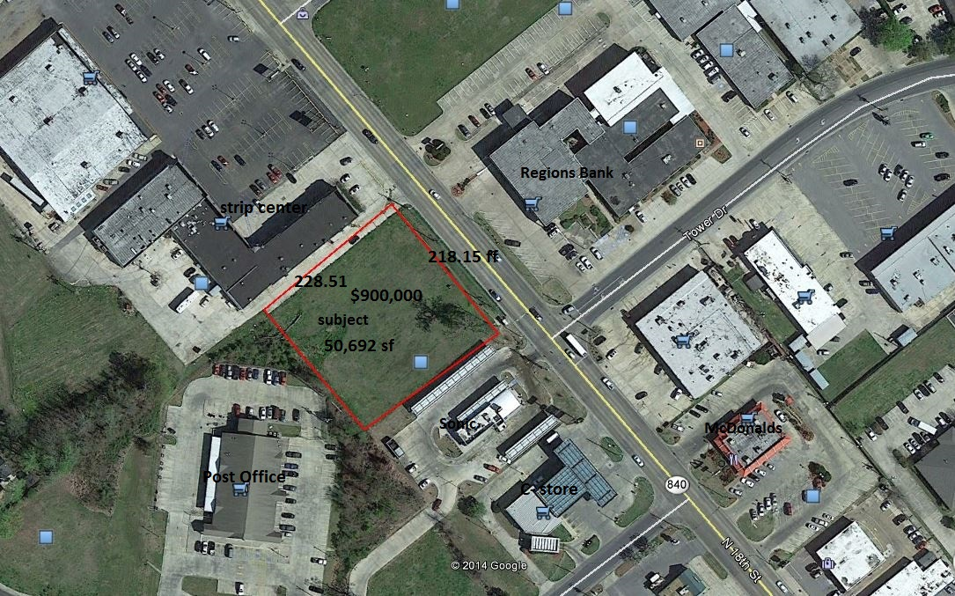

Traffic Count: 18,000 / day

Zoning: B- 2

Utilities – City of Monroe water and sewer, high speed internet , natural gas

Flood zone – not in flood zone

Contact:

Charles Wilkes
Wilkes Real Estate
1034 Nth 9th Street
Monroe, La. 71201
Email: charlesewilkes@gmail.com
Phone: 318-387-0770

