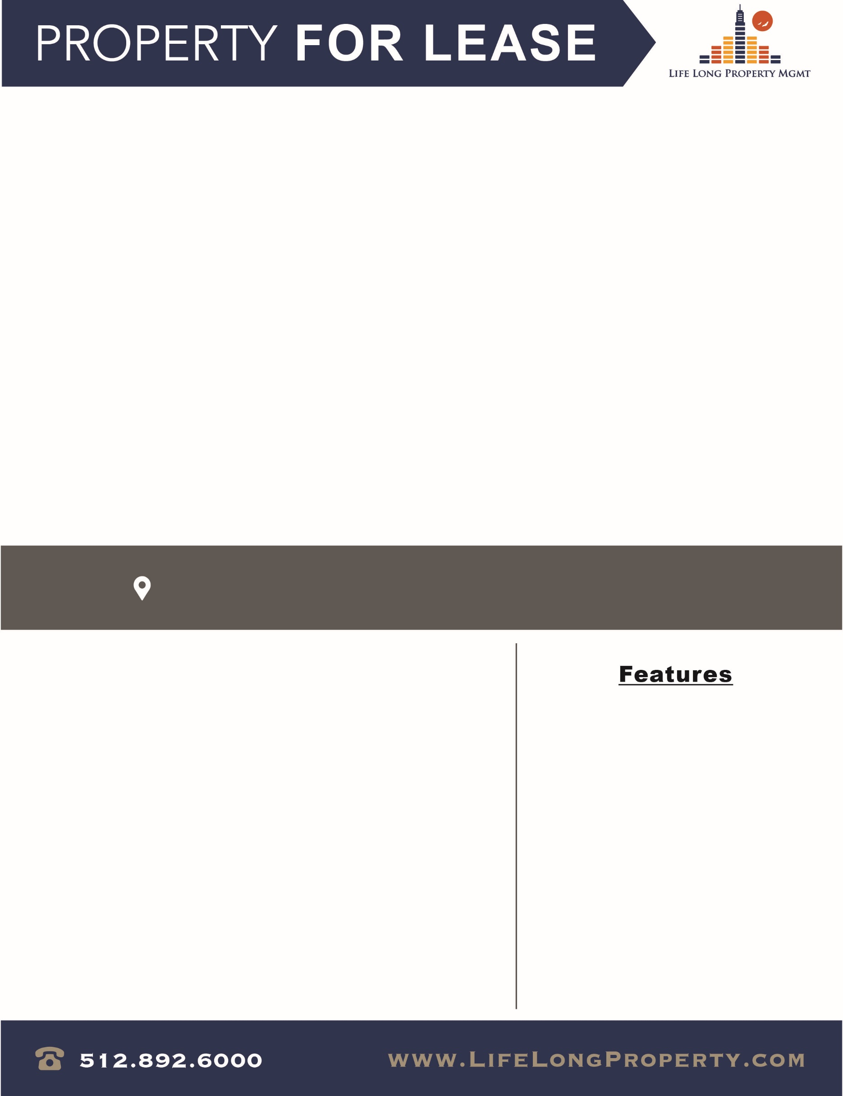

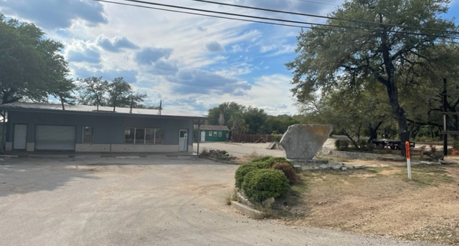

NOW AVAILABLE
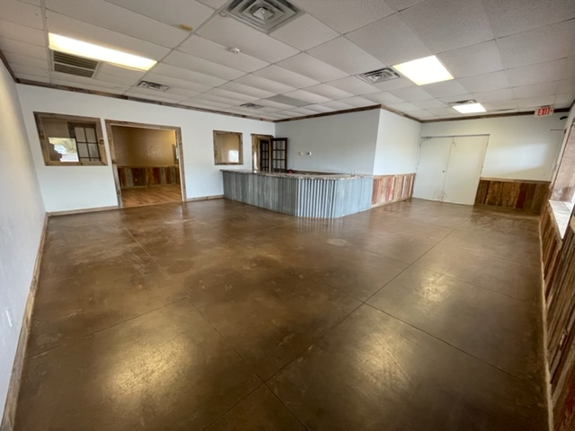
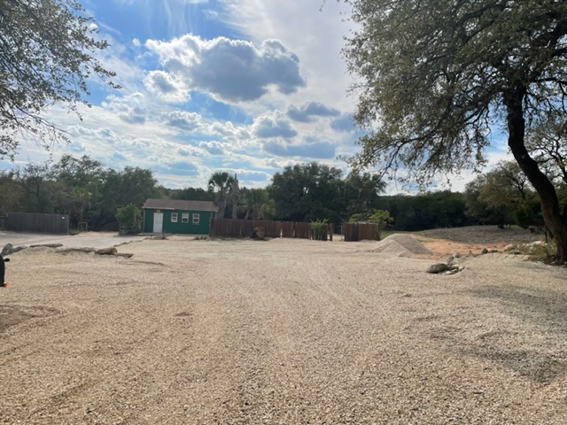
9125 Highway 71 W, Austin, TX 78735

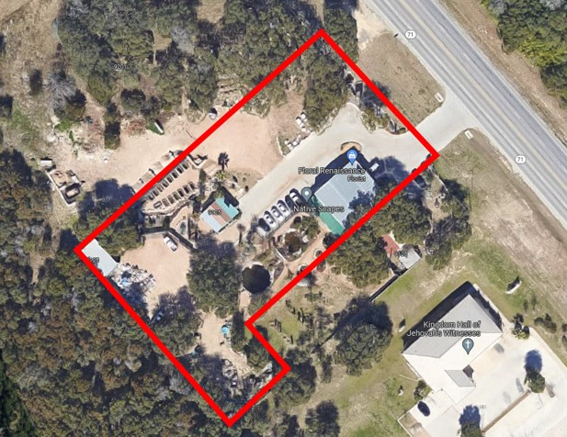
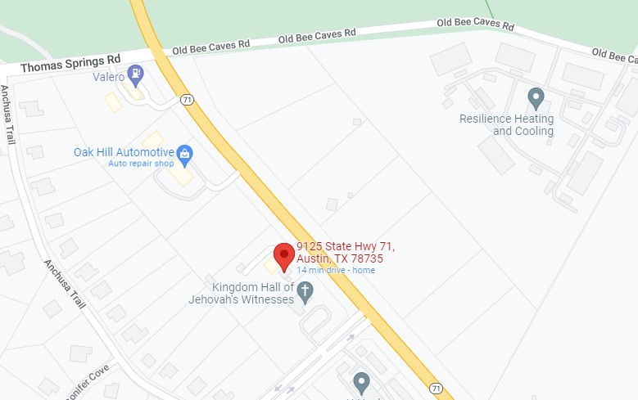

AVAILABLE NOW
- Suite A:
  - 2,000 SF – Retail
  - $40.00/SF + NNN
  - Workshop with Garage Door Access
  - 2 Acres of Securable Yard Space

Norman Phillips
Office: 512.892.6000 Cell: 512.348.0191
Email: Norman@hawkinsfamilypartners.com
Life Long Property Mgmt. | www.Lifelongproperty.com
9215 Highway 71 W, Austin, TX 78735

