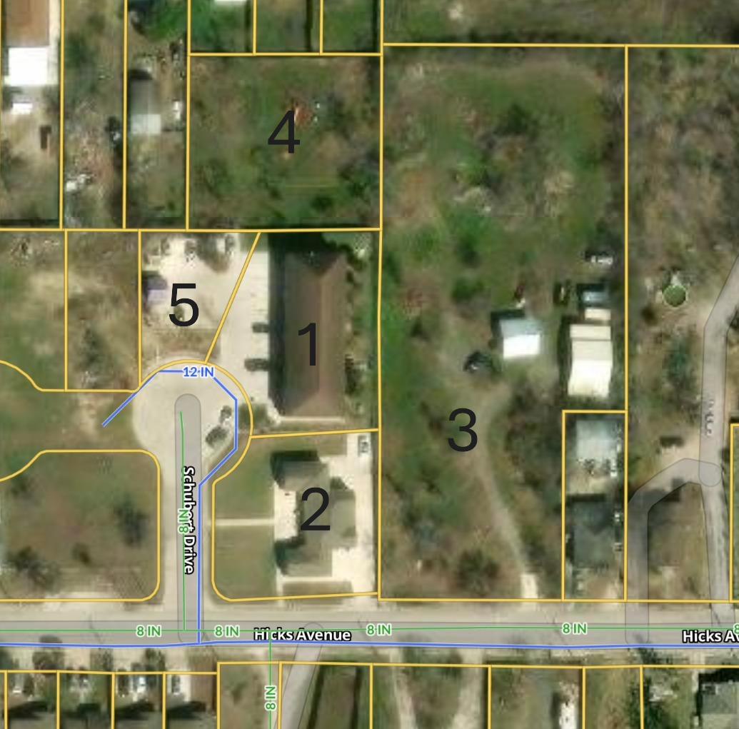

- 2523 Schubert
  - Property ID: 1192437
  - Zoning MF-33
  - 10,400 sqft living area
  - 0.4277 acres
  - Taxes $28,065.44
- 2603 Hicks Ave
  - Property ID: 395285
  - Zoning: MF-33
  - 2,852 sqft living area
  - 0.3476 acres
  - Taxes: $6,589.26
- 2611 Hicks Ave
  - Property ID: 395291
  - Zoning: R-6
  - 1.804 acres
  - Taxes: $3,887.67
- 2546 Schley Ave
  - Property ID: 395201
  - Zoning: R-6
  - 0.4944 acres
  - Taxes: $2,160.07
- 2603 Hicks Ave (parking lot for 8-unit)
  - Property ID: 395281
  - Zoning: MF-33
  - 0.1905 acres
  - Taxes: $1,461.07

