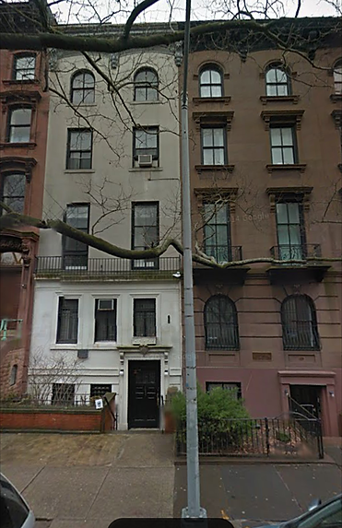
102 Pierrepont Street, Brooklyn Heights
$7,295,000
​ Rent Roll:
Apt - Rent - Lease Exp.
​
​This six story, six unit walk up townhouse is located between Henry and Clinton Streets on the south side of Pierrepont Street. The garden and parlor levels contain a large duplex apartment with garden access. The third level consists of two separate one bedroom apartments. The three remaining levels each contain separate two bedroom apartments. This property is located next to the retail strip on Montague Street, as well as blocks away from the beautiful Brooklyn Heights Promenade

Duplex- $7,500.00(FM) - 10/31/22
3F- $3,370.00(FM) - 10/31/22
3R- $2,900.00(FM) - 4/30/22
4th Flr- $4,750.00(FM) - 9/30/22
5th Flr- $688.06(RC) -
6th Flr- $4,375.00(FM) - Vacant
​
Monthly Income: $23,583.06
Yearly Income: $282,996.72
​
​Block / Lot: 243 / 34
Lot Size: 20' x 100' sq. ft.
Stories: 6
Bldg. Dimensions: 20' x 55' sq. ft.
Gross sq. ft.: 6,665 sq. ft.
Annual Expenses:
Repairs: $2,500.
Utilities: $600.
Fuel & Oil: 8,500.
Insurance: $6,000.
Water & Sewer: $3,530.
Real Estate Taxes: $55,890.00

