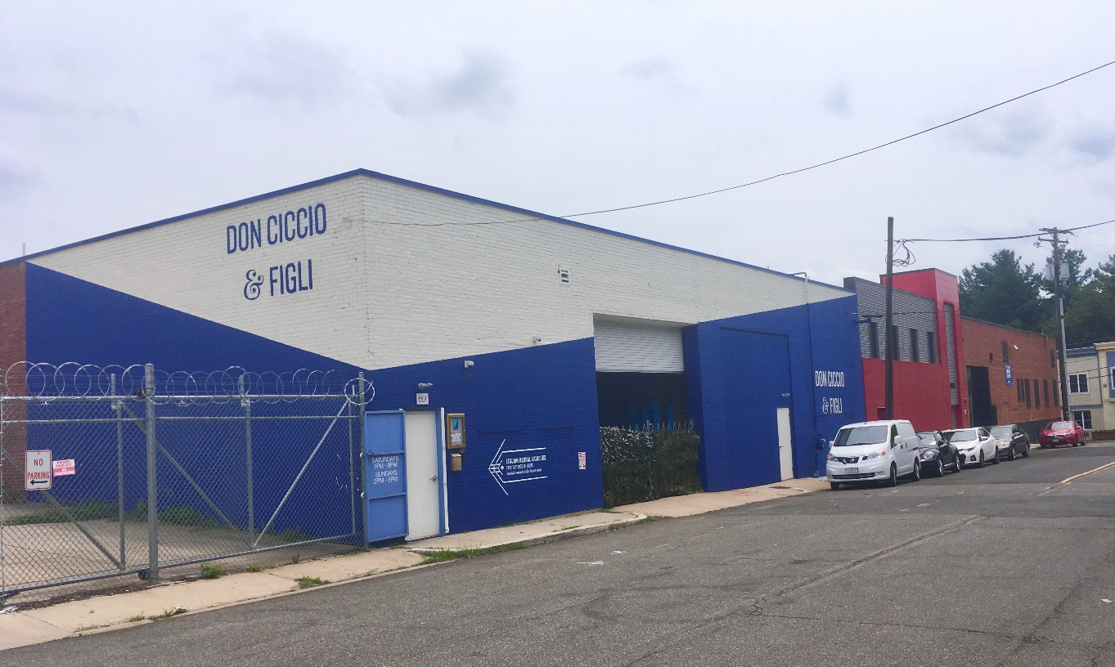

OFFERING MEMORANDUM

1901-1907 Fairview Avenue, NE



TABLE OF CONTENTS

I Executive Summary
II General Property Data
III Lease Synopsis
IV Floor Plans
V Photos
VI Market Information
VII Map

I.

EXECUTIVE SUMMARY

1901-1907 Fairview Avenue NE, Washington, DC 20002 is a 33,000 multi-tenant industrial building located in the burgeoning Ivy City neighborhood of Northeast Washington, DC, in close proximity to Union Market, Hecht Warehouse, Crummell School redevelopment site, the Pro Fish development site and New City DC among many other projects in the development pipeline.

The property consists of three bays, which are leased to (1901 Fairview) National Holistic Health LLC, a cannabis cultivation facility, (1905 Fairview) Charix LLC, an online shoe seller and (1907 Fairview) Don Ciccio y Figli, a distiller of fine Italian liquers.

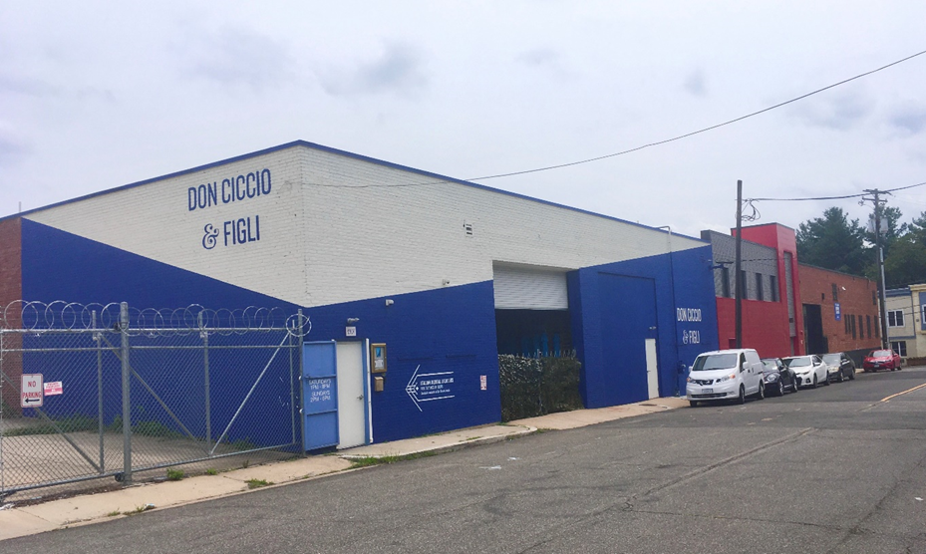

II.

GENERAL PROPERTY DATA
Purchase Price | $7,600,000
Address | 1901-1907 Fairview Avenue, NE
Year Built | 1950
Legal Description | Lot 0018 Square 4041
Gross Building Area | 33, 000 SF
Lot Size | 21,568 SF
Taxes | $115,468 (2020)
Zoning | PDR-1
Ceiling Height | 18 ft
Loading Docks | 3
Drive-in bay | 1

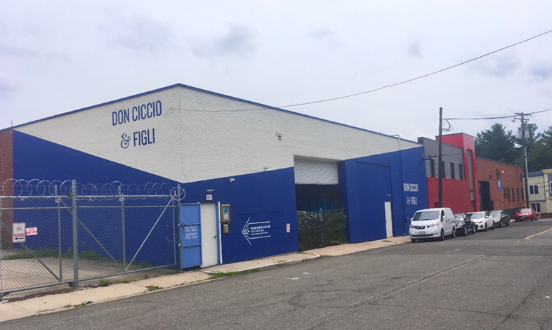

III.

LEASE SYNOPSIS
ADDRESS | TENANT | TERM | OPTIONS | SQ FT | RATE | PRO RATA | ESC | LCD | NOTES
1901 | Nat'l | 10 | TWO 5YR | 19,200 | $12.00 NNN | 59% | 2.50% | 23-Dec | CANNABIS
1905 | CHARIX | 5 | ONE 5YR | 6,326 | $11.00 NNN | 19% | 2.50% | Jun-21 | SHOE SALES
1907 | DON CICCIO | 10 | TWO 5YR | 7,100 | $15.00 NNN | 22% | 2.50% | Mar-18 | DISTILLERY

ADDRESS | TENANT | 2024 INCOME | 2025 INCOME
1901 | NAT'L HOLISTIC | $ 115,200.00 | $ 230,400.00
1905 | CHARIX | $ 74,936.00 | $ 76,809.00
1907 | DON CICCIO | $ 120,495.00 | $ 123,507.00
NOI |  | $ 310,631.00 | $ 430,716.00

IV.

FLOOR PLANS

1901 Fairview Ground Floor

1901 Fairview Lower Level

1905 Fairview Ground Floor

V.

PHOTOS

1901 Fairview – 1st Floor 1901 Fairview- Lower Level

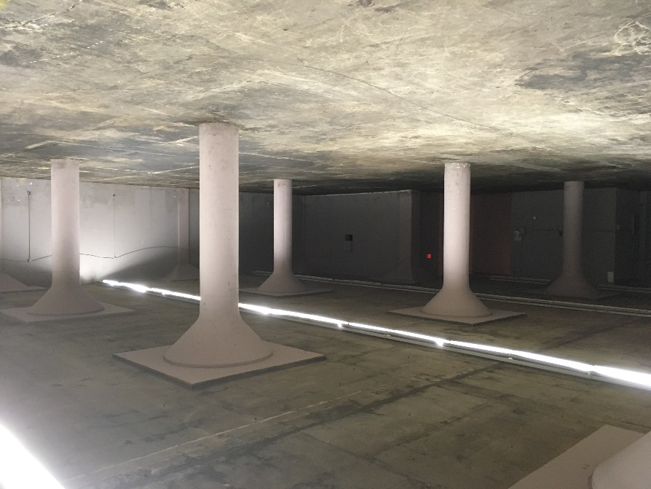

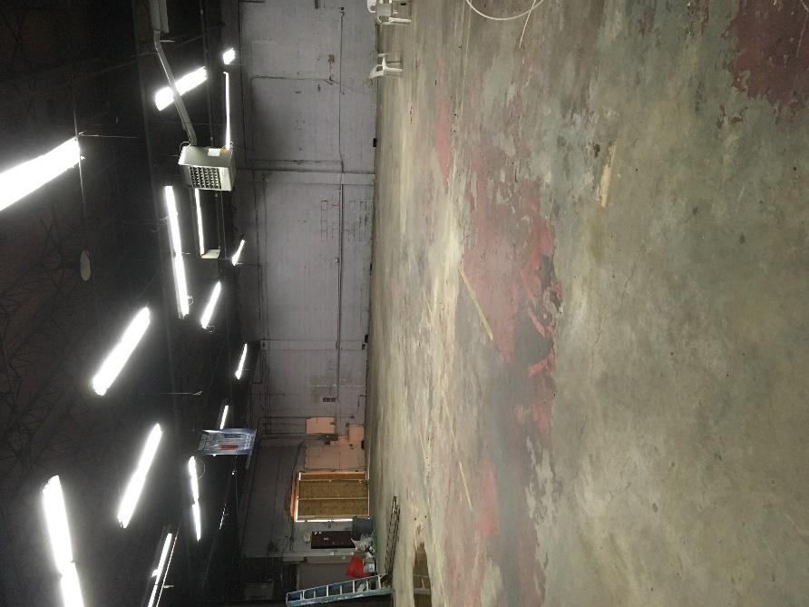

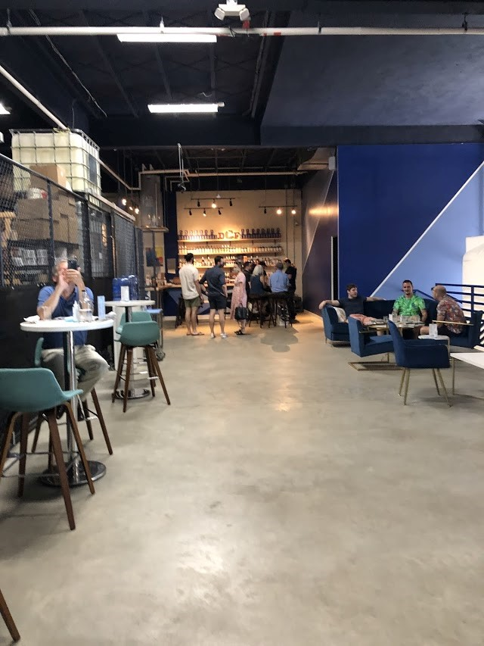

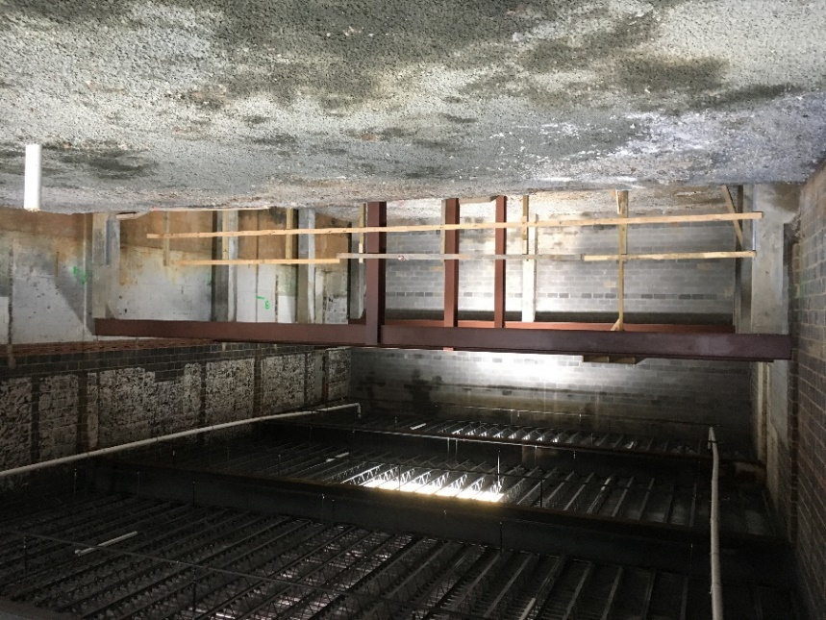

1905 Fairview 1907 Fairview

VI.

MARKET INFORMATION

Hecht Warehouse 196,000 sf, 335 residential units plus retail including Target and Mom’s Organic Market, Petsmart and more.

Crummell School 343 residential units, retail, community center

Pro Fish site 123 residential units and maker space

New City DC 9 buildings at the intersection of New York Ave, Bladensburg Rd and Montana
Ave.
Featuring 339,000 sf retail, 2,380 residential units, 179,000 sf office space

Distilleries One Eight, Don Ciccio, New Columbia, Republic Restoratives

Breweries Atlas Brew Works, Other Half Brewing Co.

Cidery Supreme Core Cidery

VII.

NEIGHBORHOOD MAP

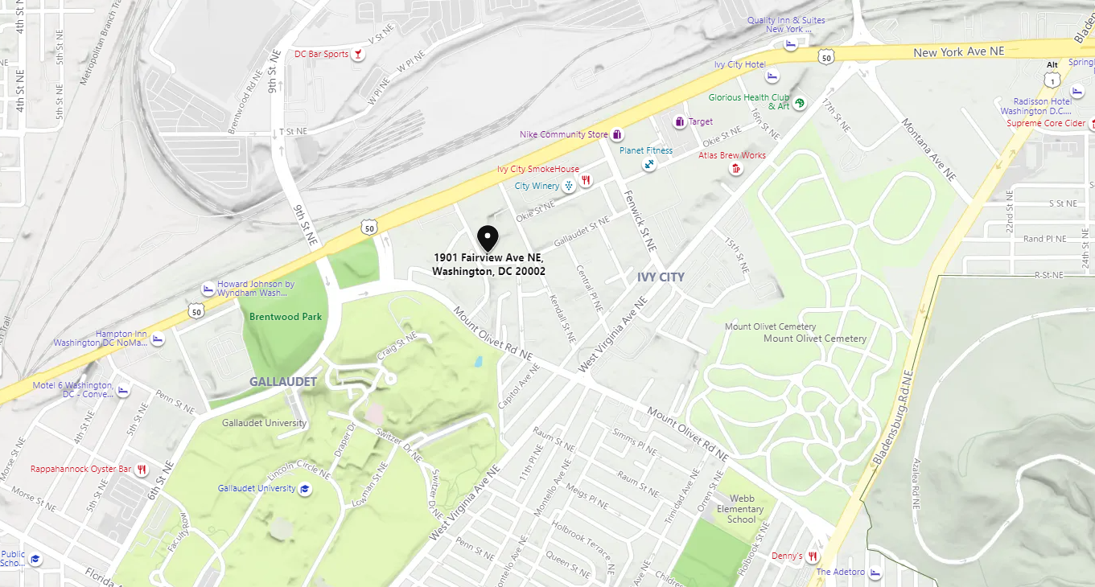
UNION MARKET
CRUMMELL
SCHOOL
PROFISH
SITE
HECHT
WAREHOUSE
NEW CITY
DC









We obtained the information in this proposal from sources we believe to be reliable. However, we have not verified its accuracy and make no guarantee, warranty or representation about it. It is submitted subject to the possibility of errors, omissions, change of price, rental or other conditions, prior sale, lease or financing, or withdrawal without notice. We include projections, opinions, assumptions or estimates for example only, and they may not represent current or future performance of the property. You and your tax and legal advisors should conduct your own investigation of the property and transaction.

