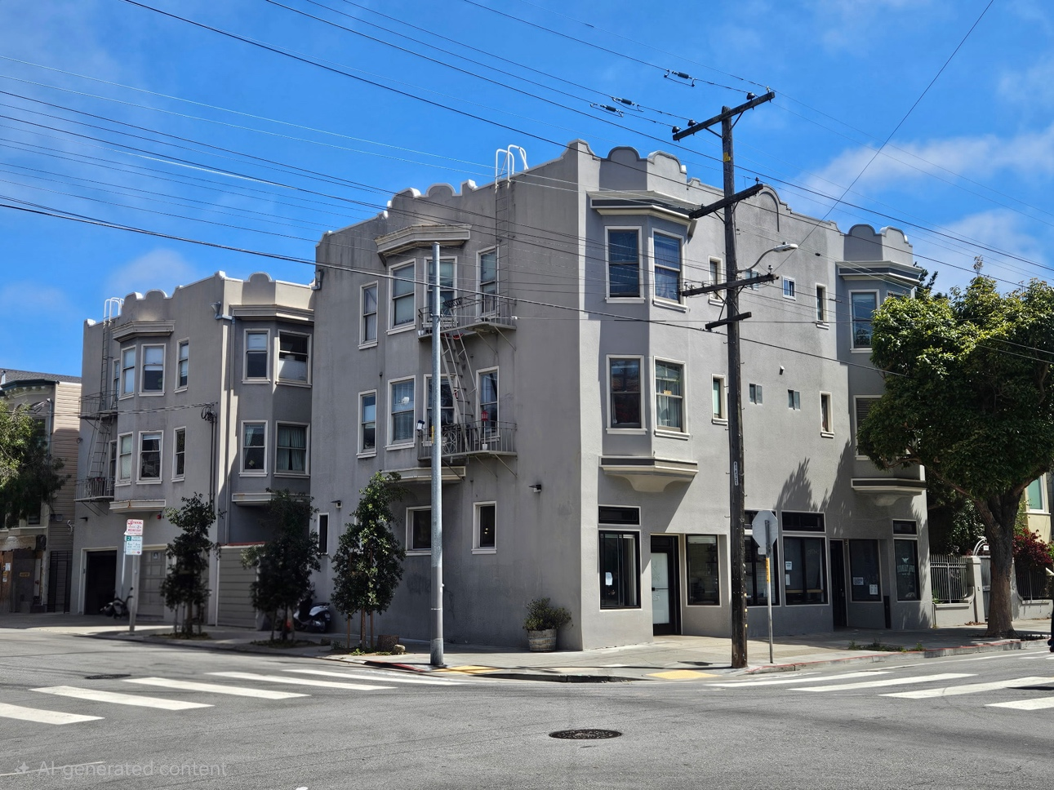
OFFERED AT $6,500,000
1686 Hayes Street
San Francisco, CA 94117
±11-Unit Mixed-Use Apartment Building · 9 Residential + 2 Commercial + 3 Garages · NoPa / Alamo Square
$6.5M  Price | ±11  Units | 10,050 SF  Building | 6.0%  Cap* | 14.8  GRM*
*Pro-forma — stabilized gross income, reported operating expenses, before property-tax reassessment.
Investment Highlights
- Rare corner mixed-use asset — nine residential apartments (incl. a JADU), two ground-floor commercial units, and three private garages.
- Prime NoPa / Alamo Square location on the walkable, transit-rich Hayes Street corridor.
- Diversified income — apartments plus a neighborhood bakery and the Scarlet Fox wine bar on long-term leases.
- Immediate value-add — lease up the vacant JADU and oversized garage; in-place $402,168 rising to $439,368 pro-forma.
- Additional loss-to-lease upside across below-market residential units already on scheduled annual increases.
- Excellent condition and irreplaceable at today’s land and construction costs — a durable long-term hold.

Property Gallery
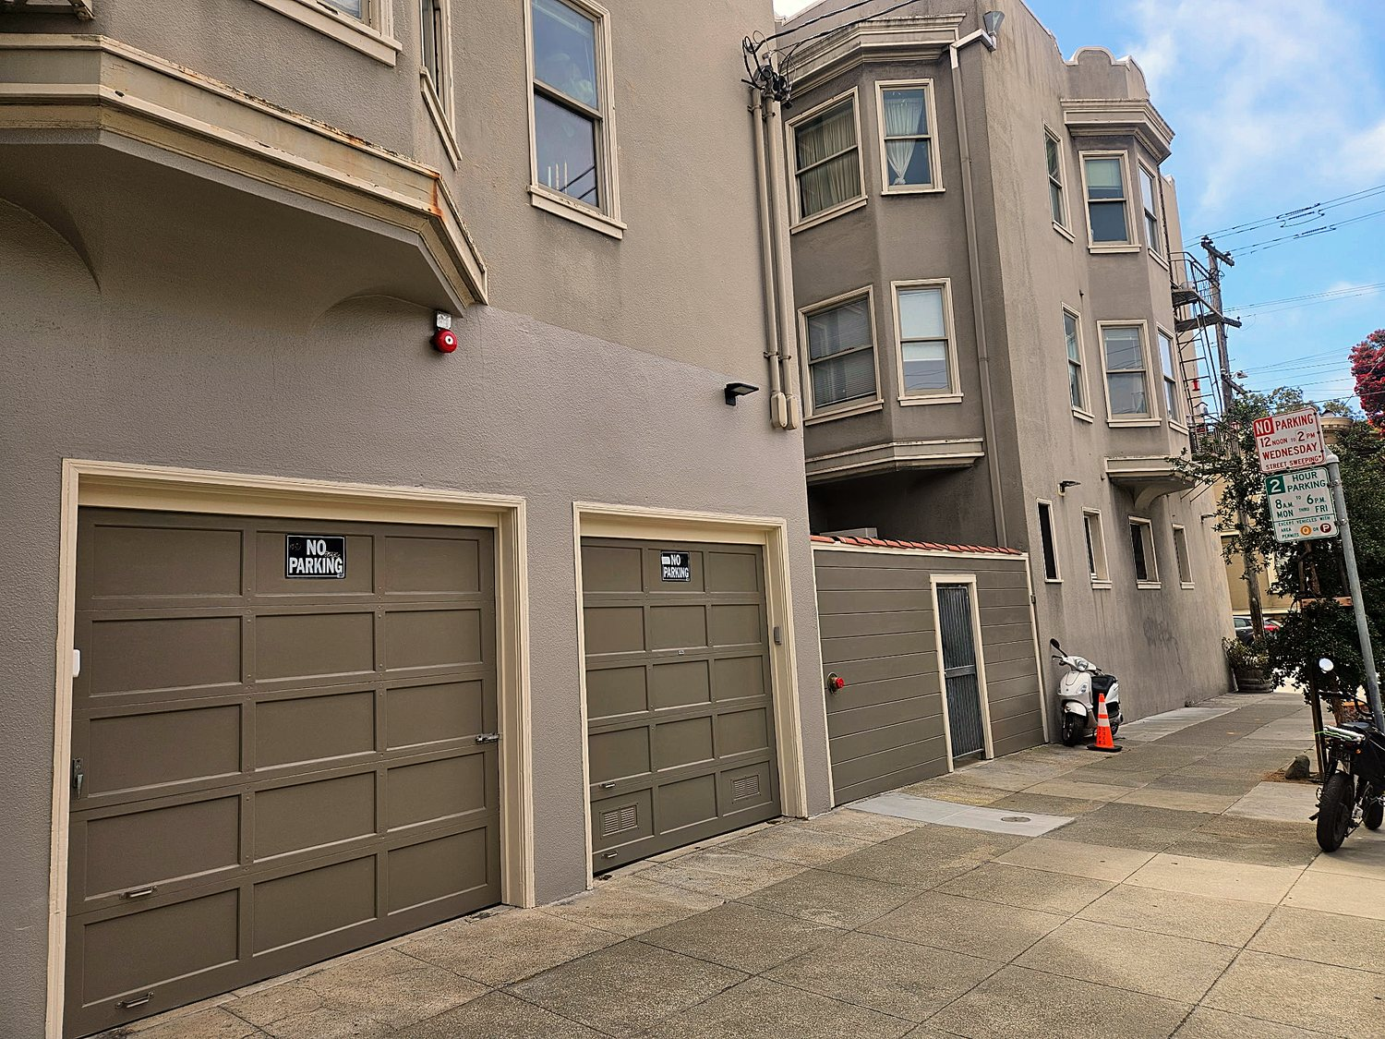  Three private garages | 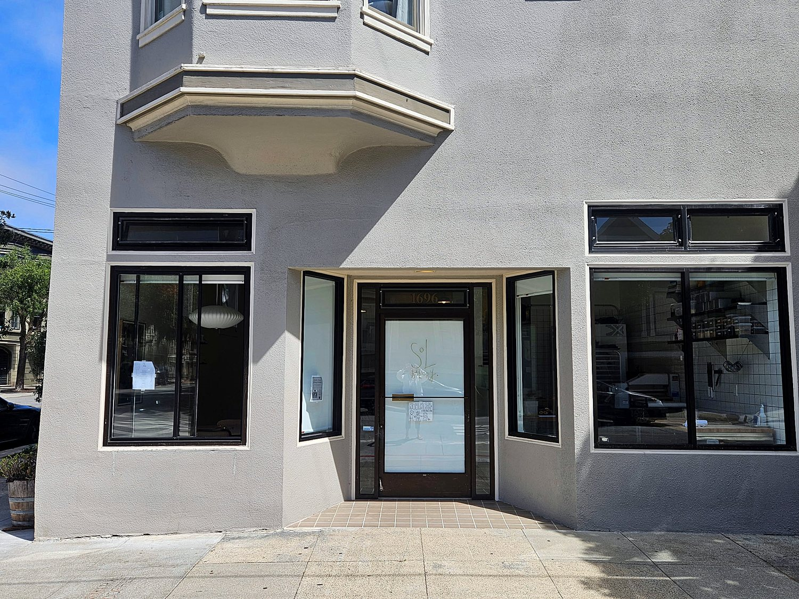  Ground-floor bakery (1696)

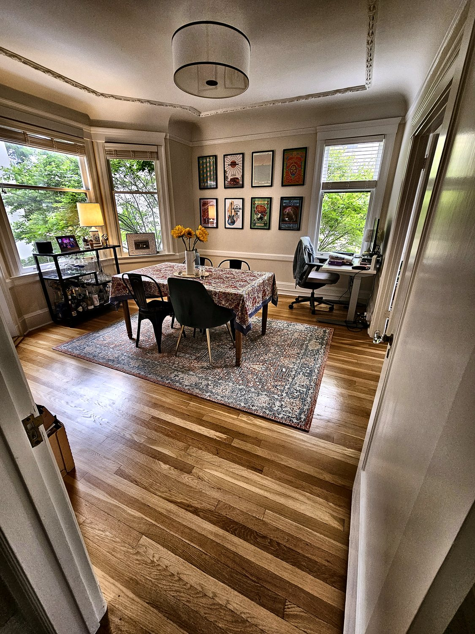  Residential interior | 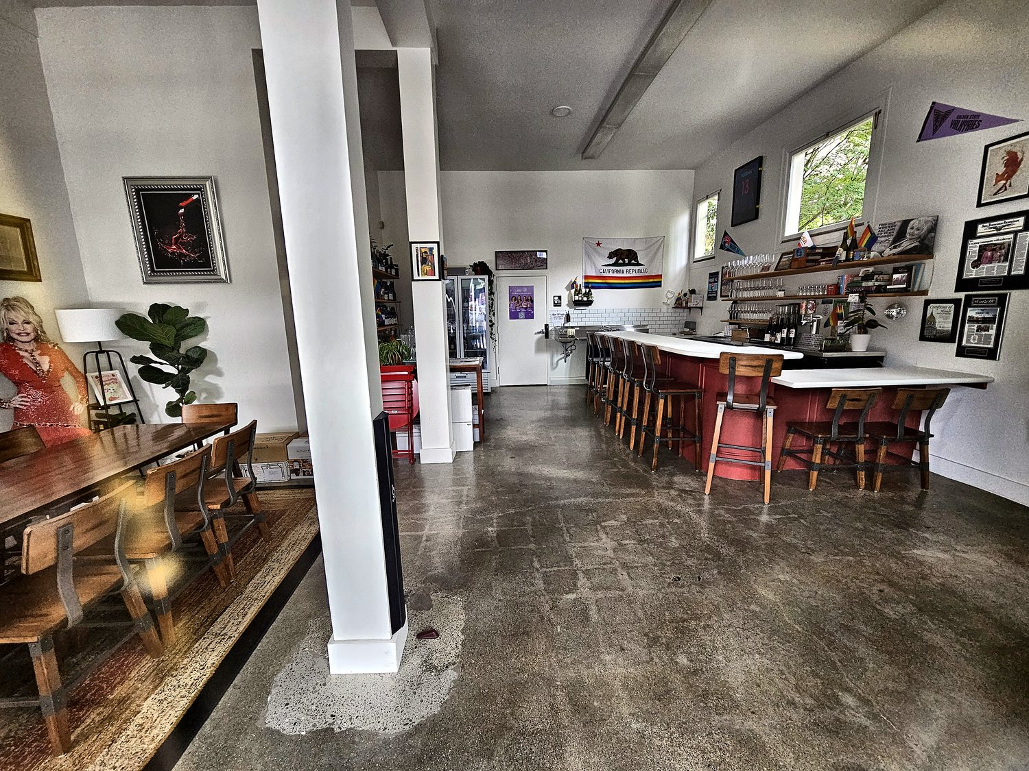  Scarlet Fox wine bar
Financial Snapshot
 | IN-PLACE | PRO-FORMA
Gross Scheduled Income | $402,168 | $439,368
Operating Expenses (excl. tax) | ($49,299) | ($49,299)
Net Operating Income | $352,869 | $390,069
Cap Rate | 5.4% | 6.0%
Gross Rent Multiplier | 16.2 | 14.8
At a normalized 25% expense ratio, NOI ≈ $329,526 (≈5.1% cap). All figures exclude the California property-tax reassessment (~1.18% of price) that occurs on sale.
Location
1686 Hayes Street sits on the Hayes Street corridor in San Francisco’s North-of-Panhandle (NoPa) and Alamo Square district — among the city’s most desirable, walkable, and transit-rich neighborhoods. Ground-floor retail activates the corner while spacious one- and two-bedroom residences above open to a landscaped interior courtyard. Supply of quality buildings here is effectively fixed, producing durable pricing and low vacancy.
Contact
Kay Stenn  Broker Associate · Coldwell Banker Real Estate  DRE #01985404  (650) 224-2222 · kay.stenn@cbnorcal.com | Michael Smith  Senior Partner · ROAM Commercial Realty  CalBRE #01725649  (925) 250-3208 · mike@roamcommercialrealty.com
Confidential — for qualified investors only. Information from sources deemed reliable but not guaranteed; buyers to verify. Not an appraisal.

