Ward County Parcels: RO L.\.'\CE, JOSEPH P
& P..\.\IALA D

Paicel ID Acreage
School District
Owner Naine
Legal Description
NE080020000000 131.51
Nedrose School District

ROMANCE, JOSEPH P & PAMAL•.c\D
N\V LS RR R\V IN }HVN\V LS CO ffiVY NE BUSINESS PARK 2ND ADDN ss.155.s2 N'EDROSE•S4, A=131.51

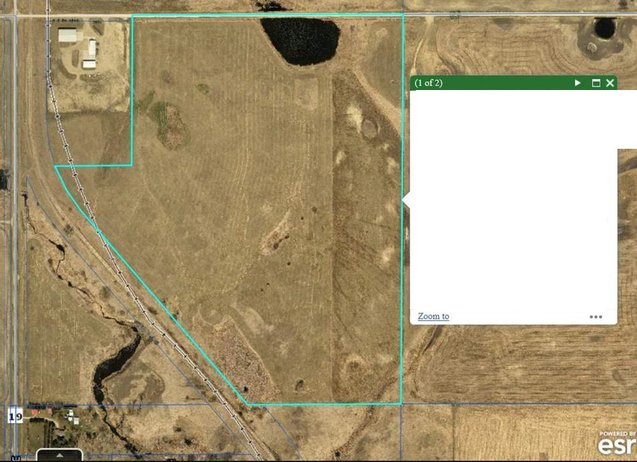
ADDRESS O *UNASSIGNED
TAXlJRL More info

