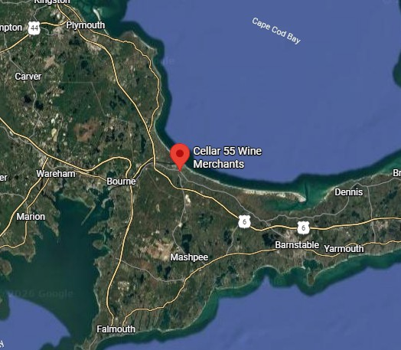


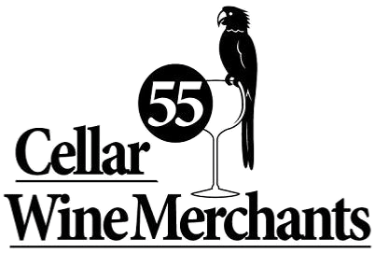

101 MA-6A
Sandwich, MA 02563
All-Alcohol Year-Round Package Store License

Richard Catania
Commercial and Residential Realtor rcatania@therealtyadvisory.com 508-367-1898

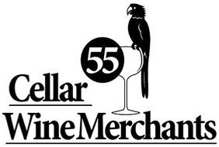
EXECUTIVE SUMMARY

Premier Boutique Wine Retail Opportunity
Price: $399,000 | Lot Size: 798 SF on 0.25 acres
ZONING: Business Limited 1 (BL1) with All-Alcohol Year-Round Store License
This offering presents a rare opportunity to acquire a highly visible retail property at the gateway to Cape Cod. Located along historic Route 6A in Sandwich, Massachusetts, and approximately three minutes from the Sagamore Bridge, the property benefits from excellent accessibility, easy parking, and significant passing traffic.
Situated at the entrance to the red-hot Sandwich Marina District, the property is surrounded by popular destinations including Tree House Brewing Company, Fishermen's View Restaurant, Pilot House Restaurant, Seafood Sam's, Sandwich Marina, the Cape Cod Canal Bike Path, and the Sandwich Boardwalk. The location attracts both year-round residents and seasonal visitors traveling to and from Cape Cod. This opportunity combines a prime Route 6A location, strong visibility, convenient access, and proximity to some of the area's most popular attractions in one of Cape Cod's most desirable communities.

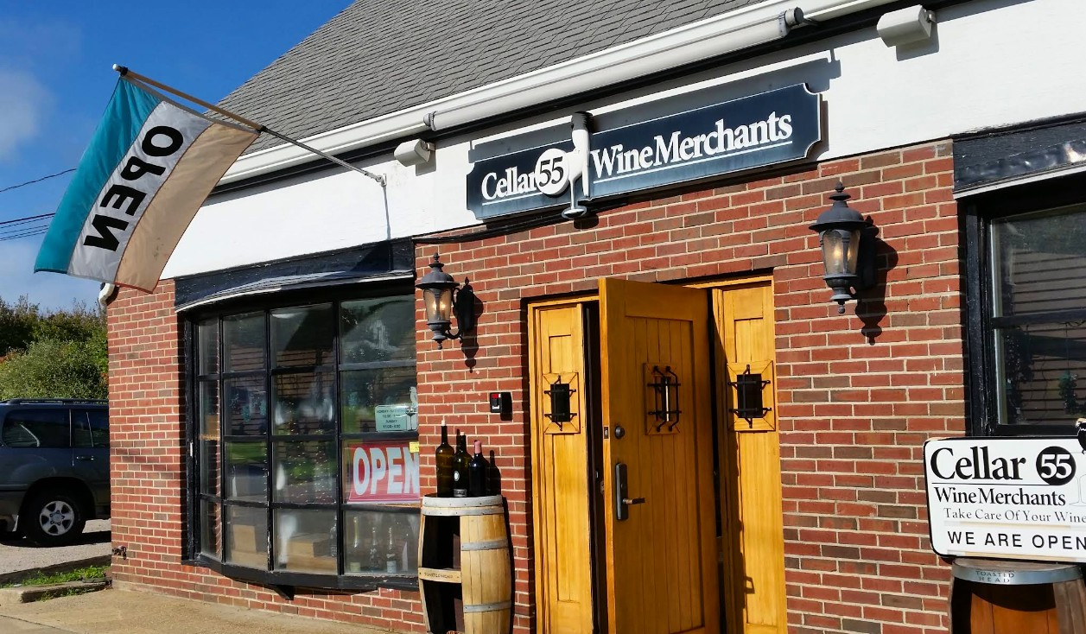
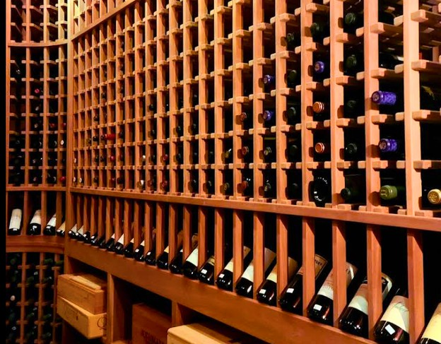
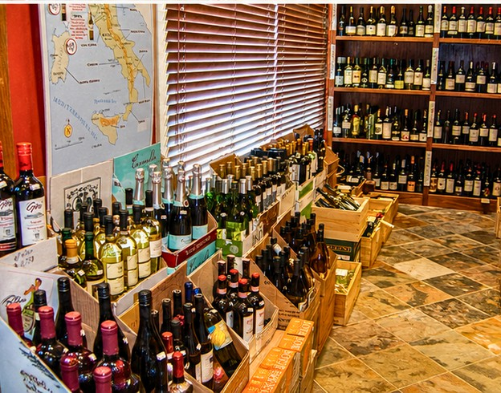
History
Cellar 55 Wine Merchants is a boutique wine shop located on historic Route 6A in Sandwich, Massachusetts, at the gateway to Cape Cod.
The property benefits from a highly visible location at the entrance to the Sandwich Marina District, just minutes from the Sagamore Bridge and surrounded by popular local attractions.
Serving both year-round residents and seasonal visitors, the business has built a strong reputation for its curated selection of fine wines, craft beers, specialty spirits, and gourmet gifts.
A standout feature is its temperature and
humidity controlled mahogany walk-in wine cellar, custom built by a local master craftsman, creating a unique retail experience in one of Cape Cod's most desirable commercial corridors.

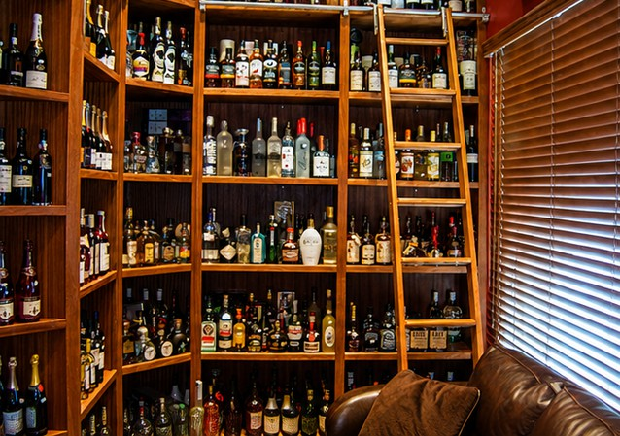

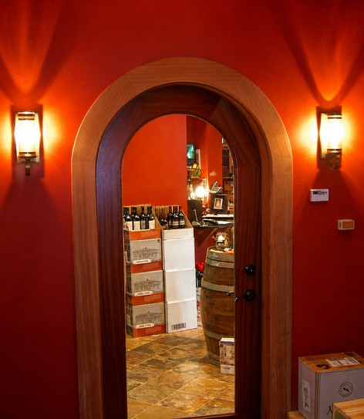
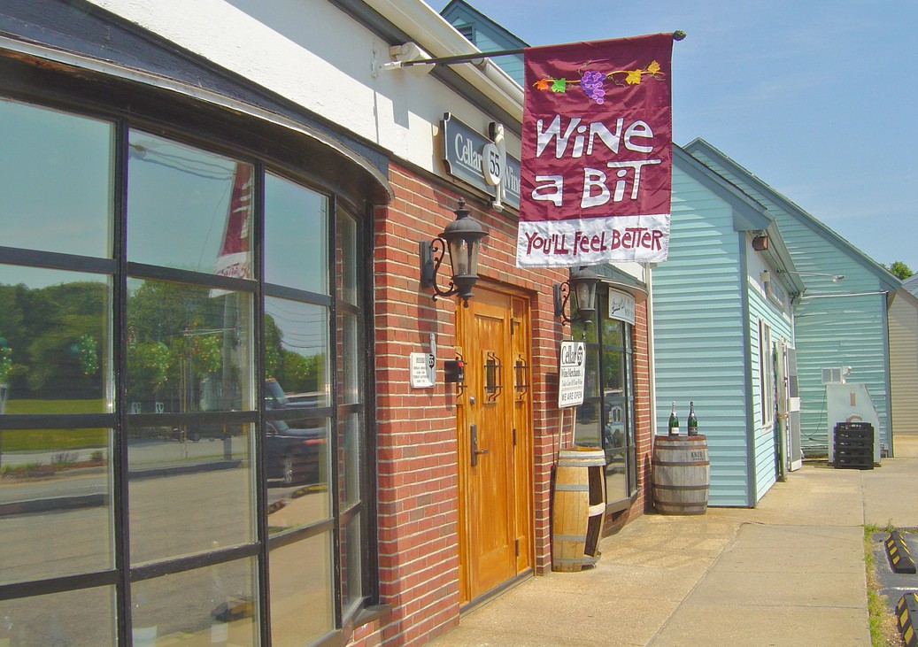
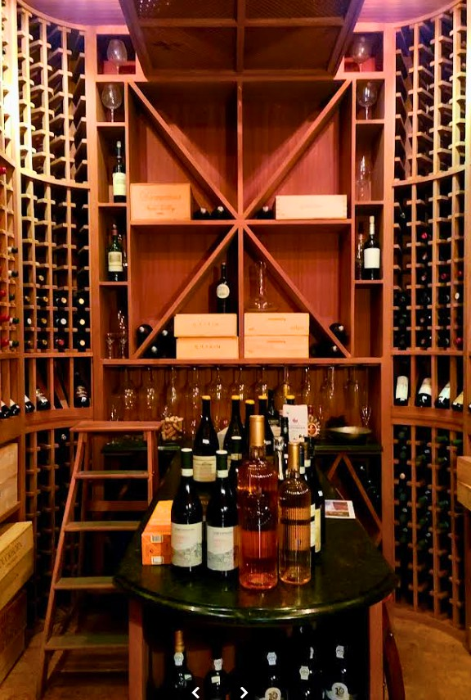
Boutique Wine Retail & Destination Business Opportunity
Product Selection
- Wines: Diverse range covering Old World classics (France, Italy, Spain) and New World varietals (California, Oregon, Argentina, Australia), with special focus on small producers, limited releases, and value-driven discoveries.
- Beer & Spirits: Curated craft beer selection and a concise offering of specialty spirits and liqueurs for gifting or pairing.
- Gourmet Gifts: Cheese boards, specialty snacks, artisanal chocolates, and elegant gift-wrap options for celebrations and corporate gifting.


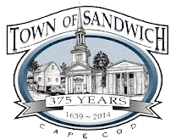


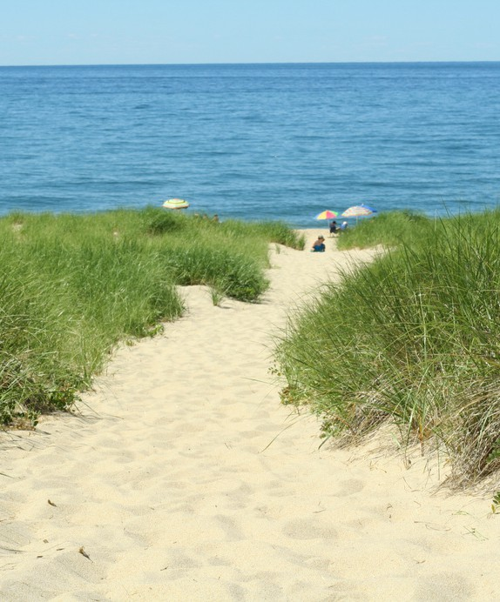
All about
Sandwich, MA
Nestled at the entrance of Cape Cod, Sandwich is the oldest town on the Cape and one of its most charming. It offers a perfect blend of coastal beauty, history, and modern-day convenience. Just minutes from the Sagamore Bridge, it’s a popular year-round destination for dining, boating, and beach-going.

Left: Marina

Right: Sagamore Bridge
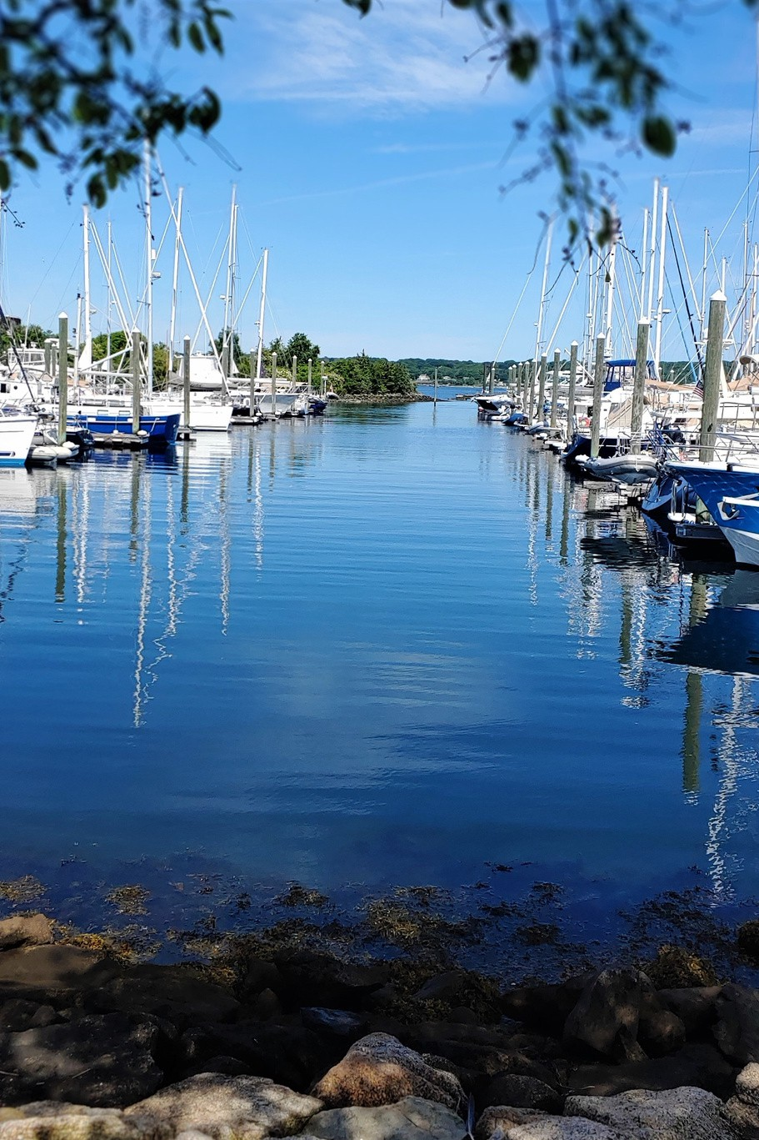

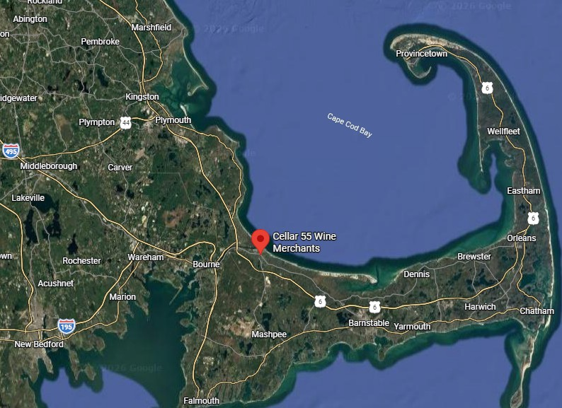
Location
Located on historic Route 6A at the gateway to Cape Cod, Cellar 55 benefits from excellent visibility, easy parking, and strong passing traffic.

101 MA- 6A
Sandwich, MA 02563
798 SF on 0.25 ACRES

Getting Here
Located on Historic Route 6A Gateway to Cape Cod
Entrance to the Sandwich Marina District

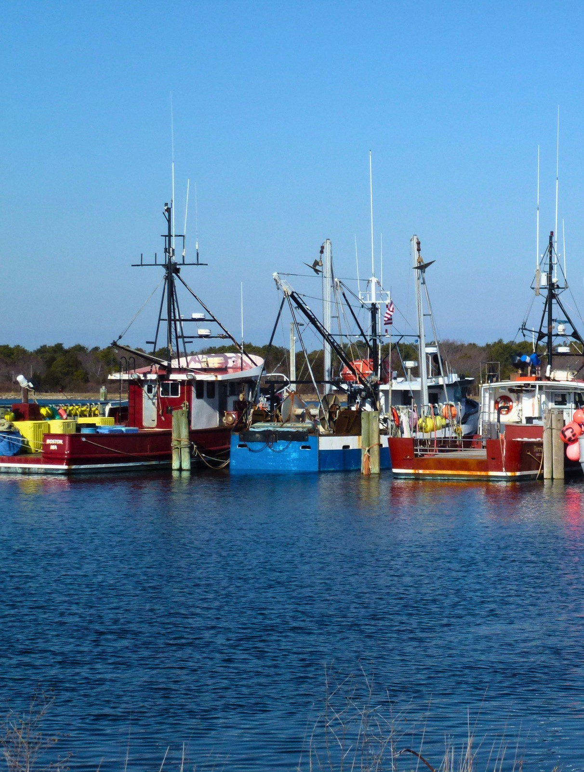
Build the Future in Sandwich, MA
Sale Includes:
- Real Estate
- Liquor License
- Furniture, Fixtures, and Equipment
- Goodwill
- Website
- Training
- Vendor Contact List
Note: Inventory is not included unless otherwise agreed upon.
This is a rare opportunity to acquire an established boutique wine business in one of Cape Cod's most desirable retail locations. Featuring an All-Alcohol Year-Round Package Store License.
Contact us today to learn more about this exceptional opportunity and discover the potential of owning Cellar 55 Wine Merchants.
Richard Catania
Commercial and Residential Realtor rcatania@therealtyadvisory.com 508-367-1898

Supplemental Financial Information
A complete supplemental offering package containing relevant financial information is available upon request.
Some information includes but is not limited to tax returns, monthly revenues and detailed income.

Offering
We are proud to offer for sale a rare opportunity to own a truly one-of-a-kind Fine Wine shop on Cape Cod. Cellar 55 is a boutique wine shop in Sandwich, Massachusetts, offering a carefully curated selection of domestic and international wines, craft beers, and gourmet gift items. The shop emphasizes quality, small-production and artisanal producers alongside thoughtfully chosen familiar labels.
Cellar 55 features a temperature and humidity controlled mahogany walk-in wine cellar built by a local master craftsman.

Representation
The Realty Advisory is entertaining offers to purchase Cellar 55, located at 101 MA-6A, Sandwich, MA 02563. All qualified prospective purchasers are required to contact Richard Catania, concerning site visits, inspections, submission of offers, of the proposed transaction.


