OFFICE SPACE AVAILABLE

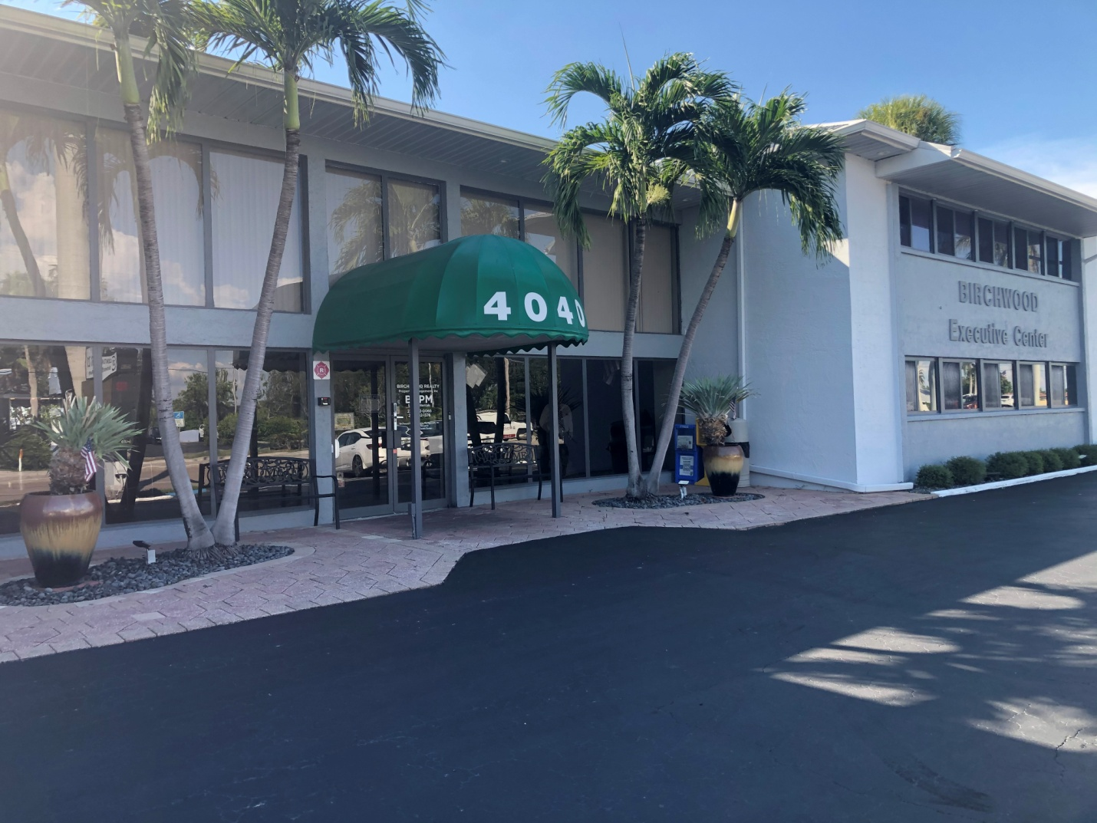

The Executive Suites at Birchwood Executive Suites is a premier professional business location situated on Del Prado Blvd. S, conveniently positioned between the two bridges. Our strategic location offers excellent visibility with signage that can be easily seen from Del Prado Blvd., providing seamless access to Fort Myers.

Our stunning two-story building boasts a variety of office spaces, catering to different sizes and requirements, both furnished and unfurnished. We understand the importance of flexibility and strive to accommodate your specific needs.

In addition to our exceptional office spaces, we offer three well-appointed conference rooms available for rent by the hour or by the day. These spaces are perfect for hosting meetings, presentations, or collaborative sessions. Furthermore, we provide a comfortable waiting area, four restrooms, and a spacious kitchen equipped with complimentary coffee for you and your guests.

At Birchwood Executive Suites, we pride ourselves on our exceptional customer service. Our friendly receptionist is always ready to assist you in any way possible, ensuring a seamless and pleasant experience for you and your clients.

To meet your technological needs, we offer secure internet service, as well as print and email services. You can trust that your confidential information will be protected while enjoying efficient and reliable connectivity.

Choose Birchwood Executive Suites for a professional and convenient business environment that caters to your unique requirements. Experience the difference of a well-equipped workspace combined with exceptional service.

Give us a call today or stop by for a tour: 239-542-0065
Birchwood Executive Center 4040 Del Prado Blvd. Cape Coral, Fl. 33904

