KEARNY
31 Pennsylvania Avenue
17,000 Square Feet
Five Minutes to Newark Airport/Port Newark
Modern, Clean, One-Story Industrial Facility
- 2 Loading Docks | - Drive-in Loading
- 22’ High Ceilings | - 1,500 sf Offices
- Dry Sprinkler System | - Gas Heat

Immediate Access to NJTP Exit 15E, Rt. 1 & 9

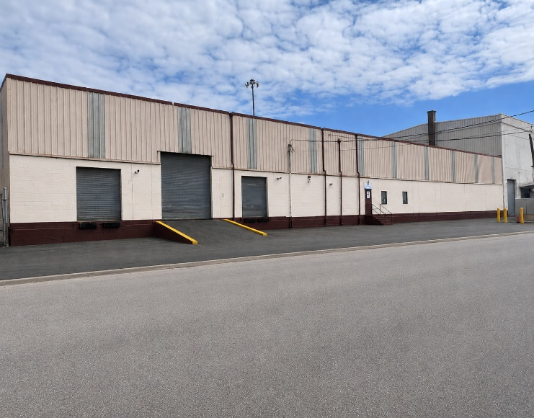

OWNER CALL KEN RUBIN
225 MILLBURN AVENUE, SUITE202 (908) 285-1100 (Mobile)
MILLBURN, NJ 07041 KRubin@Fidelco.com

