Call 303 579 4243  To RENT  1100 SF Warehouse  685 S Arthur Ave  Louisville CTC Park | 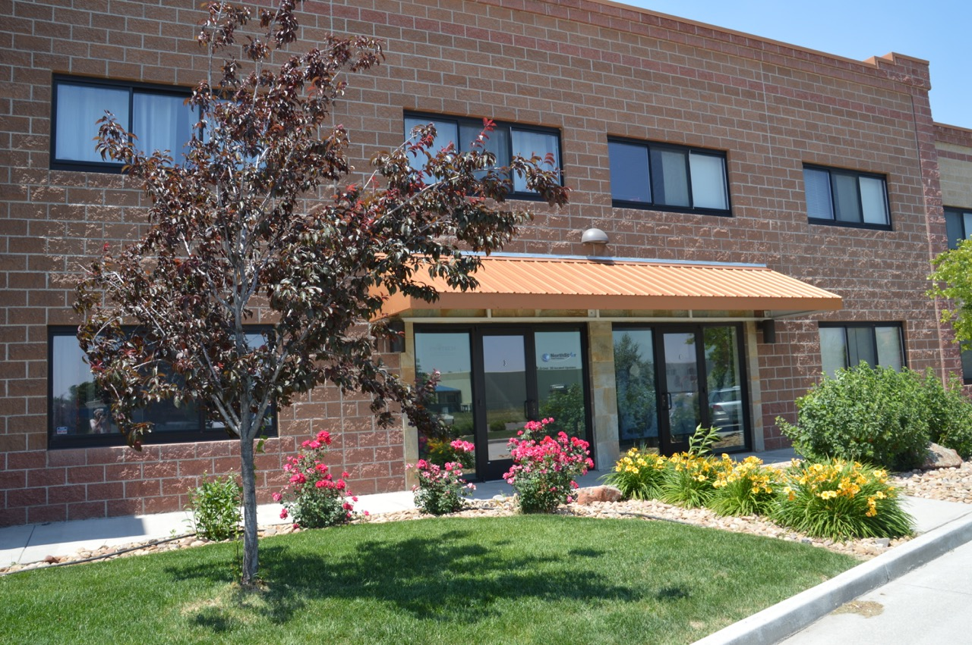
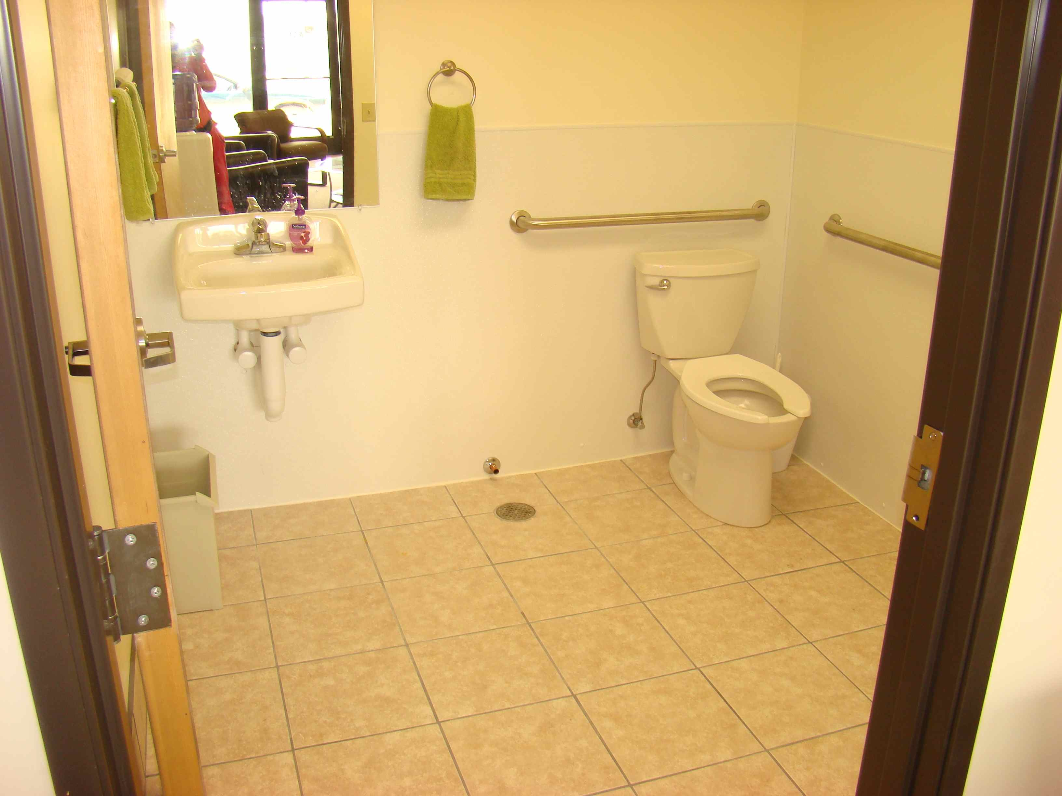 | 1100 SF open warehouse, 10 x 10 Drive In Garage Door, 18 ft clear height, tile bathroom , mop sink, windows, views, unit heater, entrepreneur friends, personal landlady not management company.  11Foo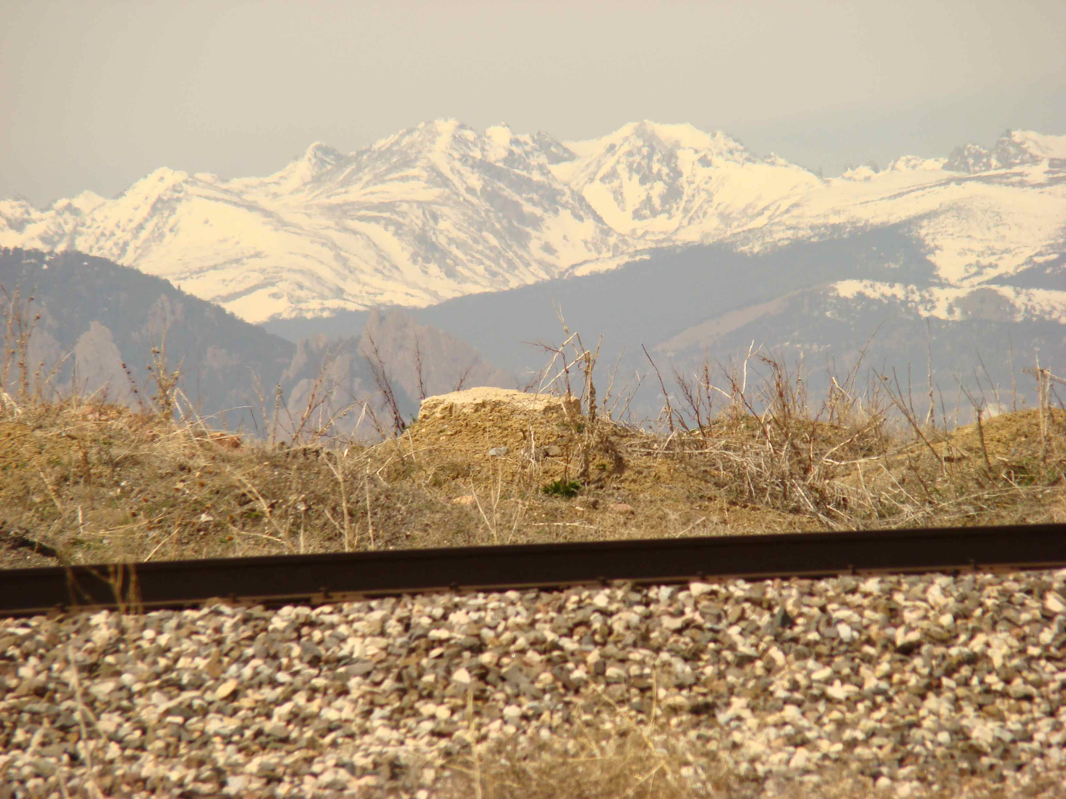ooofff00SF Warehouse  1100SF Warehouse  18ft clear ceilings  10x10 ft garage drive in doors  18ft clear ceilings  10x10 ft garage drive in doors

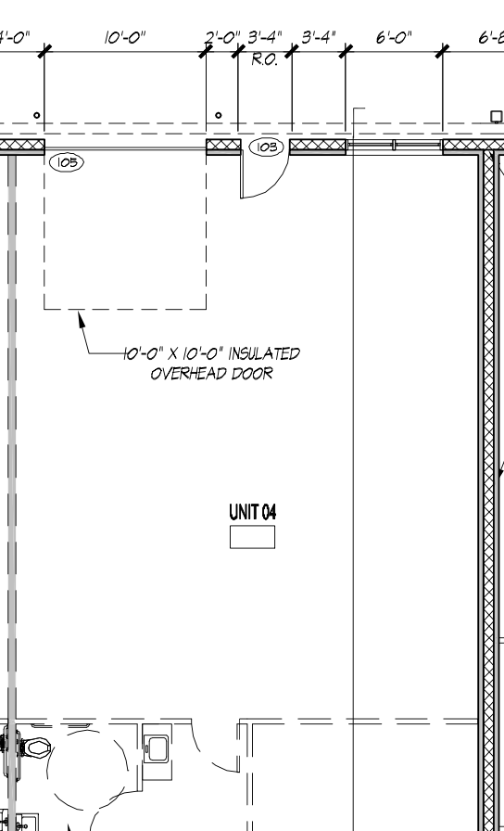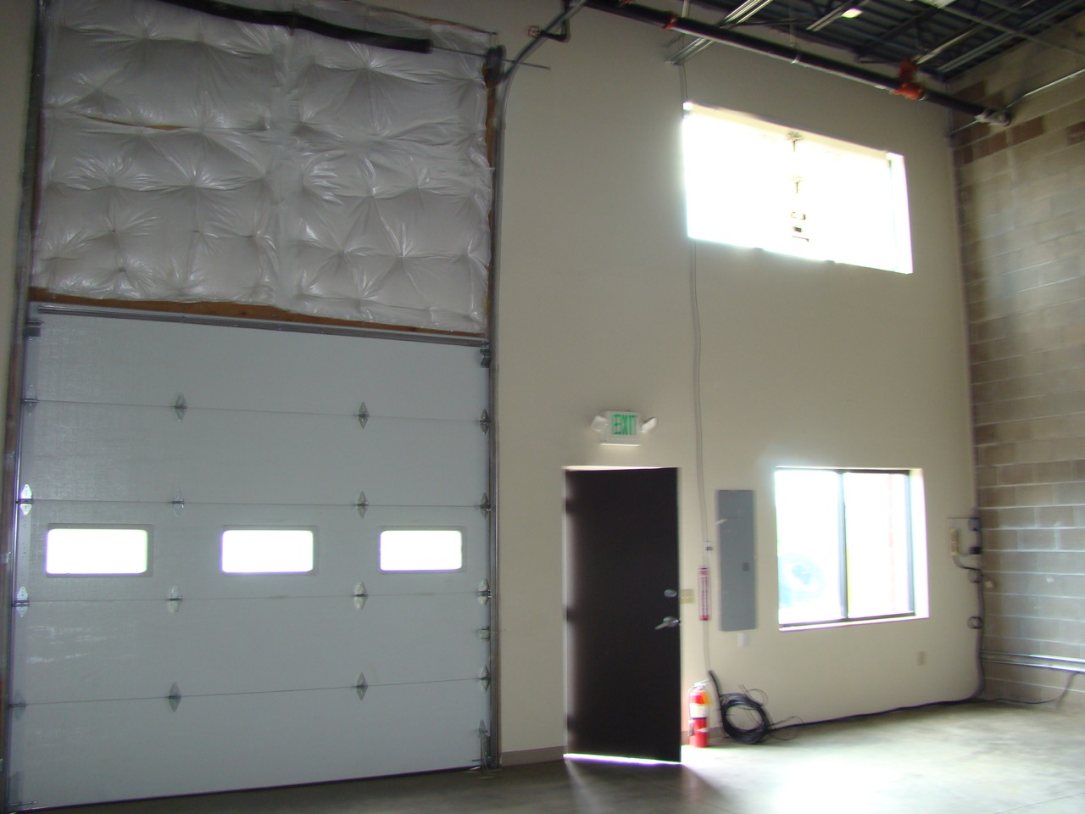

Heading 1


Heading 2
View and edit this document in Word on your computer, tablet, or phone. You can edit text; easily insert content such as pictures, shapes, and tables; and seamlessly save the document to the cloud from Word on your Windows, Mac, Android, or iOS device.


Heading 2
Want to insert a picture from your files or add a shape, text box, or table? You got it! On the Insert tab of the ribbon, just tap the option you need.


Heading 2
To apply any text formatting you see on this page with just a tap, on the Home tab of the ribbon, check out Styles.

