Location

- 1275 12th Avenue NW Suite 11
- Approximately 368 sf
- Located 1 block South of Gilman Blvd.
- Adjacent to Issaquah Transit Center

Features
- Collaborative workspace, perfect for 1 or 2 ppl
- Large Open Work Area
- Second floor suite offers plenty of natural light and mountain views
- High-speed internet
- Ample parking

Neighborhood Amenities
- 20 minutes to Seattle, 15 minutes to Bellevue, 5 minutes to Trails
- Located at the Gateway to Issaquah at I-90 Exit 15
- Excellent access via SR 900, Gilman Blvd. and I-90 with 128,000 vehicles per day
- Walking distance to restaurants, banks, retail and fitness options

1595 NW Gilman Blvd., Suite 1
Issaquah, WA 98027
www.rowleyproperties.com
To view this space or discuss
details, please contact
Kelly Richardson at 425.395.9577

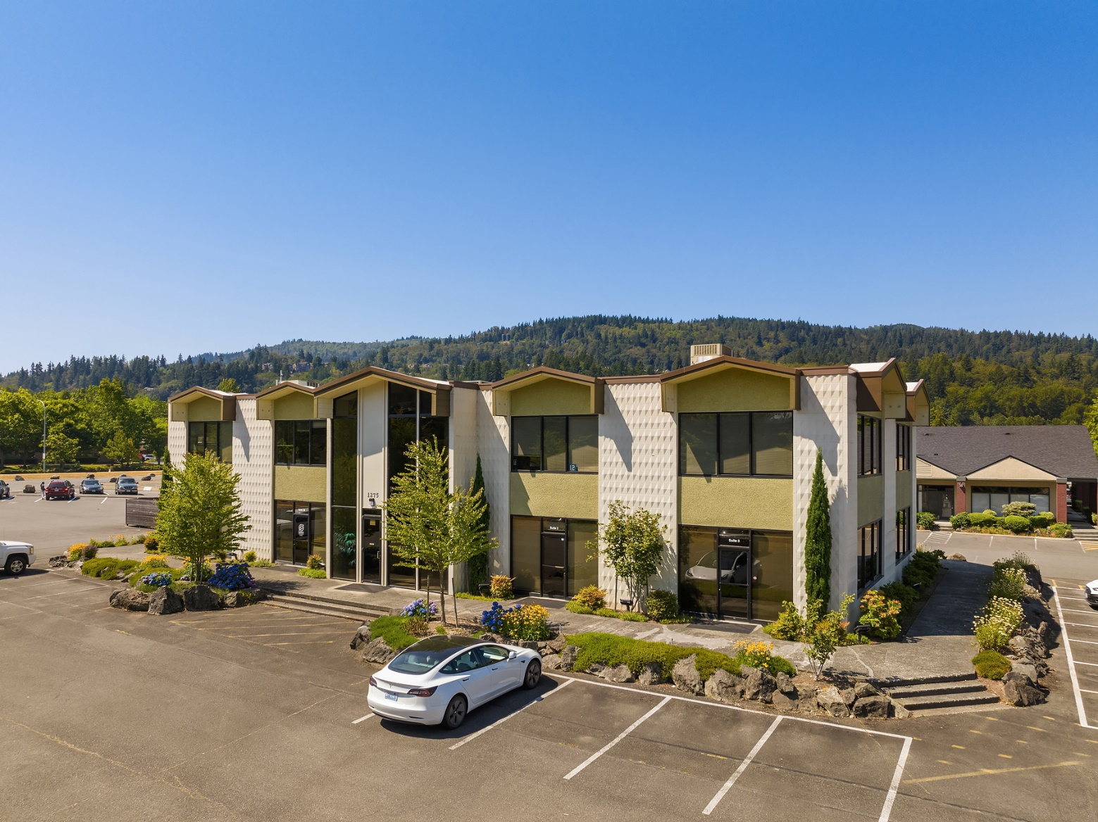
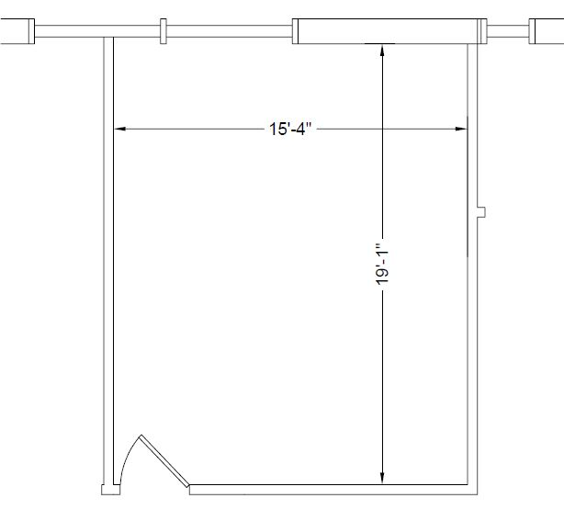
Floor Plan


