

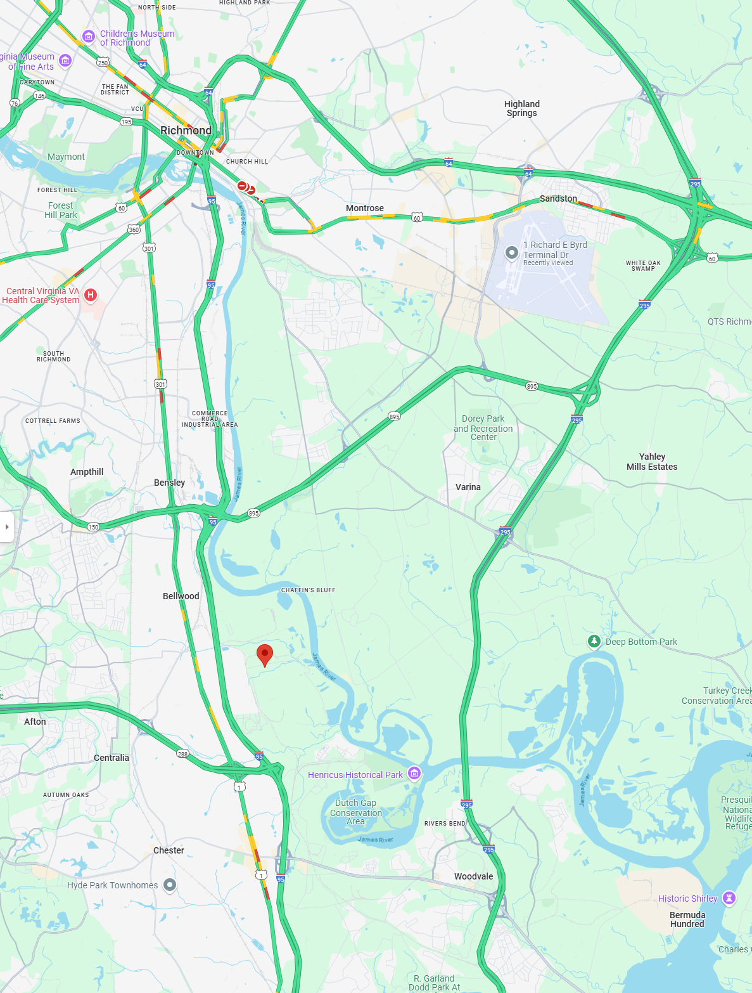




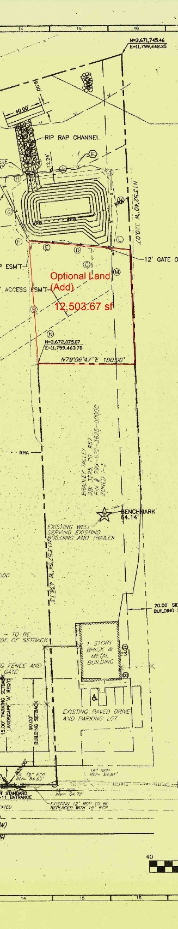
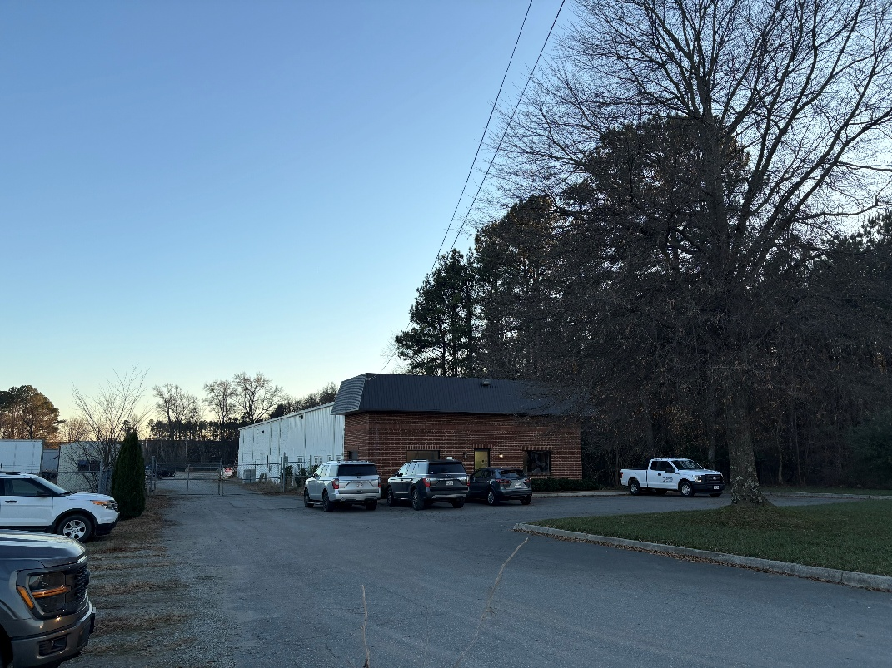
FOR SALE
1501 Willis Rd, Richmond, VA 23237

- <1 Miles from I95
- <4 Miles fromVA288
- 7 Miles from VA 895
- 15 Miles from Airport (RIC)
- 10 Miles from Richmond City

- .95 Acres 5,600 Sf Building
- Price: $1,390,000
- Leased with Tenet
- Industrial (I2)
- Fenced & Lighted
- 2,800/2,800 Sf
Office/ Warehouse

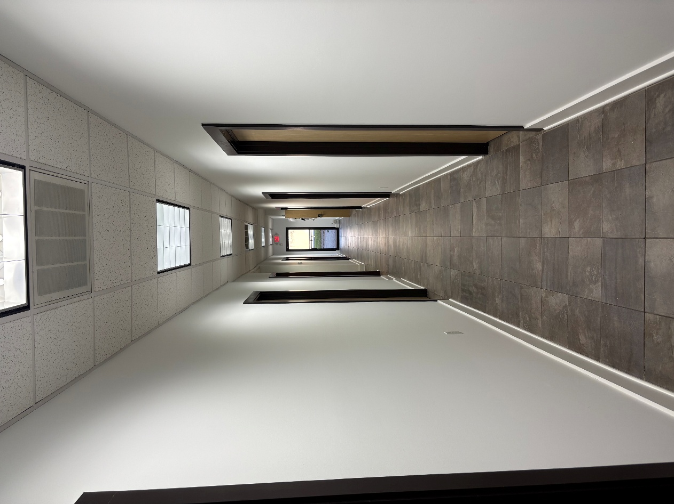
Lease Terms
- Term: 1 Year w/( M/M Extensions)
- Price: $9,000 Month
- Lease Type: NNN
Contact: Alexander L. Brown
Phone: (804)-694-7328
Email: alexanderb.management@gmail.com

