
MEDSTATION
25 Hidden Ravines Dr
Lewis Center, OH

March 31, 2021

“Rethink How You Deliver Patient Care”

MedStation is a beautiful new medical co-working space designed and owned by physicians. It provides a turnkey location on a moment’s notice allowing health care providers to further their own private practice without the red tape.

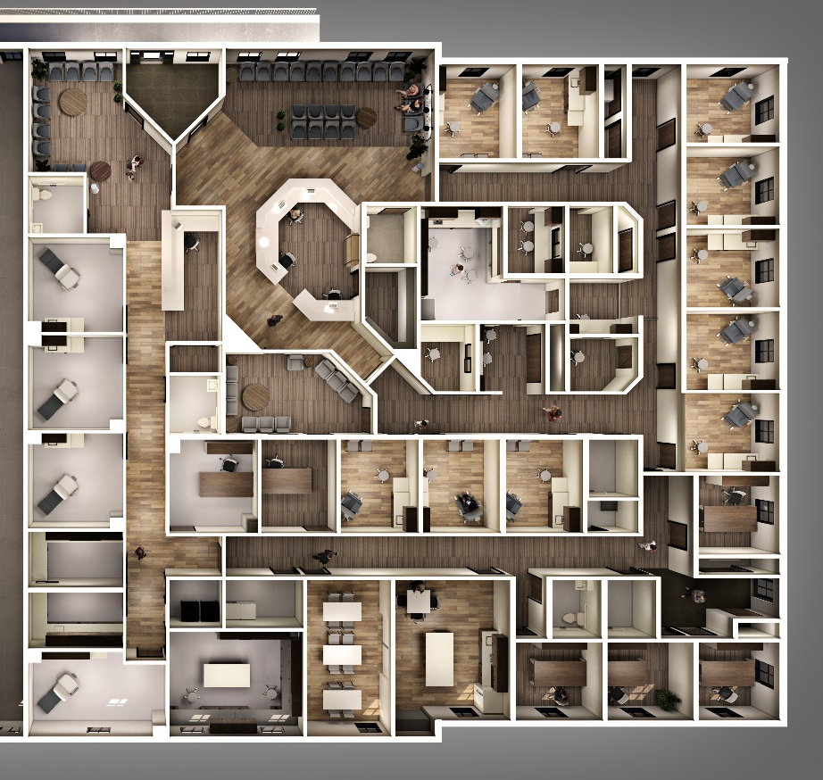
Starting a practice or expanding to another location should be nimble. As you change and develop new concepts, the environment around you should also adapt. MedStation allows complete autonomy and flexibility providing a state-of-the-art workspace for health care providers without any long-term commitments. Are you curious to see if you are ready for a second location? Perhaps, you would like to start a practice one day a week and expand from there? Or is it time to go back to the basics and downsize?

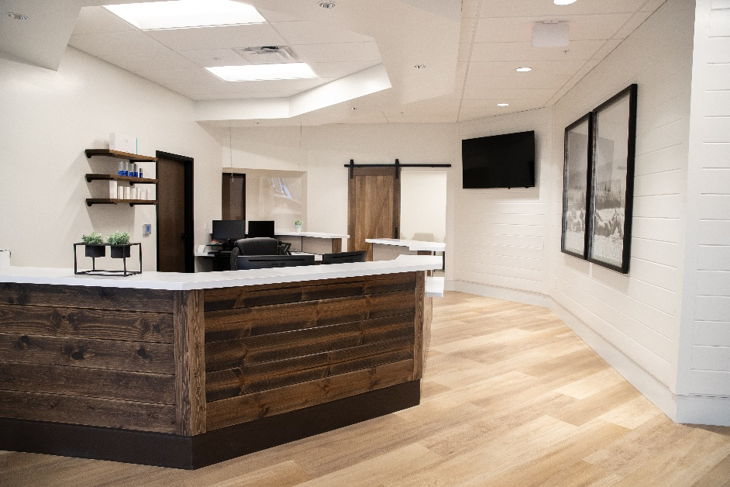
Health care providers can practice medicine in our space on a month-to-month basis for the first 90 days. After that, it is simply a yearly commitment with the flexibility to increase or decrease space as needed based on availability. It is like having your own suite without any of the hassles of a traditional medical building. Several amenities include a stand-alone building with ample parking, a friendly greeter to welcome patients, and a well-designed clinical lab. Each exam room is complete with a sink, an exam table, a stool, and a guest chair. Other amenities include cleaning and disposal of sharps and biohazard materials. Our founding physicians designed the space to accommodate private dictation rooms to document the medical visit with a sliding glass window allowing for collaboration between team members.

“As owners of an existing private practice, we know how hard it is to commit to a location long-term through capitol allocation and multi-year lease agreements. That is a significant financial risk even before you see your first patient. MedStation is designed to eliminate the red tape that is involved in owning a private practice. It also facilitates an environment that fosters collaboration between the tenants and various strategic partners. Our goal was to create the wish list we never had.”- Marya Cassandra, DO Co-Founder of MedStation and Signature Dermatology, LLC

Burnout

In recent years, hospitals, health systems, and advocacy groups have tried to curb the “burnout” by starting wellness programs, hiring chief wellness officers, or attempting to reduce administrative tasks for nurses and physicians. Some 55% of physicians reported that administrative tasks are the main driver of burnout and spending too many hours at work was also a top contributor across the board.

MedStation Solution

MedStation leverages electronic health record technology by eliminating extraneous time constraints allowing health care providers more face time with patients. MedStation is a complete paradigm shift in the evolution of patient care and provider independence.
This model allows providers to have flexible schedules at a new location without paying for unused space. For example, options include utilizing one exam room one day per week. As the health care providers’ practice grows, they may add more rooms or days that suit their schedule.

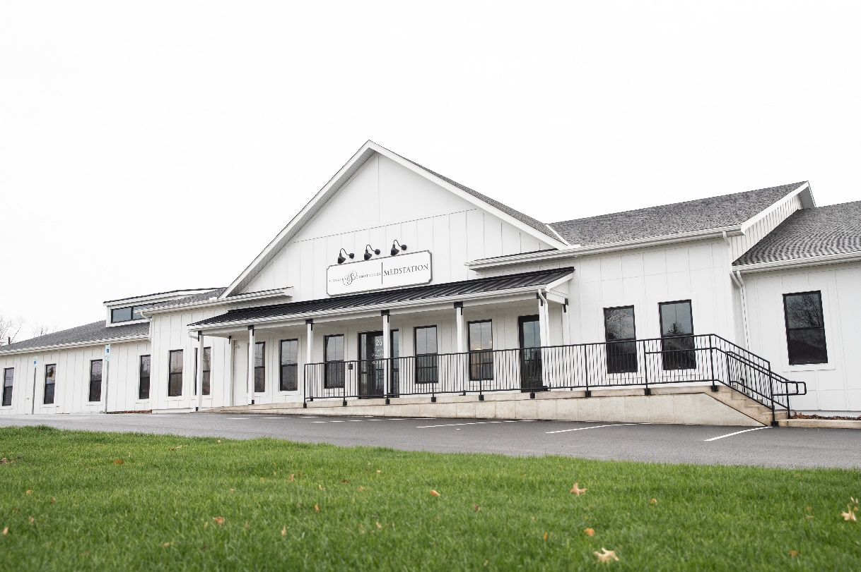

Future Impact Covid-19

The burnout trend has certainly been exasperated by Covid-19. The pandemic’s longest and most deadly surge has posed risks to quality of care and left medical professionals exhausted.

MedStation Solution

Due to hospital burnout and likely attrition of health care team members, this is an opportune time for providers to pivot their career into private practice. MedStation allows providers to easily start a private practice with minimal capital expenditure in the fastest growing county in Ohio. Through extensive market research over several years, MedStation acquired the land, designed the building, and oversaw the entire project with private practitioners in mind.

Whether you are a physician out of residency, looking for a satellite office, or looking to start your own practice our medical co-working space will reduce burnout and enhance patient care.

Medical Office Space for Rent Columbus, OH About Us | MedStation (mymedstation.com)

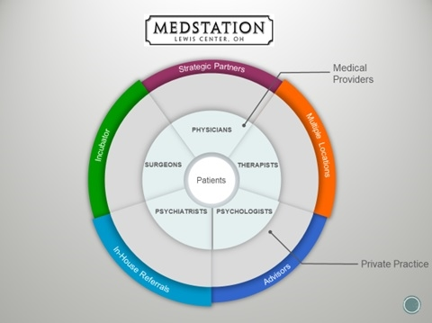

In Summary

MedStation’s female founders have successfully owned and operated their own private practice, Signature Dermatology, LLC for over eleven years. By founding one of the most well-known and trusted dermatology practices in Columbus, they are uniquely positioned to understand the marketplace and put other self-starters on the path to success.

Daniel Costanza
President & CEO
614.534.1470
daniel@mymedstation.com

###

Brianna Abbot, “Physician Burnout is Widespread, Especially Among Those in Midcareer,” Wall Street Journal, January 15, 2020.
Melanie Evans, “Covid-19 Surge Leaves Doctors, Nurses Reeling From Burnout,” Wall Street Journal, January 25, 2021
County Demographics - Regional Planning Commission (delaware.oh.us)

