open space for lease
approximately 1000 SF.
Big parking lot with incredible signage!!!
READY FOR OCCUPANCY NOW!
5530 Del Amo Blvd., Lakewood, CA

Suite A - $1,350 per month
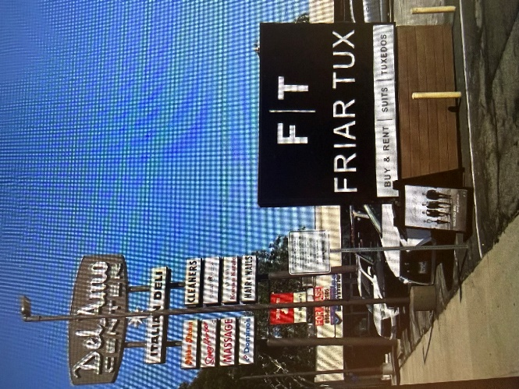
2 private bathrooms - strong income area –restaurants, etc.
2 front door entrances and 1 rear door – Unit can be split, if needed
Private corner space with lots of natural light!
Call or text Joe at 818 635 2105

