
1619 Third Avenue, New York, NY 10128 p (212) 534-7771 f (212) 534-6140
www.rymanagement.com

RUPPERT YORKVILLE TOWERS
Office Space Available

LOCATION: | 1623 Third Avenue – Ground floor and lower level
RENT: | $51.26/sq. foot, $35,000/mth.
AVAILABLE DATE: | March 1, 2024
SQUARE FOOTAGE: | Approximately 6,095 sq. ft. on the ground floor and 2,097 sq. ft. on the lower level (8192 total).
UTILITIES: | Electric: (including electricity for air conditioning and heating of the Premises) – submetered – paid by tenant – tenant to pay kwh rate paid by landlord plus $.02 per kwh handling fee.  Water: Submetered – paid by tenant Gas: None available.
REAL ESTATE TAXES: | Tenant will pay its proportionate share of landlord’s real estate taxes allocated to the space each year over and above a base year (prorated for any partial years).
BROKERAGE FEES: | RY Management Co., Inc. is the exclusive leasing agent for his space; brokerage fees to be paid by landlord. Landlord will also pay commission on any pre-approved, co-brokerage arrangement for this space. However, if tenant engages the services of another broker and it is not a pre-approved, co-brokerage arrangement, all fees and  commissions to be paid by tenant to tenant’s broker.

J&/41 ! 0 i1, i i i .. 1 i ]
1
,.. ••11,1

CJ
D,,
0
dI
q JI
□
I I

==--
D

II""
=
r
--
-- 0

i,-IIOJIII :r-- ::-IIO- ip:.,;a

p D.. o .D .D O'
I I I
I I
---7
I
d
d

/
/

fi]
=, ==":::l;::;-"w m_ JTI
, I I I'
' ''Q]_ __[g_ JI LI Jg] I□V,/

GROUND FLOOR TOTAL SQ. FT.: 8095

East 92nd Street
- ,
I
i

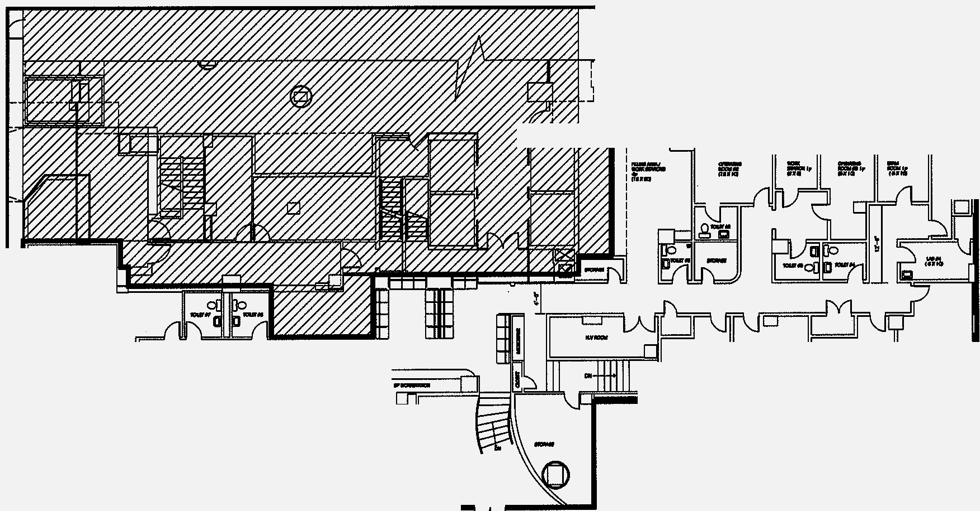

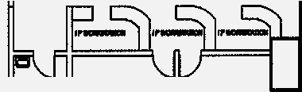
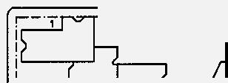

GROUND & LOWER LEVEL TOTAL SQ. FT.: 8_'192_
- GROUND FLOOR OFFICE PLAN
SCALE: 1111'• N'
--

OFFICE SPACE

C
- ! t-AFFECTED
I LJ--= •AREA
r=
_J
L----·--·--·--·-- --
East 91st Street

"

vx/ «r LrL<4«((4'ro/<ft1/««,(<X1 u,,,
E 0
d

I
I
q.. JI
I
I q
F- c:::1 7
I

»-::... C !!L.
OOlli
/
□

--_)]
I I
I I
g J L

---..;D;; D'd{
p_ _o_ o_ _o_ _o_ _o /
I I I I I I I

/p

LOWER LEVEL TOTAL SQ. FT. : 2097 "

East 92nd Street
- ,

GROUND & LOWER LEVEL TOTAL SQ. FT.: 8192
I
i
<( : j-AFFECTED

0 LOWER LEVEL OFFICE PLAN
1/11'•1'0'
I
L----·--·--·-- -- --

1
_JAREA

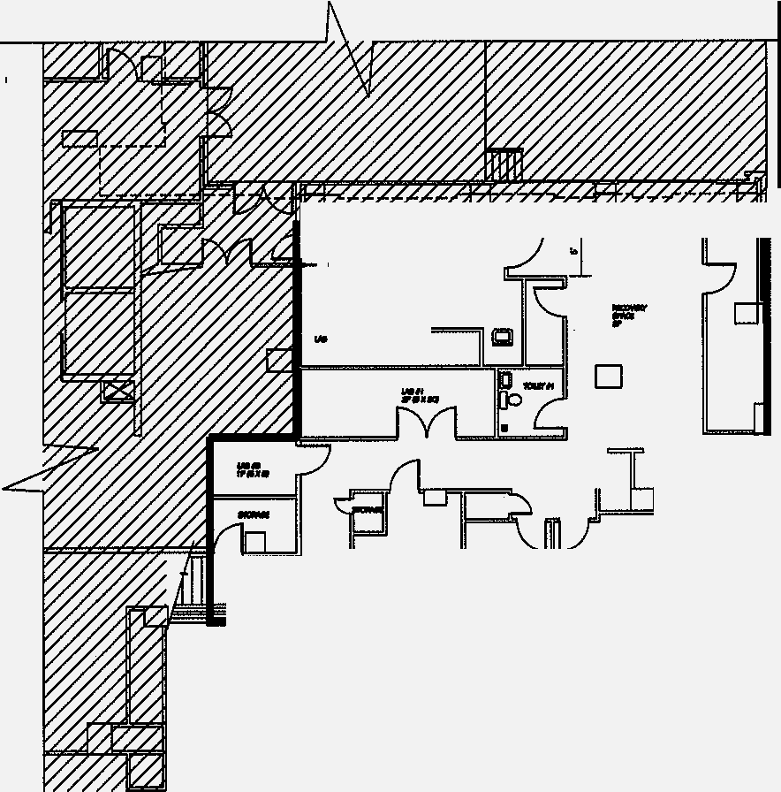
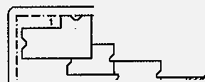
-- OFFICE SPACE
East 91st Street

