

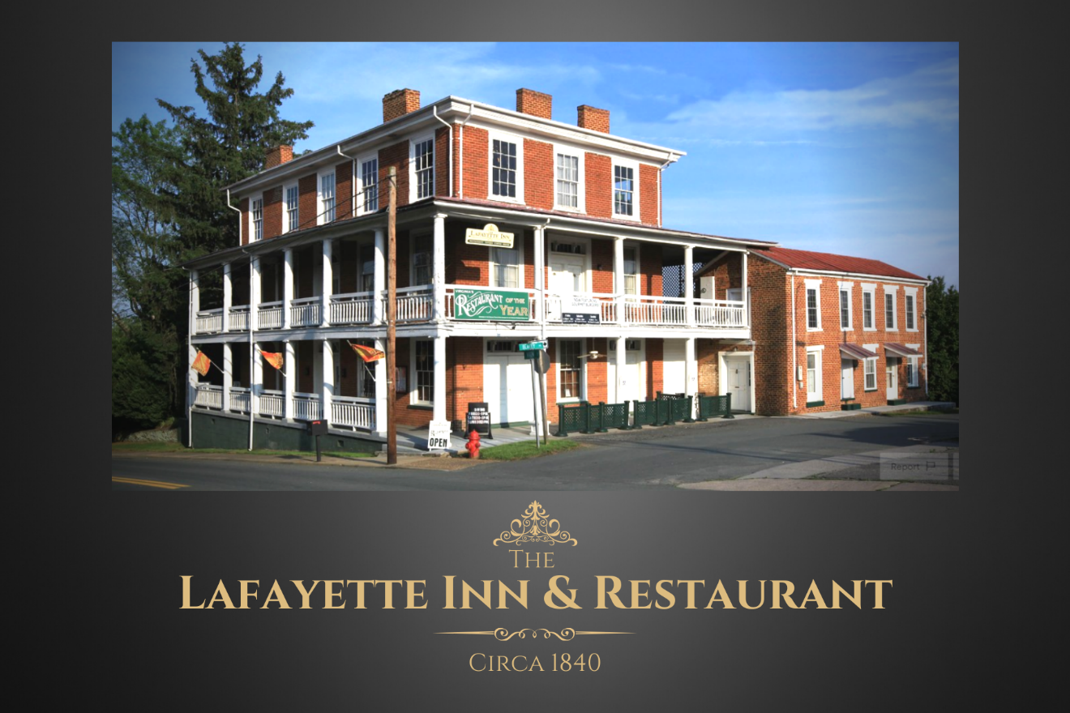

Lafayette Inn & Restaurant- Executive Summary July 2022
146 Main Street, Stanardsville, VA 22973
(County Seat, Greene County)
(Updated edits June 2022)
“A snapshot to get to know the current owners, area, business and untapped opportunities.”

Table of Contents

History- Build in 1820 & 1840
Owners and Opportunity- Alan & Kaye Pyles
Where is Stanardsville? – Just north of Charlottesville
Property- Located on Main Street in the County Seat
Inn Suites- Six unique fully furnished suites
Restaurant- Fine dining 40 seat dining room, and 25 Seat Tavern
General- Beautiful setting, private parking with over 200 additional free adjacent parking
Price and Terms- Broadly defined.

The Lafayette History
History taken from an article by Donald Covey in the 2004/2005 issue of the Greene County Magazine, published by the Greene County Historical Society by permission.
Stanardsville, was established in 1794, became the County Seat of the newly formed Greene County. In 1838 Robert Pritchett, a prominent citizen began the construction of the Lafayette.
The Lafayette (circa 1840) is a Federal-style three story building. Its walls, three layers of brick thick, surround a large central hall and stairway, with rooms on either side. The Tavern room was both a saloon and a general store. The entire second floor served as a ballroom, and the third floor was the residence for the Pritchett family. The fourth floor (cupola) offered a view of the town in all directions. Above the cupola was a bell used to call people to meetings or meals. The hotel was heated by twelve fireplaces. The side building was the earliest building on the lot, (circa 1820) constructed to house some of those who worked on the hotel. The property included “Dicey’s Cottage” (at the edge, on Main Street) served as the original slave quarters to “Miss Dicey” and others.
The most consistent and sustaining use of the Lafayette was that of a regional stagecoach stop. Travelers would stop for a few days to rest and prepare for the challenging trip over the mountain when traveling west- and equally played host to others that just conquered the mountain traveling east- resting up for several days. Historians believe the expression “We have you coming and going” may have originated from this experience.
In 1862 General Stonewall Jackson ordered General Richard S. Ewell to move his 8,500-man division into Greene County where they would be available to Jackson over in the Shenandoah Valley. Ewell’s men became sick, probably with typhoid fever. The Lafayette was converted to a hospital during this period.
After the Civil War, the manager, James Saunders, and Dr. Edwin S. Hunter, returned the Lafayette from a hospital to a hotel. The hotel became a regional destination for entertaining political groups, lodges, and celebrities of the day.
In 1887, local lawyer, schoolteacher and legislator Francis Marion McMullan began a bid to gain control of The Lafayette, by purchasing the Pritchett family’s one-third interest. But he failed, and in 1890 he sold his, by then, five-sixths interest to Magnolia and Robert Blakey, who eventually gained total ownership for $4,300. Magnolia sold it in 1893. From then until 1914 it changed hands five more times.
H.W. Moyers then bought the hotel, which was passed down to his family until the 1980s. There seems to have been plenty of social and business activity at the hotel over the years. The side building has been used for several purposes: a post office, the telephone exchange, law offices, and as home to the Greene County Record, Greene County’s weekly newspaper.
In 1989 the hotel was sold to Bob Sowder, who succeeded in having the Lafayette Hotel placed on the Virginia Landmark Register, making it possible for inclusion on the National Register of Historic Places. (*)
In early 2005, the Lafayette Hotel was bought by Alan and Kaye Pyles, who are intent on maintaining and further restoring the historical integrity of this local treasure. Alan and Kaye changed the name to The Lafayette Inn & Restaurant, which they believe is better defined their business. The Lafayette Inn and Restaurant has (and continues) to enjoy accolades reaffirming their commitment to deliver a positive, but approachable dining and lodging experience. Named “Virginia’s Restaurant of the Year” (Virginia Food & Wine Society), Open Table “Best Overall,” Trip Advisor “Travelers Choice,” and several others.
(*) The Lafayette Hotel is registered/listed with the Virginia Landmark Register, but a decision NOT to join the actual registry as it was deemed restrictive and expensive- and not overly beneficial.
Owners & Broad Opportunity
Alan and Kaye Pyles purchased the Lafayette Inn & Restaurant in 2005 with the intention of simply being supportive property owners. A decision was made to move to an owner/operator role soon after but with an open acknowledgement that they would operate the business as “retired couple.” The business model was then and remains today to take advantage of some of the best opportunities- but remain willing to pass on many (“normal”) opportunities that would require more personal work and attention they were willing to commit. This commitment has required a great deal of humility (knowing “it’s no way to run a business”). Having enjoyed a successful business career prior, they established a commitment to remain within their semi- retirement status. This has permitted them to remain successful for the past 18 years. Having aged of course and now having a new grandson, the Pyles have decided it is time to fully retire from the Lafayette Inn & Restaurant- watch someone come in and take full advantage of all the opportunities- but also allow Grandad and Mimi to turn their full commitment their grandson, Hunter.
Worthy of mention- Neither Alan nor Kaye had ANY experience in a restaurant, as a chef or innkeeper. While they are proud of their accomplishments, both look forward to where someone with experience can take the Lafayette in the next chapter in its third century.
Acknowledgement- While the Pyles relaxed efforts in running the business in a semi-retired form provided them the ability to carry the business successfully for 18 years- it also results in a lower sales price for a buyer (less gross volume produced) and provides the buyer an undeniable ability to immediately increase the sales/volume/value of the investment from day one. While cliché…a “Win/Win” for both the seller and the buyer.
As a result of our semi-retired approach:
- We are only open about 20% of the potential “Shifts” for an operator per year. (Granted- largely cherry picked)
- We blocked nearly 300 rooms (last year) from reservations for personal time off (vacation), grandson’s birthday, super bowl home viewing, take a breath…
- We stopped doing Thanksgiving meals (16 years ago) while it was our best grossing day each year, pass on the vast amount of Christmas Eve and Christmas Day reservations- to be with our own families.
- Our relaxed commitment has made us ineligible for the Rt. 33 direction signs as an example- the time has come where someone needs to position the inn for the next level. (Hugh opportunity for active owners! VDOT counts 27,000 cars daily pass ¼ mile behind the inn).
- The natural overflow of restaurants (specific) but also lodging from the high-end Glamping project (1/2 mile west) alone has staggering positive implications- Let alone the 500 homes (1/2 mile east) to eventually/some form/fashion- just blocks away.
- Attack/approach the northern Charlottesville new growth beside and entering Greene. Give them to “Dine in Greene”!

Pressing opportunity - secure a buyer willing and ready to take on the wonderful growth and opportunities that have finally reached our doorstep.

Easy grab- 1-2-3!
- Be Open!
- Being open more days will qualify the Inn for the VDOT directional road signs on Rt. 33. A VDOT study released in February 2021 indicates 26,000 vehicles travel that road daily (.4 miles from the Lafayette on Rt. 33 Business). The vehicles represent both cross state travelers as well as commuters between Charlottesville and Harrisonburg- with the Lafayette being halfway between both. Cross state travelers are key targets for the Inn and the commuters for the restaurant.

- Be Open!
  - Restaurant- Only open about 20% of the potential shifts (BF/L/D) per year. (Granted for sure- mostly the best opportunities).
Only open to the public (restaurant) on Thursday-Sunday evenings and Sunday Brunch.
- Not open for Thanksgiving, Christmas Eve & Day
- Only regular dinner hours for NYE
- Not open on Superbowl Sunday
- First half of January Siesta (completely closed)
- About 10-12 day mid-year break (completely closed)
- Not open to the public for breakfast
- Not open to the public for lunch
- Dinner only open Thursday-Sunday and brunch on Sunday.

- Be Open!
  - Inn Suites- Rooms blocked for personal time 275-300 rooms taken offline.
  - Typically focus on only one dining room.
  - No bar, lounge, wine/martini space utilized.
  - Last reservation 7:30 (Thursday-Saturday) 6:30 on Sundays.

Where is Stanardsville, Virginia?
(Just North of Charlottesville, VA)
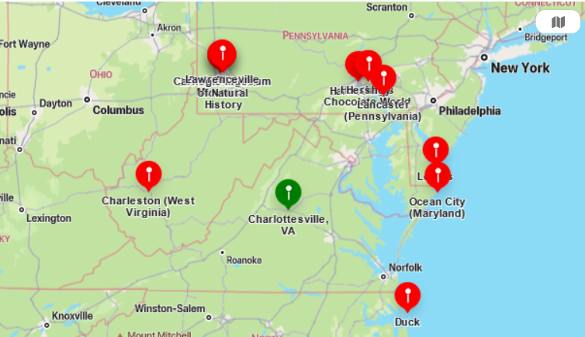
Destination location- Nearby Tourist Attractions
Millions $$$ invested by others to draw guests to our region.
- Skyline Drive/Blue Ridge Parkway (9 miles to Swift Run entrance/exit)- fall foliage
- University of Virginia (21.5 miles) James Madison University (30.4 miles)
- Monticello, Montpelier, Ashlawn, Michie Tavern
- Vineyards- Early Mountain, Barboursville, Horton, Stone Mountain, Glass House…
- Craft beer, Antiques, Carter Mountain Orchard
- Caverns- Luray, Skyline, Grand, Shenandoah
- John Paul Jones Arena, Scott Stadium, Davenport Field, Bridgeforth Stadium
- Destination Weddings- barns, vineyards, mountain overlooks
- Massanutten Resort- 22 miles west. Golf, Skiing, Water Park. Boasts over one million visitors per year!
Local View
- North of Charlottesville
- East of Harrisonburg
- South of Culpepper

Regionally –Destination Location with LARGE population base within 5 hours drive time
1 hr. 45 min: Fairfax “Northern VA”, VA
2 hr. 15 min: Washington, DC
2 hr. 30 min: Williamsburg, VA
2 hr. 30 min: Berkely Springs, WVA
3 hr. Bethesda, MD
3 hr. Annapolis, MD
3 hr. 15 min: Baltimore, MD
3 hr. 30 min: Virginia Beach, VA
3 hr. 45 min: Hersey, PA
3 hr. 45 min Durham, NC
4 hr. 15 min: Wilmington, DE
4 hr. 25 min: Pennsville, NJ
4 hr. 55 min: Philadelphia, PA
4 hr. 45 min: Charlotte, NC
4 hr. 45 min: Pittsburg, PA
5 hr. Dewey Beach, DE

East Coast Access
- East of 81 North/South
-West of 95 North/South
-North of 64 East/West

Local Transportation Hubs:
Charlottesville-Albemarle Airport- 22 min. /14.9 miles
Dulles Airport- 1 hr. 35 min./86.9 miles
Richmond International Airport- 1hr. 43 min./93.6 miles
Washington Reagan National Airport 1 hr. 56 min./102.3 miles
Charlottesville Amtrak Train Station- 39 min./23.1 miles

The Property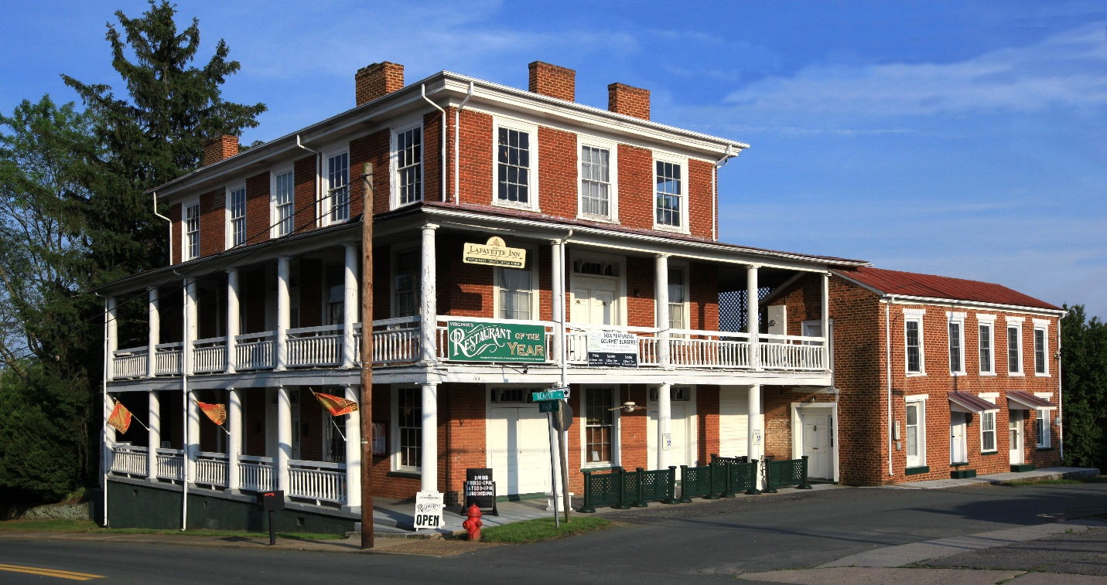
Legal Description:
Tax map- 37A-A-33A, 9D and 9E recorded in deed book 375 page 229, deed book 551 page 155.
Main Building Circa 1838 beginning, occupied 1840.
First Floor- 2,700 sf. – Dining room, Tavern, Foyer, and Kitchen.
Second Floor- 2,040 sf- Two regular suites and one double suite. (Not included is the covered deck around three sides of the building)
Third Floor- 2,040 sf- Owner’s floor. Finished office and full bathroom. Laundry room. Bedroom/Storage room. The other 40% is unfinished- used for storage.
Fourth Floor- original observation room- now houses two HVAC units.
Side Building Circa 1820
Two Inn suites- 1,120 sf
Dicey’s Cottage- Circa 1840
Two story suites approx. 1,004 sf
Total Building Space- Approximately 8,904 sf
The site consists of three parcels totaling approximately .6068 of an acre, or 26,432 square feet. Slightly above street grade the lot gradually drops to the east allowing for good site drainage. Public utilities consist of water, sewer, electric and phone service.
Zoned Mixed Use. Multi-family residential and commercial.
Signage (Grandfathered)
100+ year trees and shrubs
Landscaped
Select outdoor lighting
Private paved parking lot (and an additional 200+ adjacent free public parking spaces)

Inn Suites
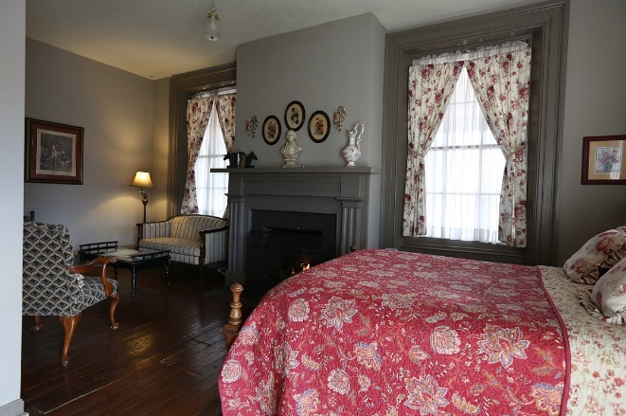
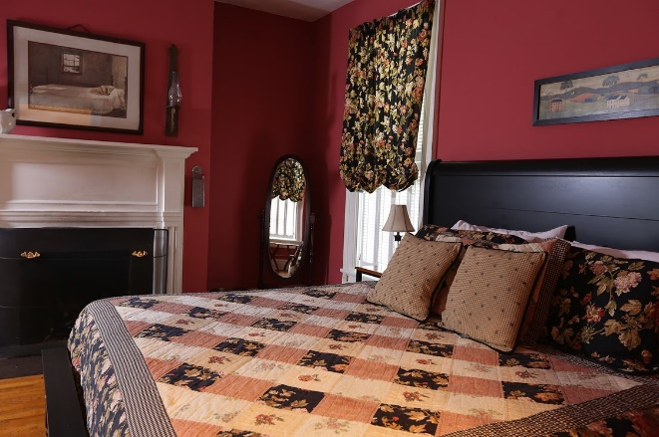
Six fully furnished Inn Suites
Full inventory of linens
Each Suite includes Keurig Coffee Machine, Flat Screen TV (Basic TV)
Full Bathroom/Private entrance
Outsourced room cleaning staff
ResNexus Reservation system/Direct Connect (integration with other travel portals)
- Prime portal relationship- Expedia Group.

- Suites:
- Wilson Suite- Loft Style. Queen Bed. $149
- Washington Suite- Handicap friendly- Queen Bed. Mini-Ref $149
- Monroe Suite – Gas Fireplace – Queen Bed. $179
- Jefferson Suite– Gas Fireplace – Queen Bed. $179
- Tyler Suite- Double Suite, mini ref Two Queen Beds, two electric fireplaces $199
- Dicey’s Cottage- Free standing/2 story. Kitchenette. King Bed, Gas FP $199
(Monday-Tuesday-Wednesday- $20.00 discount
Restaurant
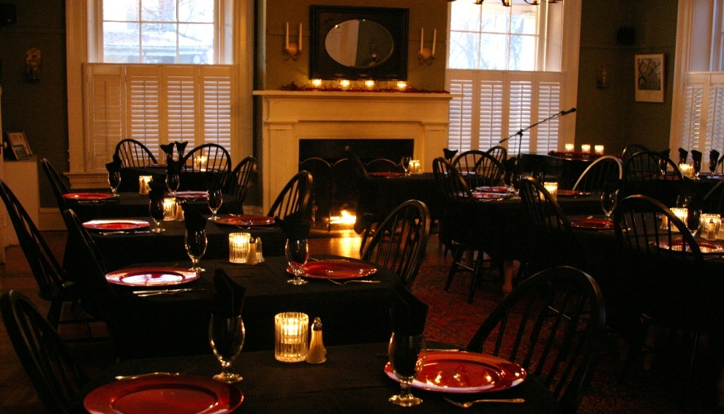
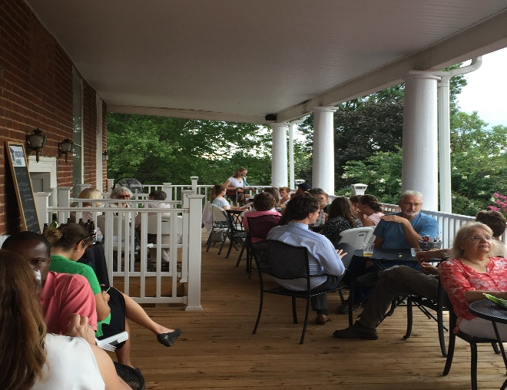
Fully furnished dining space and commercial kitchen
27 years continuous operation (18 years from current owners)
40 seat dining room with two gas fireplaces
24 seat “Tavern” with electric fireplace
Large commercial kitchen
Walk in refrigerator/Walk in Freezer
Adjacent dry storage garage.
Toast POS (Lease)
Toast Online ordering
Wine, Beer, and Liquor inventory
(2) Custom made 192 bottle wine racks
Kitchen furnishing/food inventory.
Dish Machine & Coffee machine (Leased by Ecolab and Sysco respectively)
Deposited events and reoccurring events booked
Experienced/Long term staff in place
Common area/Kitchen cleaning crew (outsourced)
General
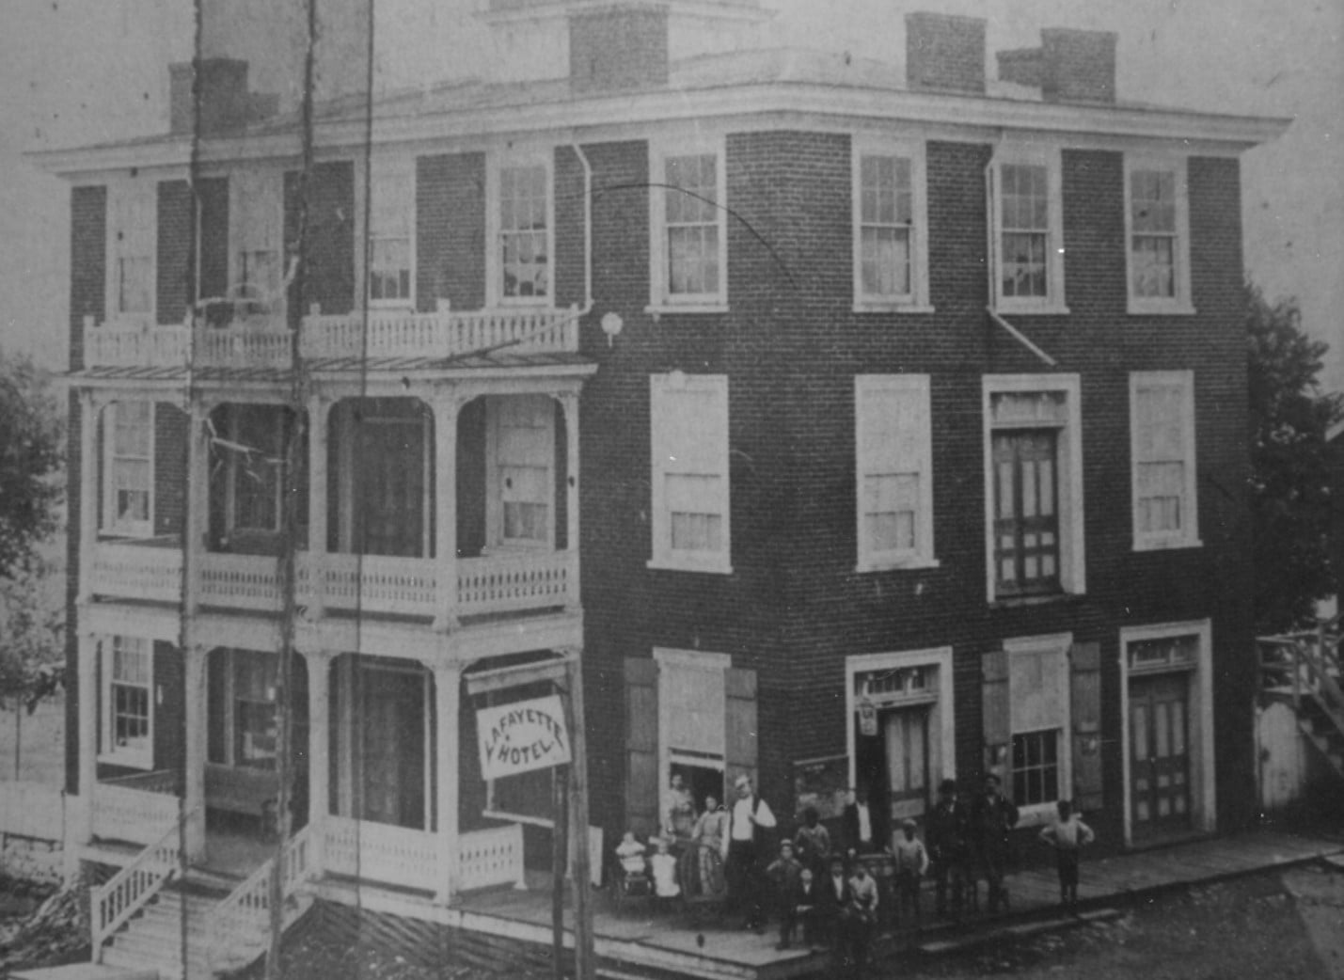
PopMenu (formerly Ordereze) Web Site & URL- www.thelafayette.com
10,000+ guest list active database (divided between a few databases)
The third floor is currently set into three spaces.
- Office, full private bathroom, laundry/storage.
- Private bedroom
- Unfinished large section/storage
The third floor & “third and a half” lends itself to as an owner or management quarters. The second-floor common space is a perfect place to move the office (third floor)- and dedicate the entire third floor to personal owner/management living quarters.
Accolades to the Lafayette Inn & Restaurant
- Trip Advisor- Hall of Fame
- Best of the Blue Ridge- Hall of Fame
- Virginia’s Restaurant of the Year- Food & Wine Society
- Open Table- Diners Choice (over a decade)
- Accolades more specific to the owners have been downplayed- opening the door for a buyer to 100% assume the name and current menu (etc.) and transition as desired to their own vision.

Package Offer- Real Estate and Business
Why the Lafayette Inn & Restaurant?
Recession resistant- (Items listed below prior, but a brief reminder). Tens of Millions $$$ invested by others (see below) to bring guests to our region. Now the trick is to get a “few” to the Lafayette! (Where WE wanted to invest our money)
- Skyline Drive
- UVA
- JMU
- Monticello
- Montpellier
- Monticello wine trail/Beer- Wine Enthusiast’s “Wine Region of the Year
- Antiques
- Weddings (Rehearsals for us), Birthdays, Anniversaries, Promotions… (Large restaurants/hotels- does not make a dent. Small- steady and helps one sleep well at night)

Critical for OUR buying decision in 2005.
Marketing aspects of owning a historic building. Many visit to explore our historical building and the romance of the hidden stories left within the walls. Imagine being a hospital during the Civil War. Others want to admire the structure, mortar style between our1820 and 1840 buildings, learning the back stories of the floorboard widths or what the knots tell historians, or 15” walls.
All the historical items are interesting, but as a business owner/investor- What drew us was the fact no one can “Build old.” We have all been invited to join someone at the “New Restaurant in town.” Virtually no one has been invited to “join us for the second newest (third, etc.) restaurant in town. We wanted to invest our dollars into a building that would continue to work for us- not simply while it was the current “new.”

Complete “Turnkey”- Down to “salt in the shaker” (inventory, dinner reservations, event bookings, inn room reservations…). Buyers can close on the sale on one day and be open for business with a pipeline of existing restaurant, event and Inn reservations starting the next day.
- Make improvements at your leisure.
- Make things “your way” at your leisure.
- But enjoy the immediate cash flow and ongoing repeat business from day one.

We are selling both the real estate and business together, here is a broad summary of our means to a price. (Complete details afforded as we move forward- this correspondence, remaining broad in terms).
Building
Using industry standard valuations for the building alone using the best local comps (No true comps available) – Performance Signs building- Nice building but odd/specific use. 8074 sf/$1.5M or $186sf. – Lafayette fully furnished at 8904 sf would be $1,656,144.
Business
Using industry standard valuations for the business utilizing a multiple of gross sales.

Combined Value- Exceeds $3,000,000.
Package offer- $1,700,000
(Understanding the above largely assumed top end, but industry standard levels).
Inviting owner financing terms available with 30% down payment. Important note- our historical revenue from Inn rooms alone will satisfy the annual mortgage responsibility based on the above.
While we are prepared to continue, our structure and offer affords a quick changeover if the buyer is interested.

Lafayette Inn & Restaurant Contact: General inquiries.
Alan Pyles- Owner
146 Main Street
Stanardsville, VA 22973
434 985-6345- Inn & Restaurant
434 466-4113- Cell
alan@thelafayette.com (Best form of initial communication)

