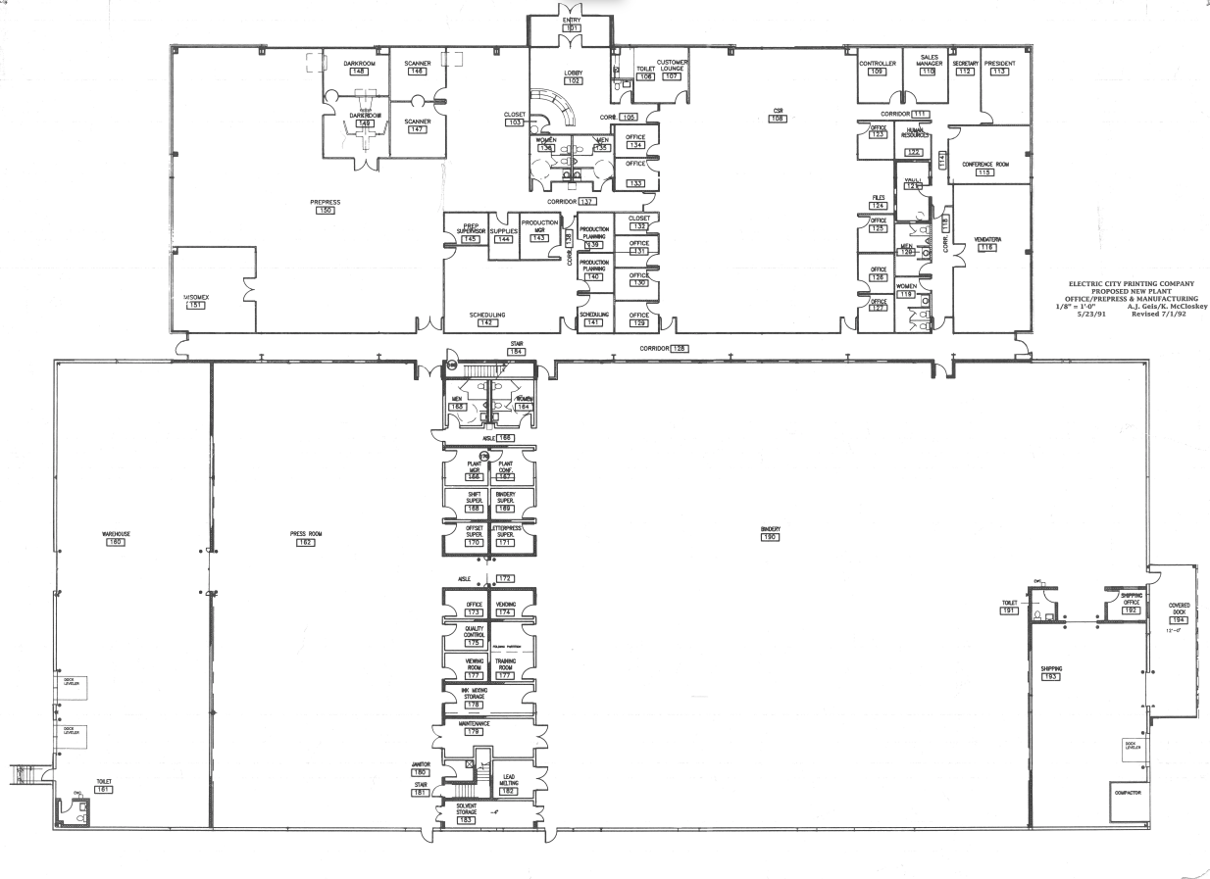

SUITE B – Approx 45,000sf Available
SUITE A – Approx 8,800sf Leased

