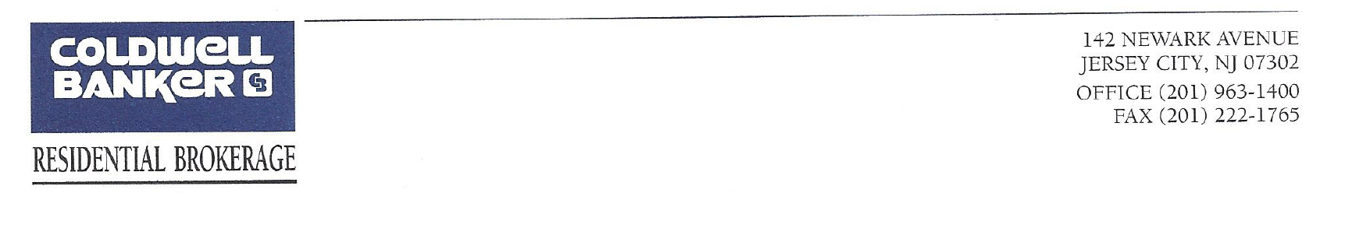
358-362 Grove St., Jersey City, NJ 07302
19 Residential units & 3 Commercial
Lot Size – 362 Grove = 25’ x 100’ – 358-360 Grove = 50’ x 75’
Income and Expenses

Asking Price - $7,500,000
Unit # | BR | Monthly Rent | Expenses
1D | 1 BR | $ 1,615.00 | Taxes - | $ 86,912.00
2A | 1 BR | $ 1,451.00 | Water - | $ 22,558.00
2B | 1 BR | $ 1,321.00 | Insurance - | $ 12,024.00
2C | 1 BR | $ 1,510.00 | PSE&G - | $ 4,166.00
2D | Studio | $ 1,250.00 | Maintenance - $ 8,000.00
2E | 1 BR | $ 1,623.00 | Exterminator/ back flow/fire monitor | $ 1,482.00
2F | 1 BR | $ 1,524.00
3A | 1 BR | $ 1,664.00 | Total Expenses - $135,142.00
3B | 1 BR | $ 1,477.00
3C | 1 BR | $ 1,700.00
3D | Studio | $ 1,224.00 | Net Operating Income - $410,690.00
3E | 1 BR | $ 1,592.00
3F | 1 BR | $ 1,600.00
4A | 1 BR | $ 1,834.00
4B | 1 BR | $ 1,620.00 | Cap Rate – 5.5%
4C | 1 BR | $ 1,707.00
4D | Studio | $ 1,450.00
4E | 1 BR | $ 1,510.00
4F | 1 BR | $ 1,650.00
Commercial |  |  | Comments
Store 1 | 400 Sq. Ft. | $ 2.700.00 | Vacant – proposed rent $2,700
Store 2 | 1,400 Sq. Ft. | $ 7,500.00 | Vacant – proposed rent $7,500
Store 3 | 1,400 Sq. Ft. | $ 4,626.00 | Current lease expires 03/2025 -market value rent then will be $8,000
Monthly Income |  | $ 44,148.00
Yearly Income |  | $529,780.00
Tax Escalation from stores |  | $ 8,835.40 | Stores share of taxes
Water, Sewer & Fire from stores |  | $ 7,216.19 | Stores share of cost
Gross Income |  | $ 545,832.00



