St. Andrew’s Episcopal Church, Waterville, Minnesota
Rebuilt Working Broker Price Opinion
Prepared from prior ECMN working assumptions and publicly available reference points
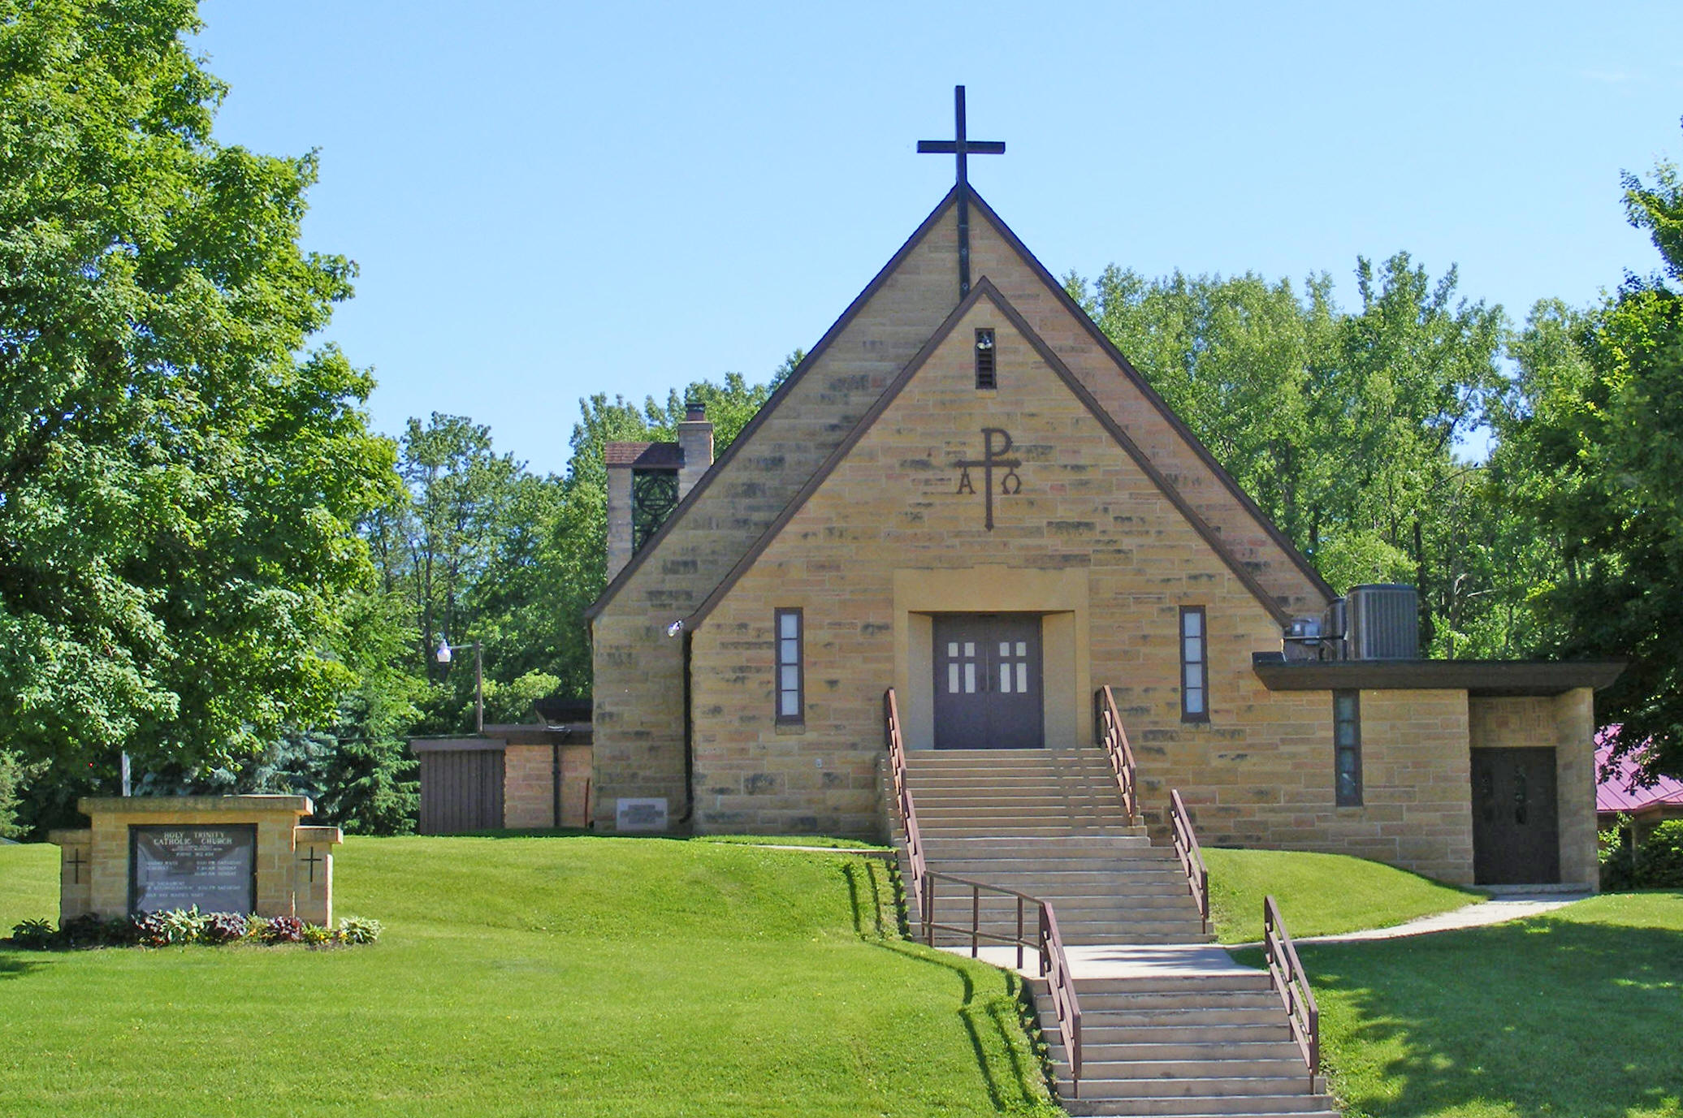 | Working address: Public sources show 208–210 W Lake St, Waterville, MN 56096; buyer to verify legal/site address.  Property type: Small historic church / assembly building  Estimated size: Approx. 1,500–2,500 SF (working assumption)  Estimated site: Approx. 1–2 acres (working assumption; confirm by survey/GIS)  Current positioning: As-is church / nonprofit / adaptive reuse opportunity  Windows: Working estimate about $15,000 total unless later authentication or appraisal proves otherwise.

Executive Summary
This rebuilt BPO treats St. Andrew’s as a thin-market church property where land value, character, and adaptive-reuse potential matter as much as the building itself. The most realistic near-term buyer is a local or regional user: congregation, nonprofit, community group, studio/event operator, or small mission-driven business.
Based on prior ECMN working assumptions, a reasonable list-price target is $265,000 to $295,000, with the most likely negotiated sale outcome in the mid-$200,000s, roughly $235,000 to $265,000. A more conservative building-only read, if acreage or reuse utility prove weaker than expected, would support roughly $169,000 to $175,000 list guidance.
The right story is not “historic church only.” The right story is “small-town landmark property with flexible community, creative, and nonprofit reuse potential.”
Conclusion | Working value guidance
Suggested list | $265,000–$295,000
Likely sale range | $235,000–$265,000
Conservative fallback | $169,000–$175,000 list if land contribution or reuse utility prove materially weaker than expected

Why this range makes sense
- Waterville is a small, low-density market with a limited buyer pool for assembly properties.
- Church architecture narrows the field of purely conventional buyers, but its character can widen appeal to niche users.
- The site likely carries meaningful land value even if the building needs selective reinvestment.
- Adaptive-reuse potential is the value bridge: community hall, studio, chapel, small event use, nonprofit office, or mission-oriented commercial use.
- The stained-glass windows may hold separate value, but they should not be heavily loaded into the real-estate price until independently documented and appraised.
Highest and best use / marketing posture
Primary positioning: market as a landmark church property suitable for local worship, community, nonprofit, or creative adaptive reuse.
Secondary positioning: emphasize land + shell value to buyers who want a small-town venue, studio, or mission-driven redevelopment play.
Do not oversell it as a conventional commercial asset. It is a niche property, and the marketing should be honest, visual, and targeted.
Key assumptions / buyer-to-verify items
- Exact parcel acreage, legal description, zoning, taxes, and assessment data were not rebuilt from a current county parcel sheet and should be verified before launch.
- Estimated building size and lot size above are working assumptions carried from prior ECMN analysis.
- Roof, structure, mechanicals, electrical, ADA, and environmental condition should be documented before final list pricing.
- Public web references show the church address as both 208 W Lake St and 210 W Lake St; confirm the exact legal mailing/site address before MLS entry.
Recommended launch plan
- Confirm parcel basics and prepare a clean property packet.
- Use strong photography and adaptive-reuse language, not just church language.
- Reach local and regional buyers directly: congregations, nonprofits, event users, studio users, and community organizations.
- Offer buyer flexibility on timing and ordinary diligence, but keep pricing disciplined.
Source note: This rebuilt BPO relies on prior ECMN working assumptions developed for St. Andrew’s, plus public reference points confirming the church’s existence, history, and public-facing address. It is intended as practical pricing guidance, not a formal appraisal.

