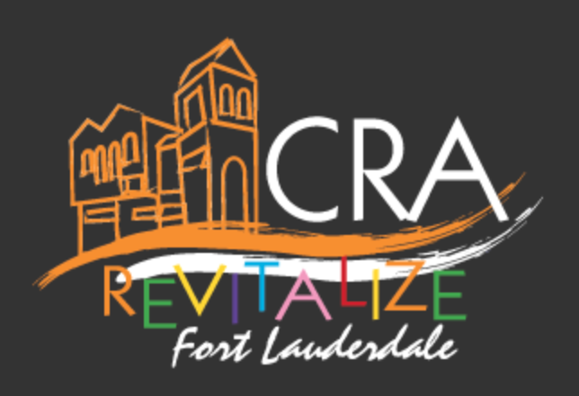

The Property and Business Improvement Program (PBIP)

The Property and Business Improvement Program (PBIP) is an incentive used to attract and grow businesses in the NPF CRA area. A forgivable loan up to $225,000 is available to assist with capital improvements to the interior and exterior of properties located within the NFP CRA area.

GOALS/OBJECTIVES: Eliminate blight, remove deterioration, retrofitting and rehabilitation of structures to remove undesirable uses, improve the “energy efficiency” of existing buildings in the NPF CRA area, or renovations designed to bring the structure into compliance with the current building codes and making them more viable for occupancy.

ELIGIBLE AREA: All properties within the NPF CRA area. There is a designated Focus Area defined as Sistrunk Boulevard between NW 24 Avenue and the FEC Railway, including one block north and south of Sistrunk Boulevard; as well as, 9th Avenue (between Sunrise Boulevard and Broward Boulevard), and 7th Avenue (between Sunrise Boulevard and Broward Boulevard).

ELIGIBLE PROJECTS:
1. Improvements to an existing building within the NPF CRA design and used for:
a. Non-residential use, or
b. Mixture of uses containing a combination of residential dwelling units with commercial retail sales, service, office uses or any combination thereof as permitted by the Unified Land Development Regulations, City of Fort Lauderdale.
2.Construction of a new building within the NPF CRA designed for:
a. Non-residential use, or
b. Mixture of uses containing a combination of residential dwelling units with commercial retail sales, service, office uses or any combination thereof as permitted by the Unified Land Development Regulations, City of Fort Lauderdale.
The proposed project must comply with the CRA Redevelopment Plan, urban design guidelines, applicable land use regulations, City of Fort Lauderdale.

ELIGIBLE PROJECT COSTS:
1. All costs associated with interior and exterior renovation of existing non-residential buildings including interior improvements, restoration, rehabilitation, and permanently attached fixtures or systems.
2. All costs associated with construction of a new non-residential building.
3. Architectural, engineering, permit fees, application fees, property taxes, tax liens, City liens and property insurance.
4. All costs specific to commercial kitchen improvements and permanently commercial grade kitchen equipment or systems. The kitchen design or engineering, construction materials, and equipment or systems must comply with applicable industry standards, such as: Dairy and Food Industries Supply Association, Inc. (3-A), United States Department of Agriculture (USDA), Food and Drug Administration (FDA), American Welding Society (AWS), Occupational Safety and Health Association (OSHA), American Society of Testing Materials (ASTM), American National Standards Institute (ANSI)Current Good Manufacturing Practices (cGMPs), and National Electrical Manufacturer’s Association (NEMA). The kitchen and its equipment will comply with all local health and safety requirements that apply to food produced for sale.

JOB CREATION AND RETENTION REQUIREMENTS: Job creation and/or job retention or another approved performance indicator may be a requirement for assistance provided through this program.

BASIS/LIMITS OF BENEFITS: A PBIP award will provide a forgivable loan for up to 75% of the eligible costs not to exceed $225,000. In the Focus Area, the program award will provide a forgivable loan for up to 90% of the eligible costs not to exceed $225,000. In the Focus Area, owner’s equity investment for funding requests that do not exceed $150,000, will be determined on a case-by-case review. The CRA Board (and/or designee), at its sole discretion, may consider increasing the funding limits and equity investment requirements on a case-by-case basis. For projects outside of the Focus Area, in order to be eligible for the PBIP, the business/property owner may be required to invest at a minimum, a dollar-for-dollar match of the CRA investment within the project. The CRA’s project contribution cannot exceed the documented contribution of the business/project owner.

TERMS AND OBLIGATIONS: The program award will have ongoing obligations/covenants, which includes, but is not limited to a lien on the applicant’s property.

SPECIAL CONDITIONS: There must be a documented selection process for the General Contractors selected for the applicants project. The City recommends the use of General Contractors from its approved contractor list. A CRA / City approved contractor must be used for projects where 60% or more of the costs are paid by the CRA. Contractors on the City/CRA contractor list, must be invited to bid on all work solicited by the project owner/developer.

