Madison Plaza
8510 – 8550 Madison Avenue, Fair Oaks, CA

Madison Plaza is 40,000 SF recently renovated commercial retail center containing a variety of tenancy including a Dutch Brothers coffee drive through, Kovar’s karate academy, Nerds on Call computer service, custom home design center, ebikes sales and service, veterinarian, salon and spa, children’s specialty school and day care, book store, hearing aid center, balloon event decor, gold/coin supplies, and smoke shop.

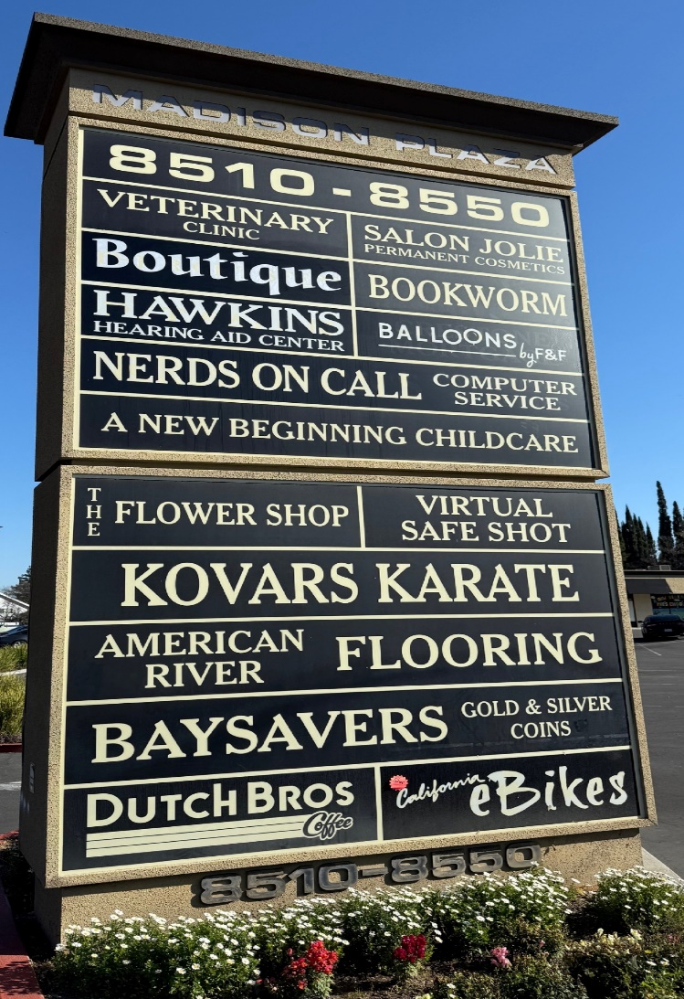 | - Rents range from $1.20/sf + NNN to $1.40/sf + NNN  - Triple Net (NNN) is approximately $0.32/sf  - Rent is waived for the first three months when lease durations are longer than 12 months  - Contact Information:  RFAM, LLC  John Roccanova, Manager  (916)759-2214  johnrocc@icloud.com
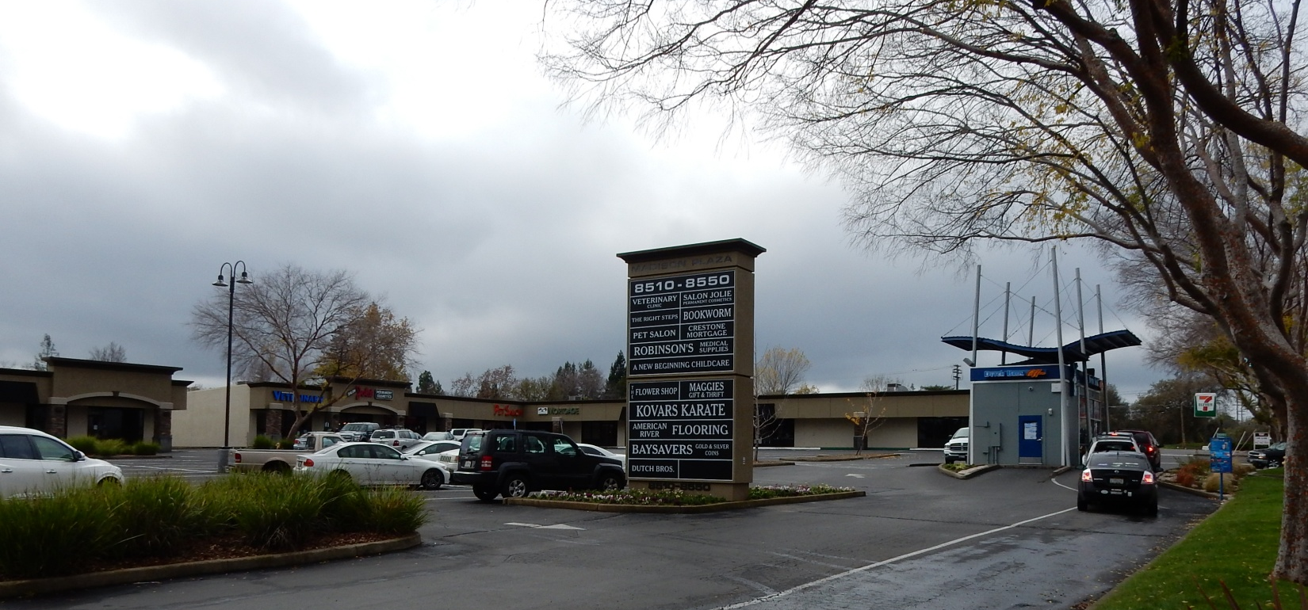
8514 Madison Ave
1200 SF Available
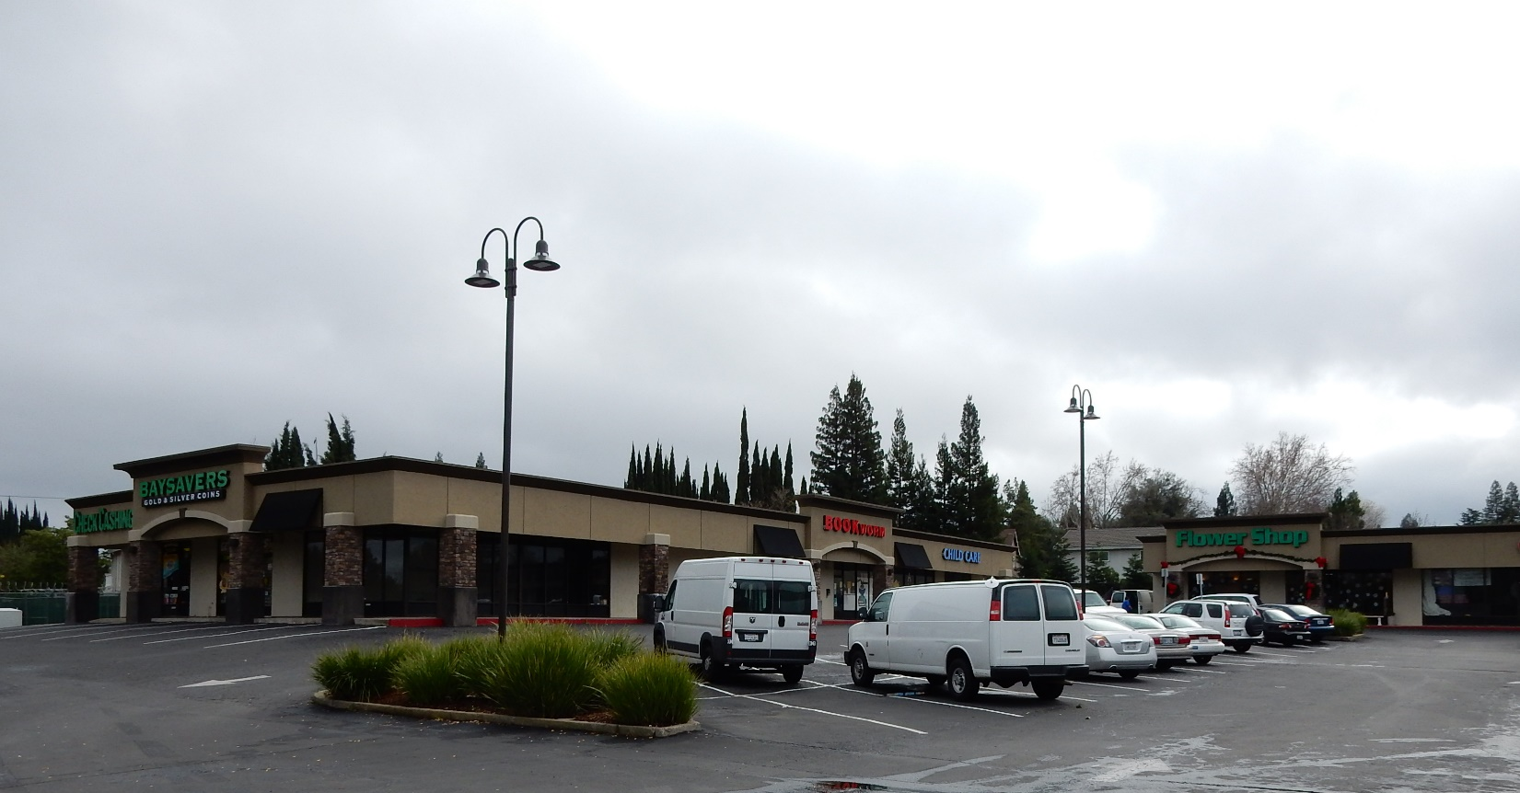

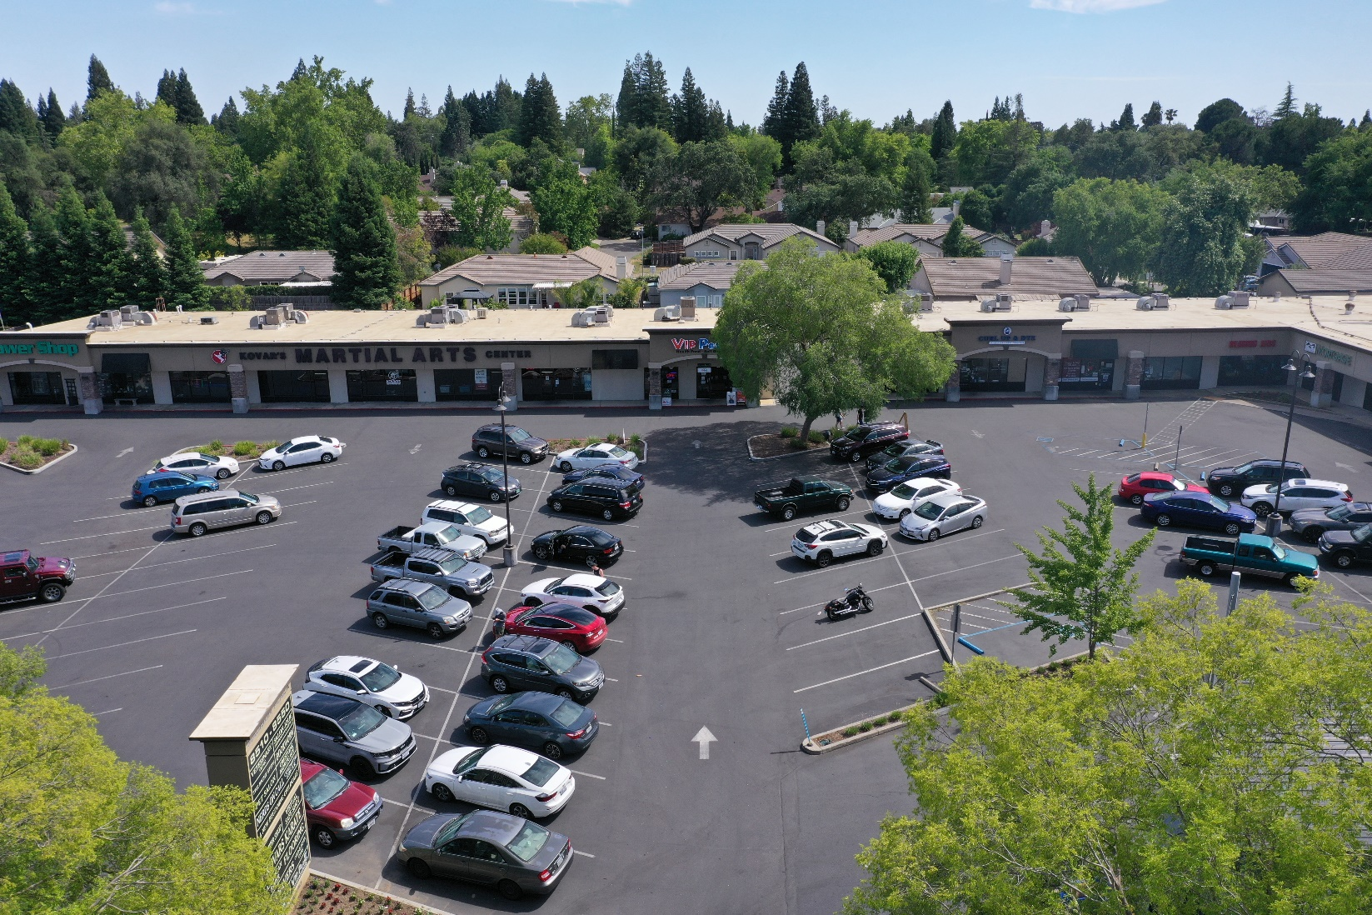
8514 Madison Ave
1200 SF Available

Aerial Site Plan
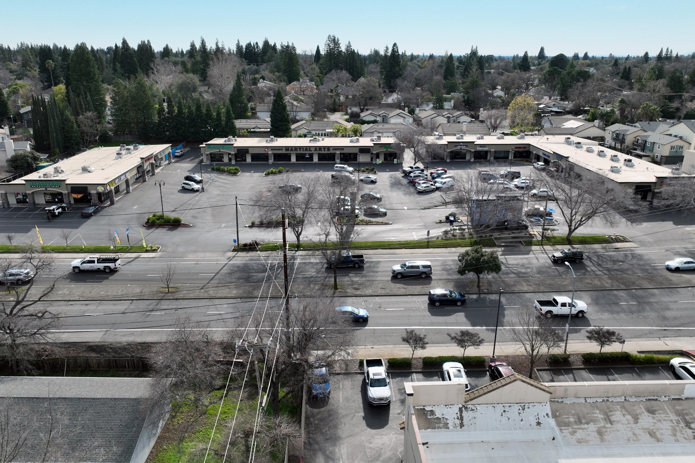

Location Map
