Sec. 3.21 GB General Business District Intent, Permitted Uses and Conditional Uses.
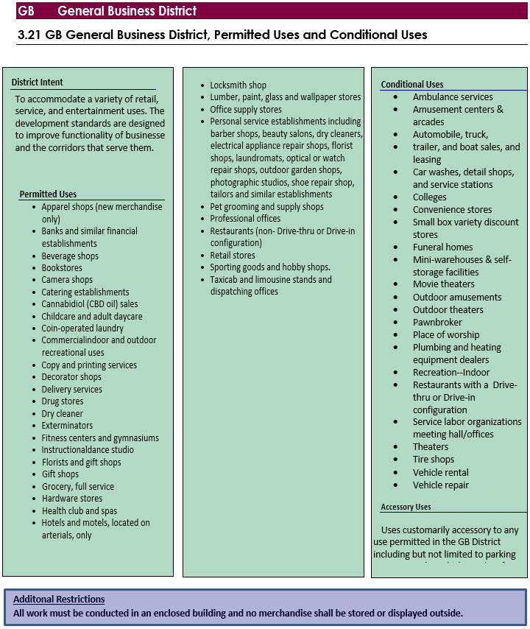
(Ord. No. 2017-41, § 3, 5-30-17; Ord. No. 2017-88, § 1, 12-19-17; Ord. No. 2018-25, §§ 3, 4, 3-20-18; Ord. No. 2021-55, § 3, 3-16-21; Ord. No. 2021-196, Pt. I(§ 2), 9-21-21; Ord. No. 2022-174, § 3, 8-16-22; Ord. No. 2023-15, pt. II, 1-17-23)

